Name: ……………………………………………… … Index No: ………………………………..

Candidate’s signature…………………………….. … Date……………………………………..

BUNAMFAN CLUSTER EXAMINATION 2021
446/1
BUILDING CONSTRUCTION
PAPER 1
December 2021
Time: 2 ½ Hours

INSTRUCTIONS TO CANDIDATES
(a) Write your name and index number in the spaces provided above.
(b) Sign and write the date of examination in the spaces provided above.
(c) Candidates should have the following for this exam:.
- Drawing paper size A3
- Drawing instruments
-Dcientific calculator
(d) This paper consists of two sections; A and B.
(e) Answer all questions in section A in the spaces provided.
(f) From section B, answer question 11 on A3 paper and any other three questions in the spaces provided.
(g) All dimensions are in millimeters unless otherwise stated.
(h) This paper consists of 10 printed pages.
(i) Candidates should check the question paper to ascertain that all the pages are printed as indicated and that no questions are missing.
(j) Candidates should answer the questions in English.

For Examiner’s Use Only
Section | Question | Maximum Score | Candidate’s Score
A | 1-10 | 40
B | 11 | 15
 | 12 | 15
 | 13 | 15
 | 14 | 15
 | 15 | 15
Total Score
SECTION A (40 marks)
Answer all questions in this section in the spaces provided.
1. (a) Define the term “shelter” (1 mark)
………………………………………………………………………………………………… …………………………………………………………………………………………………
(b) Name two tools and two equipment used for setting out a right angle of a building. (2 marks)
………………………………………………………………………………………………… …………………………………………………………………………………………………
………………………………………………………………………………………………… ………………………………………………………………………………………………… …………………………………………………………………………………………………
2. (a) Name two areas where a building line can be measured from. . (1 mark)
………………………………………………………………………………………………… …………………………………………………………………………………………………
(b) Give two reasons why the current traditional houses are better than caves. (1 mark)
………………………………………………………………………………………………… …………………………………………………………………………………………………
3. (a) Give two components of a business plan. (2 marks)
………………………………………………………………………………………………… ………………………………………………………………………………………………… …………………………………………………………………………………………………
(b) Outline three qualities of each of the following safety attire. (3 marks)
(i) Boots
………………………………………………………………………………………………… …………………………………………………………………………………………………
(ii) Helmet
………………………………………………………………………………………………… …………………………………………………………………………………………………
4. (a) Describe the following types of foundations and give two examples in each case. (4 marks)
(i) Shallow foundation
………………………………………………………………………………………………… ………………………………………………………………………………………………… ………………………………………………………………………………………………… …………………………………………………………………………………………………
(ii) Deep foundations
………………………………………………………………………………………………… ………………………………………………………………………………………………… ………………………………………………………………………………………………… …………………………………………………………………………………………………
(b) State the function of a goose neck bend in a cold water service layout. (1 mark)
………………………………………………………………………………………………… ………………………………………………………………………………………………… ………….......................................................................................................................................
5. (a) State four places where vertical damp proof courses are used. (2 marks)
………………………………………………………………………………………………… ………………………………………………………………………………………………… ………………………………………………………………………………………………… ………………………………………………………………………………………………… ……………………....................................................................................................................... .......................................................................................................................................................
(b) Describe two ways through which moisture can penetrate a building. (1 mark)
………………………………………………………………………………………………… ………………………………………………………………………………………………… ………………………………………………………………………………………………… …………………………………………………………………………………………………
6. Figure 1 shows an outline of a floor plan of a building. (4 marks)

Make sketches to show the positions of the profile boards for setting out the building.

7. (a) Use labeled sketches to show the following features on a wall: (3 marks)
(i) Raking back

(ii) Toothing.

(b) Figure 2 shows masonry wall joints. Name the type of joints labeled (a) and (b) stating the advantage of each. (2 marks)
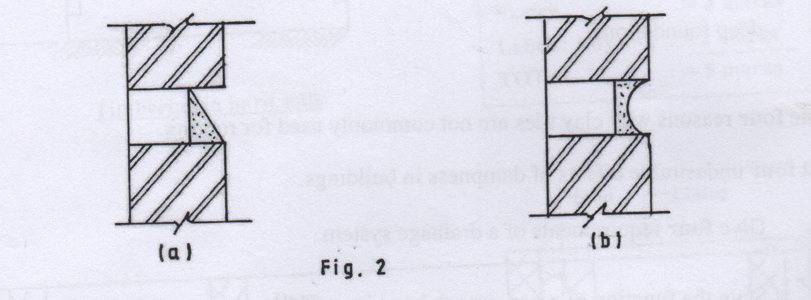

(a) Name:
……………………………………………………………………………………
Advantage: …………………………………………………………………………………………………
(b) Name: …………………………………………………………………………………………………
Advantage:
…………………………………………………………………………………………………
8. (a) List two roof covering materials for each of the following types of flat roofs. (2 marks)
(i) Concrete flat roof:
………………………………………………………………………………………………… …………………………………………………………………………………………………
(ii) Timber flat roof:
………………………………………………………………………………………………… …………………………………………………………………………………………………
(b) State two conditions necessary when installing pipes to convey hot water. (1 mark)
………………………………………………………………………………………………… ………………………………………………………………………………………………… …………………………………………………………………………………………………
9. (a) Explain the use of pipe fittings in a pipe installation. (Give two) (2 marks)
………………………………………………………………………………………………… ………………………………………………………………………………………………… …………………………………………………………………………………………………
(b) State two factors to be considered when sitting a septic tank. (2 marks)
………………………………………………………………………………………………………………………………………………………………………………………………………………………………………………………………………………………………………………………………………………………………………………………………………………………………………….
10. Construct a triangle whose perimeter is 1160 mm and sides are in the ratio 4:5:6 (4 marks)

SECTION B (60 MARKS)
Answer question 11 on the A3 paper provided and any other THREE questions from this section in the spaces provided. Candidates are advised to spend not mope more than 25 minutes on
question 11.
11. Figure 4 shows a pictorial drawing of a shaped block.
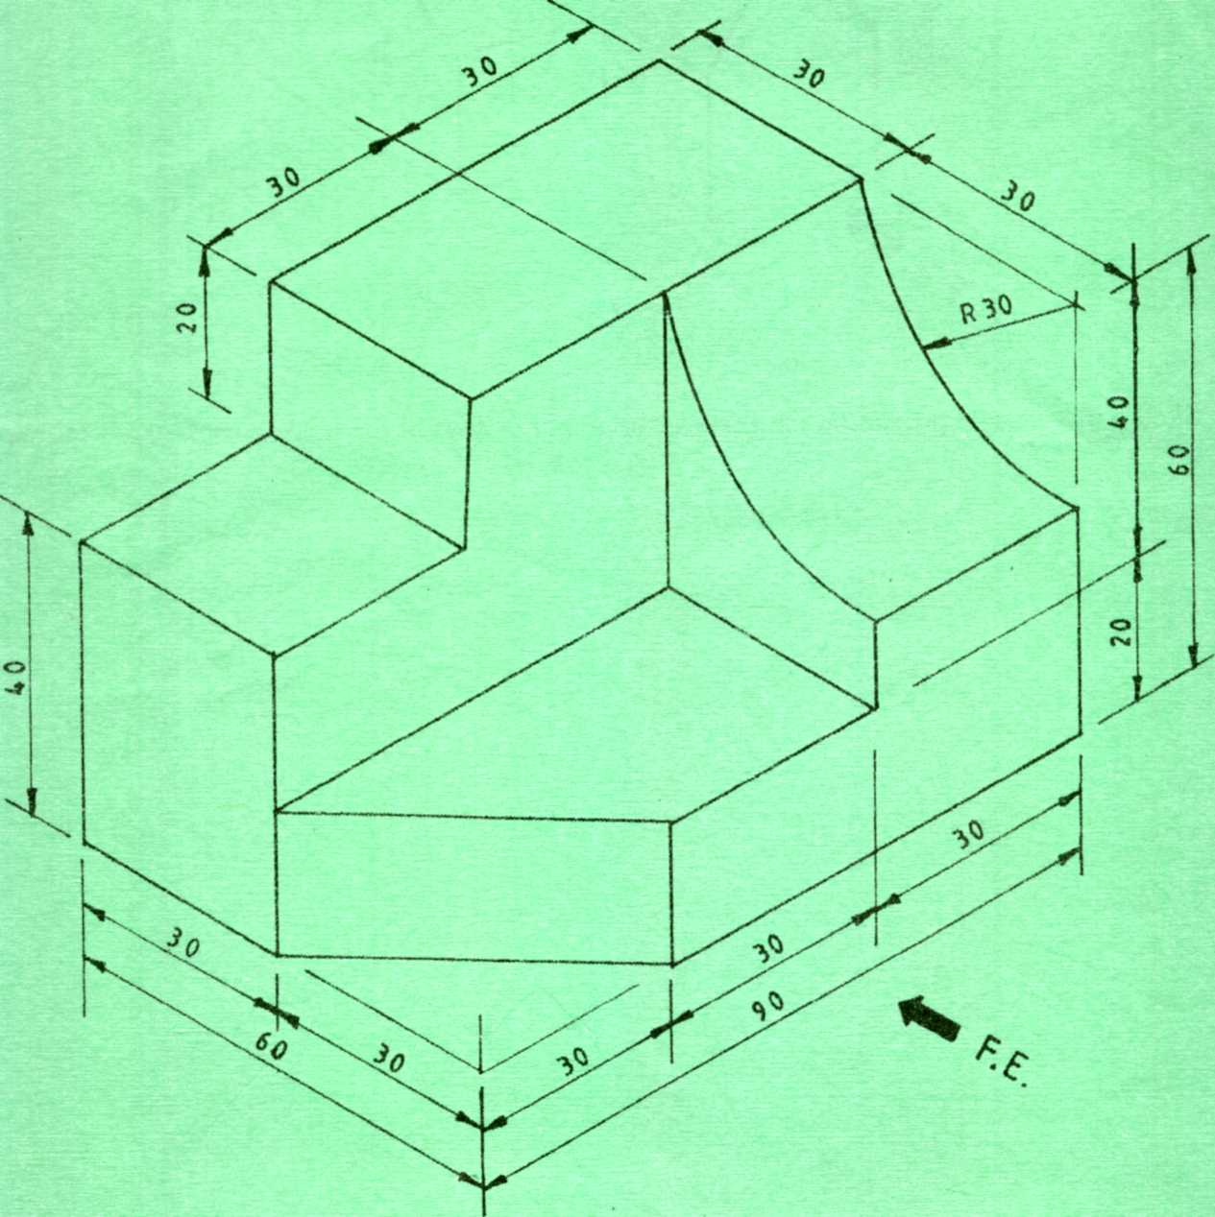
Fig. 4
To a scale of 1:1, draw three orthographic views of the block in 3rd angle projection. Insert six
dimensions. (15 marks)

12. (a) Give two advantages of twisted reinforcement bars over the round reinforcement bars when used in concrete. (2 marks)
………………………………………………………………………………………………… ………………………………………………………………………………………………… …………………………………………………………………………………………………
(b) Use labeled sketches to show the difference between a couple roof and a collar roof. (9 marks)

(c) State four methods of dropping concrete safely into a trench bottom more than 1.5 metres deep. (4 marks)

………………………………………………………………………………………………… ………………………………………………………………………………………………… ………………………………………………………………………………………………… ………………………………………………………………………………………………… ………………………………………………………………………………………………… …………………………………………………………………………………………………

13. (a) Sketch and label an elevation of a gauged brick camber arch for a door opening. (7 marks)

(b) State four functions of foundations in buildings. (4 marks)
………………………………………………………………………………………………… ………………………………………………………………………………………………… ………………………………………………………………………………………………… ………………………………………………………………………………………………… …………………………………………………………………………………………………
(c) Illustrate the stages through which a standard eight leaver may undergo training up to the highest level in technical education. (4 marks)
………………………………………………………………………………………………… …………………………………………………………………………………………………
………………………………………………………………………………………………… ………………………………………………………………………………………………… ………………………………………………………………………………………………… ………………………………………………………………………………………………… …………………………………………………………………………………………………
14. (a) Outline two reasons why concrete mixer needs a little amount of water before it’s operated. (2 marks)
………………………………………………………………………………………………… ………………………………………………………………………………………………… …………………………………………………………………………………………………

(b) Give four functional requirements of centres for arches. (4 marks)
………………………………………………………………………………………………… ………………………………………………………………………………………………… ………………………………………………………………………………………………… ………………………………………………………………………………………………… ……………………....................................................................................................................... .......................................................................................................................................................
(c) Give four precautions to take when you store cement in site. (4 marks)
………………………………………………………………………………………………… …………………………………………………………………………………………………
………………………………………………………………………………………………… ………………………………………………………………………………………………… ………………………………………………………………………………………………… ………………............................................................................................................................... .......................................................................................................................................................
(d) State five functional requirements of a solid floor. (5 marks)
………………………………………………………………………………………………… …………………………………………………………………………………………………
………………………………………………………………………………………………… ………………………………………………………………………………………………… ………………………………………………………………………………………………… …………………………………………………………………………………………………... ....................................................................................................................................................... ....................................................................................................................................................... .......................................................................................................................................................

15. Illustrate using a neat sketch the direct cold water supply system. Label all the parts. (15 marks)

