BUSINESS PAPER 2 FORM 4 END OF TERM 2 MARKING SCHEME 2022
1a) Explain five benefits of operating a public limited company (10marks)
Large capital base-plc has access to a wide source of capital through sale of shares and debentures to the public. It can also borrow loans from banks using its assets as security
Transfer of shares-shares can be transferred from one person to another without any effect on the continuity or ownership of the company
Continuity- the company will continue to exist regardless of the death insanity or bankruptcy of shareholders
Specialized professional management- its wide sources of capital enables a public ltd company to employ qualified skilled staff
Economies of scale- its size enables the company to operate on large scale hence reducing the costs while maximizing on profits
Encouragement and motivation of employees to work harder for higher profits in case where the company has share schemes for its employees
Accountability- there exist transparency and accountability since it’s a legal requirement for the company to publish its accounts and discuss them during AGM.

(b)Discuss five ways in which commercial banks facilitate trading activities in the
country.(10 marks)
Safekeeping of money for businesses people-money deposited is safely kept and released on demand
Transfer of money- through various means. Accept examples of money transfer as an explanation
Lending money- by offering various loans which enable businesses people to start or continue with business
Foreign exchange services- business people dealing in international trade can exchange currency
Investment services- to their customers which enable them invest wisely accept examples of investment services as a mention
They give advice on taxation- when preparing taxation reforms for business people
Acting as trustees
Provide night safe services-for late business bankers
Provide safe custody services
Provide credit cards
Acts as agents of stock holders
Disseminate business information in form of pamphlets

(2a) Explain five factors that an entrepreneur would consider when evaluating a business opportunity. (10 marks)
The profit margin to be earned. There should be a reasonable profit from the investment in order to cover for all the expenses
Existing attitude /beliefs of the target market. Business idea must be in line with the peoples attitude and practices
Appropriate technology-technology to be used in producing the product or offering the services should be efficient/cost effective
Size/availability of the market-should be adequate
Legal requirements- should be favorable/easily be met to operate smoothly
Level of competition- should be fair or capable to cope with
Capital- should be adequate to operate the business

(b)Explain five sources of public finance. (10 marks)
Fines-imposed on law offenders
Taxes- levying on peoples incomes and profits
Rent and rebates getting regular levies from services carried out in government institutions and properties
Fees- levies charged on documents issued by the government eg driving license trade licences and road licenses
Profits-profits from government businesses
Leasing of properties-government lets properties for a long time to get money for other projects
Internal and external borrowing-the government gets loans from the internal and external sources eg IMF and World Bank
3a) Explain five methods that the government of Kenya may adopt in its effort to control high population (10 marks)
By providing and promoting use of family planning methods to reduce the birth rate
By discouraging early marriage by imposing stiff penalties to those found practicing it
By educating public on advantage of small families and problems associated with large families
By improving medical facilities to enhance confidence on the survival of the few number children given birth to
By setting upper limit on the number of children that a couple can give birth to
By improving on social security programme so that people may not have many children as source of wealth
Restricting immigration by controlling the number of people coming into the country.
Reducing poverty levels by promoting the standards of living through incoming generating projects so that children are not viewed as security in the old age
b) Explain the various ways in which computers have improved efficiency in business organizations (10 marks)
Accurately keep the records of everything in an office
It helps in speeding up operations
It helps in giving, presentable /neat output
Has high information storage ability-thus assist to create space in an office
It facilitates communication from one point to another eg internet
Help to reduce wage bill as a few people are employed
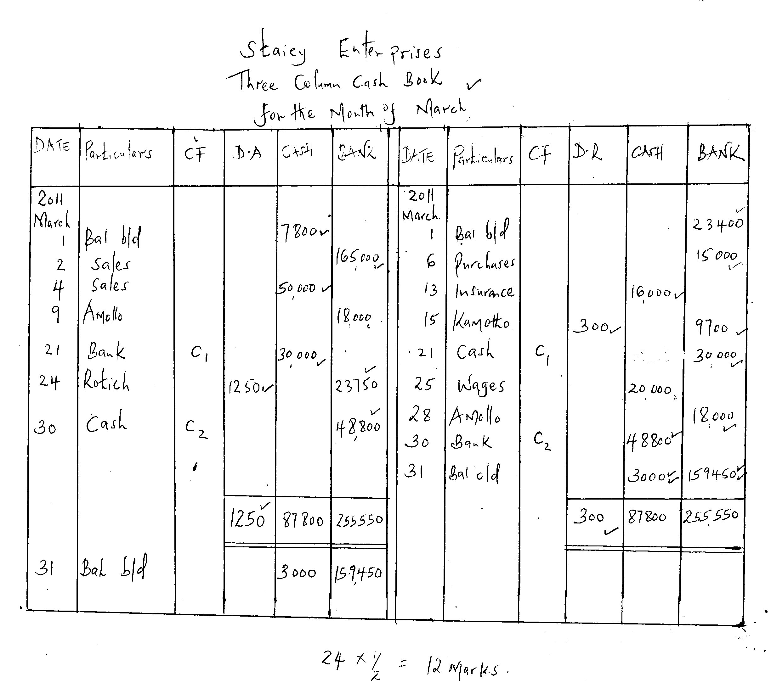
Has made the world a global village making the transactions easier/faster

4a).

4b) Apart from forces of demand and supply describe any other four ways in which the
Price of a commodity can be determined in the market (8 marks)
Auctioning/bidding-where buyers compete for the product and the product is sold to the highest bidder
Haggling/bargaining-sellers and buyers argue various possible prices until they agree on the price at which the product is exchanged
Tendering- prospective sellers suggest the price at which they are willing or able to sell and the buyer selects the appropriate price
Price fixing by the producer/seller where they fix/ set/ recommend the price at which the product should be sold
Price fixing by the government-the government sets the price at which all sellers offer the product to the market
Legislation/recommended retail price-;producers fixing prices/ manufacturers agree in prices of commodities
5a) Discuss five ways of improving the efficiency of a warehouse (10 marks)
Ensuring that there is proper and adequate handling equipment to handle goods easily
Ensuring that staff are well trained /motivated hence enhancing their performance
Ensuring proper use of space/proper arrangement of goods to allow easy movement
Ensuring adequate security to avoid theft of goods
Ensure proper system of inventory control to monitor stock and avoid losses
Ensuring that legal requirement are adhered to for smooth running with laid down laws
Ensuring adequate transport to move goods and workers in and out of the warehouse
Ensure adequate communication facilities for effective communication within/without warehouse
Ensure there are adequate proper storage facilities to cater for special different loading/offloading area to avoid congestion
Ensuring that there are safety measures in place to take care of fire, water etc to avoid damage of goods and safeguard safety of workers
Ensure that the public health requirement are met for smooth operations
5b) Explain five problems of using per capita income to measure the standards of living of people in a country (10 marks)
The income may be inequitably distributed. An increase in per capita income does not signify an improvement in the living standards
Levels of inflation-high levels of inflation may falsify higher figures of the per capita income
Wrong data/inaccurate data of population and national income figures will give misleading figures of per capita income
Lack of leisure/ lack of sleep/sacrifices leading to poor health may be a reason for increased figures of per-capita income
Since governments may deliberately manipulate the per-capita income figures to serve some political reasons
It may increase in the face of social costs such as pollution
This is not a rational way of measuring the welfare of the people
6a) Explain five means of payment available to traders in Kenya (10marks)
Cash-use of notes and coins available in various denominations
Cheque-it is a written order or instructions by an account holder (drawer) to the bank (drawee) to pay a specified sum of money to the named person (payee) or to the bearer
Bill of exchange- it is an unconditional order in writing addressed by one person to another requiring the person to whom it is addressed to pay on demand or at a stated future date the sum of money on the bill to a named person or bearer
Promissory note-it is a document where one person promises to pay another person a specified amount of money at a stated future date.
Money order-a facility offered by the post office sender fills in a money order form, hands in the money to be sent and the commission to post office clerk who prepare the money order which is then sent or taken to the payee
Postal order-postal orders are sold by the post office in fixed denominations, person sending money buys the postal orders and sends or takes them to pay a commission is paid to the post office
Credit cards-specialized design plastic cards by credit cards companies which enable one to obtain goods and services on credit from certain specified suppliers
Standing order-is an instruction given by the account holder to his bank to make regular payment of specified amount to a named party directly into the recipient account
Credit transfer-where a trader may pay several creditors or employees using one cheque by paying directly into the recipients account
Electronic fund transfer eg Posta pay, pesa point, E-money. E-banking where he can access his/her account withdraws and deposits money using ATM cards mobile phones,etc

6. (b) (i)
Mwanabiashara traders
Trading, profit and loss a/c √
For the year ended 31/December, 2015
Dr.
sh. sh.
Opening stock 90,000√ Sales 700,000 √
Add purchases 480,000√ less returns 30,000√
Add carriage inwards 29,000√ Net sales 670,000√
Less returns out 80,000√
G.A.F.S 519,000
Less closing stock 12,600√
C.O.G.S 506,400√
Gross profit c/d 163,600√√
670,000 670,000
Expenses
Carriage outwards 20,200√ Gross profit b/d 163,600√
Salaries 13,000√ discount received 16,800√
Electricity 10,000√
Telephone 16,400√
Insurance 30,200√
General expenses 28,400√
Rent 17,000√
Net profit c/d 45,200√√
180,400√ 180,400
24×⅓= 8 marks
6(bii) Rate of stock turnover = C.O.G.S
Av stock
= 506,400 ÷ (90,000 +12,600)√
2
= 9.87 times√

