BIOLOGY PP1
231/1
FORM THREE
TIME: 2HRS

NAME……………………………………………………………………..ADM………………STREAM………….…….
NAME OF SCHOOL ………………………………………………………………….DATE……………………….

END OF TERM I, 2023 EXAMINATIONS

INSTRUCTIONS
- Write your answers correctly and clearly in the spaces provided
- Be keen on Spelling of Technical Terms

FOR OFFICIAL USE

TOTAL MARKS | STUDENT’S SCORE
80

- Give TWO unique features of members of Kingdom Monera (2mks
………………………………………………………………………………………………………………………………………………………………………………………………………………………………………………………………………………………………

- The diagram shown below represents a cell
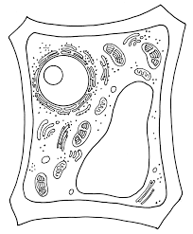
Identify TWO reasons why this is a plant cell (2mks
………………………………………………………………………………………………………………………………………………………………………………………………………………………………………………………………………………………………
- Name the organelle found in high number in the following structures (3mks
- Palisade ………………………………………………………………………………...
- Goblet cells …………………………………………………………………………….
- Muscle ………………………………………………………………………………….

- Account for the following observations
i) A plant cell does not burst when placed in a hypotonic solution (1mk
………………………………………………………………………………………………………………………………………………………………………………………………
ii) An amoeba does not burst when placed in distilled water (2mks
………………………………………………………………………………………………………………………………………………………………………………………………
ii) Submerged hydrophytes have highly dissected leaves (2mks
………………………………………………………………………………………………………………………………………………………………………………………………
- The experimental set up shown below was used to study a physiological process
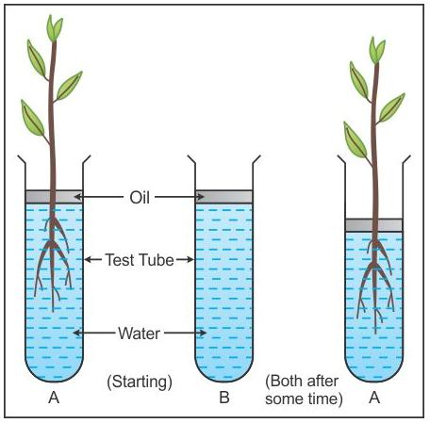
- State the function of oil in the experiment shown above (1mk
………………………………………………………………………………………………………………………………………………………………………………………………
- Account for the observation made in A after the experiment (2mks
………………………………………………………………………………………………………………………………………………………………………………………………………………………………………………………………………………………………
- What was the role of set up B in the experiment? (1mk
………………………………………………………………………………………………………………………………………………………………………………………………
- a) Explain why plants in low altitude experience higher rate of growth than those in higher altitude areas (2mks
………………………………………………………………………………………………………………………………………………………………………………………………………………………………………………………………………………………………
b) A person climbing a mountain experiences increase in number of erythrocytes in their blood. Explain (2mks
………………………………………………………………………………………………………………………………………………………………………………………………
- The following are the blood vessels in a human body
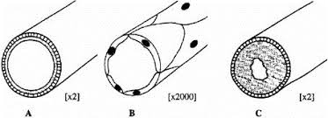
- Which letter represents the blood vessel that: (3mks
i) Experiences pulsating action……………..…………………………………………..
ii) Has valves along its length ………………………………………………………….
iii) Supplies blood to every tissue of the body ,,,……………………………………….
- Why is vessel B the only one that experiences ultrafiltration? (1mk
………………………………………………………………………………………………………………………………………………………………………………………………

- a) Define the term homeostasis (1mk
………………………………………………………………………………………………………………………………………………………………………………………………b) State TWO ways plants expel their metabolic waste products
………………………………………………………………………………………………………………………………………………………………………………………………………………………………………………………………………………………………

- Explain how sunshine contributes to having strong teeth (3mks
………………………………………………………………………………………………………………………………………………………………………………………………………………………………………………………………………………………………

- State TWO roles of mucus in the stomach (2mks
………………………………………………………………………………………………………………………………………………………………………………………………
- The following is a set up used in a biological study. After a while a starch test was done on the leaf labelled C and the result is shown on the detached leaf
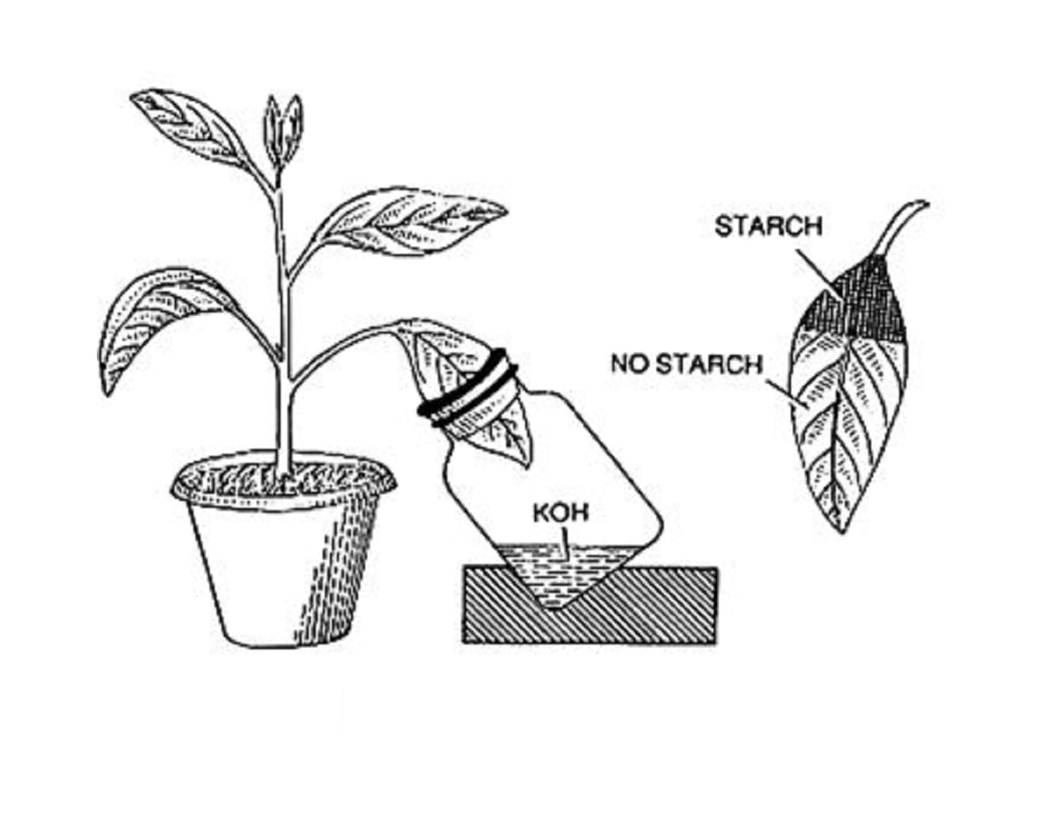
C

- What was the aim of the experiment? (1mk
………………………………………………………………………………………………………………………………………………………………………………………………
- Which colour observation on iodine solution informed the following conclusion?
i) Presence of starch (1mk
……………………………………………………………………………………………………………………………………………………………………………………
ii) No starch (1mk
……………………………………………………………………………………………………………………………………………………………………………………
- Account for the observation made on part of Leaf C that was inside the bottle (2mks
………………………………………………………………………………………………………………………………………………………………………………………………………………………………………………………………………………………………

- Name the parasites that cause the following human diseases (2mks
- Bacterial human Pneumonia….……………………………………………………….
- Cholera ………………………………………………………………………………..

- The diagram shown below represents a structure found in plant leaves
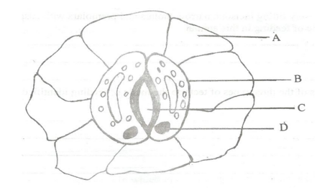
- State the importance of part C to photosynthesis (1mk
………………………………………………………………………………………………………………………………………………………………………………………………
- State TWO unique structural features found in cell B and not in A (2mks
………………………………………………………………………………………………………………………………………………………………………………………………………………………………………………………………………………………………

- Use the diagram shown below to answer the questions that follow
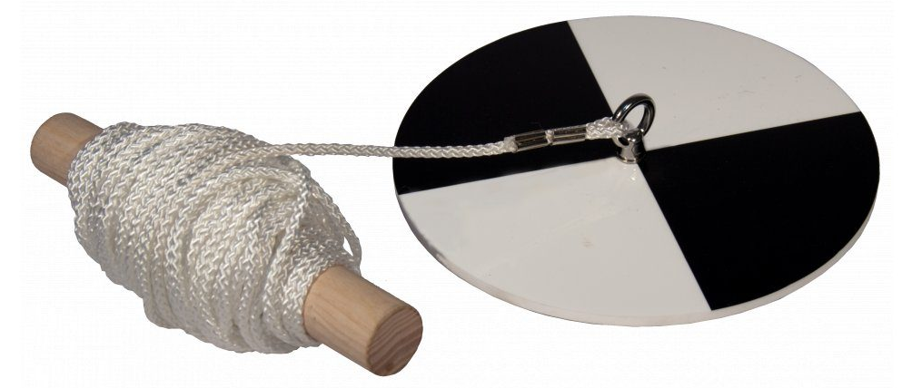

- Give the identity of the instrument shown above (1mk
………………………………………………………………………………………………………………………………………………………………………………………………
- In which environment is the instrument used? (1mk
………………………………………………………………………………………………………………………………………………………………………………………………
- The following are the three types of cells found in human blood
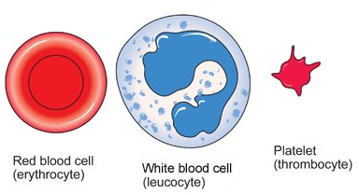
P Q R
a) State TWO roles of enzyme released when cell R bursts on exposure to air (2mks
………………………………………………………………………………………………………………………………………………………………………………………………………………………………………………………………………………………………
b) Give TWO ways cells represented by Q undertake their functions in the body (2mks
………………………………………………………………………………………………………………………………………………………………………………………………………………………………………………………………………………………………

- Explain why there were more bubbles in set up B than A in the experiment shown below
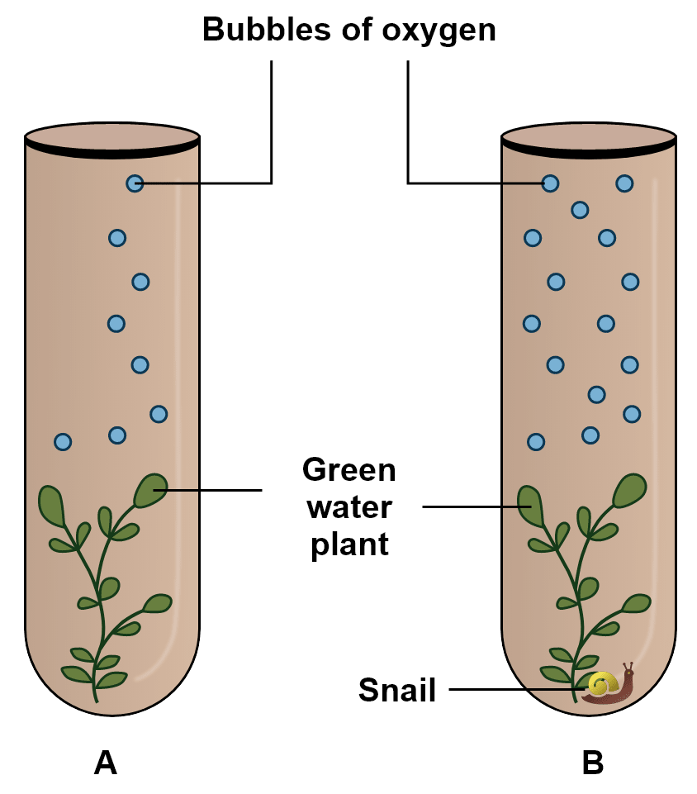
………………………………………………………………………………………………………………………………………………………………………………………………………………………………………………………………………………………..(2mks

- Use features shown of a common animal below to answer the questions that follow
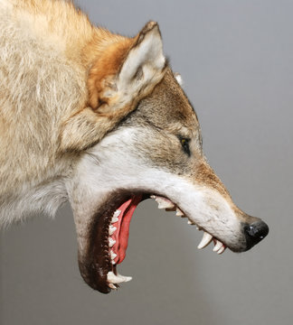

- Give TWO reasons to show that the animal above is carnivorous (2mks
………………………………………………………………………………………………………………………………………………………………………………………………………………………………………………………………………………………………
- i) Name the class to which the animal above belong (1mk
………………………………………………………………………………………………
ii) Give TWO reasons for your answer in bi) above (2mks
………………………………………………………………………………………………………………………………………………………………………………………………

- In a laboratory controlled experiment, students found that cells of a given tissue utilized 30 cm³ of Oxygen and 20 cm³ of Carbon (IV) Oxide was released during the same time.
- Calculate the Respiratory Quotient (2mks
………………………………………………………………………………………………………………………………………………………………………………………..…….………………………………………………………………………………………………
- Why is fat not a desired respiratory substrate yet it yields a lot of energy (2mks
………………………………………………………………………………………………………………………………………………………………………………………..…….………………………………………………………………………………………………
- The diagram below shows a section of a plant organ
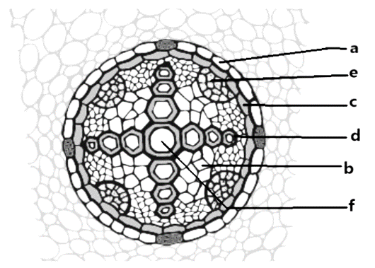
- State the function of part labelled e (1mk
………………………………………………………………………………………………
- Give TWO reasons to show that the section above was obtained from a dicot root
………………………………………………………………………………………………………………………………………………………………………………………..(2mks
- Name the other type of tissue d apart from xylem vessels (1mk
……………………………………………………………………………………………

- The specimens shown below were used by learners for a taxonomic study.
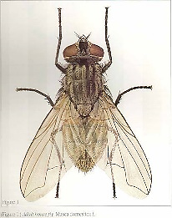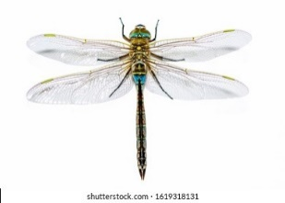
Housefly Dragon fly
- Samson indicated that the two specimen belonged to class Insecta. Give a reason.(1mk
………………………………………………………………………………………..……
- Use wings to construct a one-step dichotomus key for identification of the specimen
………………………………………………………………………………………..…….……………………………………………………………………………………..…(2mks
- The following graph was obtained after an experiment on potato strips
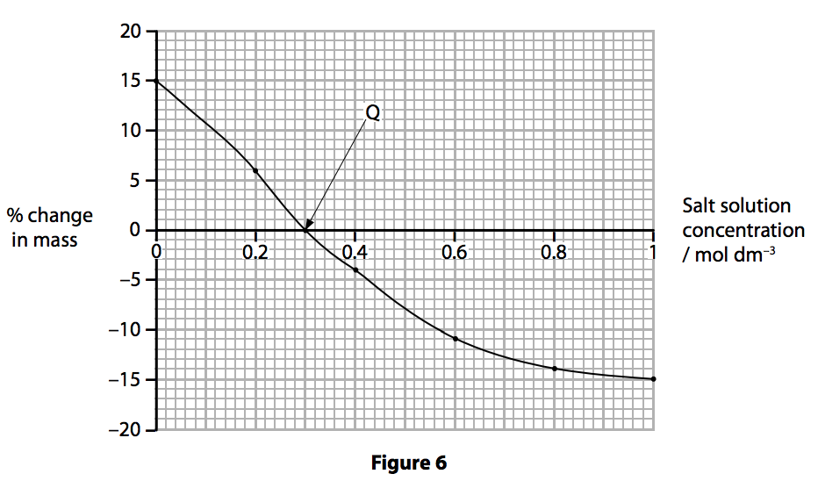
- i) Which term is used to describe the cell when it experiences -15% change in mass?
………………………………………………………………………………………..(1mk
ii) From the graph give the normal cell sap concentration of the potato cells
………………………………………………………………………………………..(1mk
- Account for the change in mass of potato strips at Q
………………………………………………………………………………………..…….………………………………………………………………………………………………………………………………………………………………………………………(2mks

- a) Name the part of the brain that regulates breathing (1mk
………………………………………………………………………………………………
b) Describe how intercostal muscles influence rib cage movements during inhalation
……………………………………………………………………………………………………………………………………………………………………………………...…….………………………………………………………………………………………………………………………………………………………………………………………..…(4mks

- a) Write a word equation for the process of photosynthesis (1mk
………………………………………………………………………………………………..………………………………………………………………………………………..……
b) Where do the following take place in the chloroplast? (2mks
i) Carbon fixation ……………………………………………………………………. …… ii) Photolysis ……………………………………………..…………..…………………….

- a) State TWO roles of enzymes in the body (2mks
……………………………………………………………………………………………………………………………………………………………………………..…………..……………………………………………………………………………………………………

b) Identify TWO factors that reduce rate of enzyme controlled metabolic reactions (2mks
………………………………………………………………………………………………………………………………………………………………………………………..…..…………………………………………………………………………………………………

THE END

BIOLOGY IS STILL THE STUDY OF LIFE.
LOVE IT MORE!!

