Term 1 – 2023 OPENER EXAM
BIOLOGY (231/3)
FORM (4)
Time: $1\frac{3}{4}Hours$

Name: …………………………………………………………. Adm No: ……………….
School: ……………………………………………………….. Class: …………………..
Signature: …………………………………………………….. Date: …………………...

INSTRUCTIONS TO CANDIDATES:
- Write your name, admission number and school in the spaces provided above.
- Sign and write the date of examination in the spaces provided above.
- Answer all the questions in the spaces provided.
- You are required to spend the first 15 minutes of the 1¾ hours allowed for
- this paper reading the whole paper carefully before commencing your work.
- This paper has three questions.
- Students should check the question paper to ascertain that all the papers are printed as indicated and that no questions are missing.
- Candidates should answer the questions in English.
FOR EXAMINER’S USE ONLY:
Question | Maximum  Score | Candidate’s  Score
1 | 14
2 | 14
3 | 12
Total Score | 40

1. You are provided with specimen T.
a) Cut a 1 cm slice from the specimen and remove its peel. Place the soft inner part into a boiling tube labelled A.

Cut another 1 cm slice from the specimen and remove its peel. Using a pestle mash the soft inner part into a paste. Place the paste into a boiling tube labelled B.

Add 4 cm³ of dilute hydrogen peroxide solution into each of the boiling tubes A and B.

i) Record your observations (2mks)
……………………………………………………………………………………………………………………………………………………………………………………………………
…………………………………………………………………………………………………
…………………………………………………………………………………………………
……………………………………………………………………………………………………………………………………………………………………………………………………
……………………………………………………………………………………………………………………………………………………………………………………………………

ii) Account for the results in 1. a) i) above (2mks)
……………………………………………………………………………………………………………………………………………………………………………………………………
……………………………………………………………………………………………………………………………………………………………………………………………………
……………………………………………………………………………………………………………………………………………………………………………………………………

iii) Write an equation for the breakdown of hydrogen peroxide (1mk)
……………………………………………………………………………………………………………………………………………………………………………………………………

b) Cut a 2 cm slice from specimen T and remove its peel. Place the soft inner part in a mortar, and using a pestle mash it into a fine paste. Add a little of distilled water and stir the mixture. Pour the mixture into a beaker and allow it to stand for 2 minutes. Using the reagents provided, test for the food substances in the mixture. Record procedure, observation and conclusion in the table below (9mks)
Food substance being tested | Procedure | Observation | Conclusion
Starch

Vitamin C

Reducing Sugar

2. The following photomicrographs K and L illustrate cross sections of an organ as found in different plants. Use the photomicrographs to answer the questions below.

K L

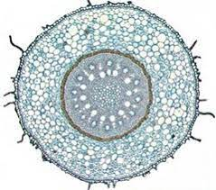
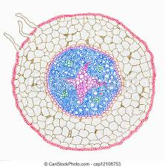

- Name the organ from which the above cross- sections have been obtained giving a reason for your answer. (2mks)

Organ ……………………………………………………………………………………

Reason …………………………………………………………………………………..

- Label the following parts on the photomicrograph K; (3mks)
Xylem
Phloem
Endodermis
- State the differences between cross section K and cross section L. (2mks)

cross section K | cross section L

- Identify any two differences between xylem and phloem. (2mks)

………………………………………………………………………………………………

………………………………………………………………………………………………

………………………………………………………………………………………………

- State two adaptations of xylem to their function. (2mks)

…………………………………………………………………………………………….

…………………………………………………………………………………………….

……………………………………………………………………………………………..

- Name a tissue present in photomicrograph K that is absent in photomicrograph L. (1mk)

……………………………………………………………………………………………..

- Give the function of each of the following tissues; (2mks)

Cortex ……………………………………………………………………………………..

Endodermis ……………………………………………………………………………….

3. Below are photographs labelled L₁, L_{2,} L_{3,} L₄ and L₅ of twigs obtained from plants. Examine them.
L₁ L₂

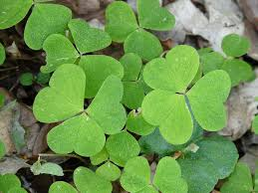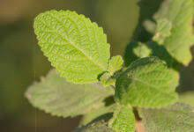
L₃ L₄
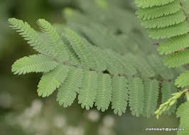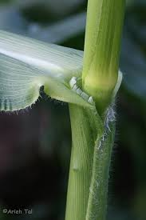

L₅

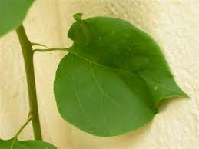

a) Using observable features in the photographs, complete the dichotomous key given below (2mks)
i. a) Leaves compound ………………………………………………… go to 2
b) ___________ …………………………………………………. go to 3

ii. a) Leaf bipinnate …………………………………………………… Mimosaceae
b) Leaf trifoliate .…………………………………………………… Oxalidaceae

iii. a) Leaf with network venation ………………………………………………… go to 4
b) ___________ …………………………………………………….. go to 5

iv. a) Leaf with entire margin …………………………………………………..Nyctaginaceae
b) Leaf with serrated margin .…………………………………………………Verbenaceae

v. a) Leaf with solid petiole ………………………………………………… Agavaceae
b) Leaf with sheath like petiole ………………………………………………Graminae

b) Use the completed dichotomous key to identify the family to which each plant belongs. In each case show the steps you followed to arrive at the identity (10mks)

Specimen | Steps | Identity
L1
L2
L3
L4
L5

