ASUMBI GIRLS HIGH SCHOOL
POST -MOCK 1
AUGUST/SEPTEMBER
2022

BIOLOGY PP3 MS

1a)
Specimen P | Specimen Q
-Has two scars | -Has one scar
-Has one cotyledon | -Has two cotyledons
-Has Food stored in endosperm | -Stores food in cotyledons.

b) P- Ovary;
Q- Ovule;
ci)
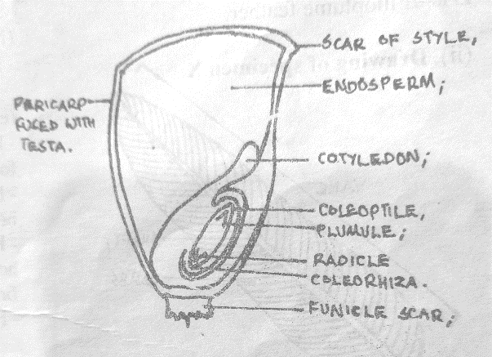
D-1mk
L- 1X3= 3mks N/B Mark first 3 labels clockwise.
ii) -Endosperm- Storage of food;
-Embryo (plumule and radicle)- Develops into shoot and roots;
-Testa – Protects inner delicate parts/embryo;
- Coleoptile – Protects plumule from mechanical damage during germination;

d)
Test | Procedure | Observation | Conclusion
Starch | To 2ml solution Q,  Add 3drps of Iodine solution; | Blue black colour ; | Starch present;
Protein | To 2ml solution Q,  Add equal amount of sodium hydroxide.  Add Copper(II) sulphate drop by drop; | Colour changes to purple/violet/mauve; | Proteins present;

2 ai) Touch;
ii) Positive phototropism;
iii)Place the potted plant on a revolving klinostat in a similar set up.
b) When the tendril comes into contact with the upright firm support; auxins migrate to the
opposite side/side away from touch;
This causes faster cell growth/ cell elongation on the side away from the contact/OR causes
Slower growth on the side in contact with the firm support; and the tendril coils round the support;
ci) K1- It offers support to the non-woody stem/plant;
K2- The plant shoot grows towards the source of light in order to photosynthesize;
3a) S- Larva;
bi) Preceding stage -Larva;
Succeeding stage- Pupa;
ii) Complete metamorphosis;
c) – Tracheal system;
- Presence of spiracles;
di)- Vegetation/ plant material;
- Has biting mouth parts;
ii) It undergoes re-organization of body tissues to form the adult form (ie metamorphosis);
iii) – Has wings for flight;
- Has jointed legs for walking/crawling;
ei)- Stimulates shedding of the larval cuticle while retaining the youthful characteristics/ prevents metamorphosis;
ii) Stimulates shedding of the adult cuticle/moulting in adult;

