231/3
NAME…………………………………………….……. INDEX NO………..…………………..
SIGNATURE……………………………….………………DATE……………………………..
ASUMBI GIRLS HIGH SCHOOL
POST -MOCK 1
AUGUST/SEPTEMBER
2022

AUGUST / SEPTEMBER - 2022
BIOLOGY
PAPER 3
(PRACTICAL)
TIME: 1 ¾ HOUR
INSTRUCTIONS TO CANDIDATES
Answer all the questions in the spaces provided.
You are required to spend the first 15 minutes of the 1 ¾ hours allowed for this paper reading the whole paper carefully before commencing your work.
Additional pages must not be inserted.
FOR EXAMINERS USE ONLY.
Question | Maximum score | Candidates score
1 | 17
2 | 09
3 | 14
Total score | 40

This paper consists of 6 printed pages. Candidates should check to ensure that all pages are printed as indicated and no questions are missing

1. You are provided with specimen P and Q. Examine them carefully and answer the questions that follow.
(a). State three observable differences between P and Q. (3mks)
Specimen P | Specimen Q

(b) Identify the parts of the flower from which specimen P and Q developed. (2mks)
P ---------------------------------------------------------------------------------------------------------------------------------
Q ---------------------------------------------------------------------------------------------------------------------------------

(c i). Make a longitudinal section of specimen P. Draw a well-labelled diagram of one half with all its
Contents intact. (4mks)

(ii). State the functions of any two structures in (c) (i) above. (2mks)
------------------------------------------------------------------------------------------------------------------------------------------------------------------------------------------------------------------------------------------------------------------------------------------------------------------------------------------------------------------------------------------------------------------------------------------------------------------------------------------------------------------------------------------------------------------------

(d). Using a mortar and pestle crush specimen Q, add 5ml distilled water to make a solution Q and carry out appropriate tests using the reagents provided. (6mks)

Test | Procedure | Observation | Conclusion

2. Study the photos below.
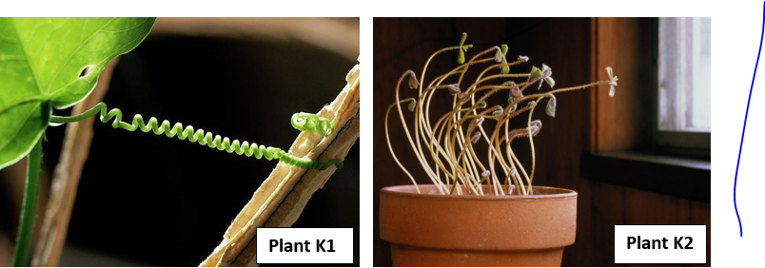

a) Name:-
i) The stimulus operating in Plant K1. (1mk)
--------------------------------------------------------------------------------------------------------------------------------
ii) The type of response being investigated in Plant K2. (1mk)
---------------------------------------------------------------------------------------------------------------------------------
iii) Suggest a control set up for Plant K2 investigation. (1mk)
------------------------------------------------------------------------------------------------------------------------------------------------------------------------------------------------------------------------------------------------------------------------------------

b) Describe the role of auxins in the response exhibited by Plant K1. (4mks)
------------------------------------------------------------------------------------------------------------------------------------------------------------------------------------------------------------------------------------------------------------------------------------------------------------------------------------------------------------------------------------------------------------------------------------------------------------------------------------------------------------------------------------------------------------------------------------------------------------------------------------------------------------------------------------------------------------------
c) What is the biological value of the tropisms evident in: -
i) Plant K1 (1mk)
-----------------------------------------------------------------------------------------------------------------------------------------------------------------------------------------------------------------------------------------------------------------------------------
ii) Plant K2 (1mk)
------------------------------------------------------------------------------------------------------------------------------------------------------------------------------------------------------------------------------------------------------------------------------------
3. Below are photos of of a certain arthropod at different stages of its life cycle.

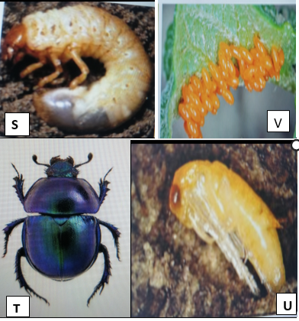

a) Identify the stage of the life cycle represented by organism S. (1mk)
-------------------------------------------------------------------------------------------------------------------------------
b i) Name the stage that immediately preceed and succeed organism S in the life cycle. (2mks)
Preceeding stage
-----------------------------------------------------------------------------------------------------------------------------
Succeeding stage.
-------------------------------------------------------------------------------------------------------------------------------
ii) What name is given to the complete life cycle of the arthropod? (1mk)
-------------------------------------------------------------------------------------------------------------------------------

c) Name the gaseous exchange system of orgaism S. Give a visible featuret that supports your answer. (2mks)
---------------------------------------------------------------------------------------------------------------------------------------------------------------------------------------------------------------------------------------------------------------------------------------------------------------------------------------------------------------------------------------------

d i) What type of food does organisms S feed on? Give a reason to support your answer. (2mks)
--------------------------------------------------------------------------------------------------------------------------------------------------------------------------------------------------------------------------------------------------------------
ii) State the significance of stage U in the life cycle of the beetle. (2mks)
--------------------------------------------------------------------------------------------------------------------------------------------------------------------------------------------------------------------------------------------------------------

iii)How is specimen T adapted to locomotion in its habitat ? (2mks)
----------------------------------------------------------------------------------------------------------------------------------------------------------------------------------------------------------------------------------------------------------------------------------------------------------------------------------------------------------------------------------------------------------------------------------------------------------------------------------------------------------------------------
e) State the role of the following in the life cycle of the arthropods. (2mks)
i) Juvinile hormone.
---------------------------------------------------------------------------------------------------------------------------------------------------------------------------------------------------------------------------------------------------------------------------------------------------------------------------------------------------------------------------------------------
ii) Moulting stimulating hormone.
--------------------------------------------------------------------------------------------------------------------------------------------------------------------------------------------------------------------------------------------------------------

