MARKING SCHEME
231/3
BIOLOGY
PAPER 3 (PRACTICAL)
June 2022
Time: 1 ¾ HOURS
MUMIAS WEST JOINT EXAMS- JUNE 2022
INSTRUCTIONS TO CANDIDATES
- Answer ALL the questions.
- Answers must be written in the spaces provided in the question paper.
- Additional pages must not be inserted.

FOR EXAMINERS USE ONLY
Question | Maximum score | Candidate’s score
1 | 12
2 | 14
3 | 14
Total Score | 40

1. study the photograph below and answer the questions that follow.

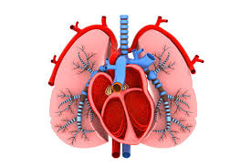

- State two organ systems in which the two organs in the photograph above are found. (2mks)
Respiratory system
Circulatory system

- Label on the photograph the following structures. (4mks)
- Bronchi
- Left ventricle
- septum
- trachea
on the diagram

- State one feature of the following structures identified in( b) above and give the importance of the features. (4mks)

structure | feature | Importance
Left ventricle | Thick muscles | Generate pressure to pumb over along distance in the body
Trachea | Rings of cartilage | prevent trachea from collapsing

- Use an arrow to show the flow of carbon (iv) oxide molecule thorough the chambers of the heart towards the lungs. (1mk)
On the diagram

- State one observable features of lungs in the photograph above that suits them to their function. (1mks)
Bronchi have cartilage to prevent them from collapsing
Highly branched bronchioles to enhanceventilation

- You are provided with the following. Solution P, Q and Z.
- (i) Put 2 cm³ of solution P into two test tubes labeled A and B. Add three drops of iodine solution into test tube A. Observe and record. (1 mark)
Blue black colour is observed
(ii) To test tube B, add an equal amount of Benedict’s solution. Heat to boil. Record your observation. (1 mark)
Blue colour of benedicts solutionpersists
(iii) From the results in (a) (i) and (ii), identify solution P. (1 mark)
starch
(iv) Put 2cm³ of solution Z into a clean test tube labeled C. Add equal volume of Benedict’s solution. Heat to boil. Record your observation . (1 mark)
Blue black coloure persists

(v) Open the visking tubing provided and tie one end tie one end tightly, Pour solution P into the visking tubing and add 1cm³ of the solution R. Tie the other end of the visking tubing and ensure there is no leakage at both ends. Pour solution Z into a clean beaker till it is half full. Immerse visking tube in the solution Z in the beaker. Allow it to stand for 30 minutes. After 30 minutes, take 2cm³ of solution Z from the beaker into a clean test tube labeled D. Add equal amount of Benedict’s solution. Heat to boil. Record your observation. (1 mark)
Solution changes from blue to green to yellow to orange

(vi)Account for the observation made in (v) above. (3 marks)
Starch is hydrolysed to glucose by enzyme diastase.glucose molecule are small enough to diffuse through the small pores of the visking tube and when heated with benedict`s solution it changes to orange.

(vii) what is the identity of solution R? (1 mark)
Enzyme/ diastase
(viii) State one factor that can affect the process demonstrated in 3a (v) above (1 mark)
Suitable temperature
b) Use the reagents provided to test for the food substance in solution Q.
Food substance | procedure | observation | conclusion
proteins | To 2ml of solution Q add equal amounts of sodium hydroxide then add copper II sulphate drop by drop | Purple colour observed | Proteins present
(4mks)

3. The photograph below shows specimen L. You are also provided with other two specimens labeled k and M. Study them then answer questions that follow:
Photograph L.
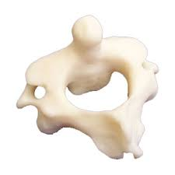

a) Identify the specimens. (3mks)
K Thoracic
L Axis
M lumbar

b) State two adaptive characteristic features of the bone L. (2mks)
Has an odontoid process that fits into the neural canal of the atlas and allows for rotational movements of the head.
Has a broad neural spine for attachment of neck muscles.
Has a neural canal for passage of spinal cord
Has a neural arch that protects the spinal cord

c) State two observable differences between bones L and M. (2mks)
Bone L | Bone M
Has short transverse processes | Large,well-developed transverse processes
Has an odontoid process | Lacks odontoid process

d) (i) Draw and label the anterior parts of specimen K. (3mks)

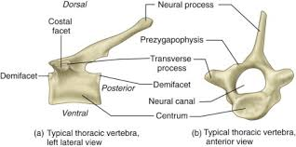

(ii)State ways by which specimen K is adapted to its functions. (2mks)

Has a long neural spine to increase surface area for attachment of muscles.
Has tuber facets to articulate with ribs
Has a large centrum to supper more height

(iii) Name the bone that articulates with specimen K at the:

Proximal end (1mk)
Scapula
Distal end (1mk)
Radius and Ulna bone

