NAME ……………………………………………. INDEX NO …………………………..
SCHOOL…………………………………………… SIGNATURE …………………..………
DATE ……..…………………...
231/3
BIOLOGY
PAPER 3
(PRACTICAL)
TIME 1 ¾ HOURS

CATHOLIC DIOCESE OF KAKAMEGA EVALUATION TEST
AUG/SEPT EXAM 2022
Kenya Certificate of Secondary Education (K.C.S.E)

INSTRUCTIONS TO CANDIDATES
- Write your name and index number in the spaces provided at the top of this page.
- Sign & write the date of the examination in the spaces provided.
- Answer all questions in the spaces provided after each question. Additional pages must not be inserted.
- You are required to spend the first 15 minutes assigned to this paper reading through the whole paper carefully before commencing your work.
- All answers must be given in English.

For Examiners Use Only

Question |  | Maximum Score | Candidate’s Score
1 |  | 13
2 |  | 15
3 |  | 12
 | Total score | 40

This paper consists of 6 printed pages. Candidates should check to ascertain that the pages are printed as indicated and that no questions are missing.

- (a) You are provided with solutions labelled Q and R, a substance labelled D and a delivery tube fitted with a rubber bung/cork.
- Label solution Q as lime water.
- Label solution R as 10% sugar solution.
- Add substance D to the 10% sugar solution.
- Tightly close/plug the boiling tube with the rubber bung/cork fitted with a delivery tube.
- Dip the other end of the delivery tube in the test tube containing lime water.
- Put the boiling tube in the warm water bath at 40oC and allow the set up to stand as shown in the diagram below.
- Observe the set up for about 15 minutes.

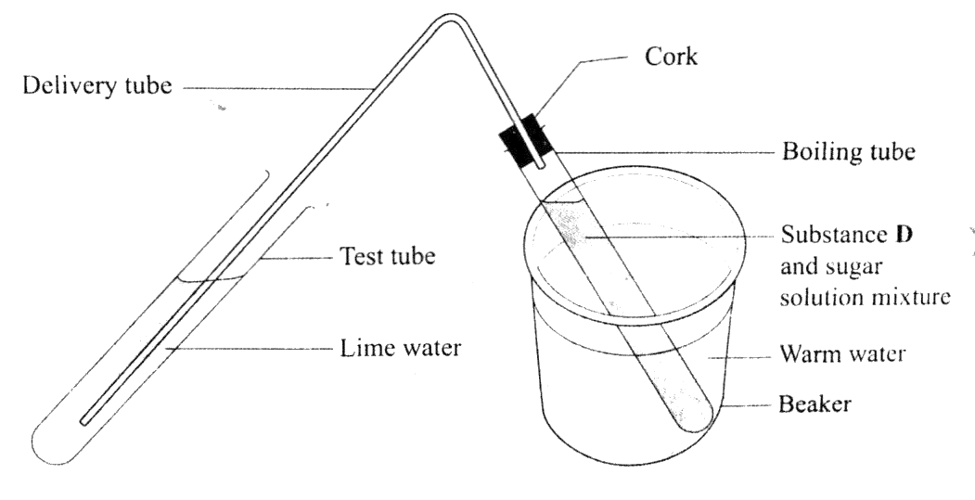

- State the observations made in the lime water. (2mks)
……………………………………………………………………………………………………………………………………………………………………………………………………
- Explain the observations made in the lime water. (2mks)
……………………………………………………………………………………………………………………………………………………………………………………………………
- Name the physiological process that was being investigated. (1mk)

…………………………………………………………………………………………………

- Write a word equation for the physiological process investigated. (1mk)
……………………………………………………………………………………………………………………………………………………………………………………………………
- Why was the warm water bath used in the experiment? (2mks)
………………………………………………………………………………………………………………………………………………………………………………………………………………………………………………………………………………………………………
b) Put a drop of the contents in the boiling tube on a microscope slide. Stain with a drop of methylene blue and cover with a cover slip. Observe it under a light microscope using low, medium and high power objective lences.
i) Draw and label one of the structures observed under the high power objective lens. (3mks)

ii) State the magnification of your drawing. (1mk)
………………………………………………………………………………………………………………………………………………………………………………………………………………………………………………………………………………………………………………………………
iii) State the identity of substance D. (1mk)
……………………………………………………………………………………………………………………………………………………………………………………………………………………………………………………………………………………………………………………………….

- The photograph below is of a mammalian heart that has been cut open to expose the inner parts. Study it and answer the questions that follow.
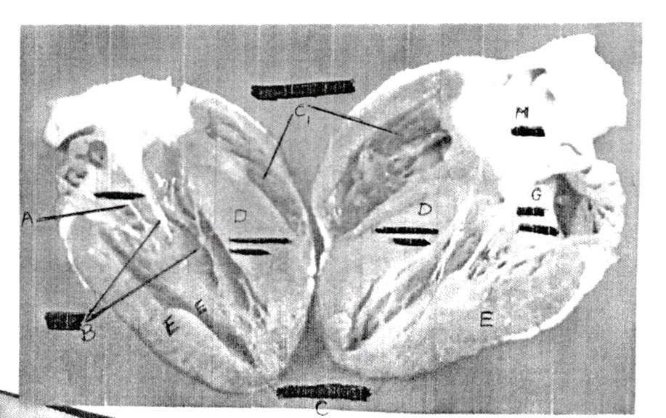

- Name the parts labelled D and E. (2mks)
D: ……………………………………………………………………………….
E: ……………………………………………………………………………….

- State the role of part D. (1mk)
………………………………………………………………………………………………………………………………………………………………………………………………………………
- Account for the structural differences between the parts marked C and E. (3mks)
………………………………………………………………………………………………………………………………………………………………………………………………………………………………………………………………………………………………………………………
- State the function of;
- Valve A (1mk) ………………………………………………………............................................................................................................................................................. ……………………………..
- Part B (1mk)
………………………………………………………………………………………………………………………………………………………………………………………………
- i) Name the part marked G. (1mk)
…………………………………………………………………………………………………………………………………………………………………………………………………………
- Account for the structural differences between the parts marked G and E. (3mks)
………………………………………………………………………………………………………………………………………………………………………………………………………………………………………………………………………………………………………………………………………………………………………………………………………………………………………………………………………………………………………………………………………
i) Name the blood vessel marked M. (1mk)
……………………………………………………………………………………..
ii) State two defects of the circulatory system. (2mks)
………………………………………………………………………………………………………………………………………………………………………………………………………………………………………………………………………………………………………………………………………………………………………………………………………………………………
- You are provided with specimens labelled E and F.
- i) Name the sub-division to which the specimens belong. (1mk)
………………………………………………………………………………………………………
ii) Using observable features on the specimens, give two reasons for your answer in in (a) (i) above. (2mks)
……………………………………………………………………………………………………………………………………………………………………………………………………………..

- State the differences between the;
- Leaves of specimens E and F. (5mks)
LEAF E | LEAF F

- Stems of specimens E and F (2mks)
STEM E | STEM F

- Using observable features on the specimen, state the adaptation of the stem of specimen E to its habitat. (2mks)
……………………………………………………………………………………………………………………………………………………………………………………………………………………………………………………………………………………………………………………

