MUMIAS WEST SCHOOLS JOINT EXAMINATION - 2022

BIOLOGY MARKING SCHEME

1 a) Glomerulus; rej. glomeruli 1mk
b) It is long to increase the surface area for re absorption of water
It is lined with a network of blood capillaries to enhance re absorption of water
It is un-shaped to bring about a counter multiplier effect/to concentrate salt in the medulla to bring about re-absorption of water
c) Vasoconstriction
Hair rises Acc pilo erection for hair rising
Metabolic rate increases
Shivering
2. a) (i) Man
X^{h}y; (2 marks)
Woman
X^{H}X^{h} ;
(ii) Parental genotype
X^{H}X^{h} X X^{h} y;
X^{H}
Xh
X^{h}
y

Gametes ;

Fusion
Offspring X^{H}X^{h} X^{H}y X^{h}X^{h} X^{h}y ;

b) ¼ x ¼; = ¹/₁₆ (2 marks)
c) y chromosomes does not have the corresponding allele for the gene that determine or cause haemophilia/y chromosome
is almost genetically empty; (1 mark)
3. (a) Metaphase of meiosis1;
(b) A = Cell membrane;
B – Spindle fibre;
C – Centriole;

(c)
 | Mitosis | Meiosis
(i) | Occurs in all somatic cells | Occurs only in reproductive cells;
(ii) | Occurs in one phase | Occurs in 2 phases;
(iii) | Daughter cells produced are diploid | Daughter cells produced are haploid;
(iv) | Homologous chromosomes do not come together/do not pair | Homologous chromosomes come together/pair;
(v) | No variation at the end | Variation occurs at the end;
(Any first 3 @ 1 Mark = 3 Marks)
(d) Crossing over;
4. (a) Pteridophyta
(b) Q
Name - Adventitious root; (reject roots)
Function - Anchorage/absorption of water
R
Name - Rhizome (underground stem)
Function - For storage of food and water
S
Name - Sorus
Function - Contains (Sporangium with a sexually
reproductive)spores
(c) Name the two body forms of the organism in its alternation of generation. (2 marks)
    - Gametophyte
    - Sporophyte

5 (a) i) Vascular cambium ;
Found between the xylem and phloem of woody plants; cells decide to give rise to secondary xylem and phloem; resulting to increase in birth / Diametre ; secondary parenchyma ; is formed between adjacent vascular bundles resulting to secondary growth ;

ii) Cork Cambium ;
Located beneath the Epidermis; Divides to form secondary cortex ; and corky cells ; ( to the inside and outside respectively Preventing rapturing of the stem and root when vascular cambium increase in firth
a) i) Juvenile hormone (1mk)
ii) Ecdysone / moulting hormone (1mk)
b) Prothoracic gland (1mk)
c) Instar (1mk)

6. (a) On the graph.
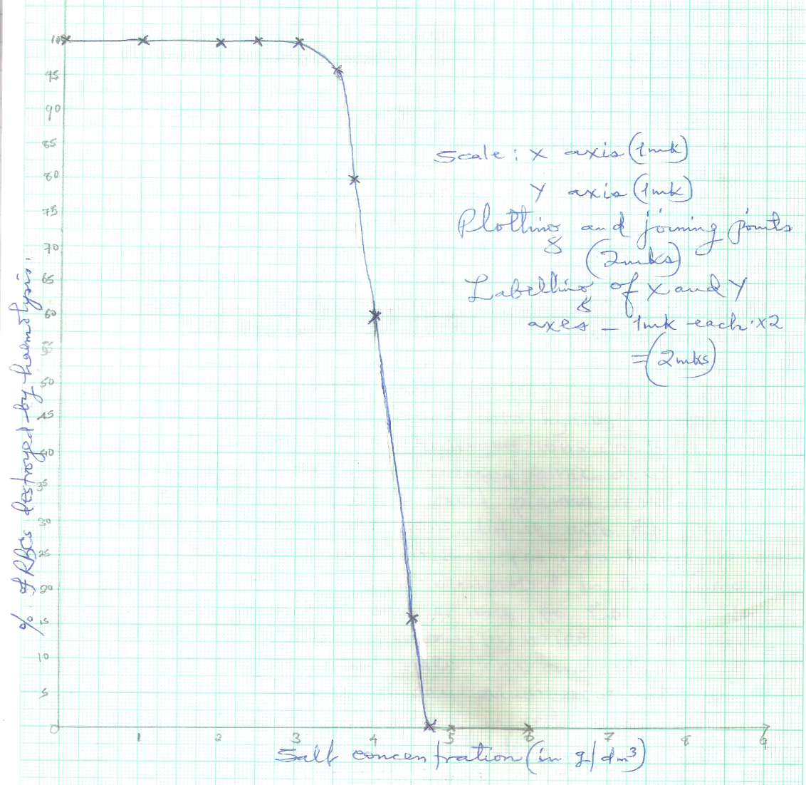

- Haemolysis of red blood cells occurs when they are placed in a hypotonic solution;
they gain a lot of water; swell an then burst; (3 mks)
(c)(i) 4.1 g/dm3; + 0.1; (1 mk)
(ii) 3.0 g/dm3; + 1; (1 mk)

(d)(i) 4.7 g / dm3+ 0.1; (1 mk)
(ii) At 4.7 g / dm3 salt concentration; as there is no haemolysis / haemolysis was zero; (2 mks)
(iii) Isotonic solution; (1 mk)

(e) Osmoregulation; Rej. homeostasis (1 mk)

(f) - Osmosis enables movement of water from one cell to another;
- Osmosis helps in closing and opening of the stomata;
- Osmosis helps in support when cells become turgid in plants;
- Osmosis helps in absorption of water by the root hairs; (max 4)

7. Follicle stimulating hormone (FHS); is secreted from the anterior lobe of the pituitary gland just
after menstruation; It causes Graafian follicle to grow in the ovary; FSH also stimulates tissues
of the ovary to produce oestrogen;
Oestrogen; brings about healing and repair of endometrium; destroyed during menstruation; Accumulation of oestrogen; stimulates pituitary gland produce Luteinising hormone (LH);
Luteinising hormone (LH); stimulates maturation of graafian follicle; The manure graafian
follicle releases an ovum into funnel shaped part of the ovary; This is known as ovulation;
LH also brings about changing of graafian follicle into corpus luteum; LH then stimulates
corpus luteum to secrete progesterone;
Progesterone; stimulates thickening of the endometrium and increases blood supply to the endometrium; in preparation for implantation. When fertilisation has taken place, progesterone
levels increase and this inhibits secretion of FSH; hence no more growth of graafian follicle;TOTAL 22 MAX 20

- (i) Process of inhalation in mammals
- External intercostals muscles contract; while internal intercostals muscles relax;
- (This movement) pulls ribs upwards and outwards;
- The diaphragm muscles contract; and the diaphragm flattens;
- (All the above movements) increases the volume of thoracic cavity; and decreases its pressure; Atmospheric pressure being higher than thoracic cavity pressure; Forces the air to rush into the lungs; (through the nose and trachea)
- The lungs are inflated;. (Max. 10 Marks)
(ii) During the day, chloroplast of guard cells accumulate sugar/glucose produced through the process
of photosynthesis;
- Accumulated sugar/glucose in the guard cells increases osmotic pressure of the cell sap of the guard cells;
- Water is drawn from the neighbouring epidermal cells by osmosis;
- Guard cells become turgid and bulges outward;
- This opens the stomata;
- At night, sugar/glucose which had accumulated in guard cells is converted to starch;
- Osmotic pressure of guard cells falls;
- The cells lose water to the neighbouring epidermal cells and become flaccid;
- The guard cells are drawn towards one another;
- The stomata closes; (Max 10 Marks)

