NAME: …………………… INDEX NUMBER: ………….……………………....................... SCHOOL……………………..... SIGNATURE: …………...………... DATE………………..
231/2
BIOLOGY
PAPER 2
FORM 4
TIME: (2 HOURS)
DECEMBER EXAM 2021
KENYA CERTIFICATE OF SECONDARY EDUCATION
BIOLOGY
PAPER 2
Instructions to candidates
- Write your name, Index Number in the spaces provided above
- Write the date of examination in the space provided above
- Answer ALL the questions in section A in the spaces provided below each question in the question paper
- In section B, answer question 6 (Compulsory) and either question 7 or 8

SECTION | QUESTION | MAXIMUM SCORE | CANDIDATE’S SCORE
A | 1 | 8
 | 2 | 8
 | 3 | 8
 | 4 | 8
 | 5 | 8
B | 6 | 20
 | 7 OR 8 | 20
 | TOTAL | 80

- The figure below is a pedigree diagram showing the inheritance of phenylketonuria a disease transmitted through a recessive gene.
Key
Normal male
Phenylketonuric male
Normal female
Phenylketonuric female

- Using the symbols P for the normal gene and p for the phenylketonuric gene, write down the genotypes of the parents 1 and 2. (1mk)

- Work out the possible genotypes of the normal child 4. (4mks)

c) Marriage between closely related individuals is always not advised in many communities. Give the biological explanation for this. (2mks)

2. Study the diagram below and answer the questions that follow.
a

a) Which part(s) marked a-d, when defective after implantation may lead to abortion. Give a reason for your answer. (2mks)

- The part labelled b can be removed after 4 months of pregnancy without interfering with the pregnancy. Explain. (2mks)

- Under each of the following, state the name of the causative organisms.
i) Syphilis (1mk)

ii) Candidiasis (1mk)

iii) Gonorrhoea (1mk)

iv) AIDS (1mk)

d) State 2 disadvantages of external fertilization. (2mks)

3. The figure below shows the body temperature of a person before, during and after taking a cold bath. The temperature of the bath water is 22⁰C
(a) What is homeostatis (1mk)
……………………………………………………………………………………………………
(b) For how long was the person in the bath? (1mk)
……………………………………………………………………………………………………
(c) Explain why the person’s body temperature fell. (1mk)
………………………………………………………………………………………………………
(d) Explain the role played by the following in helping to return the body temperature to normal.
(i) The liver (2mks)
………………………………………………………………………………………………………………………………………………………………………………………………………………………………………………
(ii) Blood vessels in the skin. (2mks)
………………………………………………………………………………………………………………………………………………………………………………………………………………………………………………
(iii) muscle of the body (1mk)
………………………………………………………………………………………………………………………………………………………………………………………………………………………………………………
4. Two sets of experiments were carried out to investigate a certain concept of population ecology. In each experiment, two different species of the protozoa paramecium were placed in flasks containing bacteria – rich in broth. The paramecia feed on bacteria
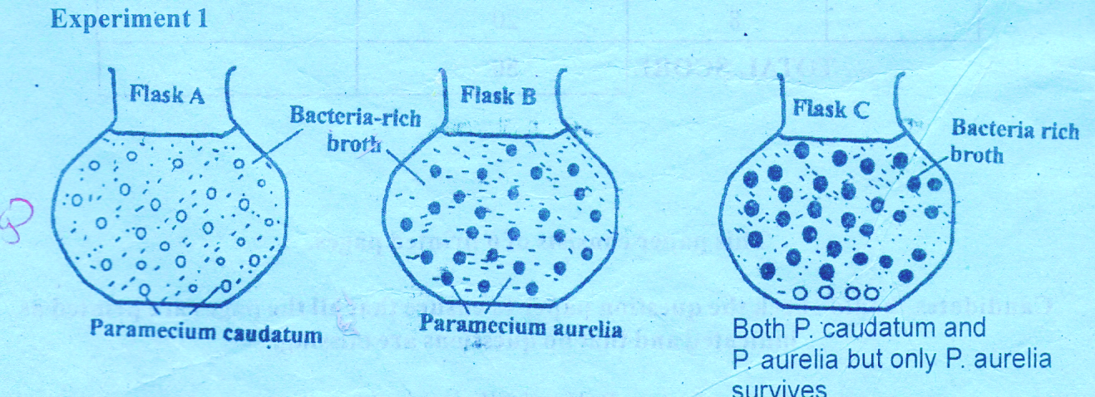
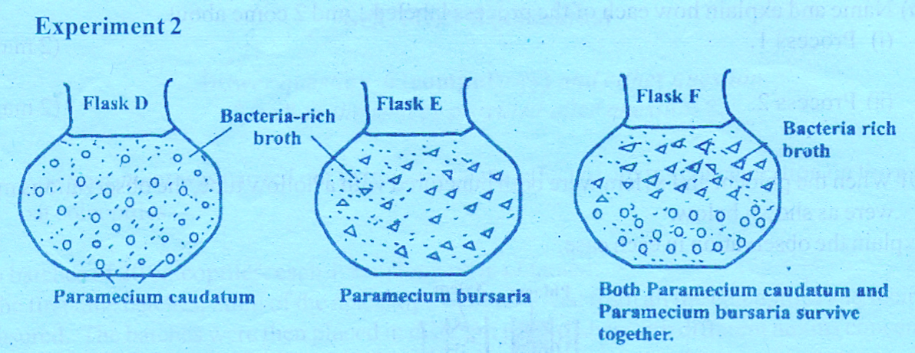
- Account for the results in:-
- Flask C (3mks)
………………………………………………………………………………………………………………………………………………………………………………………………………………
- Flask F (3mks)
……………………………………………………………………………………………………………………………………………………………………………………………………………………………………………………………………………….
- Describe briefly the principle that was being investigated in the two experiments (2mks)
……………………………………………………………………………………………………………………………………………………………………………………………………………………………………………………………………………………………………….
5. An experiment was carried out to determine the rate of transpiration in three plants A, B and C. Plants A and B belonged to different species while plants B and C belonged to the same species. Plant C had all its leaves removed. The three plants were of similar size and were exposed to the same environmental conditions. The results are as shown in the graphs below.
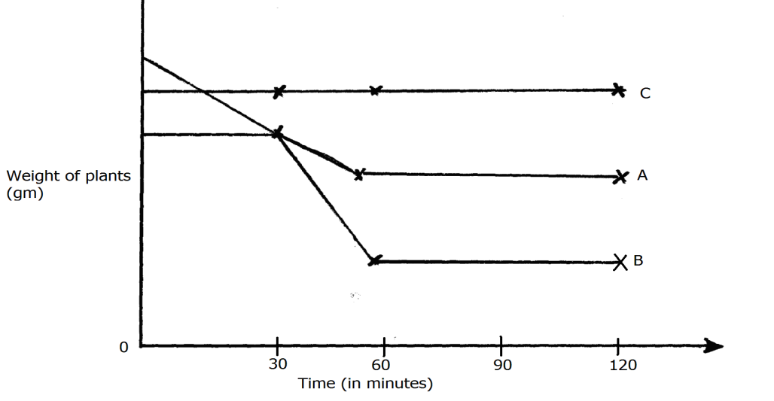

a) Suggest possible environmental conditions under which the experiment was carried out between 30 and 60 minutes (2mks)
……………………………………………………………………………………………………….………………………………………………………………………….......................................…………………………………………………………………………………………………………………………………………..
b) Account for the results obtained for plant C (2mks)
……………………………………………………………………………………………………….……………………………………………………………………………………………………….……………………………………………………………………………………………………….…………………………………………………………………………………………………………………………………………………………………………………………
c) Suggest the habitat for plant A and B. Give reasons for your answer. (4mks)
Habitat for plant A………………………………………………………………………………….
Reason ………………………………………………………………………………………………
………………………………………………………………………………………………………

Habitat for plant B………………………………………………………………………………..… Reasons…………………………………………………………………………………………………………………………………………………………………………………………………………….……
………………………………………………………………………………………………………………

SECTION B:
Answer question 6 (compulsory) and either question 7 or 8 in the spaces provided after question 8.
6. Students investigated a certain physiological process using beans treated as described below
Set up 1 – Beans soaked in water and introduced into a vacuum flask
Set up 2 – Boiled beans were introduced into a vacuum flask.
Set up 3 – Boiled beans washed in antisceptic solution
Thermometers were used to measure temperature changes. It was observed that there was no
temperature change in set up 3. The results of set up 1 and 2 shown in the table below.

Time (days) | Temperature (0c)
 | Set up 1 | Set up 2
0  1  2  3  4  5  6  7  8  9 | 15  20  25  28  30  28  25  22  20  18 | 15  15  16  18  19  20  25  28  30  32

(a) Plot graphs on the same axis of temperature change against time (7mks)

b) Account for the temperature change observed in set up 1 and 2
(i) From day zero to day two (4mks)
……………………………………………………………………………………………………………………………………………………………………………………………………………………………………………………………………………………………………………………………………………………………………………………………………………………………………………………………………………………………………………………………………………………………………………………………………………………………………………………………….
(ii) After day five (4mks)
…………………………………………………………………………………………………………………………………………………………………………………………………………………………………………………………………………………………………………………………………………………………………………………………………………………………………………………………………………………………………………

(c) Explain the observation for the physiological process taking place in set up 3 (2mk)
………………………………………………………………………………………………………………………………………………………………………………………………………………………………………………………………………………………………………………………
(d) Write a word equation for the physiological process taking place in set up 1 (1mk)
……………………………………………………………………………………………………………………………………………………………………………………………………………………
(e) The respiratory quotient of fat is 0.7 and that of carbohydrate is 1
Explain the difference (2mks)
……………………………………………………………………………………………………………………………………………………………………………………………………………………………………………………………………………………………………………………………………………………………………..………
………………………………………………………………………………………………………………………
7 (a) Describe how a green leaf is adapted for photosynthesis(10mks)
(b) Describe what happens in the nervous system of a person who withdraws a finger from a very hot object (10mks)

8. Describe locomotion in a finned fish. (20mks)

