Name……………………………………………………. Index No…………………/…….
School……………………………………………………………………………………………. Date………….…………………………… Candidate’s Signature………………………
231/2
BIOLOGY
(THEORY)
Paper 2
June/July 2022
Time: 2 Hours

MUMIAS WEST SCHOOLS JOINT EXAMINATION - 2022
Kenya Certificate of Secondary Education (K.C.S.E)

INSTRUCTIONS TO CANDIDATES
- This paper consists of two sections A and B.
- Answer ALL questions in section A
- Answer question 6 (compulsory) and either question 7 or 8 in section B.

For Examiner’s Use Only
Section | Question | Maximum score | Candidate’s score
A | 1  2  3  4  5 | 8  8  8  8  8
B | 6  7  8 | 20  20  20
Total Marks |  | 80

SECTION A (40 MARKS)
Answer all the questions in this section in the spaces provided:
1. The diagram below illustrates the structure of the kidney nephron.
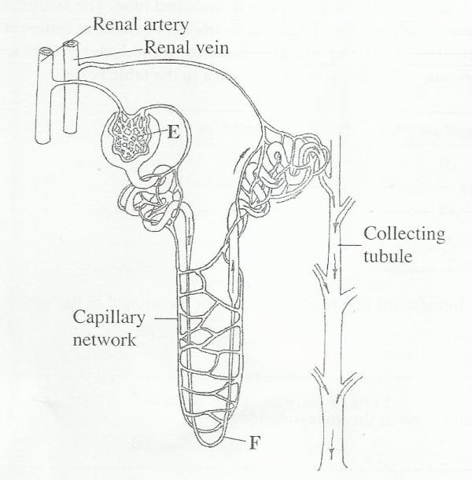

(a) Name the part labeled E. (1 mark)

………………………………………………………………………………………..

(b)How is the part labeled F adapted to its function? (4 marks)

………………………………………………………………………………………

………………………………………………………………………………………

……………………………………………………………………………………..

………………………………………………………………………………………

(c) State three physiological mechanisms of controlling the human body temperature during a cold day. (3 marks)

……………………………………………………………………………………….

……………………………………………………………………………………….

……………………………………………………………………………………….

2. The genetic disorder hemophilia is due to a recessive sex linked gene .A man who is hemophilic marries a woman who is carrier for the condition.
a) Using letter H to represent the gene normal condition and letter h for the gene for hemophiliac condition.
i) What is the genotype for the man and the woman? (2marks)
……………………………………………………………………………………….

……………………………………………………………………………………….

……………………………………………………………………………………….

ii) Work out a cross between the man and woman (3marks)
……………………………………………………………………………………….

……………………………………………………………………………………….

……………………………………………………………………………………….

……………………………………………………………………………………….

……………………………………………………………………………………….

……………………………………………………………………………………….

b) What is the chance that both the first and second sons will be hemophiliac? (2marks)
……………………………………………………………………………………….

……………………………………………………………………………………….

……………………………………………………………………………………….

c) Hemophilia is more common in males than in female humans. Explain (1mark)
……………………………………………………………………………………….

……………………………………………………………………………………….

……………………………………………………………………………………….

- The diagram below represents a state in cell division. Study it and answer the questions below.

A
B
C

- Name the stage of cell division illustrated in the diagram above. (1 mark)
……………………………………………………………………………………….…………………………………………………………………………….…………………………………………………………………………………………………..…….
- Name the parts labelled A, B and C (3 marks)

……………………………………………………………………………………….…………………………………………………………………………….…………………………………………………………………………………………………..…….
……………………………………………………………………………………….…………………………………………………………………………….…………………………………………………………………………………………………..…….
……………………………………………………………………………………….…………………………………………………………………………….………………………………………………………………………………………………………………………………………………………………………………………………………………………………………………………………………………………………………………………………………………………………………………………………………………………………………………………………………………………………………………………………………….

- State THREE differences between mitosis and meiosis. (3 marks)
……………………………………………………………………………………….…………………………………………………………………………….…………………………………………………………………………………………………..…….
……………………………………………………………………………………….…………………………………………………………………………….…………………………………………………………………………………………………..…….
……………………………………………………………………………………….…………………………………………………………………………….…………………………………………………………………………………………………..…….
……………………………………………………………………………………….…………………………………………………………………………….…………………………………………………………………………………………………..…….

- Name the process during which the exchange of genetic materials occur at prophase 1 of meiosis. (1 mark)
……………………………………………………………………………………….…………………………………………………………………………….…………………………………………………………………………………………………..…….
……………………………………………………………………………………….…………………………………………………………………………….…………………………………………………………………………………………………..…….

4. The diagram below indicates an organism that grows under shaded places with damp conditions. Study it and answer the questions that follow.

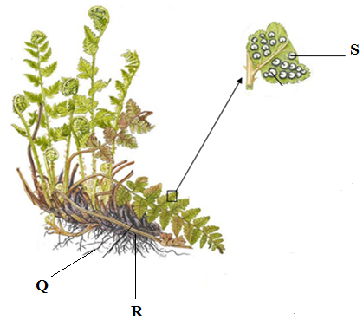

(a) Name the division to which the specimen belongs. (1 mark)

……………………………………………………………………………………….…………………………………………………………………………….…………………………………………………………………………………………………..…….

(b) Name and state the functions of the parts labeled Q, R and S. (6 marks)

……………………………………………………………………………………….…………………………………………………………………………….…………………………………………………………………………………………………..…….
……………………………………………………………………………………….…………………………………………………………………………….…………………………………………………………………………………………………..…….
……………………………………………………………………………………….…………………………………………………………………………….…………………………………………………………………………………………………..…….
……………………………………………………………………………………….…………………………………………………………………………….…………………………………………………………………………………………………..…….
……………………………………………………………………………………….…………………………………………………………………………….…………………………………………………………………………………………………..…….
……………………………………………………………………………………….…………………………………………………………………………….…………………………………………………………………………………………………..…….
(c) Name the two body forms of the organism in its alternation of generation. (2 marks)
……………………………………………………………………………………….…………………………………………………………………………….…………………………………………………………………………………………………..…….
……………………………………………………………………………………….…………………………………………………………………………….…………………………………………………………………………………………………..…….

5. a) Explain how the following meristematic tissues contribute to growth of higher plants
i) Vascular cambium (2marks)
……………………………………………………………………………………….…………………………………………………………………………….…………………………………………………………………………………………………..…….
……………………………………………………………………………………….…………………………………………………………………………….…………………………………………………………………………………………………..…….

ii) Cork Cambium (2marks)
……………………………………………………………………………………….…………………………………………………………………………….…………………………………………………………………………………………………..…….
……………………………………………………………………………………….………………………………………………
b) The diagram below shows a life cycle of a cockroach
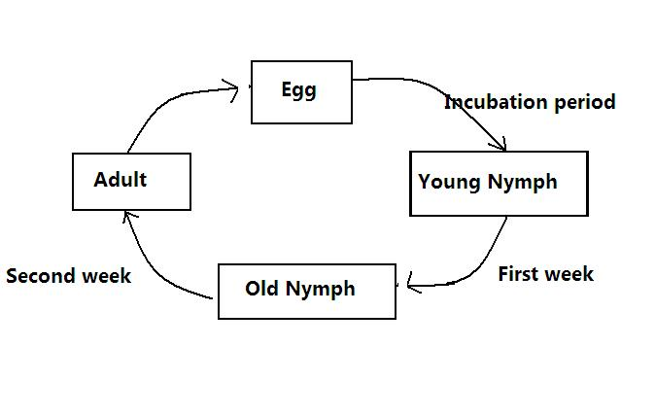

a) Name the hormone that would be at high concentration during.
- First week (1mark)
…………………………………………………………………………………….…………………………………………………………………………….………………………………………………………………………………………………
(ii) Second week (1mark)
……………………………………………………………………………………….…………………………………………………………………………….…………………………………………………………………………………………………..…….
b) Name the structure that produces hormone in a (ii) above (1 marks)

……………………………………………………………………………………….…………………………………………………………………………….…………………………………………………………………………………………………..…….
c) Name the series of stages through which the nymph undergoes to reach adult stage (1 marks)
……………………………………………………………………………………….…………………………………………………………………………….…………………………………………………………………………………………………..…….
……………………………………………………………………………………….………………………………………………
SECTION B:(40 MARKS)
Answer question 6 (Compulsory) and EITHER question 7 or 8 in the spaces provided after question 8.
6. An experiment was carried out in which red blood cells were put in salt solutions of different concentrations. The table below shows the percentage of cells which were destroyed by haemolysis in different salt concentration.

Salt concentration  (g/dm³) | % of RBC destroyed  By haemolysis
0 | 100
1 | 100
2 | 100
2.5 | 100
3.0 | 100
3.5 | 96
3.7 | 80
4.0 | 60
4.5 | 16
4.7 | 0
5.0 | 0
6.0 | 0

- Draw a graph of percentage of red blood cells haemolysed against salt concentration. (6 marks)

(b) Explain haemolysis of red blood cells. (3 marks)
……………………………………………………………………………………….…………………………………………………………………………….…………………………………………………………………………………………………..…….
……………………………………………………………………………………….…………………………………………………………………………….…………………………………………………………………………………………………..…….
……………………………………………………………………………………….…………………………………………………………………………….…………………………………………………………………………………………………..…….

(c) From the graph, state:
(i) the salt concentration at which 50% red blood cells were haemolysed. (1 mark)
……………………………………………………………………………………….…………………………………………………………………………….…………………………………………………………………………………………………..…….

- the highest salt concentration when the largest number of red blood cells were haemolysed. (1 mark)

…………………………………………………………………………………….…………………………………………………………………………….……………………………………………………………………………………………….……………………………..…….

(d) (i) Suggest the normal salt concentration in the blood of the mammal from which the red blood cells were obtained. (2 marks)
……………………………………………………………………………………….…………………………………………………………………………….…………………………………………………………………………………………………..…….
……………………………………………………………………………………….…………………………………………………………………………….…………………………………………………………………………………………………..…….

(ii) Give a reason for your answer in (d) (i) above. (1 mark)
……………………………………………………………………………………….…………………………………………………………………………….…………………………………………………………………………………………………..…….

- What term is used to describe the solution with equal solute concentration as that of the cells? (1 mark) ……………………………………………………………………………………….…………………………………………………………………………….…………………………………………………………………………………………………..…….………………………

(e) Name the process in the human body that ensures that haemolysis of red blood cells is prevented. (1 mark)
……………………………………………………………………………………….………………………………………………………………………………………………………………………………………….…………………………………………………………………………….…………………………………………………………………………………………………..…

(f) State four roles of osmosis in organisms. (4 marks)

……………………………………………………………………………………….…………………………………………………………………………….…………………………………………………………………………………………………..…….
……………………………………………………………………………………….…………………………………………………………………………….…………………………………………………………………………………………………..…….
……………………………………………………………………………………….…………………………………………………………………………….…………………………………………………………………………………………………..…….

7. Describe the role of hormones in the mammalian female reproductive cycle. (20 marks)
8. Describe the
(i) Process of inhalation in mammals (10 marks)
(ii) Mechanism of opening and closing of stomata (10 marks)

……………………………………………………………………………………….…………………………………………………………………………….…………………………………………………………………………………………………..…….
……………………………………………………………………………………….…………………………………………………………………………….…………………………………………………………………………………………………..…….
……………………………………………………………………………………….…………………………………………………………………………….…………………………………………………………………………………………………..…….
……………………………………………………………………………………….…………………………………………………………………………….…………………………………………………………………………………………………..…….
……………………………………………………………………………………….…………………………………………………………………………….…………………………………………………………………………………………………..…….
……………………………………………………………………………………….…………………………………………………………………………….…………………………………………………………………………………………………..…….
……………………………………………………………………………………….…………………………………………………………………………….…………………………………………………………………………………………………..…….
……………………………………………………………………………………….…………………………………………………………………………….…………………………………………………………………………………………………..…….
……………………………………………………………………………………….…………………………………………………………………………….…………………………………………………………………………………………………..…….
……………………………………………………………………………………….…………………………………………………………………………….…………………………………………………………………………………………………..…….
……………………………………………………………………………………….…………………………………………………………………………….…………………………………………………………………………………………………..…….
……………………………………………………………………………………….…………………………………………………………………………….…………………………………………………………………………………………………..…….
……………………………………………………………………………………….…………………………………………………………………………….…………………………………………………………………………………………………..…….
……………………………………………………………………………………….…………………………………………………………………………….…………………………………………………………………………………………………..…….
……………………………………………………………………………………….…………………………………………………………………………….…………………………………………………………………………………………………..…….
……………………………………………………………………………………….…………………………………………………………………………….…………………………………………………………………………………………………..…….
……………………………………………………………………………………….…………………………………………………………………………….…………………………………………………………………………………………………..…….
……………………………………………………………………………………….…………………………………………………………………………….…………………………………………………………………………………………………..…….
……………………………………………………………………………………….…………………………………………………………………………….…………………………………………………………………………………………………..…….
……………………………………………………………………………………….…………………………………………………………………………….…………………………………………………………………………………………………..…….
……………………………………………………………………………………….…………………………………………………………………………….…………………………………………………………………………………………………..…….
……………………………………………………………………………………….…………………………………………………………………………….…………………………………………………………………………………………………..…….
……………………………………………………………………………………….…………………………………………………………………………….…………………………………………………………………………………………………..…….
……………………………………………………………………………………….………………………………………………
…………………………….…………………………………………………………………………………………………..…….
……………………………………………………………………………………….………………………………………………
…………………………….…………………………………………………………………………………………………..…….
……………………………………………………………………………………….………………………………………………
…………………………….…………………………………………………………………………………………………..…….
……………………………………………………………………………………….………………………………………………
…………………………….…………………………………………………………………………………………………..…….
……………………………………………………………………………………….………………………………………………
…………………………….…………………………………………………………………………………………………..…….
……………………………………………………………………………………….………………………………………………
…………………………….…………………………………………………………………………………………………..…….
……………………………………………………………………………………….………………………………………………

