231/2

NAME…………………………………………….……. INDEX NO………..…………………..
SIGNATURE……………………………….………………DATE……………………………..
ASUMBI GIRLS HIGH SCHOOL
POST -MOCK 1
AUGUST/SEPTEMBER
2022

AUGUST / SEPTEMBER - 2022

BIOLOGY
PAPER 2
TIME: 2 HOURS

INSTRUCTIONS TO CANDIDATES:
- Write your name and admission number in the spaces provided.

- Answer all the questions in this paper in the spaces provided.

- Answer questions 1-6 (compulsory) and either question 7 or 8.

For Examiner’s Use Only:
QUESTIONS | MAXIMUM SCORE | CANDIDATE’S SCORE
1 | 8
2 | 8
3 | 8
4 | 8
5 | 8
6 | 20
7 or 8 | 20

This paper consists of 11 printed pages. Candidates should check to ascertain that all papers are printed as indicated and that no questions are missing.
1.The diagram below represents the direction of flow of blood in a gill capillary. The percentage of oxygen in solution at position A, B, P, Q and R is given in the table below.

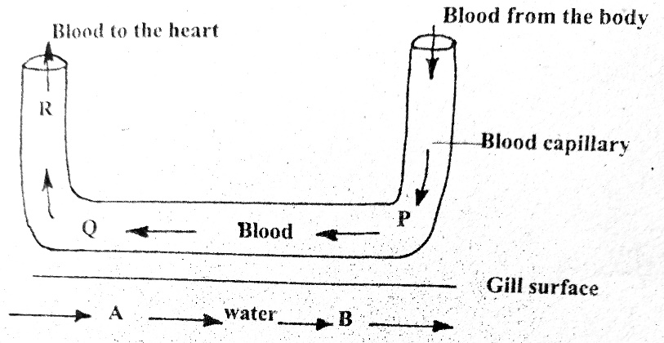

Position | Oxygen concentration in solution (%) | Haemoglobin saturation with oxygen (%)
A | 10
B | 7
P | 4 | 55
Q | 7 | 85

a) Why is the oxygen percentage low at P? (1mk)
----------------------------------------------------------------------------------------------------------------------------
-----------------------------------------------------------------------------------------------------------------------------
b) Using evidence from the data given, suggest what will happen to oxygen in the water at
point B. (3mks)
----------------------------------------------------------------------------------------------------------------------------------------------------------------------------------------------------------------------------------------------------------------------------------------------------------------------------------------------------------------------------------------------------------------------------------------------------------------------------------------------------------------------------
c) Name the organ into which blood coming from the capillary at Q flows. (1mk)
---------------------------------------------------------------------------------------------------------------------
d) Suppose the flow of blood in the capillary illustrated above was in the opposite direction, explain the disadvantage it would have to the fish. (2mks)
---------------------------------------------------------------------------------------------------------------------------------------------------------------------------------------------------------------------------------------------------------------------------------------------------------------------------------------------------------------
e) Name the principle where the blood flows in the opposite direction to another fluid. (1mk)
-------------------------------------------------------------------------------------------------------------------
2.Below is a diagram of a poorly planned town showing some building and facilities.
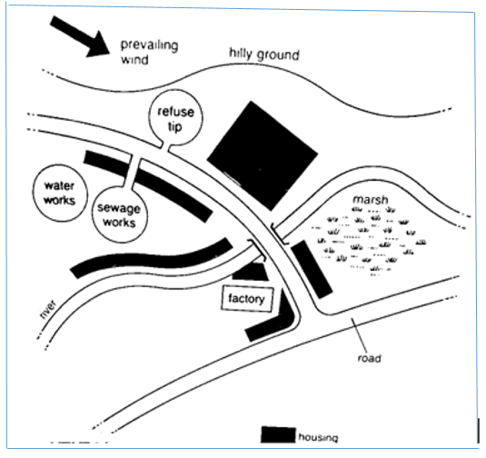
pit
a) Giving evidence from the diagram, state two likely sources of water pollution. (2mks)
------------------------------------------------------------------------------------------------------------------------------------------------------------------------------------------------------------------------------------------
b) State three ways that the positioning of the refuse pit and sewage works pose danger to the residence of the town. (3mks)
i) --------------------------------------------------------------------------------------------------------------------------------------------------------------------------------------------------------------------------------------
ii) -------------------------------------------------------------------------------------------------------------------------------------------------------------------------------------------------------------------------------------
iii) ------------------------------------------------------------------------------------------------------------------------------------------------------------------------------------------------------------------------------------
c) Residents living close to the marsh are likely to suffer from malaria. Explain. (1mk)
------------------------------------------------------------------------------------------------------------------------------------------------------------------------------------------------------------------------------------------
d) Suggest two control measures to overcome water pollution in the area. (2mks)
-----------------------------------------------------------------------------------------------------------------------------------------------------------------------------------------------------------------------------------------------------------------------------------------------------------------------------------------------------------------------------------------------------------------------------------------------------------------------------------

3. The diagram below represents a maize seedling.
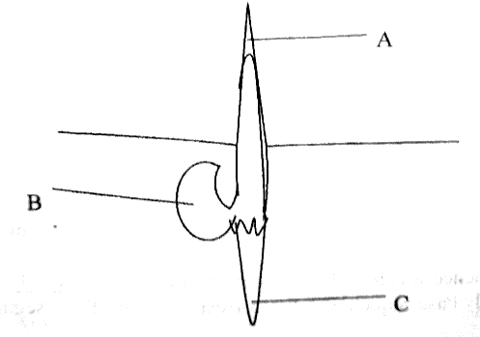

- Name the structure labeled A and C (2mks)

A -------------------------------------------------------------------------------------------------------

C --------------------------------------------------------------------------------------------------------

- State the functions of parts labeled A, B and C. (3mks)

A -----------------------------------------------------------------------------------------------------------
-------------------------------------------------------------------------------------------------------------

B ------------------------------------------------------------------------------------------------------------
-------------------------------------------------------------------------------------------------------------
C------------------------------------------------------------------------------------------------------------
-------------------------------------------------------------------------------------------------------------

- Name the type of germination exhibited by maize (1mk)

---------------------------------------------------------------------------------------------------------------
- Name two conditions necessary for seed germination other than water and oxygen.
(1mk)
-----------------------------------------------------------------------------------------------------------------
-----------------------------------------------------------------------------------------------------------------
- What is the role of oxygen in seed germination? (1mk)
------------------------------------------------------------------------------------------------------------------
-----------------------------------------------------------------------------------------------------------------
4.The figure below shows part of a human skeleton.

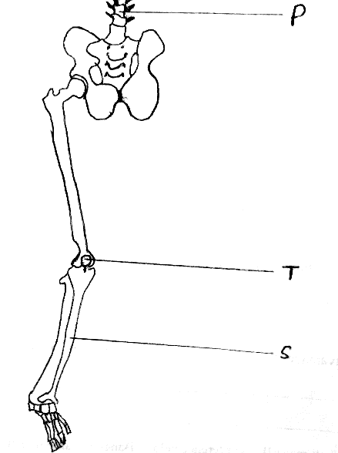

- Which part of the human skeleton is it? (1mk)

---------------------------------------------------------------------------------------------------------------------
- On the diagram label by name three types of joints. (3mks)

- Label the S, T and P. (3mks)

S -------------------------------------------------------------------------------------------------------------------

T -------------------------------------------------------------------------------------------------------------------

P -------------------------------------------------------------------------------------------------------------------

- Which two bones on the diagram manufactures red blood cells? (1mk)

-------------------------------------------------------------------------------------------------------------------
5. In maize the gene for purple colour is dominant to the gene for white colour.
A pure breeding maize plant with purple grains was crossed with a heterozygous plant.
a) Using letter G to represent the gene for purple colour, work out the genotypes of
the offspring. (4mks)

b) State the phenotype of the offspring. (1mk)
------------------------------------------------------------------------------------------------------------------

c) What is genetic engineering? (1mk)
-----------------------------------------------------------------------------------------------------------------------------------------------------------------------------------------------------------------------------------------d) Gene for smooth seed coat is dominant over gene for wrinkled seed coat.
Two heterozygous pea plants with smooth seed coats were crossed and produced a
total of 14640 seeds. How many seeds had wrinkled seed coat? Show your
calculations. (2mks)
-----------------------------------------------------------------------------------------------------------------------------------------------------------------------------------------------------------------------------------------------------------------------------------------------------------------------------------------------------------------------------------------------------------------------------------------------------------------------------------
6. The diagram below is obtained from measurements of growth in the leaf petiole of a certain plant. The relative growth rate is calculated and the data is obtained as shown below.

Time in days | 0 | 1 | 2 | 3 | 4 | 5 | 6 | 7 | 8 | 9
Relative growth rate(cm/day) | 0 | 0.1 | 0.3 | 0.8 | 2.0 | 4.0 | 4.5 | 3.5 | 0.2 | 0

a) Plot a graph of relative growth rate against time. (5mks)

b) State two functions of a leaf petiole. (2mks)
---------------------------------------------------------------------------------------------------------------------------------------------------------------------------------------------------------------------------------------------------------------------------------------------------------------------------------------------------------------------------------------------

c) State two characteristics of cells found in the region of cell division. (2mks)
--------------------------------------------------------------------------------------------------------------------------------------------------------------------------------------------------------------------------------------------------------------------------------------------------------------------------------------------------------------------------------------------
d) Account for the shape of the curve between the following days (3mks)
i) 2 – 5.
----------------------------------------------------------------------------------------------------------------------------------------------------------------------------------------------------------------------------------------------------------------------------------------------------------------------------------------------------------------------------------------------------------------------------------------------------------------------------------------------------------------------------
ii) 6 – 8 (3mks)
----------------------------------------------------------------------------------------------------------------------------------------------------------------------------------------------------------------------------------------------------------------------------------------------------------------------------------------------------------------------------------------------------------------------------------------------------------------------------------------------------------------------------
iii)6 – 8 (3mks)
----------------------------------------------------------------------------------------------------------------------------------------------------------------------------------------------------------------------------------------------------------------------------------------------------------------------------------------------------------------------------------------------------------------------------------------------------------------------------------------------------------------------------
d) Distinguish between primary growth and secondary growth in a flowering plant. (2mks)
----------------------------------------------------------------------------------------------------------------------------------------------------------------------------------------------------------------------------------------------------------------------------------------------------------------------------------------------------------------------------------------------------------------------------------------------------------------------------------------------------------------------------

7. How are flowers adapted to wind and insect pollination? (20mks)
8a) Name factors that affects the enzyme controlled reactions. (6mks)
b) Explain the factors that affect the rate of enzyme activity. (14mks)

------------------------------------------------------------------------------------------------------------------------------------------------------------------------------------------------------------------------------------------------------------------------------------------------------------------------------------------------------------------------------------------------------------------------------------------------------------------------------------------------------------------------------------------------------------------------------------------------------------------------------------------------------------------------------------------------------------------------------------------------------------------------------------------------------------------------------------------------------------------------------------------------------------------------------------------------------------------------------------------------------------------------------------------------------------------------------------------------------------------------------------------------------------------------------------------------------------------------------------------------------------------------------------------------------------------------------------------------------------------------------------------------------------------------------------------------------------------------------------------------------------------------------------------------------------------------------------------------------------------------------------------------------------------------------------------------------------------------------------------------------------------------------------------------------------------------------------------------------------------------------------------------------------------------------------------------------------------------------------------------------------------------------------------------------------------------------------------------------------------------------------------------------------------------------------------------------------------------------------------------------------------------------------------------------------------------------------------------------------------------------------------------------------------------------------------------------------------------------------------------------------------------------------------------------------------------------------------------------------------------------------------------------------------------------------------------------------------------------------------------------------------------------------------------------------------------------------------------------------------------------------------------------------------------------------------------------------------------------------------------------------------------------------------------------------------------------------------------------------------------------------------------------------------------------------------------------------------------------------------------------------------------------------------------------------------------------------------------------------------------------------------------------------

