Biology ppr 1 marking scheme
- State the function of a mirror in a light
microscope. (1 mark)
Reflects light (through the condenser) to object;
(b) Give one reason why the coarse adjustment knob should not be used to lower the high power objective. (1 mark)
Can destroy the specimen (making the
microscope dirty);
- (a) (i) Name the physiological process.
(1 mark)
Diffusion;
(ii) Give two examples of the process named in (a) (i) above in plants.
(2 marks)
 Gaseous exchange/ excretion of CO2 and
oxygen;
 Translocation of materials;
 Absorption/ uptake of mineral ions/salts;
(b) State two ways by which the movement of dye molecules in the set up
would be slowed down. (2 marks)
 Lowering temperature of the medium;
 Increasing thickness of the membrane;
 Use less dye and more water/ reduce
concentration gradient;
- (a) (i) Vigorous physical exercises(2 marks)
Less water and urea; since some is excreted/
eliminated through the skin (as sweat);
(ii) A meal rich in proteins (2 marks)
Increase amount of urea in the urine; due to
deamination of amino acids (from protein)
(b) (i) Presence of glucose in the
glomerular filtrate  Ultrafiltration; | (1 mark)

4. Temperature, surface and thickness of membranes/changes that particles have to travels diffusion/concentration gradient, size/density of molecules medium of diffusion surface area to ratio

- Plant make their own food from carbon (iv) oxide and water in the presence of flight/photosynthesis autotrophic, while animals cut ready made food (from plants and animals heterotrophic 2mks

- a) Crustaceae, ace crustacean 1mk
b) Head fused with thoras thus cephelothorax;
- Have compound eyes/ a pair of compound eyes;
- Have five pairs of limbs/ 5-20 pairs of limbs,
- Have external gills;

7 a nucleapore/ nuclear pore;
Rough endoplasmic reticulum
b) surface area covered with ribosome’s; for protein synthesis/ channels for transport of protein

8a) the solution was hypotonic/less concentrated compared to the cell sap of pawpaw cylinder cells/cell sap hypertonic to the solution
The tissue/ cells grained water by osmosis becoming turgid/longer/stiff

b) Paw paw cylinder of the same size/length; placed in isotonic solution;
Boiled paw paw cylinders of same size/lengths; placed in isotonic solution;

9a) plant c 1mk
b) Thick cuticle reduces water loss 3mks
low number of stomata reduces water loss/leased number of stomata on upper surface reduces water loss;
large root surface area enhances water absorption

10a) F -bronchiole
G- Intestinal muscles/external intestinal muscle;
Internal intercostals muscles
b) (Pleural membranes) secrets/encloses pleural fluid to lubricate/protein lungs
Diaphragm separates chest cavity from abdominal cavity/work to effect volume/pressure changes in chest cavity necessary for inhalation and exhalation (ventilation,
11. a) i. Pollen grains; Acc. Male reproductive gamete in flowing plants.
ii. Anther
b) Spermatophyta

c)
E_________________Generative nucleus; rej. Generative nuclei
F_________________ Tube nucleus;
12. a) Pollination is the transfer f pollen grains from anthens to stigma of flower of the same species.
b) (i) Protandry
(ii) Protogyny
(iii) Self fertility or incompatibility
(iv) Heterostyly
(v) Dioecism
(Accept the first 3)

13. (i) Is the bursting of the graafian follicle of the ovary to release an ovum egg/egg
(ii) The process by which the blastocyst becomes embedded in the inner lining of the uterus (endometrium)

14) a. Proteins are important for the formation of the tissues of the developing foetus
Calcium is needed for formation of bones in the embryo.

15) -collect the number needed only
- Use forceps or gloves when handling dangerous or stinging specimen
- Immobile highly mobile specimens.
- Keep collected specimens in a specimen bottle
- Do not destroy or alter their natural habitat
- After their use return them to their habitat

16)
(i) Poofer

(ii)
- Ants
- Crickets
- Spiders
17)a. Develop ability to;
- Observe an organism
- Recording data
- Identifying
-Classifying
b. - Both oxidize organic substance to get energy
Both get rid of waste products i.e. Water and Carbon (iv) oxide gas
Both consume organic food substances.
18) Lenticels
Stomata
Root hairs of pneumatophores in aquatic plants
19) Is a diagrammatic representation that show total dry mass of organisms present at each trophic level of a food chain
(ii) Is a diagrammatic representation of total numbers of individual at each trophic level of a food chain.

20)a. (i) Plasmodium ssp eg. P. vivax, P. ovale, p. falciparum p. malaria
(ii) Female Anapheles mosquito

b) - Bush clearing e.g. Cutting tall grass and bushes around homes
- Spraying mosquitoes with insecticide to kill them.
- Use of electrical emissions that attract and shock mosquitoes
- Sleeping under treated mosquito nets
- Fumigating sleeping rooms with mosquito repellant sprays or coils
21 a) is the scientific double naming system of giving an organism two names, generic and specific name
b) The first name is generic name followed by the specific name
Generic name should start with a capital letter while the specific name is small letters
c) Two names should be underlined separately in the manuscripts of italicized in typescript
22) a) Antigen B corresponding to antibody b in the donor, this will cause agglutination of blood.
23)
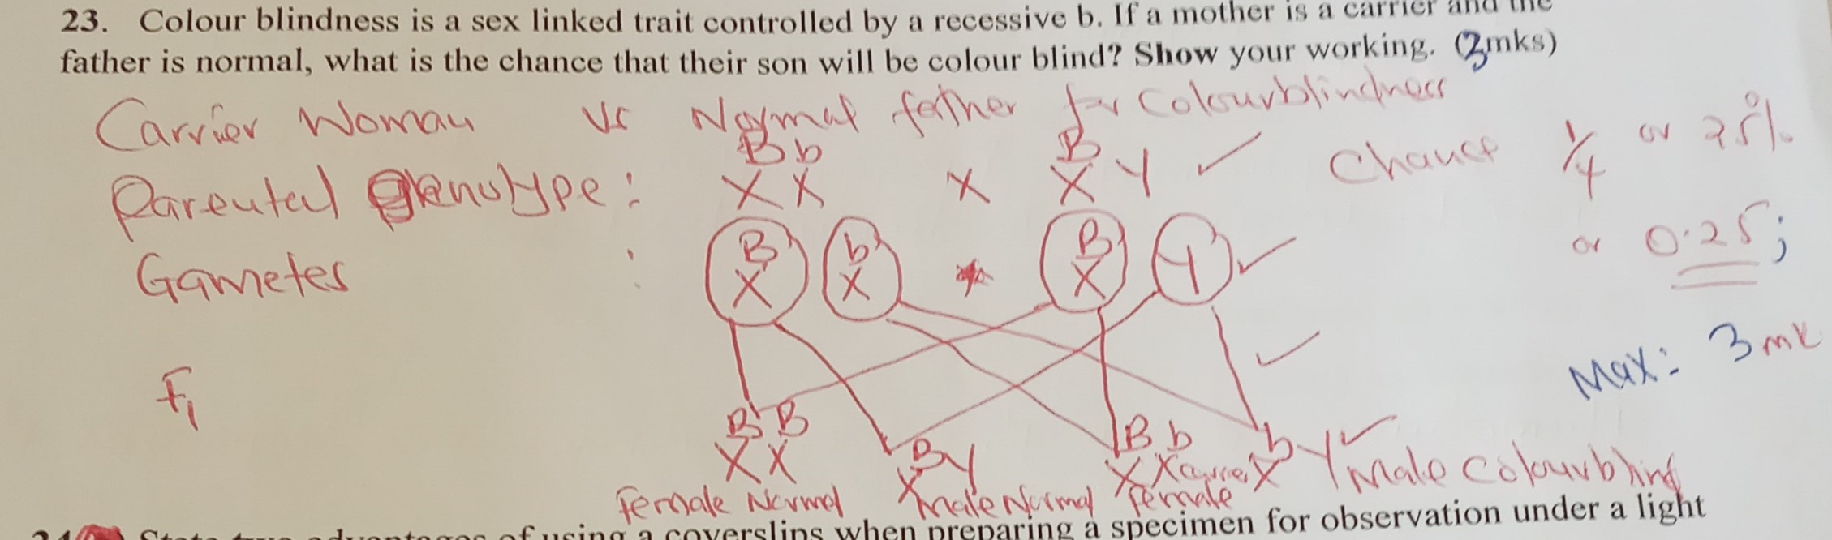

24) Prevent dust from reaching the specimen
Prevent the specimen from drying

