NAME: …………………… INDEX NUMBER: ………….…………………………………... SCHOOL…………….... SIGNATURE: ……….......... DATE: ………………………………

231/1
BIOLOGY
PAPER 1
FORM 4
TIME: (2 HOURS)

DECEMBER EXAM 2021
KENYA CERTIFICATE OF SECONDARY EDUCATION
BIOLOGY
PAPER 1

INSTRUCTIONS TO CANDIDATES
Answer ALL the questions in the spaces provided.

FOR EXAMINERS USE ONLY

QUESTIONS | TOTAL MARKS | TOTAL SCORE
1-29 | 80

- How is support provided for in herbaceous plants? (1mk)
…………………………………………………………………………………………………………………………………………….…………………………………………………………………………………………………………………………………………….
- Briefly explain the role of the Pinna in the hearing process. (2 marks)
………………………………………………………………………………………………………………………………………………………………………………………………………………………………………………………………………………………………
- Using Lamarck’s theory, explain why ducks have webbed feet (4 marks)
………………………………………………………………………………………………………………………………………………………………………………………………………………………………………………………………………………………………………………………………………………………………………………………………………………………………………………………………………………………………………………………………………………………………………………
- State two main differences between a millipede and centipede. (2 marks)
………………………………………………………………………………………………………….………………………………………………………………………………………………………….…………………………………………………………………………………………………………………………………………………………………………………………………………………………………..
- Explain the immediate reaction of the body bathed in cold water. (2 marks)
………………………………………………………………………………………………………….…………………………………………………………………………………………………………………………………………………………………………………………………………………………………
- (a) Name one enzyme present in all living cells (1mk)
…………………………………………………………………………………………………..
(b. In a certain part of the gut, large fats are broken down into small fatty acid droplets, name two salts involved in the process? (2 marks)
……………………………………………………………………………………………………………………………………………………………………………………………………………………………………
- (i) what is a habitat? (1mk
………………………………………………………………………………………………………………………………………………………………………………………………………………………………

(ii) Differentiate between population and a community. (2mks

…………………………………………………………………………………………………………………………………………………………………………………………………………………………………………………………………………………………………………………………………………………………………………………………………………………………………………………………………………………………….

(iii) 600 flies were caught and marked. After 24 hrs 400 flies were caught out of which 120 had the marks.
Estimate the population size of the flies in that house. (3 marks)
…………………………………………………………………………………………………………..…………………………………………………………………………………………………………………………………………………………………………………………………………………………………
- a) State three importance of DNA molecule. (3mks
………………………………………………………………………………………………………………………………………………………………………………………………………………………………………………………………………………………………………………………………………………
(b) Give two causes of discontinuous variations. (2mks)
…………………………………………………………………………………………………..…………………………………………………………………………………………………..…………………………………………………………………………………………………..………………………………
(c) The sequence below is a portion of a nuclei acid
U
G
C
C
C

With a reason, identify the nucleic acid to which the portion belongs (2mks)
…………………………………………………………………………………………………………………………………………………………………………………………………….…………………………………………………………………………………………………………………………………….

- The diagram below shows a mature pollen grain

X
Y

State the function of the structure labelled. (2marks)
X…………………………………………………………………………………………………………………………………………………………………………………………………………………………………………..
Y………………………………………………………………………………………………………………………………………………………………………………………………………………………………………….
- The diagram below shows some changes in the external views of the mammalian eye. Study them and answer the question that follows.

Change to

  - Name the stimulus that resulted into the change above (1mark)
………………………………………………………………………………………………… ……………………………………………………………………………………………………
  - Explain the events that led to the change above. (3marks) …………………………………………………………………………………………………………..…………………………………………………………………………………………………………..………………………………………………………………………………………………………………………………………………………………………………………………….
- a) In the Savannah, hyenas have been known to kill and eat lion cubs (young ones of lions). With reference to trophic levels, the hyenas in this case may be referred to as (1mk)
................................................................................................................................................................
b. In terms of biotic factors in Savannah ecosystem, the hyena act as (1mk)
................................................................................................................................................................
c) In some terrestrial ecosystem, 10% of energy is normally transmitted to the next trophic level. If a sample of potatoes contained 100,000 kJ , how much energy would you expect to be passed on to weaver birds that feed on 20% of larvae that ate all the potatoes? Show your working (2mks)
………………………………………………………………………………………………………………………………………………………………………………………………………………………………………………………………………………………………………………………………………………………………………………………………………………………………………………………………………………………………

- State three adaptations of aquatic plants to photosynthesis. (3 marks)
…………………………………………………………………………………………………………..…………………………………………………………………………………………………………………………………………………………………………………………………………………………………………………………………………………………………………………………………………………………………………………
- Explain why tadpoles in a certain fishpond failed to become adults throughout their cycle? (2mks)
……………………………………………………………………………………………………………………………………………………………………………………………………………………………………………………………………………………………………………………………………………………………………………………………………………………………………………………………..
- Name the type of response exhibited by:

- Movement of termites from dry soil towards moist soil (1mark)

…………………………………………………………………………………………………………………..

- Tendrils of Pisum sativum twinning on another plant (1mk)

.......................................................................................................................................................................

c) State the significance of the response you named in (b) above (1mk)
......................................................................................................................................................................................
.......................................................................................................................................................................................

- State the structural difference between sensory and motor neurons (1mk)
…………………………………………………………………………………………………..……………………………………………………………………………………………………………………………………………………………………………………….

- State two reasons why the class Insecta in the phylum Arthropoda has the largest number of individuals (2mks)
…………………………………………………………………………………………………..…………………………………………………………………………………………………..…………………………………………………………………………………………………..……………………………………………………………………………………………………………………………………………..

- Explain why the shortest food chains are always the most efficient (1mk)
…………………………………………………………………………………………………..…………………………………………………………………………………………………..…………………………………………………………………………………

- Give a reason why the breakdown of pyruvic acid in the mitochondria occurs in a series of enzyme controlled reaction (1mk)
………………………………………………………………………………………………….…………………………………………………………………………………………………..…………………………………………………………………………………..

- (a) A patient whose pancreatic duct had blocked was found to have normal blood glucose but the process of digestion was impaired. Explain this observation? (2mks)
…………………………………………………………………………………………………..…………………………………………………………………………………………………..…………………………………………………………………………………………………..…………………………………………………………………………………………………..………………………………………………………………………..
- The diagram below shows the internal structure of the mammalian ear
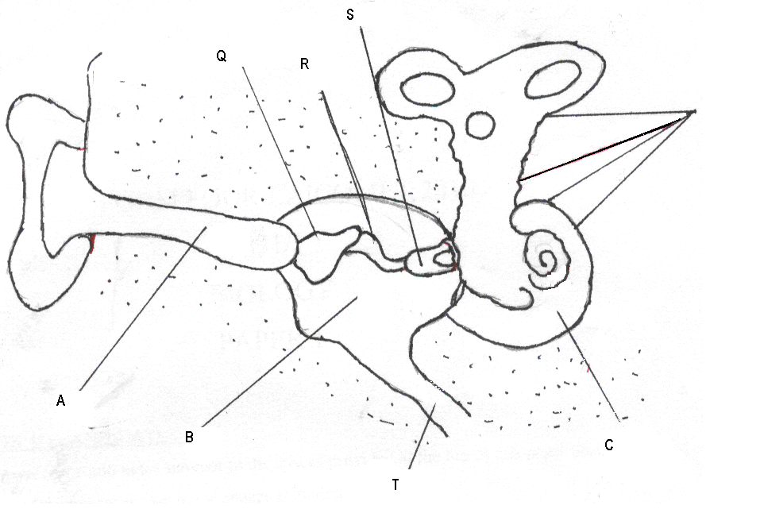
- What is the function of the parts labelled Q and S (1mk)
…………………………………………………………………………………………………………………………………………………………………………………………………………………………….

(b) Explain what would happen if the part labelled T is blocked (2mks)
………………………………………………………………………………………………………………………………………………………………………………………………………………………………………………………………………………………………
- A teacher set-up the apparatus below to investigate a certain phenomenon. The cobalt (II) chloride paper was placed on the upper and lower surfaces of the leaf as shown.

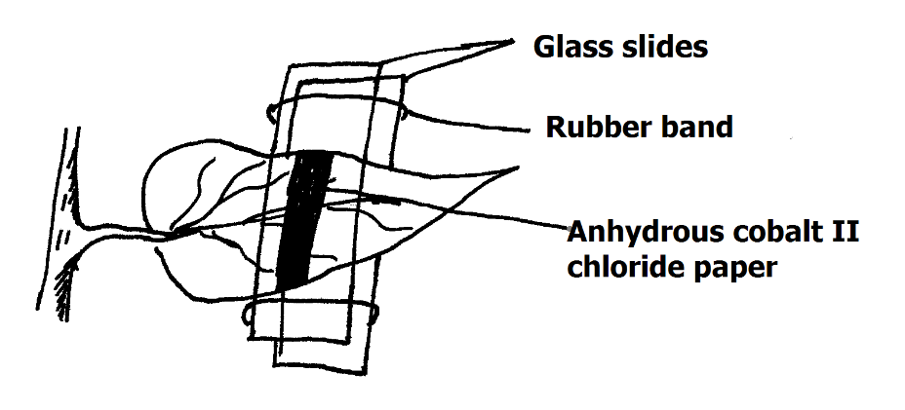
i) What was the aim of the experiment? (1mk)
……………………………………………………………………………………………………....
ii) What observations were made after 2hrs? (2mks)
……………………………………………………………………………………………………....
……………………………………………………………………………………………………....
……………………………………………………………………………………………………....
- a) What is sex-linkage (1mk)
……………………………………………………………………………………………………………………………………………………………………………………………………………………………………………..
b) Name two genes located on the Y chromosome (2mks)
……………………………………………………………………………………………………………………………………………………………………………………………………………………………………….

- The diagram below shows the articulation of bones of the left fore-limbs of a rabbit.
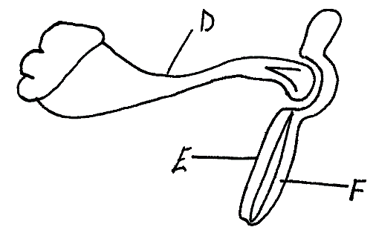
a) On the diagram, identify the bones labelled E and F (2mks)
E …………………………………………………………………………
F …………………………………………………………………………
b) Name the type of joint found at the distal end of the bone labelled D (1mk)
……………………………………………………………………………………………………....

- Name the organelle that:

a) Manufacture and transport lipids and steroids in a cell. (1mk)

………………………………………………………………………………………………

b) Contain enzymes that are capable of destroying old damaged cells. (1mk)

………………………………………………………………………………………………

- The scheme below shows a process that takes place in the human gut.
Trypsinogen + substance K Trypsin
a) Name substance K (1mk
………………………………………………………………………………………………………

b) In which part of the gut does the process occur. (1mk)
……………………………………………………………………………………………………..

c) Name the substrate that is acted upon by trypsin and the product formed. (2mks)

Substrate…………………………………………………………………………………
Product……………………………………………………………………………………

- State the characteristics that can separate the following organisms into respective classes;
Millipedes, tsetse fly and spider (2mks)
……………………………………………………………………………………………………….……………………………………………………………………………………………………….…………………………

- a) During which phase of meiosis does crossing over occur? (1mk)

……………………………………………………………………………………………………….
b) How do identical and fraternal twins arise?
i) Identical twins (2mks)
……………………………………………………………………………………………………….……………………………………………………………………………………………………V….………………………………………………………………………………………………………………………………………………………………………………………………………..
ii) Fraternal twins (2mks)
……………………………………………………………………………………………………….……………………………………………………………………………………………………….……………………………………………………………………………………………………….………………………………………
- Which one of the cell organelles would be found in large numbers in;
a) An enzyme secreting cell (1mk)
………………………………………………………………………………………………………
b) A rapidly respiring cell in comparison to other cells in the same organism (1mk)
………………………………………………………………………………………………………
- A mature red blood cell lacks the nucleus for packaging of more haemoglobin. Name one other organelle present in other animal cells but absent in a red blood cell? (1mk
……………………………………………………………………………………………………………………………………………………………………………………………..

