MID TERM SERIES –TERM 1-2023
BIOLOGY (232/1)
FORM 4
TIME: 2 HOURS
PAPER 1
INSTRUCTIONS
- All Questions are Compulsory
- Write your Answers in the Spaces Provided
- Wrong Spelling of Technical Terms shall be Penalized

Max  Score | Student’s Score
80

- The photomicrograph shown below is a section of a cell
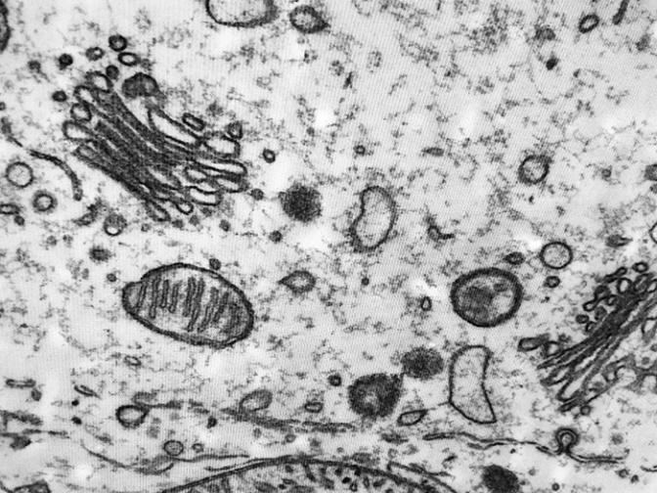
- Using the letters provided, label the organelle that: (2mks
i) Is found in high number in kidney cells (KC)
ii) Is abundant in secretory glands (SG)
- State the importance of cytoplasmic streaming to a cell (1mk
…………………………………………………………………………………………………………………………………………………………………………………....

- An athlete experienced a muscle cramp after a sprint race
- Name the acid that accumulated in her muscles to bring about the discomfort (1mk
………………………………………………………………………………………....
- Describe the fate of this acid when the athlete takes a rest (2mks
…………………………………………………………………………………………………………………………………………………………………………………....

- State the functions of the following cells (3mks
i) Sertoli cells
………………………………………………………………………………………....
ii) Interstitial cells
………………………………………………………………………………………....
iii) Guard cells
………………………………………………………………………………………....

- The experimental set up shown below was placed in the sunshine for 2 hours to study a particular phenomenon in plants
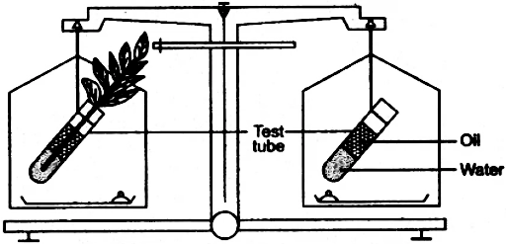
- What is the expected result after the 2hours of experiment? (1mk
…………………………………………………………………………………………………………………………………………………………………………………....
- Account for the answer given in a) above (2mks
……………………………………………………………………………………………………………………………………………………………………………………………………………………………………………………………………………....
- What is the expected result if the experiment was done under high humidity? (1mk
…………………………………………………………………………………………………………………………………………………………………………………....

- Name (2mks
- A cell in the human body that lacks mitochondria
…………………………………………………………………………………………
- A Kingdom whose members lack mitochondria
…………………………………………………………………………………………

- Fill the table below to show differences between guttation and transpiration (2mks
Guttation | Transpiration
- A plant cell was placed in solution X and after a while it appeared as cell B shown below
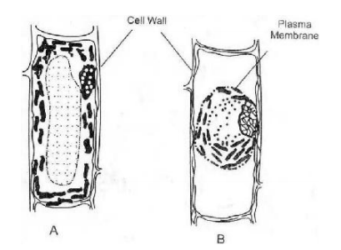
P
- Which TWO features show that cell B is plasmolysed? (2mks
…………………………………………………………………………………………………………………………………………………………………………………....
- Which process facilitated the presence of solution X in part P? (1mk
…………………………………………………………………………………………
- What is the nature of solution X? (1mk
…………………………………………………………………………………………

- Name the tissue that forms the following hormones (2mks
- Glucagon ………………………………………………………………………………
- Progesterone ……………………………………………………………………………

- Learners suspected that a liquid they found in the laboratory contained starch
- Describe a procedure they will use to determine whether starch was present (2mks
…………………………………………………………………………………………………………………………………………………………………………………....………………………………………………………………………………………....

- State the expected colour change for them to conclude that starch was present (1mk
…………………………………………………………………………………………
- What is the advantage of plants storing carbohydrates as starch? (1mk
…………………………………………………………………………………………………………………………………………………………………………………....
- The diagram below shows the root of a leguminous plant
- Name the bacterium found in the root nodules (1mk
…………………………………………………………………………………………
- How are the bacteria named in a) important to the legume? (1mk
…………………………………………………………………………………………

- The following data was collected from study of same crop grown in different temperature
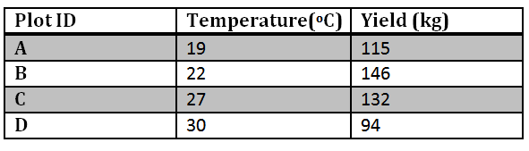
- Which is the ideal temperature for the growth of this crop? (1mk
…………………………………………………………………………………………

- Account for the yield obtained in plot D (2mks
………………………………………………………………………………………………………………………………………………………………………………………………………………………………………………………………………………

- Explain the ways by which movement of the ovum is achieved along the oviduct.
……………………………………………………………………………………………………………………………………………………………………………………………………………………………………..…………………………………………………(2mks
- a) Name the salivary gland found beneath the tongue (1mk
………………………………………………………………………………………………………………………………………………………………………………………………
b) Outline TWO ways in which saliva is suited to its function (2mks
……………………………………………………………………………………………………………………………………………………………………………………

- The picture below shows a disorder that affects blood vessels in humans
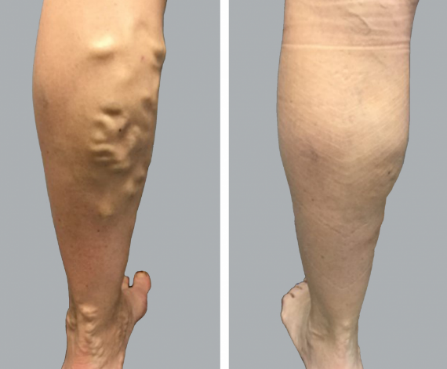
- Name the disorder shown above (1mk
…………………………………………………………………………………………
- Which blood vessel is affected by this disorder? (1mk
……………………………………………………………………………………………………………………………………………………………………………………

- A tall garden pea plant was crossed with a dwarf garden pea plant.
a) Given that the allele ‘d’ for dwarfness is recessive, write the genotype of the offspring if the tall garden pea used was: (2mks
- Pure breed ………………………………………………………………………………
- Heterozygous …………………………………………………………………………...
b) Write the base sequence of the DNA from which the messenger-RNA shown below was derived. ACUGAACCGUAU (1mk
………………………………………………………………………………………………
- Use the illustration shown below to answer the questions that follow
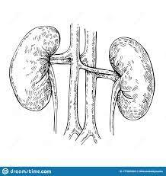

Z
- Why is the right kidney slightly pushed higher up compared to the left kidney? (1mk
…………………………………………………………………………………………
- Explain how gland labelled Z help raise amount of Sodium ions (Na+) in the blood
……………………………………………………………………………………………………………………………………………………………………………..(2mks

- The illustration shown below is of a common organism
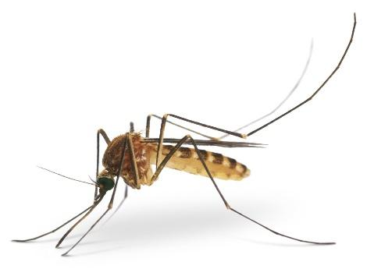
- Why is the above organism medically important globally? (2mks
……………………………………………………………………………………………………………………………………………………………………………………
- Name the class to which the organism belongs. (1mk
…………………………………………………………………………………………
- Give TWO reasons for your answer in b) above (2mks
………………………………………………………………………………………………………………………………………………………………………………………………………………………………………………………………………………
- How are the following significant to the development of seeds
- Seed dormancy (2mks
………………………………………………………………………………………………………………………………………………………………………………………………………………………………………………………………………………
- Seed dispersal (2mks
………………………………………………………………………………………………………………………………………………………………………………………………………………………………………………………………………………

- Use the images shown below to answer questions that follow
- Why are the structures above said to be homologous structures? (1mk
……………………………………………………………………………………………………………………………………………………………………………………
- Which type of evolution is represented above? (1mk
…………………………………………………………………………………………
- What is the significance of the type of evolution named in b) to animals? (1mk
……………………………………………………………………………………………………………………………………………………………………………………

- A protein has 100 amino acids. Calculate the number of nitrogenous bases in the gene for this protein (2mks
………………………………………………………………………………………………………………………………………………………………………………………………………………………………………………………………………………………………
- Study the photomicrograph shown below and answer the questions that follow
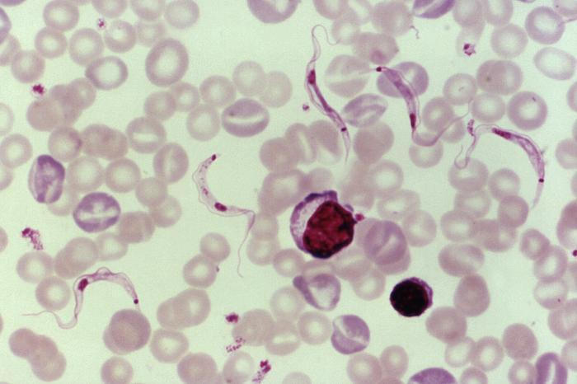

100ߎm
- Name the parasite shown in the photo above (1mk
…………………………………………………………………………………………
- Which organism is the vector of the parasite? (1mk
…………………………………………………………………………………………
- Calculate the magnification used to obtain the image shown above (3mks
…………………………………………………………………………………………………………………………………………………………………………………………………………………………………………………………………………………………………………………………………………………………………………

- a) Name the chemical form in which the following are transported in the blood (2mks
- Carbohydrates
……………….…………………………………………………………………………
- Carbon (IV) Oxide
................................…………………………………………………………………….
b) Explain why transfusion of blood from a blood group B donor to a recipient with blood group A may be fatal. (2mks
………………………………………………………………………………………………………………………………………………………………………………………………………………………………………………………………………………………………………………………………………………………………………………………………
- Use the photograph shown below to answer questions that follow
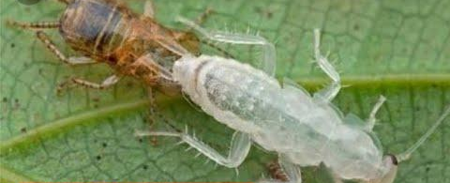
- Explain the role of prothoracic gland during this phase of metamorphosis (2mks
……………………………………………………………………………………………………………………………………………………………………………………
- State the significance of this process to the life of the insect (1mk
…………………………………………………………………………………………

- An animal has 6 molars, 2 canines, 4 incisors and 6 premolars in the lower jaw while the upper jaw has 6 molars, 4 premolars, 0 incisors and 2 canines in the upper jaw
- What is the significance of absence of incisors in the upper jaw to the feeding of the animal (2mks
……………………………………………………………………………………………………………………………………………………………………………………
- Write the correct dental formula for the animal (1mk
…………………………………………………………………………………………
- Why do such animals have a longer alimentary canal? (2mks
……………………………………………………………………………………………………………………………………………………………………………………

- Describe double fertilization in flowering plants (4mks
…………………………………………………………………………………………….…………………………………………………………………………………………….…………………………………………………………………………………………….

