NAME….……………………………………….ADM NO………..DATE……………SIGN…..

231/1 BIOLOGY THEORY PAPER 1
JUNE 2022
TIME: 2 HRS

MUMIAS WEST JOINT EVALUATION
FORM FOUR

INSTRUCTIONS TO CANDIDATES

- Write your name and admission number in the spaces provided.
- Sign and write date of examination in the spaces provided above.
- Read all questions and answer in the spaces provided.
- Candidates should check the question paper to ascertain that all the pages are printed as indicated and that no questions are missing.
- No blank spaces should be left during examination as they do not score.

1 | 2 | 3 | 4 | 5 | 6 | 7 | 8 | 9 | 10 | 11 | 12 | 13 | 14 | 15 | 16 | 17 | 18 | 19 | 20 | 21 | 22 | 23 | 24

GRAND TOTAL

- (a) State the function of a mirror in a light microscope. (1 mark)

- Give one reason why the coarse adjustment knob should not be used to lower the high power objective. (1 mark)

- The set below illustrates a certain physiological process:

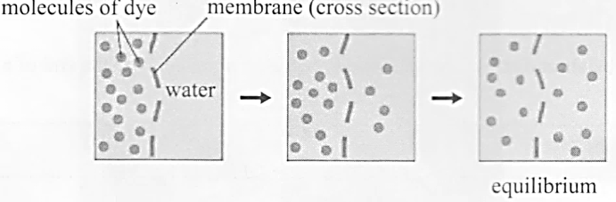
- (i) Name the physiological process (1 mark)

(ii) Give two examples of the process names in (a) (i) above in plants. (2 marks)

- State two ways by which the movement of dye molecules in the set up would be going down. (2 marks)

- The table below shows the percentage concentration of certain substances in blood plasma glomerular filtrate and urine in a human being at a particular time.

Percentage concentration
Substance | Blood plasma | Glomerular filtrate | Urine
Glucose | 0.023 | 0.02 | 0.0
Water | 92.70 | 92.70 | 96.08
Protein | 5.69 | 0.0 | 0.0
Urea | 0.087 | 0.098 | 2.6

- Explain the likely impact on the composition of urine in case of the following:
- Vigorous physical exercises (2 marks)

- A meal rich in proteins (2 marks)

- Name the processes responsible for:
- Presence of glucose in glomerular filtrate (1 mark)

- Absence of glucose in urine (1 mark)

- State three factors that affect the rate of diffusion. (3 marks)

5. How does nutrition as a characteristic of living organisms differ in plants and animals? (2 marks)

6. The diagram below represents a certain organism collected by a student at the sea shore.
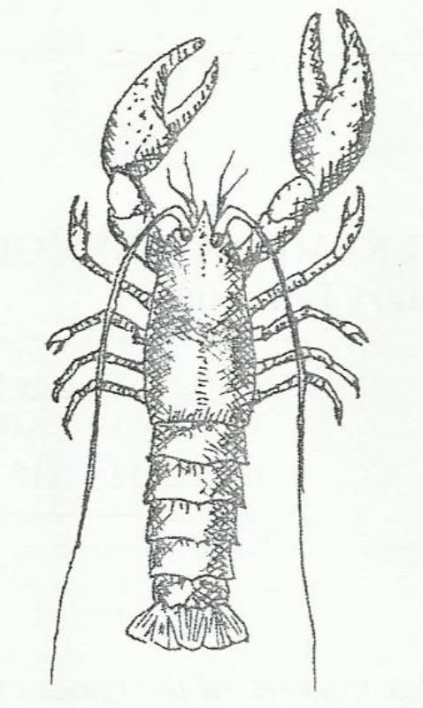

(a) Name the class to which the organism belongs. (1 mark)

(b) Give three reasons for your answer in (a) above. (3 marks)

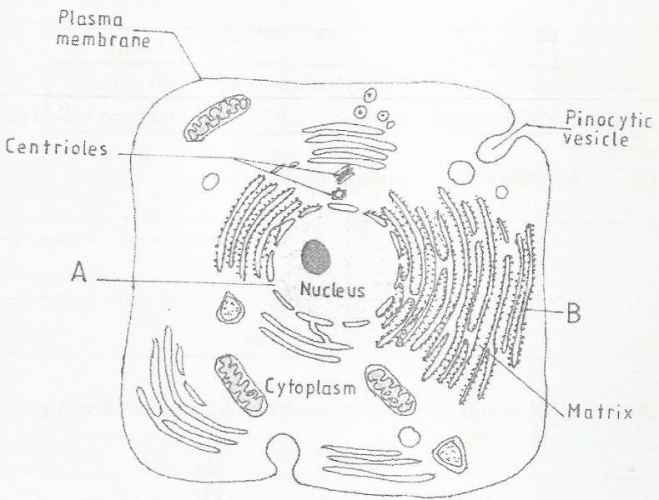
7. The figure below is a fine structure of a generalized animal cell as seen under an electron microscope.

(a) Name the parts labeled A and B. (2 marks)

A ………………………………………………………………………

B ………………………………………………………………………

(b) How is the structure labeled B adapted to its function? (2 marks)

8. In an investigation, a student extracted three pieces of pawpaw cylinders using a cork borer. The cylinders were cut back to 50mm length and placed in a beaker containing a solution. The results after 40 minutes were as shown in the table below.

Feature | Result
Average length of cylinders (mm) | 56 mm
Stiffness of cylinders | Stiff

(a) Account for the results in the table above. (3 marks)

(b) What would be a suitable control set-up for the investigation? (1 marks)

9. The table below shows results of a study of three plants C, D and E growing in different habitats.
Feature | Plant C | Plant D | Plant E
Number of stomata on upper surface of leaf per square area | 4 | 20 | 6
Number of stomata on lower surface of leaf per square area | 6 | 0 | 8
Thickness of leaf cuticle (mm) | 0.4 | 0.1 | 0.2
Surface area of roots (cm³) | 2000 | 1000 | 1200

(a)Which one of the plant C, D and E grows in an area of relatively low water availability?(1 mk)

(b) Explain your answer in (i) above. (2 marks)

10. The diagram below shows part of the mammalian system
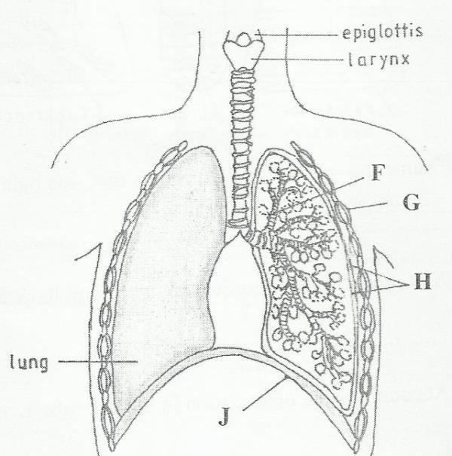

(a) Name the parts labeled F and G. (2 marks)

F ……………………………………………………………………………

G ……………………………………………………………………………

(b) State one function of each of the parts labeled H and J (2 marks)

H …………………………………………………………………………

J ………………………………………………………………………….

11. The diagram below shows a reproductive structure of a plant.
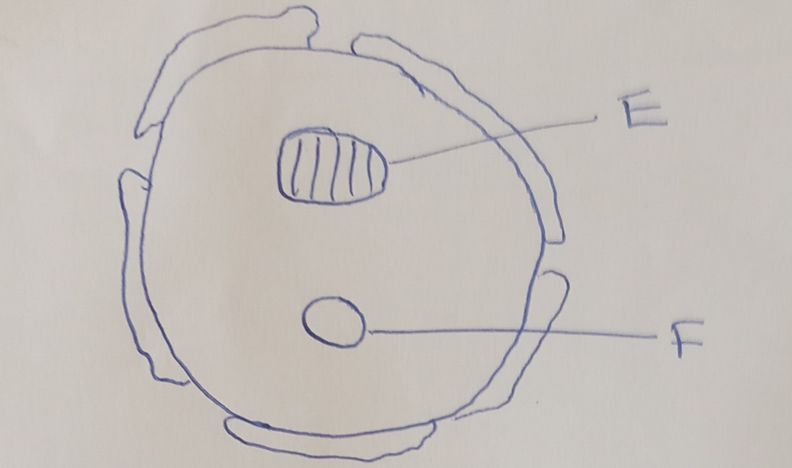

a) i. Identify the reproductive structure. (1mk)

ii. In which part of the reproductive system is the structure produced? (1mk)

b) Name division of the plant that produces the reproductive structure above. (1mk)

c) Name structures E and F (2mks)
E_______________
F_______________
12.a) What is pollination? (1mk)

b) Cross pollination leads to cross fertilization which results to hybrid vigour. State three mechanisms that encourages cross pollination instead of self pollination. (3mks)

13. Define the terms; (2mks)
i. Ovulation

ii. Implantation

14. Explain why
a) A pregnant woman needs to be on a diet rich in proteins and mineral salts such as calcium. (2mks)

b) A drop in progesterone levels during pregnancy my cause miscarriage. (2mks)

15. Outline two precautions taken when collecting and observing specimens. (2mks)

16. Below is a diagram representing one of the apparatus used in biological studies?
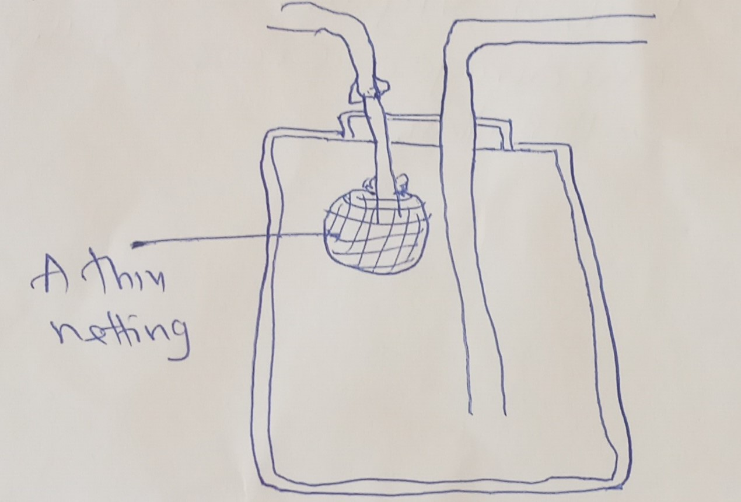

- Identify the apparatus. (1mk)

- Name two animals which require the use of the apparatus during their collection. (2mks)

17. a) What are the benefits of scientific skills acquired in studying Biology? (2mks)

b) Outline two ways in which an aircraft can be compared to a bird apart from flying. (2mks)

18. Name two structures used for gaseous exchange in plants. (2mks)

19. What is meant by each of the following?
i) Pyramid of biomass? (1mk)

- Pyramid numbers?(1mk)

20. (a) Name the organism that;
i. Causes malaria (1mk)

ii. Transmits malaria (1mk)

b) State two control measures for malaria (2mks)

21. a) What is meant by the term binomial nomenclature (1mk)

b) State two guidelines that should be followed when typing scientific name. (2mks)

22. An individual is of blood group B positive.
a) Name the antigens in the individual’s blood. (2mk)

b) Give the reasons why the individual cannot receive from a blood group A donor. (2mks)

23. Colour blindness is a sex linked trait controlled by a recessive b. If a mother is a carrier and the father is normal, what is the chance that their son will be colour blind? Show your working. (3mks)

24. State two advantages of using a coverslips when preparing a specimen for observation under a light microscope. (2mks)

