231/1

NAME…………………………………………….……. INDEX NO………..…………………..
SIGNATURE……………………………….………………DATE……………………………..
ASUMBI GIRLS HIGH SCHOOL
POST -MOCK 1
AUGUST/SEPTEMBER
2022

AUGUST / SEPTEMBER - 2022
BIOLOGY
PAPER 1
TIME: 2 HOURS

INSTRUCTIONS TO CANDIDATES:
- Write your name and index number in the spaces provided.
- Sign and write date of examination in the spaces provided above
- Answer all the questions in this paper in the spaces provided.

For Examiner’s Use Only:
QUESTIONS | MAXIMUM SCORE | CANDIDATE’S SCORE %
1- 22 | 80

Kenya Certificate of Secondary Education (K.C.S.E.)
This paper consists of 12 printed pages. Candidates should check to ascertain that all papers are printed as indicated and that no questions are missing

- Study the diagram below showing a portion of an onion epidermis that had been irrigated with a certain solution X.
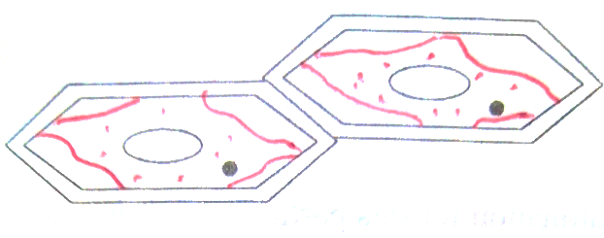
a) In one word describe the condition of the cells (1mk)

---------------------------------------------------------------------------------------------------------------------

b) Describe the process that lead to the condition named above. (3mks)
------------------------------------------------------------------------------------------------------------------------------------------------------------------------------------------------------------------------------------------------------------------------------------------------------------------------------------------------------------------------------------------------------------------------------------------------------------------------------------
------------------------------------------------------------------------------------------------------------------------------------------------------------------------------------------------------------------------------------------
2. The following reaction may proceed in forward or backward direction
Glucose + fructose sucrose + water.

- What term is used to refer to the backward reaction. (1mk)

--------------------------------------------------------------------------------------------------------------

- In which part of alimentary canal does the backward reaction occur? (1mk)

---------------------------------------------------------------------------------------------------------------

- Name the enzyme that catalyzes the backward reaction. (1mk)
----------------------------------------------------------------------------------------------------------------
3. A certain metabolic pathway takes the following sequence.
J K L M N
At the start of the experiment an inhibitor was added to the reactants. After the experiment it was found out that there was the same concentration of J, more than normal concentration of K, near absence of L, M and N. When L was added to the inhibitor set M and N were detected.

- At what stage of the reaction sequence did the inhibitor have its effect? (1mk)

-------------------------------------------------------------------------------------------------------------

- Explain how the inhibitor affected the reaction. (1mk)
----------------------------------------------------------------------------------------------------------------------------------------------------------------------------------------------------------------------------------------------------------------------------------------------------------------------------------------------
c) What is the identity of substance L? (1mk)
-------------------------------------------------------------------------------------------------------------------
4. After fertilization of an ovule, which parts develops into: -
- Testa (1mks)
-------------------------------------------------------------------------------------------------------------

b) Endosperm (1mk)

----------------------------------------------------------------------------------------------------------------
5a) Explain two roles of diffusion in human beings. (4mks)
---------------------------------------------------------------------------------------------------------------------------------------------------------------------------------------------------------------------------------------------------------------------------------------------------------------------------------------------------------------------------------------------------------------------------------------------------------------------------------------------------------------------------
bi) Name the process through which a plant takes up some mineral ions against a concentration gradient. (1mk)
-------------------------------------------------------------------------------------------------------------------------------
ii) State two factors that may affect the process named in b(i) above. (2mks)
--------------------------------------------------------------------------------------------------------------------------------------------------------------------------------------------------------------------------------------------------------------
c) Distinguish between haemolysis and plasmolysis. (1mk)
------------------------------------------------------------------------------------------------------------------------------------------------------------------------------------------------------------------------------------------------------------------------------------------------------------------------------------------------------------------------------------------------------------------------------------------------------------------------------------------------------------------------------------------------------------------------------------------------------------------------------------------------------------------------------------------------------------------------------------------------------------------------------------------

6.An insect landed on a leaf of an insectivorous plant. Consequently, the leaf closed with its spines interlocking trapping the insect inside it. Name the response exhibited by the leaf. (1mk)
------------------------------------------------------------------------------------------------------------------
7.The figure below represents a plant.

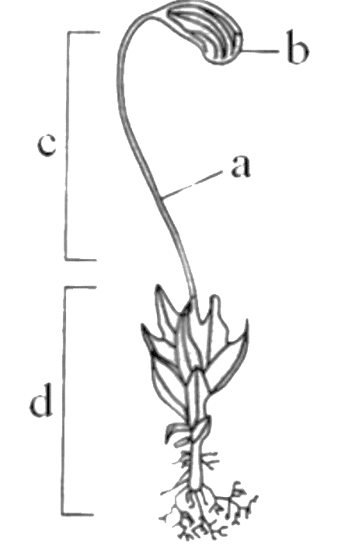

- State the division it belongs to. (1mk)
-------------------------------------------------------------------------------------------------------------
- Label the parts labeled (2mk)
a. ---------------------------------------------------------------------------------------------------
b. ----------------------------------------------------------------------------------------------------
c) State the role of part labeled d in the life cycle of the organism. (1mk)
------------------------------------------------------------------------------------------------------------------------
------------------------------------------------------------------------------------------------------------------------

8. State any two adaptations of the cardiac muscle that enable it to undergo systole.
(2mks)
i) ---------------------------------------------------------------------------------------------------------------------------------------------------------------------------------------------------------------------------------------ii) ------------------------------------------------------------------------------------------------------------------------------------------------------------------------------------------------------------------------------------
9.A respiratory substrate has the formula C₅₇H₁₁₀O₆.
a) Write a balanced equation to represent its complete oxidation to carbon dioxide and
water. (1mk)

b) Why are carbohydrates and not lipids the first choice respiratory substrates? (2mks)
----------------------------------------------------------------------------------------------------------------------
-----------------------------------------------------------------------------------------------------------------------
-----------------------------------------------------------------------------------------------------------------------
c) Calculate the RQ from the equation in (a) above. (2mks)

10. Below is a diagram of a group of cells of a specific tissue.
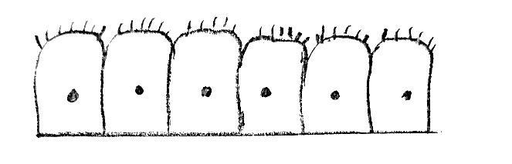
- Name the tissue (1mk)

-------------------------------------------------------------------------------------------------------------------
- This tissue lines the trachea and bronchi. Suggest its function in these structures. (1mk)

-------------------------------------------------------------------------------------------------------------------------

11. Study the flow chart below which represents a physiological process in mammals

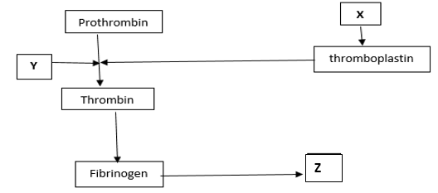
ai) Name blood components represented by X. (1mk)
---------------------------------------------------------------------------------------------------------------------------
ii) What is the significance of product represented by Z. (2mks)
---------------------------------------------------------------------------------------------------------------------------------------------------------------------------------------------------------------------------------------------------------------------------------------------------------------------------------------------------------------------------------------------------------------------------------------------------------------------------------------------------------------------------
b) Under what condition is thrombokinase released by the platelets? (1mk)
--------------------------------------------------------------------------------------------------------------------------------------------------------------------------------------------------------------------------------------------------------------
12 a) Explain what happens to excess amino acids in the liver of humans. (3mks)
----------------------------------------------------------------------------------------------------------------------------------------------------------------------------------------------------------------------------------------------------------------------------------------------------------------------------------------------------------------------------------------------------------------------------------------------------------------------------------------------------------------------------
b) Which portions of the human nephron are only found in the cortex? (1mks)
------------------------------------------------------------------------------------------------------------------------------
13.A potted plant is transferred from outside on a sunny and windy day, to a dark room.
a) Briefly explain the effect this is likely to have on:
i)The rate of loss of water from its leaves. (3mks)
-------------------------------------------------------------------------------------------------------------------------
--------------------------------------------------------------------------------------------------------------------------
--------------------------------------------------------------------------------------------------------------------------
ii)The rate of water absorption. (2mks)
---------------------------------------------------------------------------------------------------------------------------
----------------------------------------------------------------------------------------------------------------------------
14.Give a reason why urine of a mammal does not contain amino acids. (1mks)
----------------------------------------------------------------------------------------------------------------------------------------------------------------------------------------------------------------------------------------------------
15.a) In what form is energy stored in muscles? (1mk)
-------------------------------------------------------------------------------------------------------------------------------
b) State the role of insulin in human body. (3mks)
----------------------------------------------------------------------------------------------------------------------------------------------------------------------------------------------------------------------------------------------------------------------------------------------------------------------------------------------------------------------------------------------------------------------------------------------------------------------------------------------------------------------------
--------------------------------------------------------------------------------------------------------------------------------------------------------------------------------------------------------------------------------------------------------------
16.Name the processes that take place in the liver to bring about differences between blood
in the Hepatic portal vein and that in the hepatic vein. (3mks)

i) -------------------------------------------------------------------------------------------------------------------
ii) ------------------------------------------------------------------------------------------------------------------
iii) -----------------------------------------------------------------------------------------------------------------

17. The graph below shows how the body temperature of a toad and man varies with time in hours. Study it and answer the questions that follow.

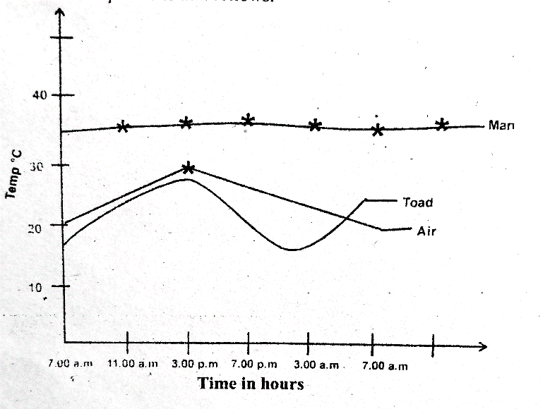

a) What is the relationship between the body temperature of the toad and that of the atmospheric air? (1mk)
-------------------------------------------------------------------------------------------------------------------------------------------------------------------------------------------------------------------------------------------------------------
b) State two corrective measures that maintains man’s body temperature at norm even when the environmental temperature is below 30⁰C. (2mks)
-----------------------------------------------------------------------------------------------------------------------------------------------------------------------------------------------------------------------------------------------------------------------------------------------------------------------------------------------------------------------------------------------------------------------------------------------------------------------------------------------------------------------------------------------------------------------------------------------------------------------------------------------------------
c) Give one behavioral adaptation observed in a lizard when the environmental temperature is above 39⁰C. (1mk)
-------------------------------------------------------------------------------------------------------------------------------------------------------------------------------------------------------------------------------------------------------------

18. The figure below shows the exposed breathing apparatus of a fish.
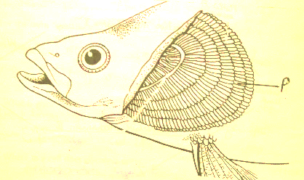

a) Name the structure that was removed to expose the apparatus. (1mk)
------------------------------------------------------------------------------------------------------------------------
b i) Name structure P. (1mk)
-------------------------------------------------------------------------------------------------------------------------
ii) State two structural adaptations of the respiratory surface in insects. (2mks)
-----------------------------------------------------------------------------------------------------------------------------
-----------------------------------------------------------------------------------------------------------------------------
-----------------------------------------------------------------------------------------------------------------------------
-----------------------------------------------------------------------------------------------------------------------------
19. The following is a reproductive structure of a plant.

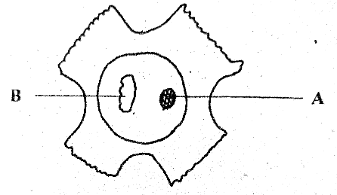

a) Identify the structure. (1mk)
-----------------------------------------------------------------------------------------------------------------------------
b) Name the sub-division of the plants that produces the above reproductive structure. (1mk)
------------------------------------------------------------------------------------------------------------------------------
ci) Name structure B. (1mk)
-------------------------------------------------------------------------------------------------------------------------------
ii) What is the function of structure A? (1mk)
--------------------------------------------------------------------------------------------------------------------------------------------------------------------------------------------------------------------------------------------------------------
20.Nucleic acids are made up of nucleotides that bears a sugar component.
a) Name the sugar component found in: - (2mks)
i) DNA fragment -----------------------------------------------------------------------------------------------------
ii) RNA fragment ----------------------------------------------------------------------------------------------------
b) The following nucleotide sequence was found in a segment of DNA: - A G C C T.
Write down the complementary base sequence in the corresponding m RNA segment during transcription. (1mk)
---------------------------------------------------------------------------------------------------------------------
c) A point mutation altered the base sequence from the original to G G C C T.
Identify the type of gene mutation. (1mk)
----------------------------------------------------------------------------------------------------------------------
21. Below is a drawing of a cell.
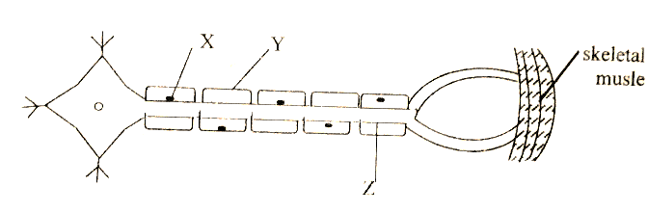
- With two reasons, identify the cell. (3mks)

Identify. ---------------------------------------------------------------------------------------------------
Reasons:
i) -----------------------------------------------------------------------------------------------------------------
-------------------------------------------------------------------------------------------------------------------
ii) -----------------------------------------------------------------------------------------------------------------
------------------------------------------------------------------------------------------------------------------
- Which of the three structure X, Y and Z speeds up transmission of the impulse. (1mk)

-------------------------------------------------------------------------------------------------------------------
22.a) State two structural differences between skeletal muscles and smooth muscles. (4mks)

Skeletal muscle | Smooth muscle
(i)

(ii)

b) What are antagonistic muscles? (1mk)
--------------------------------------------------------------------------------------------------------------------------------------------------------------------------------------------------------------------------------------------------------------

