NAME ……………………………………………. INDEX NO …………………………..
SCHOOL…………………………………………… SIGNATURE …………………..………
DATE ……..…………………...
231/1
BIOLOGY
PAPER 1
(Theory)
2 HOURS

CATHOLIC DIOCESE OF KAKAMEGA EVALUATION TEST
AUG/SEPT EXAM 2022
Kenya Certificate of Secondary Education (K.C.S.E)

INSTRUCTIONS TO CANDIDATES

- Write your name and Index Number in the spaces provided above.
- Sign and write date of examination in the spaces provided above.
- Answer ALL questions in the spaces provided.

FOR EXAMINERS USE ONLY.
Question | Maximum Score | Candidates Score
1 – 28 | 80

1. Name the antigens present in red blood cells of a person whose blood group is B positive. (2mks)
………………………………………………………………………………………………………

2. Give reasons for the following structural modifications in axial skeleton of humans
(i) Fused sacral vertebrae (1mk)
………………………………………………………………………………………………………
………………………………………………………………………………………………………
(ii) Long transverse process in lumbar vertebrae. (1mk)
………………………………………………………………………………………………………
………………………………………………………………………………………………………
3. (a) What is adaptive radiation? (1mk)
………………………………………………………………………………………………………
………………………………………………………………………………………………………
(b) State two ways in which Homo sapiens differs from Homo habilis (2mks)
………………………………………………………………………………………………………
………………………………………………………………………………………………………
………………………………………………………………………………………………………
………………………………………………………………………………………………………
4. State three characteristics of class Reptilia. (3mks)
………………………………………………………………………………………………………
………………………………………………………………………………………………………
………………………………………………………………………………………………………
………………………………………………………………………………………………………
………………………………………………………………………………………………………
………………………………………………………………………………………………………
5. The diagram below represents the structure of a yeast cell as seen under a light microscope.
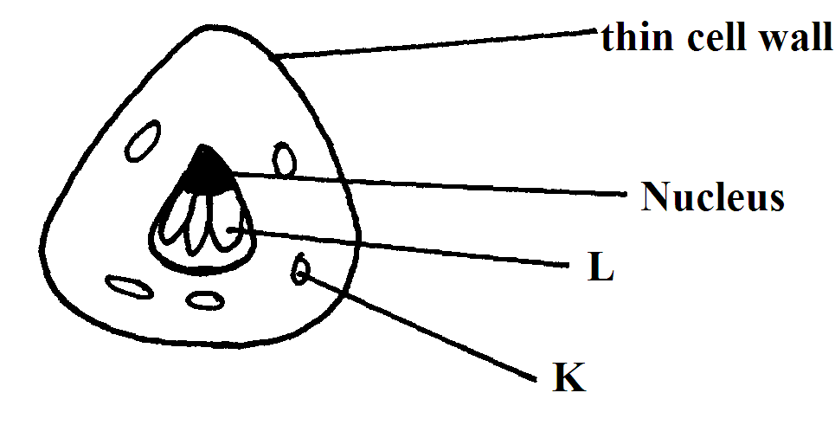

(a) Name parts labeled (2mks)
L……………………………………………………………………………………………...
K……………………………………………………………………………………………..
6. (a) Which part of plant normally shows
(i) Increased growth at lower auxin concentration (1mk)
………………………………………………………………………………………………………
………………………………………………………………………………………………………
(ii) Decreased growth at lower auxin concentration (1mk)
………………………………………………………………………………………………………
………………………………………………………………………………………………………
7. State the functions of the following parts of a light microscope.
(i) Fine adjustment knob (1mk)
………………………………………………………………………………………………………
………………………………………………………………………………………………………
(ii) Condenser (1mk)
………………………………………………………………………………………………………
………………………………………………………………………………………………………
8. Give a reason for the following features present in human trachea
(i) Ring of cartilage (1mk)
………………………………………………………………………………………………………
………………………………………………………………………………………………………
(ii) Presence of cilia (1mk)
………………………………………………………………………………………………………
………………………………………………………………………………………………………
9. The diagram below shows a plant supportive tissue
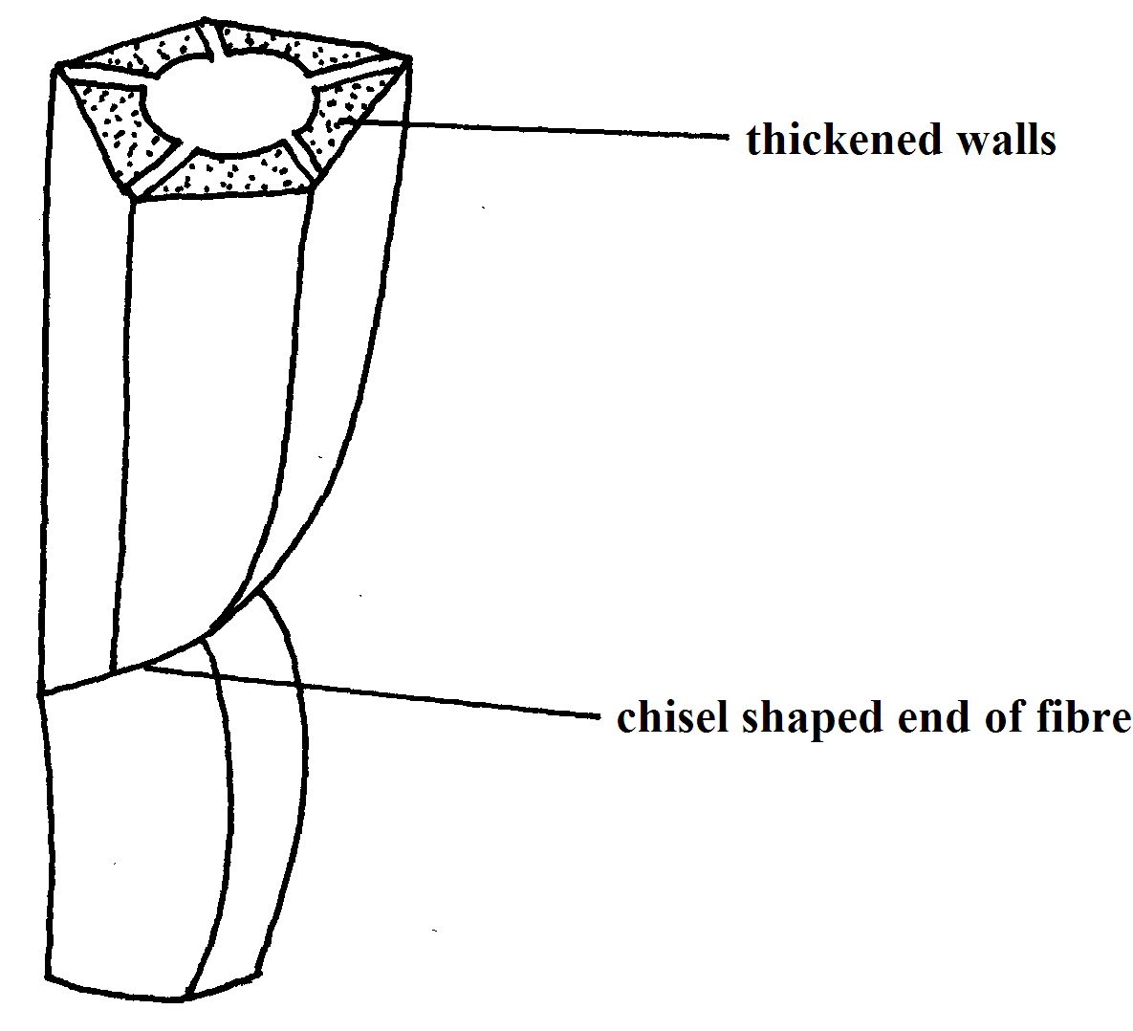
(a) Identify the tissue (1mk)
………………………………………………………………………………………………………
………………………………………………………………………………………………………

(b) State two similarities between tissue named in 9(a) above and one conducting water in
dicotyledonous plant. (2mks)
………………………………………………………………………………………………………
………………………………………………………………………………………………………
………………………………………………………………………………………………………
………………………………………………………………………………………………………
10. A wild beast in Masai Mara National Park was found to be infested with a lot of ticks. State the trophic level occupied by the following organisms:
(a) (i) Wild beast (1mk)
………………………………………………………………………………………………………
………………………………………………………………………………………………………
(ii) Ticks (1mk)
………………………………………………………………………………………………………
………………………………………………………………………………………………………
(b) Sketch a pyramid of numbers to represent above feeding relationship. (1mk)

11. (a) Name the causative agent of the following diseases in humans.
(i) Bilharziasis (1mk)
………………………………………………………………………………………………………
………………………………………………………………………………………………………
(ii) Syphillis (1mk)
………………………………………………………………………………………………………
………………………………………………………………………………………………………
(b) Describe the following defects:
(i) Varicose veins (1mk)
………………………………………………………………………………………………………
………………………………………………………………………………………………………
(ii) Thrombosis (1mk)
………………………………………………………………………………………………………
………………………………………………………………………………………………………

12. The flow chart below shows the movement and fate of carbohydrate synthesized by green plants.
Photosynthetic tissues in a leaf

Meristematic tissues
Storage tissues

(a) Name the type of carbohydrate that is
(i) Transported from leaf to other parts of plant (1mk)
………………………………………………………………………………………………………
………………………………………………………………………………………………………
(ii) Found in storage tissues (1mk)
………………………………………………………………………………………………………
………………………………………………………………………………………………………
(b) Name two main photosynthetic tissues found in a leaf (2mks)
………………………………………………………………………………………………………

13. State the roles of the following cell organelles in a cell
(a) Lysosomes (2mks)
………………………………………………………………………………………………………
………………………………………………………………………………………………………
………………………………………………………………………………………………………
………………………………………………………………………………………………………
(b) Centrioles (1mk)
………………………………………………………………………………………………………
………………………………………………………………………………………………………
14. Name the physiological process involve in the movement of the following substances in and out of the cell.
(a) Mineral salts (1mk)
………………………………………………………………………………………………………
………………………………………………………………………………………………………

(b) Water (1mk)
………………………………………………………………………………………………………
………………………………………………………………………………………………………

15. Below is the dental formula of an organism

(i) Calculate the total number of teeth in the jaw of the animal (2mks)

(ii) With a reason, identify the type of dentition for the organism (2mks)
………………………………………………………………………………………………………
………………………………………………………………………………………………………
………………………………………………………………………………………………………
………………………………………………………………………………………………………
16. The diagram below shows a section through a plant organ
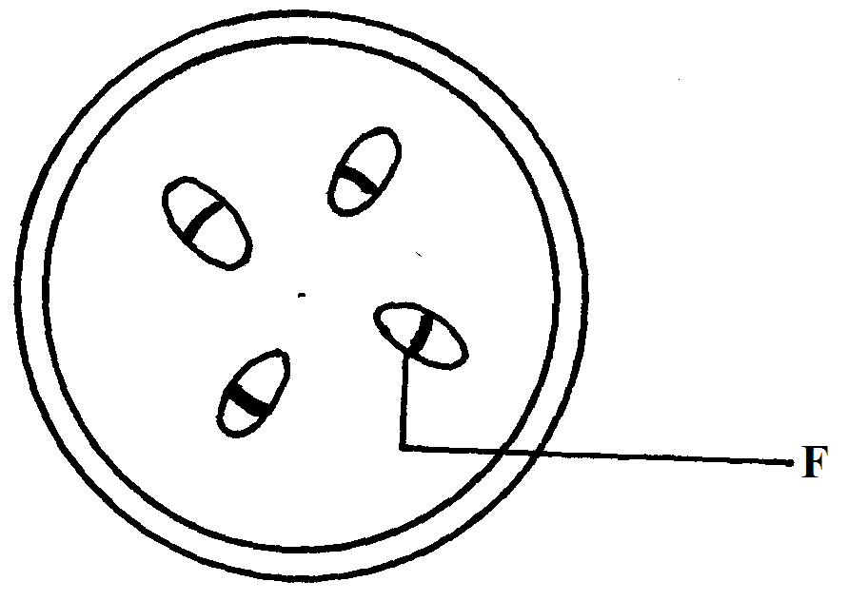
(a) (i) Name the class of the plant from which the section was obtained (1mk)
………………………………………………………………………………………………………
………………………………………………………………………………………………………

(ii) Give a reason for your answer in a(i) above (1mk)
………………………………………………………………………………………………………
………………………………………………………………………………………………………
17. (a) Name two structures for gaseous exchange in aquatic plants. (2mks)
………………………………………………………………………………………………………
………………………………………………………………………………………………………
………………………………………………………………………………………………………
………………………………………………………………………………………………………
(b) State one adaption of the above named structures. (1mk)
………………………………………………………………………………………………………
………………………………………………………………………………………………………

18. During a biological trip, plants that had flowers drew the attention of students
(a) Name the subdivision of the plants (1mk)
………………………………………………………………………………………………………
………………………………………………………………………………………………………
(b) Name two possible characteristics that students would use to conclude that they were
insect pollinated. (2mks)
………………………………………………………………………………………………………
………………………………………………………………………………………………………
………………………………………………………………………………………………………
………………………………………………………………………………………………………
19. Define the following terms
(a) Homologous structures (1mk)
………………………………………………………………………………………………………
………………………………………………………………………………………………………
(b) Vestigial structures (1mk)
………………………………………………………………………………………………………
………………………………………………………………………………………………………
20. Name the type of responses exhibited by the following
(a) Pollen tube growth towards the embryo sac (1mk)
………………………………………………………………………………………………………
………………………………………………………………………………………………………

(b) Maggot moving from the lit part of boiling tube to the part painted black (1mk)
………………………………………………………………………………………………………
………………………………………………………………………………………………………
(c) Folding of the leaves of the Mimosa Pudica plant on touch (1mk)
………………………………………………………………………………………………………
………………………………………………………………………………………………………
21. Insulin is a hormone synthesized using bacteria DNA. It is possible to obtain from hospitals because of the new technology
(a) Name the technology used in the case above. (1mk)
………………………………………………………………………………………………………
………………………………………………………………………………………………………
(b) Why were bacteria preferred in the medicine production (2mks
………………………………………………………………………………………………………
………………………………………………………………………………………………………
………………………………………………………………………………………………………
………………………………………………………………………………………………………
22. (a) State the role of the following parts of ear in the hearing process
(i) Ear drum (1mk)
………………………………………………………………………………………………………
………………………………………………………………………………………………………
(ii) Cochlea (1mk)
………………………………………………………………………………………………………
………………………………………………………………………………………………………
(b) Explain why the body temperature of a healthy human being may rise up to 39⁰C on a hot
humid day. (3mks)
………………………………………………………………………………………………………
………………………………………………………………………………………………………
………………………………………………………………………………………………………
………………………………………………………………………………………………………
………………………………………………………………………………………………………
………………………………………………………………………………………………………
23. Explain what happens to human body when glucose level is above normal (3mks)
………………………………………………………………………………………………………
………………………………………………………………………………………………………
………………………………………………………………………………………………………
………………………………………………………………………………………………………
………………………………………………………………………………………………………
………………………………………………………………………………………………………
24. Name three mechanisms that ensure cross pollination takes place in flowering plants. (3mks)
………………………………………………………………………………………………
………………………………………………………………………………………………
………………………………………………………………………………………………
………………………………………………………………………………………………
………………………………………………………………………………………………
………………………………………………………………………………………………

25. State the functional difference between sensory and motor neurons (1mk)
………………………………………………………………………………………………………
………………………………………………………………………………………………………
26. Give two reasons why class insecta is the most numerous among members of phylum arthropoda. (2mks)
………………………………………………………………………………………………………
………………………………………………………………………………………………………
………………………………………………………………………………………………………
………………………………………………………………………………………………………
27. The diagram below shows the appearance of a plant cell after it had been placed in a strong salt solution
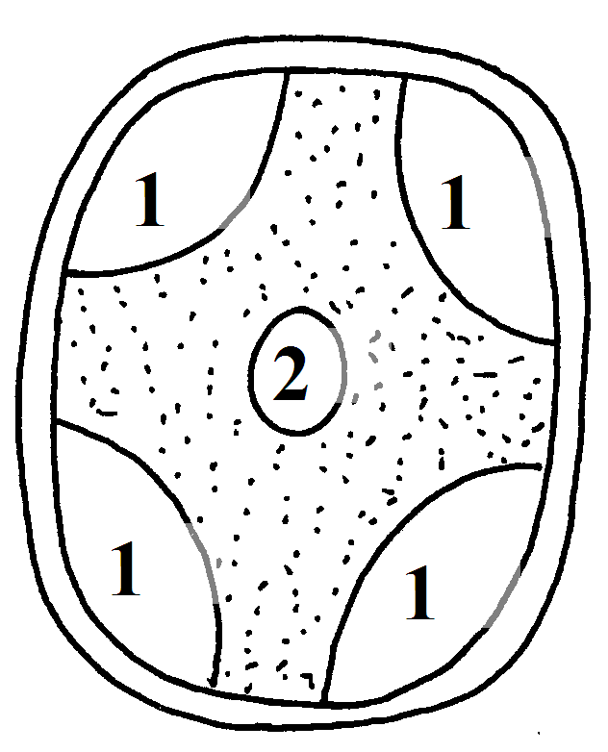
(a) Name the process that occurred in the cell shown above. (1mk)
………………………………………………………………………………………………………
………………………………………………………………………………………………………
(b) (i) Which substance is present in the regions marked 1? (1mk)
………………………………………………………………………………………………………

(ii) Give reasons for your answer in b(i) above (2mks)
………………………………………………………………………………………………………
………………………………………………………………………………………………………

28. State two roles of a fruit to a plant (2mks)
………………………………………………………………………………………………………
………………………………………………………………………………………………………

29. What is the importance of the following in an ecosystem?
(i) Bacteria and fungi (1mk)
………………………………………………………………………………………………………
………………………………………………………………………………………………………
(ii) Predators (1mk)
………………………………………………………………………………………………………
………………………………………………………………………………………………………
30. Outline three roles of active transport in the human body. (3mks)
………………………………………………………………………………………………………
………………………………………………………………………………………………………
………………………………………………………………………………………………………
End

