Name………………………………………. ………………….…Index No:…………………….…….
Candidate’s Signature ……………..…
Date: ……….……….……
231/3
BIOLOGY
PAPER 3
(PRACTICAL)
JUNE 2022
TIME: 1 $3/{4 }$HOURS

MOMALICHE JOINT PRE-MOCK EXAMINATION
Kenya Certificate of Secondary Education (K.C.S.E.)
231/3
BIOLOGY
Paper 3
1 $3/{4 }$HOURS

INSTRUCTIONS TO CANDIDATES
- Write your name and index number in the spaces provided above
- Sign and write the date of examination in the spaces provided.
- Answer all the questions in the spaces provided.
For Examiners Use Only
Question | Maximum score | Candidate’s score
1 | 16
2 | 12
3 | 12
TOTAL | 40

This paper consists of 5 printed pages. Candidates should check to ascertain that all pages are printed as indicated and that no questions are missing.

1. You are provided with iodine solution, Benedict’s solution, visking tubing, test tubes, a beaker and a solution labelled X ( shake thoroughly before use)
a) Using the reagents provided test the identity of solution labeled X. (6 mrks)
Foot test | Procedure | Observation | Conclusion

Tie one end of the visking tubing provided with a thread tightly. Measure 5ml of solution X. Pour 5ml of solution X into the visking tubing. Tie the other end of the tubing tightly. Ensure there is no leakage. Rinse the outside of the tubing with distilled water and immerse it with its contents in a beaker containing iodine solution. Allow it to stand for 20 minutes.
b (i) Record your observation at the beginning and end of the experiment. Record your results in the table below. (4 mrks)
Experimental set up | Solution X inside the visking tubing | Iodine solution outside the visking tubing
Beginning of experiment
End of experiment

(ii) Suggest the nature of visking tubing. (1 mrk)

(iii) Account for the results obtained in a (i) above. (4 mrks)

c) Which physiological process was being investigated in this experiment? (1 mrk)

2. You are provided with specimens labelled:
J: Hibiscus rosaninensis
K: Bougainvillea glabra
L: Jacaranda mimosifolia
M: Zea mays
N: Lantana camara
- Using the characteristics given below and in the order in which they occur, construct a dichotomous key to identify the specimens.(8mks)
Characteristics
1. Type of leaf
2. Leaf venation
3. Leaf margin
4. Texture of leaf lamina

b i) Identify the likely habitat of the plant from which specimen labelled N was obtained from. (1 mrk)

ii) Give a reason for your answer in bi) above. (1 mrk)

c i) Name the class of the plant from which specimen M belong. (1 mrk)

ii) Give a reason for your answer in c i) above. (1 mrk)

3. Below are photographs labelled J and K of organs obtained from different animals. Examine them and answer the following questions.
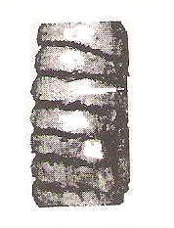
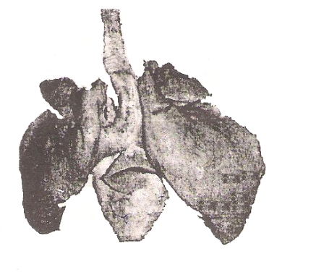
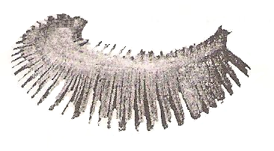
1
W
X
Y
Z

Photograph J
Photograph K
3
2

- Identify the organs labelled: (2 mrks)
X:

Y:

(b i) State the function performed by the above named organs. (2 mrks)
Organ X:

Organ Y:

ii) State three adaptations of organ labelled Y to its function. (3mrks)

c i) Identify the parts labelled 1, 2 and 3 in photograph K.(3 mrks)
1:
2:
3:
ii) Using observable features, state how the parts labelled 1 and 3 you identified
in (i) above are adapted to their functions. (2 mrks)

