231/3
BIOLOGY PRACTICAL
PAPER 3
June 2022

KASSU JET EXAMINATION 2022
MARKING SCHEME

1.You are provided with a tablet which is a nutritional supplement, distilled water and a boiling tube. Put about 6ml of the distilled water in the boiling tube and add the nutritional tablet to dissolve it to form solution T. Use the reagents provided to find out the food substances present in the tablet.
Food substance | Procedure | Observation | Conclusion
Ascorbic acid/Vitamin C | Put DCPIP into the test tube.  Add solution T dropwise to the DCPIP | DCPIPis decolourised | Vitamin C/Ascorbic acid present
Starch | To solution T in a test tube, add iodine solution | Brown colour of iodine persists; | Starch absent
Reducing sugars | To solution T in a test tube, add an equal amount of Benedict’s solution, shake the mixture and boil/ heat to boil in a water bath. | Colour changed from blue,green,yellow,orange | Reducing sugars present
Proteins | To solution T in a test tube, add an equal amount of sodium hydroxide. Add copper(II) sulphate dropwise and shake mixture | Blue colour of copper (II) Sulphate persists | Proteins absents

- a. (i) You are provided with a pestle, mortar, scapel specimen Q and R,. Cut from each a
cube, each measuring 1cm by 1cm. put them each in a different test tube having
10mls of solution X. Record the observations in the table below? (2marks)

Specimen | Observation
Specimen Q | A lot of bubbling / Effervescence / Fizzling
Specimen R | Little bubbling / less effervescence / little fizzling

(ii) Account for the observations in the experiment involving specimen Q and R? (3marks)
There is more bubbling / more gas produced in Q (liver) than in R banana; since there is more metabolic activities in Q than in R; Animals are more active than plants;

- i) Using the remaining portion of specimen Q. Cut 2 other pieces measuring 1cm by 1cm ,Crush them separately to form a paste and put them in boiling tubes labeled A and B.
To the paste in boiling tube labeled A, add 5mls of solution X .Record the observation in the table below. .
To the paste in boiling tube labeled B add 10mls of distilled water and boil for 5minutes then allow it cool then add 5mls of solution X. Record the observation in the table below? (2marks)

BOILING TUBE | Observation
A | fast/rapid/More effervescence/fizzing /bubbling
B | Fewer/no/very little effervescence/fizzing /bubbling

(ii) Account for the observations in the experiment involving boiling tube A and B? (4marks)
Boiling tube A
Crushing increases surface area for enzyme catalase; rapid / faster metabolism / breakdown of hydrogen peroxide occurs

Boiling tube B
Boiling denatures the cells / enzyme catalase; reduces enzyme activity / metabolism / substrate breakdown.

(iii) Name the biological substance being investigated and its significance to the
living tissue? (2marks)

Biological substance
Catalase/enzyme

Significance
Detoxification/breakdown harmful substance/hydrogen peroxide

iv) Name the factor being investigated in question 2(b) above (1mark)
Effect of temperature on enzyme action
3.(a) Study the following photograph and answer the questions that follow
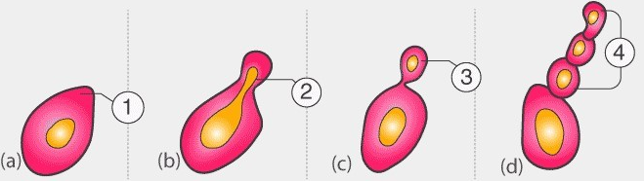
a.Name the mode of reproduction above and give an example of organism where it occurs.2mks
Budding; in yeast,
b.Briefly explain how the process occurs? 4mks
cytoplasm bulges out forming bud;which enlarges until almost equal in size to mother cell;nuclear division occurs and a cross wall is formed between the two cells;which then separate;

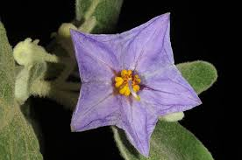
(c)Describe the features of the above photograph with respect to the following (3mks)
(i) Androecium
-Has five stamens
-Has short slender filaments each arising from the base of the ovary
-Anthers are large and yellow
-Anthers are below the stigma and surrounding the style
(ii) Gynoecium (3mks)
-Style longer than the filament/stigma above anthers
-Single superior ovary
-Has one long hairy style
(d) (i)Suggest the agent of pollination of the flower (1mk)
Insect (rej animal )
(ii)Explain how it is adapted to pollination agent you have named in (b)(i)above (2mks)
-Has coloured petals to attract insects
-Large/conspicuous petals to attract insects

