NAME: …………………… INDEX NUMBER: ………….………………….. SCHOOL………… SIGNATURE: ………............. DATE: ………………….

231/3
BIOLOGY PRACTICAL
PAPER 3
FORM 4
TIME: (1¾ HOURS)

DECEMBER EXAM 2021
KENYA CERTIFICATE OF SECONDARY EDUCATION
BIOLOGY
PAPER 3

INSTRUCTIONS TO CANDIDATES
- Write your name and index number in the spaces provided at the top of this page.
- Answer all questions in the spaces provided after each question. Additional pages must not be inserted.
- You are required to spend the first 15 minutes of the1 ¾ hours allowed for this paper reading through the whole paper carefully before commencing your work.
- Candidate may be penalized for recording irrelevant information and for incorrect spelling especially of technical terms

For Examiners Use Only

Question |  | Maximum Score | Candidate’s Score
1 |  | 14
2 |  | 14
3 |  | 12
 | Total score | 40

This paper consists of 6 printed pages. Candidates should check the question paper to ensure that all pages are printed as indicated and no questions are missing.

- Study photographs shown below then answer the questions.

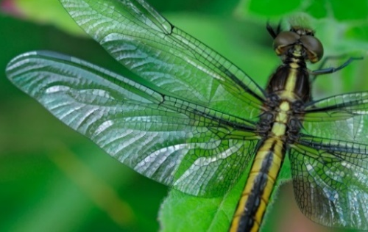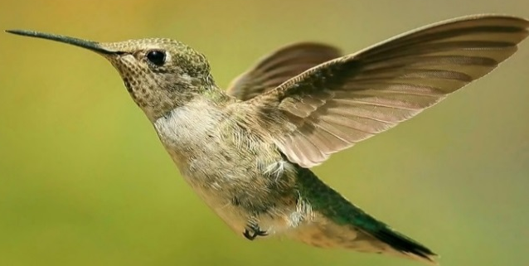
R1
R
Q1
Q
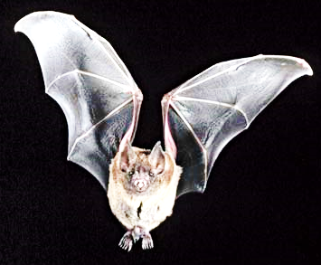
S
S1
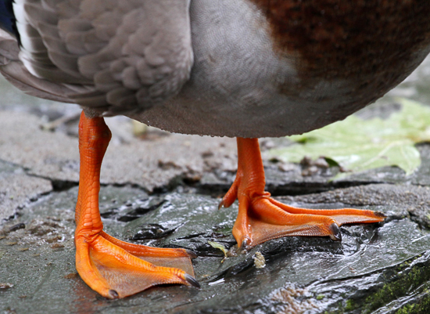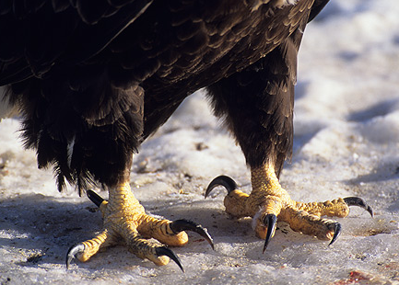
A
B
C
M
A1
B1
C1
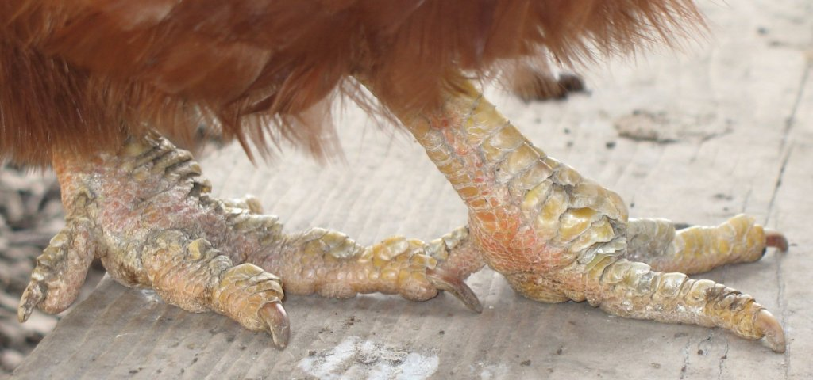

(a) State the type of evolution represented by structures Q₁, R₁ and S₁. (1mk)
…………………………………………………………………………………………………
(b) Explain the type of evolution identified in (a) above. (1mk)
…………………………………………………………………………………………………
(c) Give the evolution term used to describe structures:
(i) Q₁, R₁ andS₁ (1mk)
…………………………………………………………………………………………………
- A₁, B₁ and C₁ (1mk)
…………………………………………………………………………………………………
d) What type of evolution is illustrated by the limbs A1, B1 and C1? (1mk)
……………………………………………………………………………………………………………………………………………………………………………………………………………………………………
………………………………………………………………………………………………………………….
e) (i) Name class for each Q, R and S.
Q ………………………………………………………… (1mk)
R ………………………………………………………… (1mk)
S ………………………………………………………… (1mk)
(ii) Give two observable reasons for your answer for class S. (2mks)
……………………………………………………………………………………………………………………………………………………………………………………………………
(f) (i) Suggest the diet of animals B and R.
B……………………………………………………… (1mk)
R……………………………………………………… (1mk)
(ii) How is beak of animal B adapted to its function? (1mk)
……………………………………………………………………………………………………………………………………………………………………………………………………………………………………

g) How are animals A, B and C adapted for thermoregulation? (1mk)
……………………………………………………………………………………………………………………………………………………………………………………………………………………………………

2. You are provided with Iodine solution, starch suspension and visking tubing.
- Wet the visking tubing in running water to soften it and make it easy to open. Tie one end of the tubing tightly.
- Using a dropper, put starch suspension into the tubing until about three-quarters full.
- Tie the open end of the tubing tightly.
- Ensure that there is no leakage at both ends of the tubing.
- Clean outer surface of the visking tubing over running water to remove all traces of starch Suspension.
- Place the visking tubing containing starch suspension into the beaker with iodine solution and leave the set up undisturbed for about 30minutes.
- Remove the tubing from the beaker and observe.
- Record your observation in a table by indicating the colour of the solution at the beginning on at the end of the experiment. (4mks)
 | Starch solution inside tubing | Iodine solution in the beaker
Start experiment
End of experiment

- Account for the observations. (6mks)
……………………………………………………………………………………………………………………………………………………………………………………………………………………………………………………………………………………………………………………………………………………………………………………………………………………………………………………………………………………………………………………………………………………
……………………………………………………………………………………………………………………………………………………………………………………………………………………………………………………………………………………………………………………………………………………………………………………………………………………………………………………………………………………………………………………………………………………
…………………………………………………………………………………………………………
(c) Explain the modifications you could have made to realise faster results in the above experiment. (2mks)
………………………………………………………………………………………...…………………………………………………………………………………………...……………………………………………………………………………………………………………………………………………...
- State the importance of the process under investigation in the above experiment in both plants and animals as far as reproduction is concerned. (2mks)
……………………………………………………………………………………………………………………………………………………………………………………………………………………………………………………………………………………………………………………………………………………………………………………………………………………………………………………

- You are provided with a photograph of a flower of a higher plant.
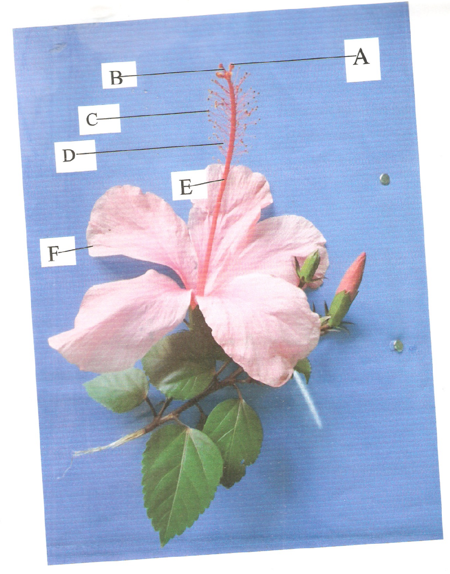
X
Y

- With reasons, state the class of kingdom plantae from which the specimen in the diagram was obtained.
Class (lmk)
…………………………………………………………………………………………
Reasons (2mks)
……………………………………………………………………………………………………………………………………………………………………………………
(b) Name the parts labeled A, E, and F. (3mks)
A: ……………………………………………………………………………..
E: ……………………………………………………………………………..
F: ……………………………………………………………………………..
(c) State how the specimen shown in the photograph is adapted to its mode of pollination. (2mks)
…………………………………………………………………………………………………………………………………………………………………………………………………………………….
………………………………………………………………………………………………………….
(d) Label the structure in the photograph which protects the flower before it blooms. (1mk)
…………………………………………………………………………………………………………
(e) Which letter in the photograph represents structure where the male gametes are produced. (lmk)
…………………………………………………………………………………………………………
(f) Calculate the image magnification of the leaf from point X to Y if its actual length was 2cm. show your working. (2mks)

