Name…………………………………………………………………………………………………Adm no. …………………

Class…………………………..…. School ………………………………………………..................Sign………………

231/3
BIOLOGY
PAPER 3 (PRACTICAL)
June 2022
Time: 1 ¾ HOURS
MUMIAS WEST JOINT EXAMS- JUNE 2022
INSTRUCTIONS TO CANDIDATES
- Answer ALL the questions.
- Answers must be written in the spaces provided in the question paper.
- Additional pages must not be inserted.

FOR EXAMINERS USE ONLY
Question | Maximum score | Candidate’s score
1 | 12
2 | 14
3 | 14
Total Score | 40
1. Study the photograph below and answer the questions that follow.

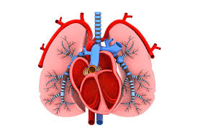

- State two organ systems in which the two organs in the photograph above are found.
(2mks)

- Label on the photograph the following structures. (4mks)
- Bronchi
- Left ventricle
- septum
- trachea

- State one feature of the following structures identified in( b) above and give the importance of the features. (4mks)
structure | feature | Importance
Left ventricle
Trachea

- Use an arrow to show the flow of carbon (iv) oxide molecule thorough the chambers of the heart towards the lungs. (1mk)

- State one observable features of lungs in the photograph above that suits them to their function. (1mks)

- You are provided with the following. Solution P, Q and Z.
- (i) Put 2 cm³ of solution P into two test tubes labeled A and B. Add three drops of iodine solution into test tube A. Observe and record. (1 mark)

(ii) To test tube B, add an equal amount of Benedict’s solution. Heat to boil. Record your observation. (1 mark)

(iii) From the results in (a) (i) and (ii), identify solution P. (1 mark)

(iv) Put 2cm³ of solution Z into a clean test tube labeled C. Add equal volume of Benedict’s solution. Heat to boil. Record your observation (1 mark)

(v) Open the visking tubing provided and tie one end tightly, Pour solution P into the visking tubing and add 1cm³ of the solution R. Tie the other end of the visking tubing and ensure there is no leakage at both ends. Pour solution Z into a clean beaker till it is half full. Immerse visking tube in the solution Z in the beaker. Allow it to stand for 30 minutes. After 30 minutes, take 2cm³ of solution Z from the beaker into a clean test tube labeled D. Add equal amount of Benedict’s solution. Heat to boil. Record your observation. (1 mark)

(vi)Account for the observation made in (v) above. (3 marks)

(vii) What is the identity of solution R? (1 mark)

(viii) State one factor that can affect the process demonstrated in 2a (v) above (1 mark)

b) Use the reagents provided to test for the food substance in solution Q.
Food substance | procedure | observation | conclusion
(4mks)

3. The photograph below shows specimen L. You are also provided with other two specimens labeled k and M. Study them then answer questions that follow:
Photograph L.
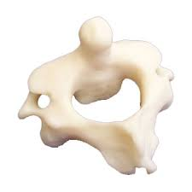

a) Identify the specimens. (3mks)
K
L
M

b) State two adaptive characteristic features of the specimen L. (2mks)

c) State two observable differences between specimen L and M. (2mks

Bone L | Bone M

d) (i) Draw and label the anterior parts of specimen K. (3mks)

(ii)State ways by which specimen K is adapted to its functions. (2mks)

(iii) Name the bone that articulates with specimen K at the:

Proximal end (1mk)

Distal end (1mk)

