Name…………………………………………………………….Index Number……………..

Class………………….…Candidate’s Signature…………………… Date…………………

231/1
BIOLOGY
PAPER 1
KASSU JET – JUNE 2022
TIME: 2 HOURS

KASSU JET – JUNE 2022
(Kenya Certificate of Secondary Education)
BIOLOGY THEORY

For examiner’s use only

QUESTION | MAXIMUM SCORE | CANDIDATE’S SCORE
1 - 29 | 80

This paper consist of 11 printed pages.
Candidates should check the questions to ascertain that all the pages are printed as indicated and no questions are missing.

- The study of biology enhances international cooperation, as countries work together to solve environmental problems. Name 2 biology related international conventions that help solve environmental problems. (2 marks)

...………………………………………………………………………………………….. ...………………………………………………………………………………………….. …………………………………………………………………………………………....
- A zebra is observed to be grazing at a grassland. Apart from nutrition, name one other characteristic of living things observed on the zebra as it grazes. (1 mark)
...…………………………………………………………………………………………..
- The diagram below represents an organism. Study it and answer the questions that follow.
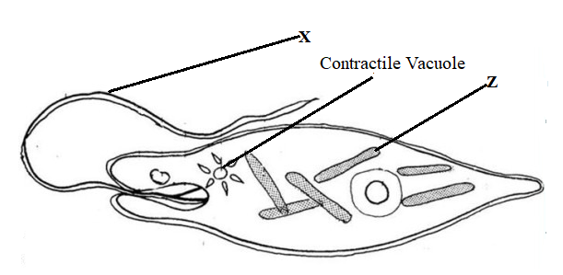
- Identify the kingdom to which the organism belongs (1 mark)
...…………………………………………………………………………………………..
- Name the structures labelled X (1 mark)
...…………………………………………………………………………………………..
- Identify the type of nutrition carried out by the organism and give a reason (2 marks)
Type of:
Nutrition
.......................................................................................................................................
Reason
...………………………………………………………………………………..............
...………………………………………………………………………………………...

- The diagram shown represents part of a cell.
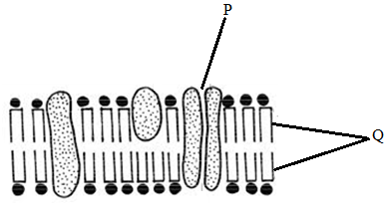
- Identify the structure (1 mark)
…………………………………………………………………………………………
- Label the following parts: (2 marks)
P………………………………………………………………………
Q…………………………………………………………………………
- Name the following organelles. (3 marks)
- Contains chromatin material
...……………………………………………………………………………………
- Forms spindle fibres
...……………………………………………………………………………………
- Digests pathogens that enter the cell
...……………………………………………………………………………………
- The bacterium that causes typhoid is known as salmonella typhi.
- Write the scientific name correctly (1 mark)
...……………………………………………………………………………………
- State the main mode of transmission of the above organism. (1 mark)
...………………………………………………………………………………………….. ...…………………………………………………………………………………………..

- Three stems of tradescantia of equal length were placed in three solutions of different concentrations. The set ups were left to stand for 30 minutes. The results were recorded in the table below.
Solution | Initial length of stem (mm) | Final length of stem (mm)
A | 37 | 37
B | 37 | 35.2
C | 37 | 39.7

- Describe the nature of solution A in relation to the final length of the tradescantia stem. (1mark)

…………………………………………………………………………………………..
- Explain the observation that was made on the tradescantia stem which was put in solution B. ( 2marks)

…………………………………………………………………………………………..…………………………………………………………………………………………..…………………………………………………………………………………………..
- State what would happen to red blood cells if they were placed in solution C.
(1 mark)
…………………………………………………………………………………………..
- A KASSUME researcher found out that oxygen concentration and sugar consumption is directly related to potassium ion uptake in wheat roots. Name the process by which potassium ions is taken by the roots. Give a reason for your answer ( 2 marks)

…………………………………………………………………………………………..……………………………………………………………..………………………………………………………………………………………………..………………………
- The diagram below is an experiment that was carried out to investigate a certain biological process. Study it an answer the questions below.
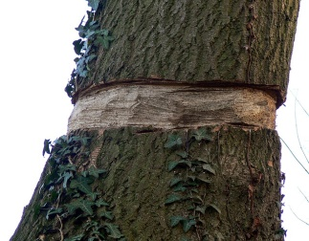

- What is the aim of the experiment? ( 1mark)
…………………………………………………………………………………………
- Which specialised tissue was removed in the above experiment? ( 1mark)
…………………………………………………………………………………………
- How is the tissue named above adapted to perform its function? ( 1mark)
…………………………………………………………………………………………
- Predict in diagrammatic form the fate of the trunk after 3 weeks? ( 1 mark)

......................................................................................................................................
- Two potted plants A and B that had been kept in dark for 48 hours were placed in polythene bags.

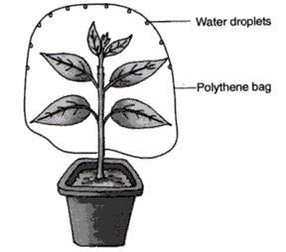
NaOH pellets
NaHCO₃

set up A Set up B

Into set up A, a dish of sodium hydroxide was placed inside the polythene bag. In the
set up of plant B, a dish of sodium hydrogen carbonate was similarly placed. The plants were then placed in sunlight for six hours. After six hours a leaf from each plant was tested for starch.

- What is the expected results for set up A (1 mark)
…………………………………………………………………………………………
- What was the purpose of:
- Sodium hydroxide (1 mark)
……………………………………………………………………………………
……………………………………………………………………………………
- Sodium hydrogen carbonate. (1 mark)
………………………………………………………………………………………
………………………………………………………………………………………
- What would have been the case if neither sodium hydroxide nor sodium hydrogen carbonate were placed in the set up? (1 mark)

…………………………………………………………………………………………
…………………………………………………………………………………………
- State the purpose of this experiment. (1 mark)
.......................................................................................................................................
.......................................................................................................................................
- Explain how the teeth of a lion are adapted to carnivorous mode of feed. (2 marks)
………………………………………………………………………………………………………………………………………………………………………………………………………………………………………………………………………………………………………………………………………………………………..............................................
- Explain how emotional state of the body affect heart beat rate. (1 mark)
…………………………………………………………………………………………
…………………………………………………………………………………………
…………………………………………………………………………………………
- (i) What is meant by immune response? (1 mark)
…………………………………………………………………………………………
…………………………………………………………………………………………
(ii) Name one cell responsible for immune response in a human being. (1 mark)
…………………………………………………………………………………………
- Describe the mechanism of closing the stomata on the basis of photosynthetic theory (3 marks)

..............……………………………………………………………………………………
..............……………………………………………………………………………………
..............……………………………………………………………………………………
..............……………………………………………………………………………………
..............……………………………………………………………………………………
- Explain how the floating aquatic plants are adopted of gaseous exchange. ( 1 mark)
..............……………………………………………………………………………………
..............……………………………………………………………………………………
..............……………………………………………………………………………………

- The chart below shows a summarized process that occurs in animals.

Lactic acid + N
Reactions
in cytoplasm
Process X
Substance A + ATP
Glucose

Reactions
Product B + water + ATP
in matrix

- Name the: (3 marks)
- Process X ......................................................................................................
- Substance A .....................................................................................................
- Product B .....................................................................................................
- State the condition necessary for the reactions in matrix to occur. (1 mark)
..............……………………………………………………………………………………
- Explain the roles of the following plant hormones
- Gibberellins (3 marks)
……………………………………………………………………………………
……………………………………………………………………………………
……………………………………………………………………………………
……………………………………………………………………………………
……………………………………………………………………………………
…………………………………………………………………………………….
- Ethylene (2 marks)
………………………………………………………………………………………………………………………………………………………………………………………………………………………………………………………………………………………………………………………………………………………………
- (a) Define the first law of heredity as postulated by Gregor Mendel (1 mark)
…………………………………………………………………………………………………………………………………………………………………………………………………………………………………………………………………………………………………………………………………………………………………………

(b) A common species of rats has individuals with white, black or grey coats. During a study, a rat with white coat was crossed with a rat with black coat. Both parents were pure lines. All the offspring in F1 generation had grey coats. The F1 offspring were selfed to get F2. Using letter B to represent the gene for black coat and W for white coat, work out the phenotypic ratio of F2 offspring. Show your working.
(4 marks)

- What is meant by the following terms
(a) Natural selection (2 marks)
…………………………………………………………………………………………
…………………………………………………………………………………………
(b) Struggle for existence
……………………………………………………………………………………………………………………………………………………………………………………
- Despite the best efforts to make and use the most effective pesticides, bedbugs have not been eradicated from most homes. Give an explanation for this observation. (2 marks)

………………………………………………………………………………………………………………………………………………………………………………………………………………………………………………………………………………………

19. The diagram below illustrates the mechanism of blood glucose concentration

Corrective mechanism A

Excess

Normal glucose level Normal glucose level

Deficiency
Corrective mechanism B

- What principle of homeostasis is illustrated in the diagram? (1 mark)
…………………………………………………………………………………………
(b) Name the condition that may result from further excess (1 mark)
…………………………………………………………………………………………
(c) State how the corrective mechanism B restores blood glucose to normal level
(2 marks) ………………………………………………………………………………………………………………………………………………………………………………………………………………………………………………………………………………………………………………………………………………………………………………………………………………………………………………………………………………………………………………………………………………

20. The diagram below shows a stage in cell division
- Name the type of cell division? (1 mark)
……..…………………………………………………………………………………

- Give two reasons for your answer in (a) above (2 marks)
………………………………………………………………………………………………………………………………………………………………………………………………………………………………………………………………………………………………………………………………………………………………………………………………………………………………………………………
- State two differences between the end products of mitosis and meiosis (2 marks)
………………………………………………………………………………………………………………………………………………………………………………………………………………………………………………………………………………………………………………………………………………………………………………………………………………………………………………………
………………………………………………………………………………………
21. Study the diagram below and use to answer the questions that follow;

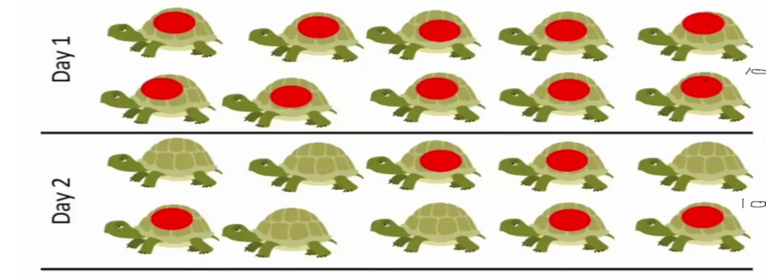

a) Identify the sampling method illustrated. (1 mark)
…………………………………………………………………………………
b) Describe how the sampling method above was used to estimate the population of organisms (4 marks)
………………………………………………………………………………………………………………………………………………………………………………………………………………………………………………………………………………………………………………………………………………………………………………………………………………………………………………………………………………………………………………………………………………………………………………………………………………………………………………………………………………………………………………………………………………………………………………………………
c) Give any two assumptions that would be made when estimating the population the named organism in (a) above (2 marks)
………………………………………………………………………………………………………………………………………………………………………………………………………………………………………………………………………………………………………………………………………………………………………………………………………………………………………………………………………………………………………………………………………………………………………………………………………………………………………………………………………………………………………………………………………………………………………………………………
d) Differentiate between the terms; habitat and ecological niche (1 mark)
……………………………………………………………………………………………………………………………………………………………………………………………………………………………………………………………………………………………………………………………………………………
22. Study the food relationship below and answer the questions

Nile perch

Frog Tilapia Gray fish

Mosquito larva

Green algae

a) State the ecosystem from which the above food web was obtained (1 mark)
…………………………………………………………………………………
b) What will be the effect of increased fishing of nile perch on the number of malaria cases.
(2 marks)
………………………………………………………………………………………………………………………………………………………………………………………………………………………………………………………………………………………………………………………………………………………………
c) How is malaria transmitted from infected person to a healthy person (1 mark)
…………………………………………………………………………………………
d) What will be the benefit of controlling malaria in the above ecosystem using biological control (2 marks)
………………………………………………………………………………………………………………………………………………………………………………………………………………………………………………………………………………………………………………………………………………………………………………………………………………………………………………………

