NAME _________________________________________ SCHOOL ____________________
INDEX NO_______________________CANDIDATE’S SIGNATURE __________________
DATE ______________________
231/3

BIOLOGY
PRACTICAL

Paper 3
Time: 1 ¾ hours.
August 2022

ARISE AND SHINE EXAMINATION
Kenya Certificate of Secondary Education (K.C.S.E)
TRIAL 1 –TERM 2 AUGUST - 2022

INSTRUCTIONS TO THE CANDIDATES
- Sign and write your Name and index Number in the spaces provided above.
- Answer all the questions in the spaces provided.
- You are required to spend the first 15 minutes off the 1 ¾ hours allowed for this paper reading the whole paper carefully before commencing your work.
- Additional pages must NNOT be inserted.
- Candidates may be penalized for recording irrelevant and incorrect spelling especially of technical terms.
- Candidates should answer all the questions in English.

For Examiner’s Use Only

Question | Maximum Score | Candidate’s Score
1 | 13
2 | 14
3 | 13
Total Score | 40

- You are provided with the specimen labeled M-soaked millet. Grind them using pestle and mortar, add some water to get fine solution label four clean test tubes; A, B, C and D. Put about 4ml of the solution into each of the four test tubes.
(a). To solution in test tube A, add some few drops of iodine. Shake the solution to mix well. Pour some little solution onto a white tile.
(i). Record your observation. (1 mark)
………………………………………………………………………………………………
(ii). Account for your observations in a) (i) above. (1 mark)
……………………………………………………………………………………………….
(b). Into solution in test tube B, add about 2ml of Benedict’s solution. Place it in a boiling water bath.
(i). After about 3 minutes, record your observation. (1 mark)
……………………………………………………………………………………………….
(ii). What is your conclusion from observation in (b) i) above?
……………………………………………………………………………………………….

- For the remaining test tubes;-
(c). To each of test tube C, add about 3ml of solution labeled K. To test tube D and about 3ml of solution K and about 2ml of solution labeled L. Place both test tubes C and D in a water bath. Maintain the water bath at 37ºC. Allow it to stand in the water bath for 30 minutes. After 30 minutes, remove the test tubes. Add about 2ml of Benedict’s solution to each test tube and shake well. Place the two test tubes in a boiling water bath. After about 5 minutes record your observations in the table below. (4 marks)
Test tube | Observation | Conclusion
C
D

d). Account for your observations in the test tubes C and D. (2 marks)
………………………………………………………………………………………………………………………………………………………………………………………………………………………………………………………………………………………………

e). i). Why was set up placed at 37ºC? (1 mark)
……………………………………………………………………………………………
(ii). Suggest identify of solutions K and L. (2 marks)
K ……………………………………………. L ……………………………………….
- You are provided with a piece of animal organ labelled C
(a). Identify the organ. (1 mark)
………………………………………………………………………………………………

(b). Explain why malfunctioning of this organ causes;
(i). Impairment of blood sugar regulation. (2 marks)
………………………………………………………………………………………………………………………………………………………………………………………………
(ii). Impairment of food digestion. (2 marks)
……………………………………………………………………………………………………………………………………………………………………………………………….
(c). Cut specimen C into two equal pieces, immerse one of the pieces in water inside a boiling tube and boil it for five minutes.
Put 10ml of hydrogen peroxide in one boiling tube and label it D1, then put another 10ml of hydrogen peroxide into the other boiling tube and label it D2.
Drop the fresh piece of organ C into D1 and the boiled piece into D2.
(i). Record your observation:
D1 (1 mark)
……………………………………………………………………………………………………………………………………………………………………………………………….
D2 (1 mark)
………………………………………………………………………………………………………………………………………………………………………………………………
(ii). Which homeostatic function of the organ C is being investigated. (1 mark)
………………………………………………………………………………………………………………………………………………………………………………………………
(iii). Account for the observation made in
D1 (2 marks)
………………………………………………………………………………………………………………………………………………………………………………………………
D2 (2 marks)
………………………………………………………………………………………………………………………………………………………………………………………………
(d). Name two diseases that affects organ C. (2 marks)
………………………………………………………………………………………………………………………………………………………………………………………………
3. The photographs below shows bones obtained from different regions of a mammalian body. The photographs are in different views.
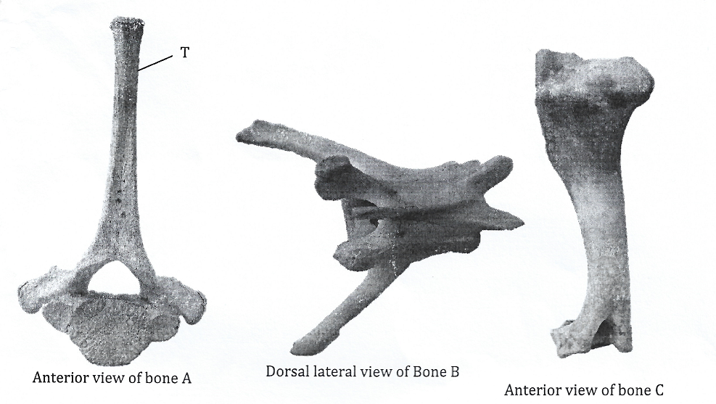
(a). Identify the bones. (3 marks)
A …………………………………………………………….
B ……………………………………………………………
C ……………………………………………………………
(b). Name the regions from which bone B was obtained from. (1 mark)
……………………………………………………………………………………………………………………………………………………………………………………………….
(c). State two distinguishing features of the bone in photograph labeled B. (2 marks)
………………………………………………………………………………………………………………………………………………………………………………………………………………………………………………………………………………………………………………………………………………………………………………………………………………………………………………………………………………………………
(d). Name the part labelled T in the photograph of bone A and state its significance.
(2 marks)
………………………………………………………………………………………………………………………………………………………………………………………………
(e). With reason state the type of joint formed at the distal and proximal and of specimen C.
(4 marks)
- Distal end …………………………………………………………………………..
Reason ………………………………………………………………………………
(ii). Proximal end …………………………………………………………………………
Reason ………………………………………………………………………………
(f). Name the bone that articulates with the proximal end of the bone in photograph labelled C.
(1 mark)
…………………………………………………………………………………………………….

