NAME _________________________________________INDEX NO_____________________ CANDIDATE’S SIGNATURE __________________DATE _____________________________
231/2

BIOLOGY
Paper 2
Time: hours.
August/September, 2022

ARISE AND SHINE TRIAL EXAMINATION
Kenya Certificate of Secondary Education (KCSE)

Instructions to the Candidates
- Write your name and index number in the spaces provided above.
- Sign and write the date of examination in the spaces provided above..
- This paper consists of TWO sections A and B
- Answer ALL questions in section A in the spaces provided.
- In section B answer question 6 (compulsory) and either question 7 or 8 in the spaces provided after question 8.
- This paper consists of 11 printed pages.
- Candidates should check the question paper to ascertain that all the pages are printed as indicated and that no questions are missing.
- Candidates should answer the questions in English.

For Examiner’s Use Only

Section | Question | Maximum score | Candidate’s Score
A | 1  2  3  4  5 | 8  8  8  8  8
B | 6  7  8 | 20  20  20
 | TOTAL | 80

SECTION A – (40 MARKS)
Answer All Questions In This Section In The Spaces Provided.

- (a)What is meant by the term sex linkage? (1 mark)
………………………………………………………………………………………………………………………………………………………………………………………………
(b) Name two sex-linked traits in humans (2 marks)
……………………………………………………………………………………………………………………………………………………………………………………………….
(c) In Drosphilamelanogaster, the inheritance of eye colour is sex-linked. The gene for the red eye is dominant. A cross was made between a homozygous red-eyed female and a white eyed male. Work out the phenotypic ratio of F1 generation. (Use R to represent the gene for the red eyes) (5 marks)

- A response exhibited by a certain plant tendril is illustrated below.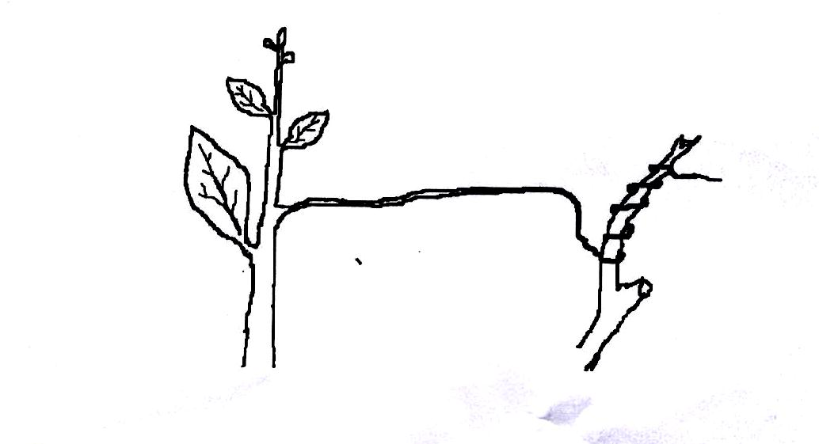
- (i) Name the type of response. (1 mark)
………………………………………………………………………………………..
(ii) Explain how the response named in (a) (i) above occurs. (3 marks)
………………………………………………………………………………………………………………………………………………………………………………………………………………………………………………………………………………
- What is the importance of tactic response to microscopic plants? (1 mark)
………………………………..……………………………………………………………………………………………………………………………………………………...
- State three applications of plant hormones in Agriculture. (3 marks)
………………………………………………………………………………………………………………………………………………………………………………………………………………………………………………………………………………

- The diagram below represents a simple respiratory pathway in cells
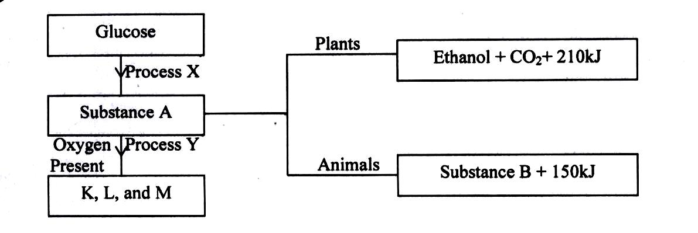

- Name the process marked X and Y. (2 marks)
X ……………………………………………………………………………….……….
Y ………………………………………………………………………………………..
- State two differences between process X and Y. (2 marks)
……………………………………………………………………………………………………………………………………………………………………………………

- State the name of substance B and condition under which it is formed. (2 marks)
……………………………………………………………………………………………………………………………………………………………………………………

- Explain how body size affects the rate of respiration in animals. (2 marks)
………………………………………………………………………………………………………………………………………………………………………………………………………………………………….……………………………………………

- The diagram below represents a setup to investigate the conditions necessary for seed germination. The setup was left for 5 days.
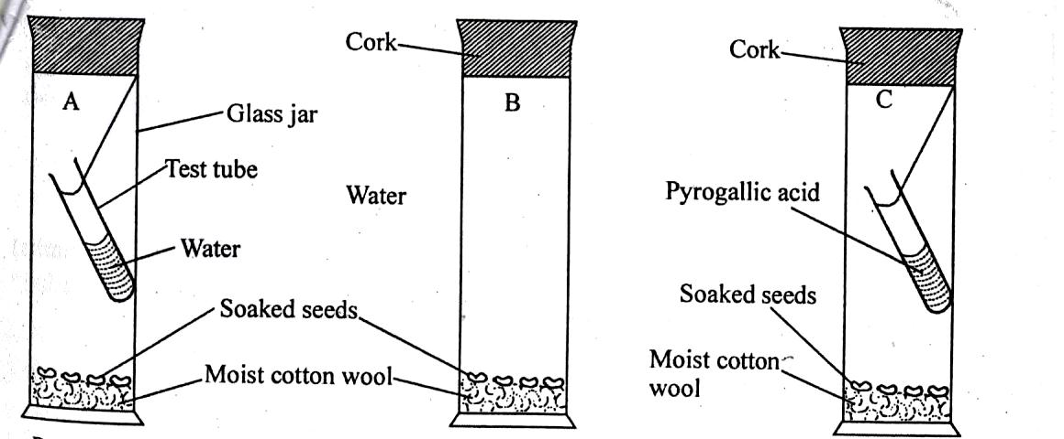

- What conditions were being investigated in the experiment? (2 marks)
……………………………………………………………………………………………………………………………………………………………………………………
- Explain the role of water during seed germination. (3 marks)
………………………………………………………………………………………………………………………………………………………………………………………………………………………………………………………………………………
- Account for the expected results in each setup after 5 days. (3 marks)
…………………………………………………………………………………………………………………………………………………………………………………………………………………………………………………………………………………………………………………………………………………………………………
- Examine the diagram below and use it to answer the questions that follow.
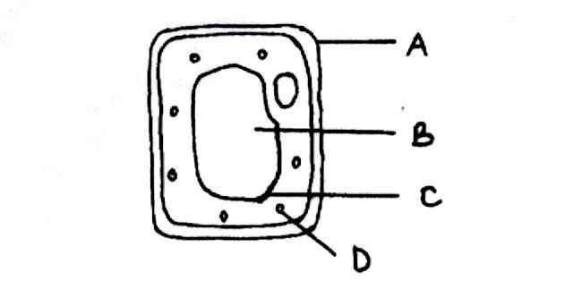
- Name the parts labeled. (3 marks)
B…………………………………………………………………………………….…
C……………………………………………………………………………………….
D………………………………………………………………………………………..

- What is the substance that makes up part labeled A? (1 mark)
…………………………………………………………………………………………
- Name the process by which mineral salts move into structure B. (1 mark)
………………………………………………………………………………………….
- Explain what happens when a red blood cell is put in distilled water. (3 marks)
..……………………………………………………………………………………………………………………………………………………………………………………………………………………………………………………………………………………………………………………………………………………………………………………………

SECTION B – 40 MARKS
Answer question 6(compulsory) and either question 7 or 8 in the spaces provided.

- The data below shows the rate of photosynthesis at different temperature in attached leaves of three East African plants. (Crotolarie, Gynandropsis and Amaranthus species) respectively which were grown outside with the same condition while water and carbon (iv) oxide are not limiting factors in this experiment.

Rate of photosynthesis was expressed in terms of carbon (IV) oxide uptake in mg/mm²/hr at varius temperatures as tabulated below.
Temperature ⁰C | Rate of Photosynthesis (mg/mm²/hr)
 | Gynadropsis sp | Crotolasis sp | Amaranthus sp
5  10  15  20  25  30  35  40  45  50 | -  22  50  60  80  85  80  73  66  2 | 20  40  49  64  48  45  42  31  15  - | -  10  27  42  55  54  50  45  40  11

- Represent the results graphically (rate of photosynthesis against temperature)
- Using the graph in (a) above indicate optimum temperature for the Gynandaropsis and Amaranthus species (2 marks)
- Gynandaropsis ………………………………………………………………………
- Amaranthus………………………………………………………………………….
- Give a reason why Gynandaropsis and Aaranthus could not function photosynthetically at 5ºC. (1 mark)
…………………………………………………………………………………………...
- What are the possible ecological habitats for the following plants (2 marks)
- Amaranthus………………………………………………………………………….
- Crotolaria…………………………………………………………………………….
- At what temperature was the amount of carbon (IV) oxide around the leaf of Gynandaropsis highest? (1 mark)
…………………………………………………………………………………………...
- What raw material required in the light stage of photosynthesis. (1 mark)
…………………………………………………………………………………………...
- Name the parts of chloroplasts in which the following stages of photosynthesis take place. (2 marks)
- Light stage
…………………………………………………………………………………………...
- Dark stage
…………………………………………………………………………………………...
- State one structural similarity and difference between chloroplast and mitochondria. (2 marks)
Similarity
…………………………………………………………………………………………...
Difference
…………………………………………………………………………………………...
- What is the compensation of photosynthesis? (1 mark)
…………………………………………………………………………………………………………………………………………………………………………………....
- (a) Explain the role of mammalian skin in thermoregulation. (10 marks)
(b) Describe how the alveolus is adapted to perform its functions. (10 marks)

- (a) Discuss the evidence of organic evolution. (10 marks)
(b) Describe how the xerophytes are adapted to their habitat. (10 marks)
………………………………………………………………………………………………………………………………………………………………………………………………………………………………………………………………………………………………………………………………………………………………………………………………………………………………………………………………………………………………………………………………………………………………………………………………………………………………………………………………………………………………………………………………………………………………………………………………………………………………………………………………………………………………………………………………………………………………………………………………………………………………………………………………………………………………………………………………………………………………………………………………………………………………………………………………………………………………
………………………………………………………………………………………………………………………………………………………………………………………………………………………………………………………………………………………………………………………………………………………………………………………………………………………………………………………………………………………………………………………………………………………………………………………………………………………………………………
………………………………………………………………………………………………………………………………………………………………………………………………………………………………………………………………………………………………………………………………………………………………………………………………………………………………………………………………………………………………………………………………………………………………………………………………………………………………………………
………………………………………………………………………………………………………………………………………………………………………………………………………………………………………………………………………………………………………………………………………………………………………………………………………………………………………………………………………………………………………………………………………………………………………………………………………………………………………………
………………………………………………………………………………………………………………………………………………………………………………………………………………………………………………………………………………………………………………………………………………………………………………………………………………………………………………………………………………………………………………………………………………………………………………………………………………………………………………
………………………………………………………………………………………………………………………………………………………………………………………………………………………………………………………………………………………………………………………………………………………………………………………………………………………………………………………………………………………………………………………………………………………………………………………………………………………………………………
………………………………………………………………………………………………………………………………………………………………………………………………………………………………………………………………………………………………………………………………………………………………………………………………………………………………………………………………………………………………………………………………………………………………………………………………………………………………………………
………………………………………………………………………………………………………………………………………………………………………………………………………………………………………………………………………………………………………………………………………………………………………………………………………………………………………………………………………………………………………………………………………………………………………………………………………………………………………………
………………………………………………………………………………………………………………………………………………………………………………………………………………………………………………………………………………………………………………………………………………………………………………………………………………………………………………………………………………………………………………………………………………………………………………………………………………………………………………
………………………………………………………………………………………………………………………………………………………………………………………………………………………………………………………………………………………………………………………………………………………………………………………………………………………………………………………………………………………………………………………………………………………………………………………………………………………………………………
………………………………………………………………………………………………………………………………………………………………………………………………………………………………………………………………………………………………………………………………………………………………………………………………………………………………………………………………………………………………………………………………………………………………………………………………………………………………………………
………………………………………………………………………………………………………………………………………………………………………………………………………………………………………………………………………………………………………………………………………………………………………………………………………………………………………………………………………………………………………………………………………………………………………………………………………………………………………………
………………………………………………………………………………………………………………………………………………………………………………………………………………………………………………………………………………………………………………………………………………………………………………………………………………………………………………………………………………………………………………………………………………………………………………………………………………………………………………
………………………………………………………………………………………………………………………………………………………………………………………………………………………………………………………………………………………………………………………………………………………………………………………………………………………………………………………………………………………………………………………………………………………………………………………………………………………………………………
………………………………………………………………………………………………………………………………………………………………………………………………………………………………………………………………………………………………………………………………………………………………………………………………………………………………………………………………………………………………………………………………………………………………………………………………………………………………………………
………………………………………………………………………………………………………………………………………………………………………………………………………………………………………………………………………………………………………………………………………………………………………………………………………………………………………………………………………………………………………………………………………………………………………………………………………………………………………………
………………………………………………………………………………………………………………………………………………………………………………………………………………………………………………………………………………………………………………………………………………………………………………………………………………………………………………………………………………………………………………………………………………………………………………………………………………………………………………
………………………………………………………………………………………………………………………………………………………………………………………………………………………………………………………………………………………………………………………………………………………………………………………………………………………………………………………………………………………………………………………………………………………………………………………………………………………………………………
………………………………………………………………………………………………………………………………………………………………………………………………………………………………………………………………………………………………………………………………………………………………………………………………………………………………………………………………………………………………………………………………………………………………………………………………………………………………………………
………………………………………………………………………………………………………………………………………………………………………………………………………………………………………………………………………………………………………………………………………………………………………………………………………………………………………………………………………………………………………………………………………………………………………………………………………………………………………………
………………………………………………………………………………………………………………………………………………………………………………………………………………………………………………………………………………………………………………………………………………………………………………………………………………………………………………………………………………………………………………………………………………………………………………………………………………………………………………………………………………………………………………………………………………………………………………………………………………………………………………………………………………………………………………………………………………………………………………………………………………………………………………………………………………………………………………………………………………………………………………………………………………………………………………………………………………………………………………………………………………………………………………………………………

