BIOLOGY - Paper 2 - MARKING SCHEME
TRIAL 1 2022 – SEPTEMBER

SECTION A – (40 MARKS)
Answer All Questions In This Section In The Spaces Provided.
- (a) What is meant by the term sex linkage? (1 mark)
Genes are located on the sex chromosomes; they are transmitted along with those determining sex;
(b) Name two sex-linked traits in humans (2marks)
- Colour blindness;
- Haemophilia;
- Hairy pinna/nose;
- (premature)Baldness; Any 2X1=2 marks
(c) In Drosphilamelanogaster, the inheritance of eye colour is sex-linked. The gene for the red eye is dominant. A cross was made between a homozygous red-eyed female and a white eyed male. Work out the phenotypic ratio of F1 generation.
(Use R to represent the gene for the red eyes) (5 marks)
Parental Homozygous White eyed
Phenotype red eyed female male

Parental X^{R}X^{R} X X^{r} Y
Genotype
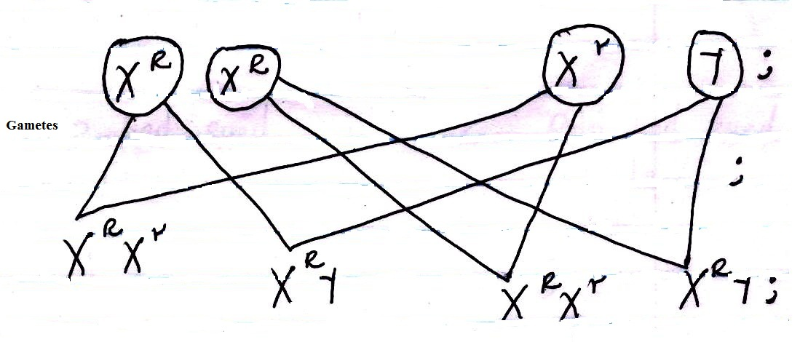
Phenotypic : 2 Red eyed : 2 Red eyed
Ratio Male Female

= 2 : 2

1 : 1

1 red eyed male:1 red eye female
NB: For a candidate to score, the phenotypic ratio should be; the phenotype must be stated, not the ratio only.
Using a punnet square:
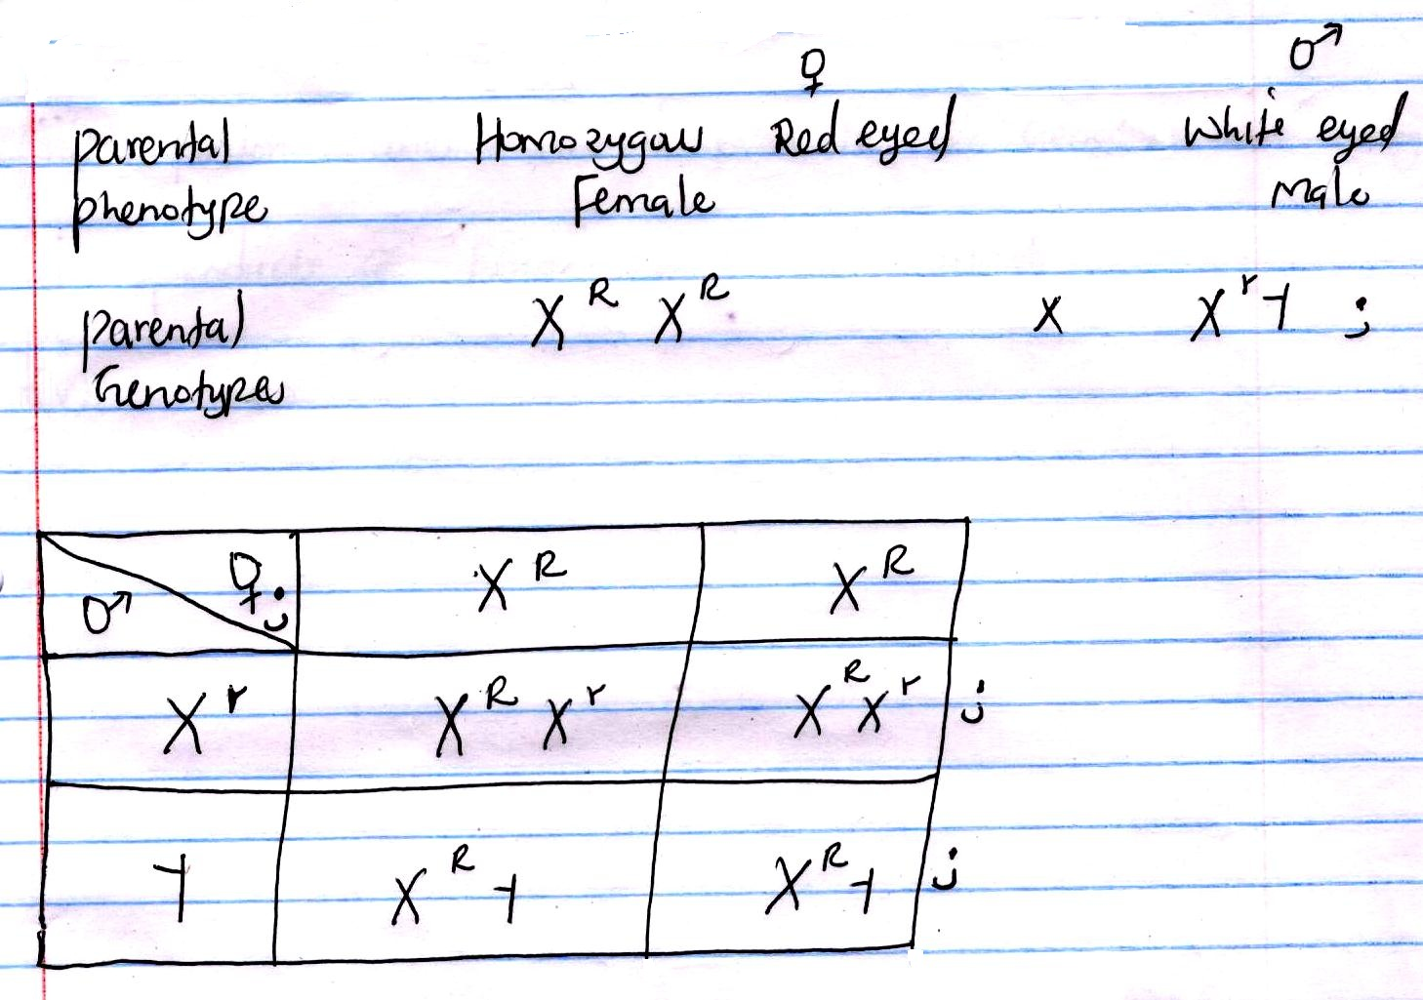
Phenotypic = 2 red eyed : 2 red eyed
Ratio female male

= 1 : 1 ;

Marks are awarded as follows:
= for correct Genotypes with a cross

For correct gametes - with full complete circle
- The fusion lines should not hang nor penetrate the circle.

In punnet square, marks are awarded for:-
- Correct Genotypes - with a cross
- Gametes
- Fusion lines – scored even if the Genotypes are wrong.
- Products of Fusion - which are correct.
- Ratio

- A response exhibited by a certain plant tendril is illustrated below.
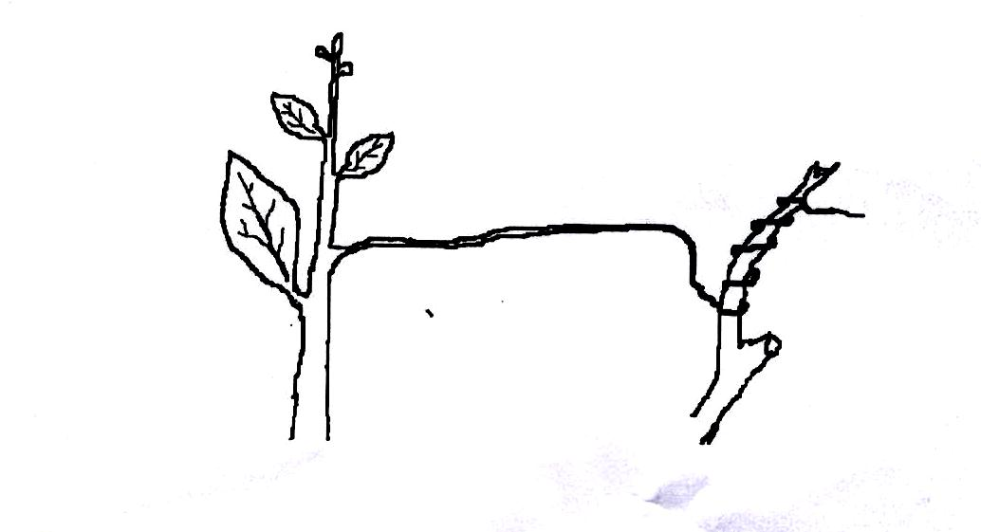
- (i) Name the type of response. (1 mark)
Thigmotropism;/ Haptotropism; Rej. Thigmotrophism/ Haptotrophism
(ii) Explain how the response named in (a)(i)above occurs. (3 marks)
Contact with support;
- Cause migration of auxins to outer side; causing faster growth /cell elongation on the on the side away from contact surface; (causing tendrils to curl around support)
- What is the importance of tactic response to microscopic plants? (1 mark)
- Escape injuries stimuli;/ seek favorable habitat;

- State three applications of plant hormones in Agriculture. (3 marks)
- Induce root growth in the stem cutting;
- Selective weed killer;
- Encourage sprouting of side branches;
- Induces parthenocarpy;
- Promote flowering;
- Accelerate ripening of fruits;
- Induces/encourages fruit fall/abscission;

- The diagram below represents a simple respiratory pathway in cells
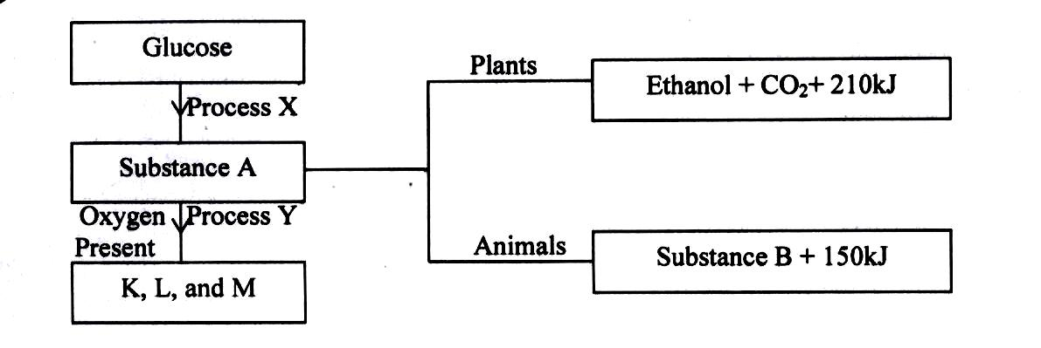
- Name the process marked X and Y. (2 marks)
X - Glycolysis
Y - Kreb`s cycle

- State two differences between process X and Y. (2 marks)
Process X Process Y
- Occurs in cytoplasm - Occurs in mitochondria
- Independent of oxygen - Oxygen dependent
- Produce less energy - Produce more energy
- Raw material is glucose - Raw material is pyruvate
- End products are energy, - End products are energy,
carbon (iv) oxide, lactic carbon (iv) oxide and
acid or ethanol. water.

- State the name of substance B and condition under which it is formed. (2 marks)
Lactic acid; under anaerobic conditions.
- Explain how body size affects the rate of respiration in animals. (2 marks)
Smallbody size leads to a large surface area to volume ratio; hence more loss of heat to the environment; leading to increased rate of respiration to replace the lost heat;

- The diagram below represents a setup to investigate the conditions necessary for seed germination. The setup was left for 5 days.
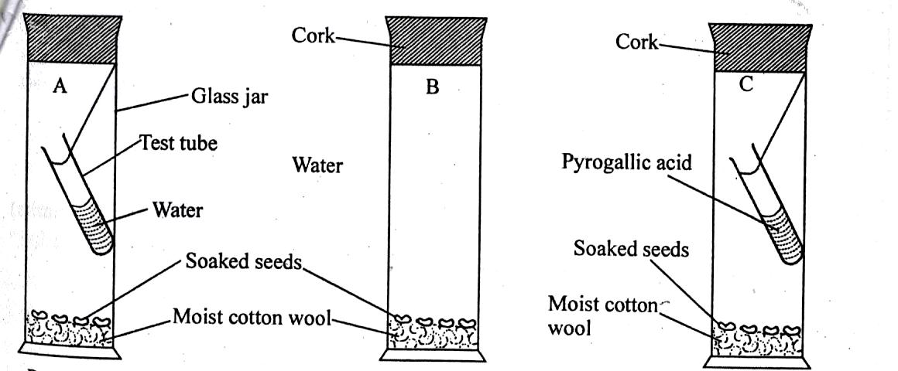
- What conditions were being investigated in the experiment? (2 marks)
Optimum temperatures; and oxygen; are necessary for germination.
- Explain the role of water during seed germination. (3 marks)
Activate enzymes involved in germination; breaking seed dormancy; hydrolyses food; dissolves food (material); softens seed testa; (any 3)
- Account for the expected results in each setup after 5 days. (3 marks)
A: There was germination- since all conditions necessary for germination were present
B: No germination- low temperature inactivate the enzymes
C: No germination –absence of oxygen
(Observation tied to explanation).

- Examine the diagram below and use it to answer the questions that follow.
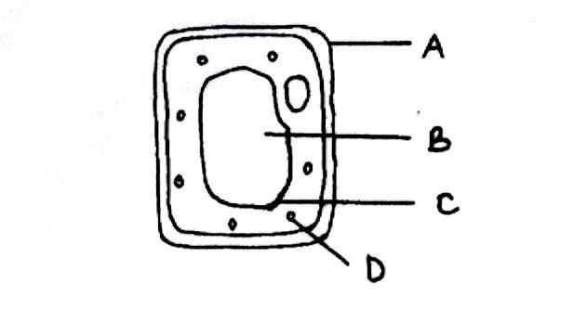
- Name the parts labeled. (3 marks)
B - Sap vacuole/cell vacuole/vacuole
C - Tonoplast
D - Chloroplast
- What is the substance that makes up part labeled A? (1 mark)
Cellulose
- Name the process by which mineral salts move into structure B. (1 mark)
Active transport
- Explain what happens when a red blood cell is put in distilled water. (3 marks)
The cell sap is hypertonic to distilled water; hence water molecules move into the cell by osmosis; making it swell and eventually burst/get haemolysed;

SECTION B (60 MARKS)

- The data below shows the rate of photosynthesis at different temperature in attached leaves of three East African plants. (Crotolarie, Gynandropsis and Amaranthus species) respectively which were grown outside with the same illustration while water and carbon (iv)oxide are not limiting factors in this experiment.

Rate of photosynthesis was expressed in terms of carbon (IV) oxide uptake in mg/mm²/hr at various temperatures as tabulated below.
Temperature ⁰C | Rate of Photosynthesis (mg/mm²/hr)
 | Gynadropsis sp | Crotolasis sp | Amaranthus sp
5  10  15  20  25  30  35  40  45  50 | -  22  50  60  80  85  80  73  66  2 | 20  40  49  64  48  45  42  31  15  - | -  10  27  42  55  54  50  45  40  11

- Represent the results graphically (rate of photosynthesis against temperature)
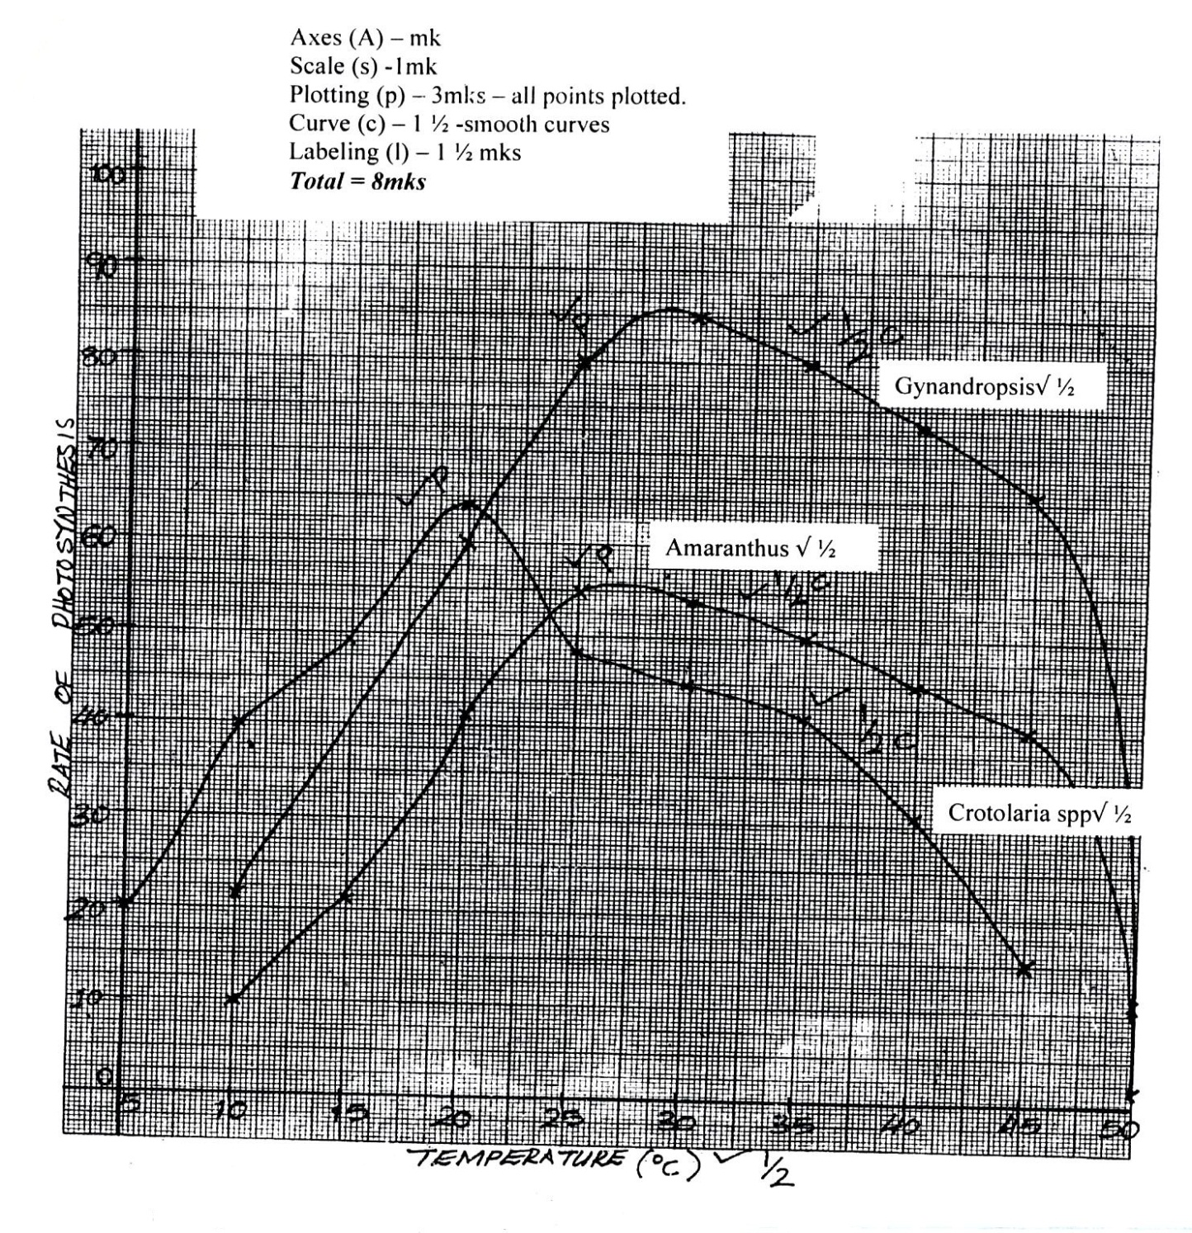
- Using the graph in (a) above indicate optimum temperature for the Gynandropsis and Amaranthus species (2 marks)
Gynandropsis - opt to = 30 ⁰C
Amaranthus - opt to = 25 ⁰C
- Give a reason why Gynandaropsis and Aaranthus could not function photosynthetically at 5ºC. (1 mark)
At 5 ⁰C, the enzymes that catalyze the process of photosynthesis are inactivated.
- What are the possible ecological habitats for the following plants? (2 marks)
- Amaranthus - Terrestrial;
- Crotolaria - Terrestrial;
- At what temperature was the amount of carbon (IV) oxide around the leaf of Gynandaropsis highest? (1 mark)
- 50 ⁰C
- What raw material is required in the light stage of photosynthesis? (1 mark)
Water
- Name the parts of chloroplasts in which the following stages of photosynthesis take place. (2 marks)
(i)Light stage - Granum;
(ii)Dark stage - Stroma;
- State one structural similarity and difference between chloroplast and mitochondria. (2 marks)
Similarities
- Both have double membrane;
- Both have fluid filled matrix;
Differences
- Inner membrane of mitochondrion is folded to form cristae while inner membrane of chloroplast is smooth;
- Chloroplast is biconcave shaped while mitochondria is oval / sausage shaped;
- What is the compensation of photosynthesis? (1 mark)
_____________________________
- (a) Explain the role of mammalian skin in thermoregulation. (10 marks)
When it is hot
- Sweat glands are more stimulated to release more sweat; more sweat/ water in sweat evaporates taking away excess heat; Bringing cooling to the body
When it is cold
- Sweat glands are less stimulated to release less sweat; less sweat evaporates taking away less heat; helping to conserve heat in the body.
When it is hot
- Blood vessels /arterioles reject blood capillaries / veins / arteries dilate / vasodilate; more heat is lost by radiation and convection.
When it is cold
- Blood vessels / arterioles vasoconstrict / constrict; less blood flow near the skin surface; less heat is lost by radiation and convection.
When it is cold
- Erecti pili muscles contract; making the hairs to stand upright / erect on the skin surface; increasing insulatory layer / insulation against heat loss; less heat is lost.
When it is hot
- Erecti pili muscles relax; the hairs lies flat; trapping less hair in between the hairs; reducing insulation; more heat is lost.

(b) Describe how the alveolus is adapted to perform its functions. (10 marks)
- Highly vascularized / highly supplied with bloob capillaries/ has a dense network of blood capillaries / blood; increasing surface area ; and creating a steep concentration gradient; for rapid diffusion of oxygen and carbon (IV) oxide.
- Moist lining; to allow oxygen and carbon (IV) oxide to dissolve in it;
- Have a large surface area; for rapid diffusion of oxygen and carbon (IV) oxide;
- Has one cell thick membrane / one cell thick/ thin epithelium / epithelial layer of cells; to shorten the distance; for rapid diffusion of oxygen and carbon (IV) oxide.
11 Max 10

- (a) Discuss the evidence of organic evolution. (10 marks)
- Fossil records; fossils are the remains of organisms preserved in naturally occurring materials for many years; They show morphological changes of organisms over a long period of time,.e.g skull of man, legs of horse.
- Comparative anatomy; members of the same phylum show similarities / organisms of the same phylum have similar structures performing same function; e.g digestive, urinary, circulatory, nervous systems.
- The pentadactyl limbs (of vertebrates) are an example of homologous structures; which have some embryonic origin but perform different functions, e.g. forelimbs of a bird and that of a mammal; They thus show divergent evolution.
- There are analogous structures; which have different embryonic origin but perform similar functions; eg. Wings of birds and wings of insects, eyes of octopus and eyes of humans (and any other correct example); they thus show convergent evolution.
- Comparative embryology; vertebrate embryos are morphologically similar; suggesting that the organisms have common ancestry/origin;
- Cell biology/cytology; occurrence of similar organelles such as mitochondria, ribosomes, golgi apparatus in cells of different organisms; suggests that the organisms have common ancestry/origin;
- Comparative serology; some organisms have similar blood groups, Rhesus factor, DNA, Nucleic acids and show similar antigen-antibody reactions; suggesting that they have a common ancestry;
- Geographical distribution; present present continents are thought to have been a large land mass occurring as a single unit; due to continental drift; isolation of organisms occurred resulting in different patterns of their evolution; This is the reason why Ilamas of S. America resemble Camels of Africa, long tailed monkey of S. America resemble short tailed monkeys of Africa, Jaguars of S. America resemble cheetah of Africa, Kangaroos are only found in Australia;
NB: Stating the evidence – 1 mark
1 Explaining correctly – 1 mark

(b) Describe how the xerophytes are adapted to their habitat. (10mks)
- Their leaves are modified into spines/thorn like structures; to reduce surface area exposed for transpirations.
- Their stomata are sunken; water vapour accumulate in sunken pits/depression; lowering water vapour concentration gradients between sub-stomatal air spaces in leaves and atmospheric air; reducing the rate of transpiration; leaves are covered with thick waxy cuticle; to reduce cuticular transpiration; since waxy cuticle is less permeable to water; allowing for reduced rate of transpiration. The number of stomata is minimal/fewer on upper surface of leaf; to reduce stomatal transpiration; more on lower surface to shelter away from direct sunlight; small stomatal apertures, reducing rate of transpiration.
- Plants are deeprooted; so that the roots can reach and absorb water in deep layers of soil; they have parenchyma cells (in stem and leaves) for storage of water when it is inadequate supply for use during drought.
- Have succulent leaves and stem which contain parenchyma cells for storage of water.
- Some have hairy leaves, that trap water vapour in between the spines/hairs to reduce saturation deficit; to reduce water loss; xerophytes have superficial roots; which grow extensively close to to surface of soil; enabling them to absorb maximum water after a short shower.
- Shiny cuticle to reflect light rays from the sun to prevent overheating/prevent raising internal temperature; reduced internal temperature of the leaf reducing rate of transpiration.

