NAME________________________________________INDEX NO ___________________
SCHOOL__________________________ CANDIDATE’S SIGN ____________________ DATE _____________________

231/1

BIOLOGY
Paper 1
Time: 2 Hours.

ARISE AND SHINE EXAMINATION
Kenya Certificate of Secondary Education (K.C.S.E)
TRIAL 1 –TERM 2 AUGUST - 2022

Instructions
- Write your name, Index Number and School in the spaces provided above.
- Sign and write the date of the examination in the spaces provided above.
- Answer all the questions in the spaces provided.
- Additional pages must not be inserted.
- Check the question paper to ascertain that all the pages are printed and that no questions are missing.

FOR EXAMINER’S USE ONLY
Question | Maximum Score | Candidate’s Score
1-25 | 80

- (a). State the meaning of the following terms. (1mark)

(i). Science -
…………………………………………………………………………………………………………………………………………………………………………………….

(ii). Biology- (1 mark)
…………………………………………………………………………………………………………………………………………………………………………………….

(b) Explain the following braches of biology. (3 mark)

(i). Zoology -
…………………………………………………………………………………………………………………………………………………………………………………….

(ii). Entomology -
…………………………………………………………………………………………………………………………………………………………………………………….

(iii). Morphology –

…………………………………………………………………………………………………………………………………………………………………………………….

- The diagram below illustrates a process in an organism of a given species

- Identify the process taking place in the organism above. (1 mark)
………………………………………………………………………………………………State two economic importance of the organism above. (2 mark)
………………………………………………………………………………………………………………………………………………………………………………………………

- HIV/AIDS is a major killer disease with no known treatment. Anti-Retroviral drugs are used to manage it.

(a). What is the role of anti-Retroviral drugs in HIV/AIDS management. (1 mark)
…………………………………………………………………………………………………………………………………………………………………………………….
…………………………………………………………………………………………..
(b). Suggest two ways of controlling the spread of HIV/AIDS. (2 marks)
…………………………………………………………………………………………………………………………………………………………………………………….

- Name two bones that articulate to form a ball and socket joint at the hip. (2 marks)
…………………………………………………………………………………………………………………………………………………………………………………….

- The figures below illustrates specialized cells in an animal’s body.

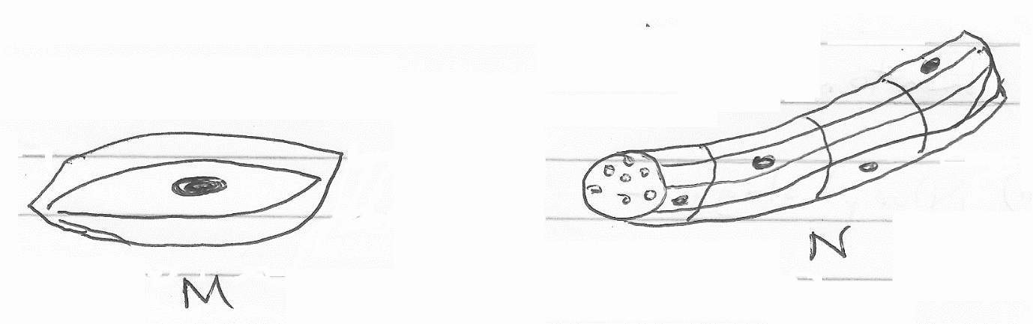

(i). Identify the cells M and N. (2 marks)
M –

N –

(ii). State the structural differences between M and N. (2 marks)
…………………………………………………………………………………………………
…………………………………………………………………………………………………
…………………………………………………………………………………………………

(iii). Which of the above specialized cells is found in the gut. (1 mark)
…………………………………………………………………………………………………
…………………………………………………………………………………………………

6. Explain why tracheids are not efficient in transporting water up the plant. (2 marks)
…………………………………………………………………………………………………
…………………………………………………………………………………………………
…………………………………………………………………………………………………

7. Insect’s blood is noted to lack a respiratory pigment. Explain. (2 marks)
…………………………………………………………………………………………………
…………………………………………………………………………………………………
…………………………………………………………………………………………………

- Give two destinations of food translocated from the leaves of plants. (2 marks)
………………………………………………………………………………………………
………………………………………………………………………………………………
- Name the organelle that is likely to be found in abundance in
- An enzyme secreting cell. (1 mark)
………………………………………………………………………………………………
b). Cell producing lipid related secretions (1 mark)
………………………………………………………………………………………………

- A form one student trying to estimate the size of onion cells observed the following on the microscope field of view. (2 marks)

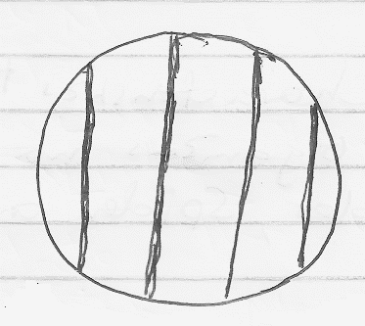

If the student counted 20 cells across the field of view. Calculate the size of one cell in micrometers. (3 marks)
................................................................................................................................................................................................................................................................................................................................................................................................................................................................................................................................................................................................
11.a). Name the cells that secrete mucus in the human alimentary canal (1 mark)
…………………………………………………………………………………………………..
(b). Explain the role of hydrochloric acid in protein digestion in the stomach of mammals.
(2 marks)
………………………………………………………………………………………………………………………………………………………………………………………………
……………………………………………………………………………………………..
- Assume you are a nutritionist, name the kind of vitamins you would recommend to patients with the following conditions
(a). Poor night vision. (1 mark)
……………………………………………………………………………………………..

(b). Bleeding gums (1 mark)
……………………………………………………………………………………………..

(c). Excessive bleeding after an injury. (1 mark)
……………………………………………………………………………………………..

- State the characteristics that distinguish the following organisms into their respective classes,millipedes,spider and Tsetsefly (3 marks)
………………………………………………………………………………………………………………………………………………………………………………………………
………………………………………………………………………………………………
- Name two classes of phylum Arthropoda with cephalothorax (2 marks)
………………………………………………………………………………………………………………………………………………………………………………………………
- (a). Name the main group of organisms which comprises the kingdom monera.
(1 mark)
………………………………………………………………………………………………………………………………………………………………………………………………

(b). State any three ways in which the organism; named in (a) above affect human lives.
(3 marks)
……………………………………………………………………………………………………………………………………………………………………………………………………
……………………………………………………………………………………………………………………………………………………………………………………………………

16. (a). The experiment illustrated below was set up to investigate a certain physiological process using a raw Irish potato tuber.
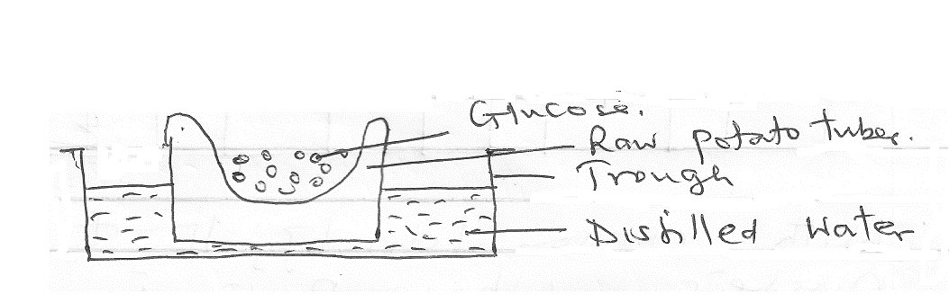

(i). Suggest a possible physiological process that was being investigated. (1 mark)
……………………………………………………………………………………………………………………………………………………………………………………………………
(ii). Explain the results obtained in the above experiment after a few hours. (2 marks)
……………………………………………………………………………………………………………………………………………………………………………………………………
(iii). State the observations that would have been made if the experiment was repeated using boiled potato. (2marks)
……………………………………………………………………………………………………………………………………………………………………………………………………
(b). Explain why growing grass die a few days when salt is sprinkled on it. (3 marks)
……………………………………………………………………………………………………………………………………………………………………………………………………………………………………………………………………………………………………….17.Give an example o a sec-linked trait in human one
(i). Y- chromosome- (1 mark)
………………………………………………………………………………………….
(ii). X-Chromosome- (1 mark)
………………………………………………………………………………………….
18. The diagram below represents a portion of a certain nucleic acid
G A C C A U U C G A

With reason identify the type of nucleic whose portion is shown above
Identify- (1 mark)
………………………………………………………………………………………………….
Reason- (1 mark)
…………………………………………………………………………………………………………………………………………………………………………………………………….19. The diagram below show a pair of homologous chromosomes. Study them and answer the questions that follow.
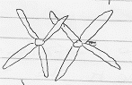

(i). State the genetic significance of the phenomenon. (2 marks)
………………………………………………………………………………………………………………………………………………………………………………………………………………………………………………………………………………………………………
20. The table below shows the percentage composition of carbon (IV) oxide and Oxygen in inhaled and exhaled air. Inhaled air contain oxygen 20% and carbon (IV) oxide 0.04%.
Gas | Inhaled air | Exhaled air
Oxygen | 20% | 17%
Carbon (IV) Oxide | 0.04% | 40%

Explain the differences in the percentage of the two gases in inhaled and exhaled air
(a). Oxygen. (2 marks)
…………………………………………………………………………………………………………………………………………………………………………………………………….

(b). Carbon (IV) oxide. (2 marks)
…………………………………………………………………………………………………………………………………………………………………………………………………….
21. Give the forms in which the following gases are transported in blood. (3 marks)
(a). Oxygen
…………………………………………………………………………………………………
(b). Carbon (IV) Oxide
…………………………………………………………………………………………………
(c). Carbon (II) Oxide
…………………………………………………………………………………………………
22. The following graph represents a growth pattern observed in a group of animals.

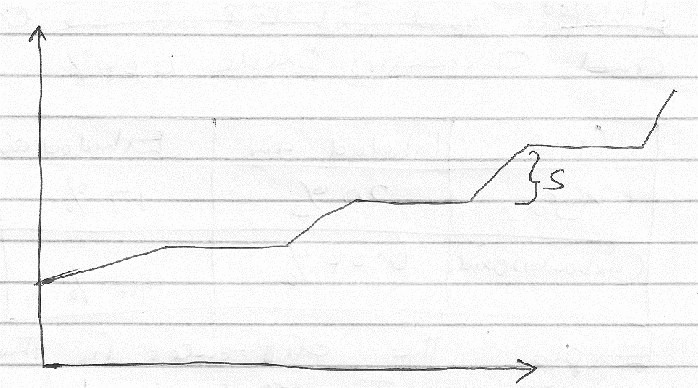
(a). Name the type of growth shown above. (1 mark)
……………………………………………………………………………………………… (b). Name the phylum of animals whose members display the growth pattern named in (a) above. (1 mark)
………………………………………………………………………………………………
(c). Identify the process which lead to increase in body size at part marked S. (1 mark)
………………………………………………………………………………………………
23. The diagram below show a tip of a plant coleoptile with light coming towards it from one direction.
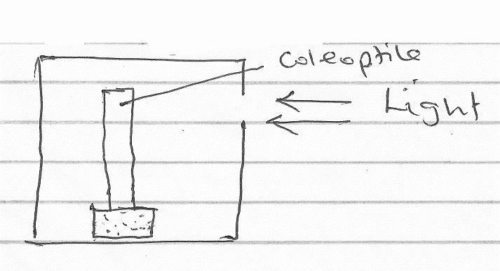
(a). How would the plant respond to light. (1 mark)
………………………………………………………………………………………………
(b). Give the name of such a response. (1 mark)
………………………………………………………………………………………………

(c). What is the advantage of plant responding in this way? (2 marks)
………………………………………………………………………………………………………………………………………………………………………………………………

24. The diagram below illustrates parts of a nephron from a mammalian kidney.

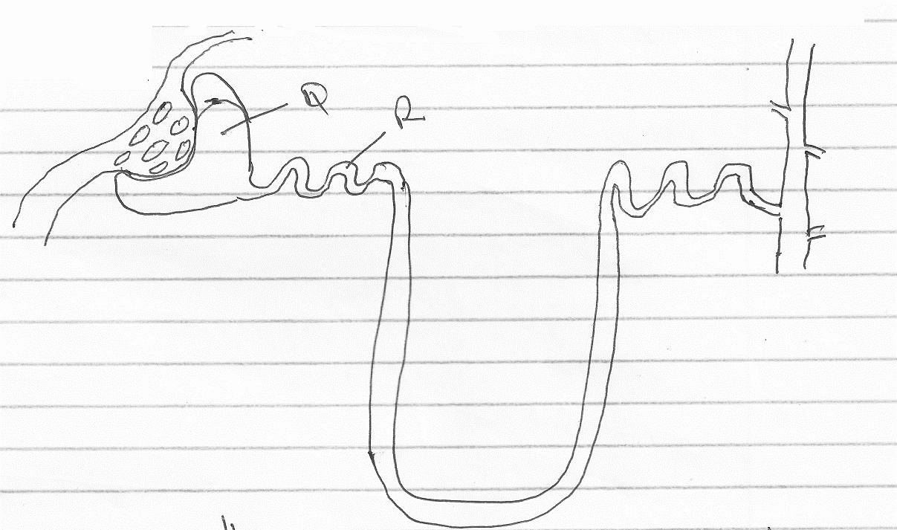

(a). Name the fluid found in part labelled Q. (1 mark)
……………………………………………………………………………………………..

(b). Identify the process that lead to the formation of fluid named in (a) above. (1 mark)
……………………………………………………………………………………………..

(c). Which two hormones exert their effect in the nephron? (2 marks)
………………………………………………………………………………………………

25. Name the habitat of the following plants. (2 marks)

(i). Xerophytes –

(ii). Halophytes -

