MINCKS GROUP OF SCHOOLS
FORM FOUR
END OF TERM TWO 2022
BIOLOGY PAPER TWO (PP2)
MARKING SCHEME

SECTION A: 40 MARKS

1.a) Genetics – Branch of biology that deals with the study of inheritance and variation. (1mk)
b) - sex
- ABO blood group
- Toungue rolling
- free or attached earlobe
- Hairs in ear pinna / nose (2mks)

c) parental Genotype Hb^{A}Hb^{A} X Hb^{A} Hb^{s}

Hb^{S}
Hb^{A}
Hb^{A}
Hb^{A}
Gametes

Male / Female | Hb^{A} | Hb^{A}
Hb^{A} | Hb^{A}Hb^{A} | Hb^{A}Hb^{A}
Hb^{s} | Hb^{A}Hb^{s} | Hb^{A}Hb^{s}

Probability of sickle cell trait (Hb^{A}Hb^{s})
$2/4$ = ½; 0.5; 50%; (5mks)

2.a) X – External auditory meatus;
Y – Ear ossicles;
N – Eustachian tube;

b) They are bony/solid and small forming a lever system that amplifies and transmits vibrations to the fenestra ovalis.
They are loosely held by suspensory ligaments which enables them to transmit vibrations;
NB: Mark any one.

c)i) Maintaining body balance / posture;
ii) M; NB: (ii) is tied to (i)

d) Permanent deafness; rej. Deafness alone
lack of balance Mark any one

3.a)i) Epigeal germination; (1mk)
ii) Hypocotyl grows faster pulling the cotyledons above the ground; (1mk)
b) Seed coat; (1mk)

c) -protect the embryo; (1mk)
- food storage; (1mk)

d) Exposure of the curved part to light stimulates migration of auxin to the lower side; higher concentration of auxin on the lower side stimulates faster cell elongation; on the lower side than on the upper side; and this causes P to straighten. (3mks)

4.a) Cell membrane;
b)i) It encloses cell contents;
ii) It selectively allows materials in and out of the cell;

c)i) Centriole;
ii) Take part in formation of cilia and flagella.
- Take part in formation of spindle fibres during cell division

d)- Sensitive to changes in temperature and pH
- Posses electric charges / polarized
- Semi-permeability

5.a) Water; acc moisture
Temperature; acc warmth (2mks)

b) Mobilise / Activate enzymes / hydrolyse stored food / breaking of dormancy;
- softens the testa / seed coat;
- acts as a solvent / medium of transport; (3mks)

c)i) Those in set up A will geminate; (1mk)
ii) Those in set up B will not geminate; (1mk)
iii) Those in set up C will not germinate; (1mk)

SECTION B.

6.a) On graph paper. (7mks)

b)i) Urine 74 cm³ / hr $± 1$
Sweat 14cm³ / hr $±$1 (2mks)

ii) Evaporation (1mk)

iii) An increase in external temperature decreases the amount of urine produced; this is due to increased sweating; which increases osmotic pressure of blood; hence more water is reabsorbed back into the blood stream at the kidney tubules. (4mks)

c) Urea
- Uric acid (3mks)
- Ammonia

d) - Aestivation
- Staying under shaded places. (3mks)
- Borrowing underground.

7.a) pollen grains land and stick onto the stigma; stigma secretes / produces a sticky fluid; that causes pollen grains to adhere onto it.
Sticky secretion also stimulates the pollen grain to germinate; into a pollen tube;
The pollen tube grows into the stigma and protrudes down the style tissues;
The pollen tube denies its nutrition from style tissues
As the tube grows downwards, the tube nucleus occupies the position just behind the tip;
The generative nucleus then enters the tube and divides mitotically; to give a pair of male gamete nuclei; which follow the tube nucleus and the pollen tube grows further doen the style.
On reaching the ovary, the pollen tube enters the ovule through the microphle;
It bursts open;
The vegetative (tube) nucleus disintegrates; leaving a clear passage for the two male gamete nuclei.
One male gamete fuses with the functional egg cell; to form a diploid zygote;
The other fuses with the two polar nuclei; to form a triploid nucleus; called primary endosperm nucleus;

b) Zygote (divides mitotically) and forms the embryo; Embryo differentiates into plumule and radicle; primary endosperm nucleus (divides mitotically) and becomes the endosperm (for food storage);
integuments become the seed coat;
antipodal nuclei and synergids disintegrate;
ovules become seeds;
ovary wall becomes the pericarp;
stigma and style dry up leaving a scar;
corolla dries up;
calyx may dry up or persist;

8.a) Searching for food / mates / shelter, (4mks)
Migration away from unfavourable conditions/ environments;
Escape from predators / enemies;
Colonization of new areas;

b) Vertebral column consists of a series of vertebrae; held together loosely so that its flexible;
Myotomes / muscles; associated with vertebral column contract and relax to produce movement;
The sideways and backwards thrust of the tail and body against water, result in resistance of the water pushing the fish sideways;
Head is inflexible; to maintain the forward thrust;
Body streamlined; to reduce resistance;
Presence of fins; for forward movement / balance in water;
Presence of swim bladder; make fish buoyant;
Scales tip towards the back; provide smooth surface to reduce resistance (friction);
Body covered with mucus making it slippery; hence reducing friction during movement in water.
18 marks, max 16 marks

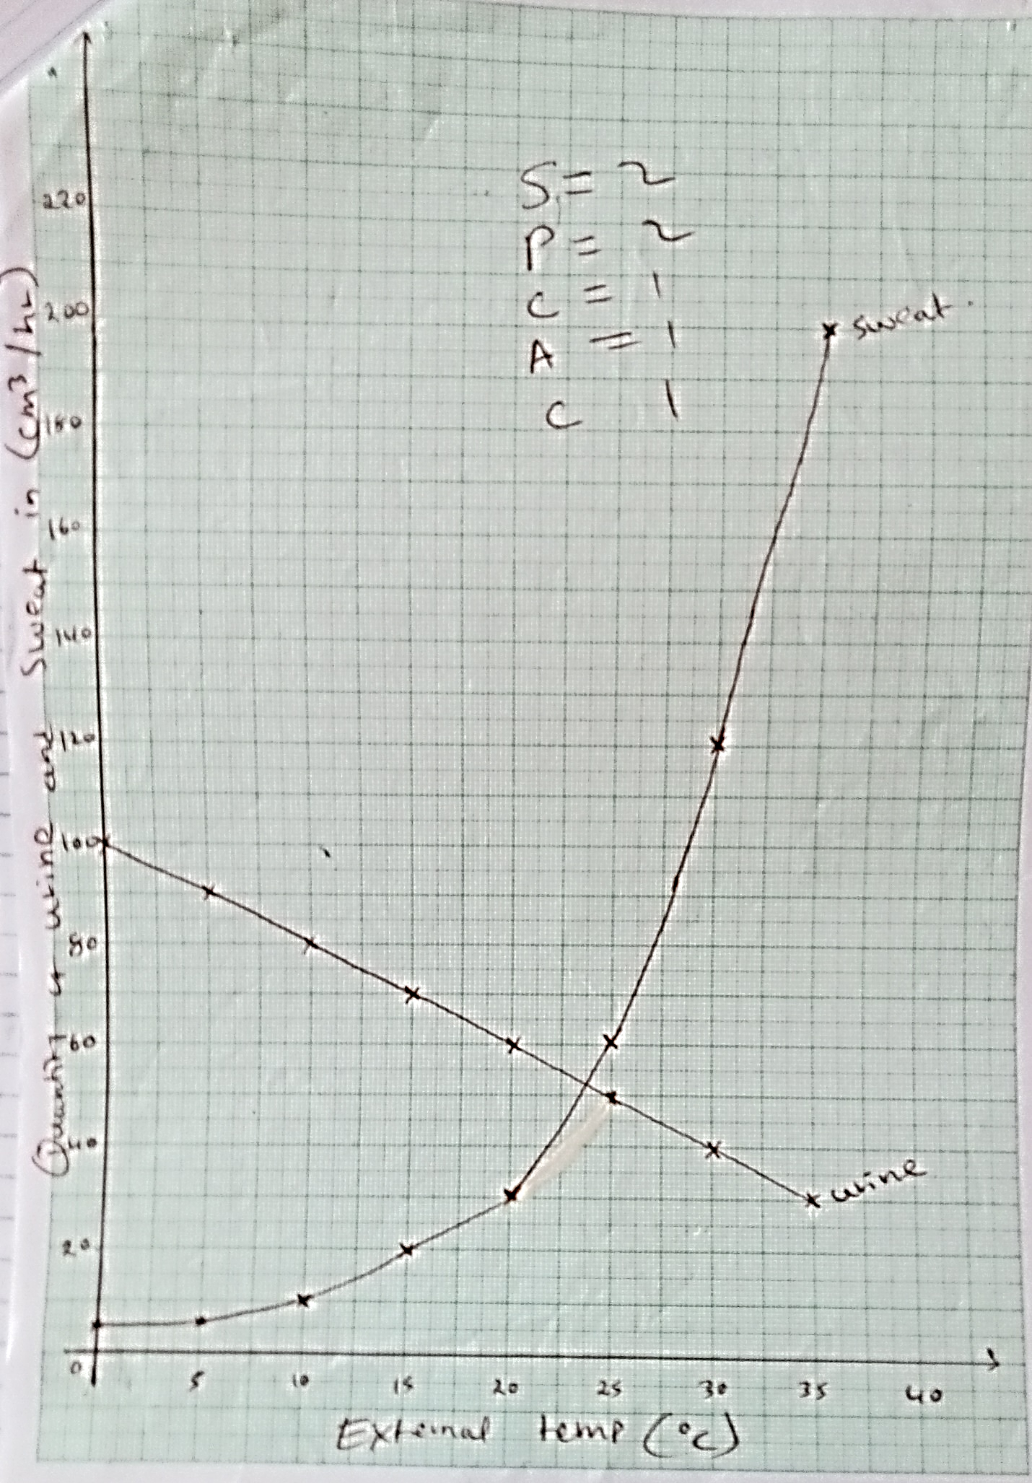
External temp (ºc)

