NAME……………………………………………………….…… INDEX NO.:………………………...
STREAM: .…..…………………………………………………… ADM NO: …………………………
DATE: …………………….………

231/3
BIOLOGY
PAPER 3
(PRACTICAL)
AUGUST-2022
TIME: 1HR 45 MIN

MINCKS GROUP OF SCHOOLS
FORM FOUR EXAM
Kenya Certificate of Secondary Education.(K.C.S.E)

231/3
BIOLOGY
PAPER 3
(PRACTICAL)
AUGUST-2022
TIME: 1HR 45 MIN

INSTRUCTIONS TO CANDIDATES
- Write your name and Adm.No. in the spaces provided.
- Answer all the questions in the spaces provided
- Candidates should check to ascertain that all pages are printed as indicated and that no questions are missing.

FOR EXAMINERS USE ONLY
QUESTION | MAXIMUM SCORE | CANDIDATE’S SCORE
1

2

3

TOTAL | 40

- You are provided with solutions labeled L₁,L₂ and L₃. L₃ is the same as L₂ except that L₃ has been boiled.
Label three test tubes A,B and C. into the test-tube labeled A, add 1ml of solution L₁.
Into the test tube labeled B, add 1ml of L₁ and 1ml of L₂.
Into the test tube labeled C, add 1ml of L₁ and 1ml of L₃.

- Withdraw a drop from test tube A and place in on a white tile. To the drop, add one drop of iodine solution. Record your observation in the table below. (3mks)

Test tube | Observation | conclusion
A

B

C

Repeat the procedure with contents in test-tubes B and C. record your observations in the table. Place the three test tubes labeled A,B and C into a water bath at 37ºC. Ensure that the temperature of the water bath does not fall below 35ºC or exceed 38ºC. Leave the set up for about 30 minutes.

- After 30 minutes, test the contents of each of the test tubes labeled A,B and C following the procedure in (a) above. Record your observations in the table below. (3mks)

Test tube | Observation | conclusion
A

B

C

- Account for the results at the end of the experiment in the test tube labeled:
- B ____________________________________________________________(1mk)
- C ____________________________________________________________ (2mks)
d)i) Suggest the identity of solution L₂. (1mk)
___________________________________________________________________________ ___________________________________________________________________________
ii) Give reasons for your answer in d(i) above. (3mks)
___________________________________________________________________________ ___________________________________________________________________________ ___________________________________________________________________________

e)i) Suggest where the process being investigated in this experiment would take place in:-
an animal _____________________________________________________
a plant _______________________________________________

ii) Give a reason for your answer in e(i) above. (1mk)

___________________________________________________________________________ ___________________________________________________________________________2. You are provided with a piece of petiole of kale, two unknown liquids labeled E₁ and E₂, means of cutting and means of timing.

- Using the blade split the pieces lengthwise into halves and then into quarters.
- Place two of the splits in liquid E₁ and the other two in liquid E₂.
- Allow the set up to stand for 30 minutes

- Record the appearance of the splits placed in:
- Liquid E₁ (1mk)
___________________________________________________________________________ ___________________________________________________________________________
- Liquid E₂ (1mk)
___________________________________________________________________________ ___________________________________________________________________________

- Account for the appearance of the split placed in
- Liquid E₁. (4mks)

- Liquid E₂. (3mks)

- State the importance of the physiological process in the above experiment in plants.(3mks)
___________________________________________________________________________ ___________________________________________________________________________ ___________________________________________________________________________

- The photograph below is specimen from the same animal of two different bones each shown in two views. Examine them.
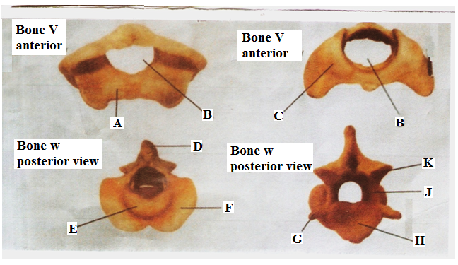
- Identify the two specimens. (2mks)
Specimen V _________________________________________________________
Specimen W _________________________________________________________
- Give four observable differences between bones V and W. (4mks)
____________________________________________________________________________________________________________________________________________________________________________________________________________________________________________________________________________________________________________________________________________________________________________________________________________________________________________________________________________________
- Name the structure that articulated with part labeled A. (1mk)
___________________________________________________________________________
- State two roles of opening labeled B. (2mks)
___________________________________________________________________________ ___________________________________________________________________________ ___________________________________________________________________________
- Name the part labeled E. (1mk)
___________________________________________________________________________
f) State the function of each part labeled H and J on bone W. (2mks)
H _________________________________________________________
J _________________________________________________________
THIS IS THE LAST PRINTED PAGE!

