NAME……………………………………………………….…… INDEX NO.:………………………...
STREAM: .…..…………………………………………………… ADM NO: …………………………
DATE: …………………….………

231/2
BIOLOGY
PAPER 2
(THEORY)
AUGUST-2022
TIME: 2 ½ HOURS

MINCKS GROUP OF SCHOOLS
FORM FOUR EXAM
Kenya Certificate of Secondary Education.(K.C.S.E)

231/2
BIOLOGY
PAPER 2
(THEORY)
AUGUST-2022
TIME: 2 ½ HOURS

INSTRUCTIONS TO CANDIDATES
- -Write your name, class and admission number in the spaces provided above.
- -Answer all questions in the spaces provided.
- -This paper consists of Question 1 to 8
- Answer all questions in section A. Question 6 is compulsory, then choose either question 7 or 8.
- -Students should check the question paper to ascertain that all the pages are printed as indicated and no questions are missing.

FOR EXAMINER’S USE ONLY
Question | Maximum Score | Candidate’s score
1 | 8
2 | 8
3 | 8
4 | 8
5 | 8
6 | 8
7 | 20
8 | 20

SECTION A - 40 MARKS

1.a) What is meant by the term Genetics. (1mk)
__________________________________________________________________________________________________________________________________________________________________________________________________________________________________________
b) State two examples of discontinuous variation in human beings. (2mks)
__________________________________________________________________________________________________________________________________________________________________________________________________________________________________________
c) A female with sickle cell trait marries a normal man. The allele for Sickle cell is Hb^{s} and the normal allele Hb^{A}. Determine the probability that their first born will have sickle cell trait. Show your working. (5mks)
__________________________________________________________________________________________________________________________________________________________________________________________________________________________________________________________________________________________________________________________________________________________________________________________________________________________________________________________________________________________________________________________________________________________________
2. Study the diagram below of the mammalian ear and answer the questions that follow.

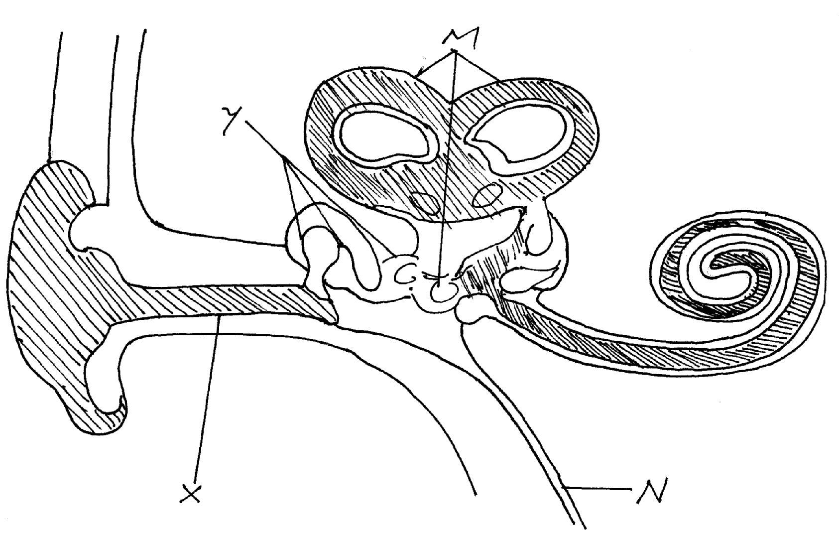

a) Name the parts labeled X,Y and N. (3mks)
X ______________________________________________
Y ______________________________________________
N ______________________________________________
b) State how the parts labeled Y are adapted to their functions. (2mks)
__________________________________________________________________________________________________________________________________________________________________________________________________________________________________________
c)i) Besides hearing, state one other function of the ear. (1mk)
____________________________________________________________________________________________________________________________________________________________
ii) Which of the labeled parts is responsible for the function you have stated in c(i) above. (1mk)

______________________________________________________________________________
d) What would happen if the auditory nerve is completely damaged? (1mk)
____________________________________________________________________________________________________________________________________________________________

3. The diagram below represents a stage of growth in a seed during germination.
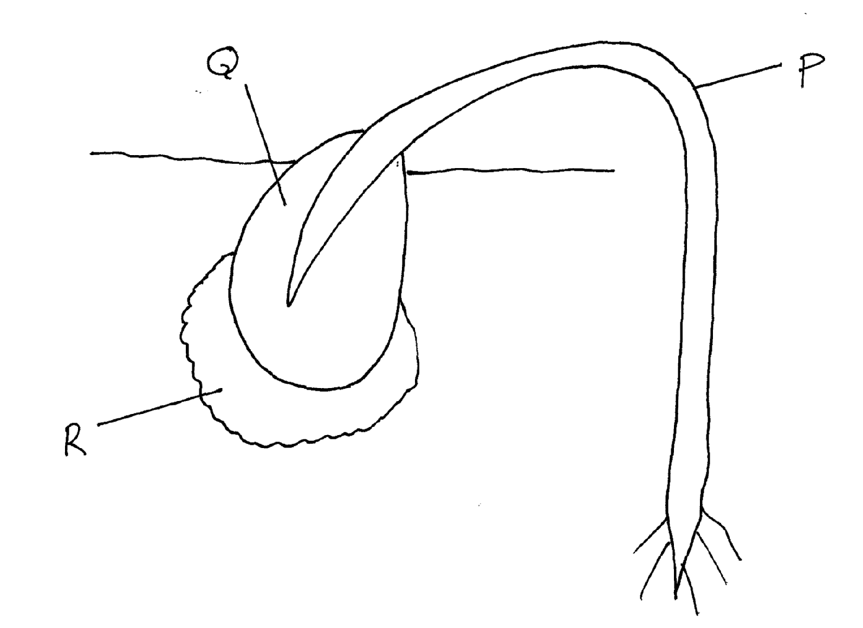
a)i) Name the type of germination illustrated above. (1mk)
____________________________________________________________________________________________________________________________________________________________
- Give a reason for your answer in a(i) above. (1mk)
____________________________________________________________________________________________________________________________________________________________
b) Name the part labeled R. (1mk)
______________________________________________________________________________
c) Give two functions of the part labeled Q. (2mks)

__________________________________________________________________________________________________________________________________________________________________________________________________________________________________________

d) Explain how part labeled P straightens. (3mks)
__________________________________________________________________________________________________________________________________________________________________________________________________________________________________________________________________________________________________________________________________________________________________________________________________________________________________________________________________________________________________________________________________________________________________
4. Below is a diagram of structure found in Eukoryotic cells. Study it and answer the questions that follows.
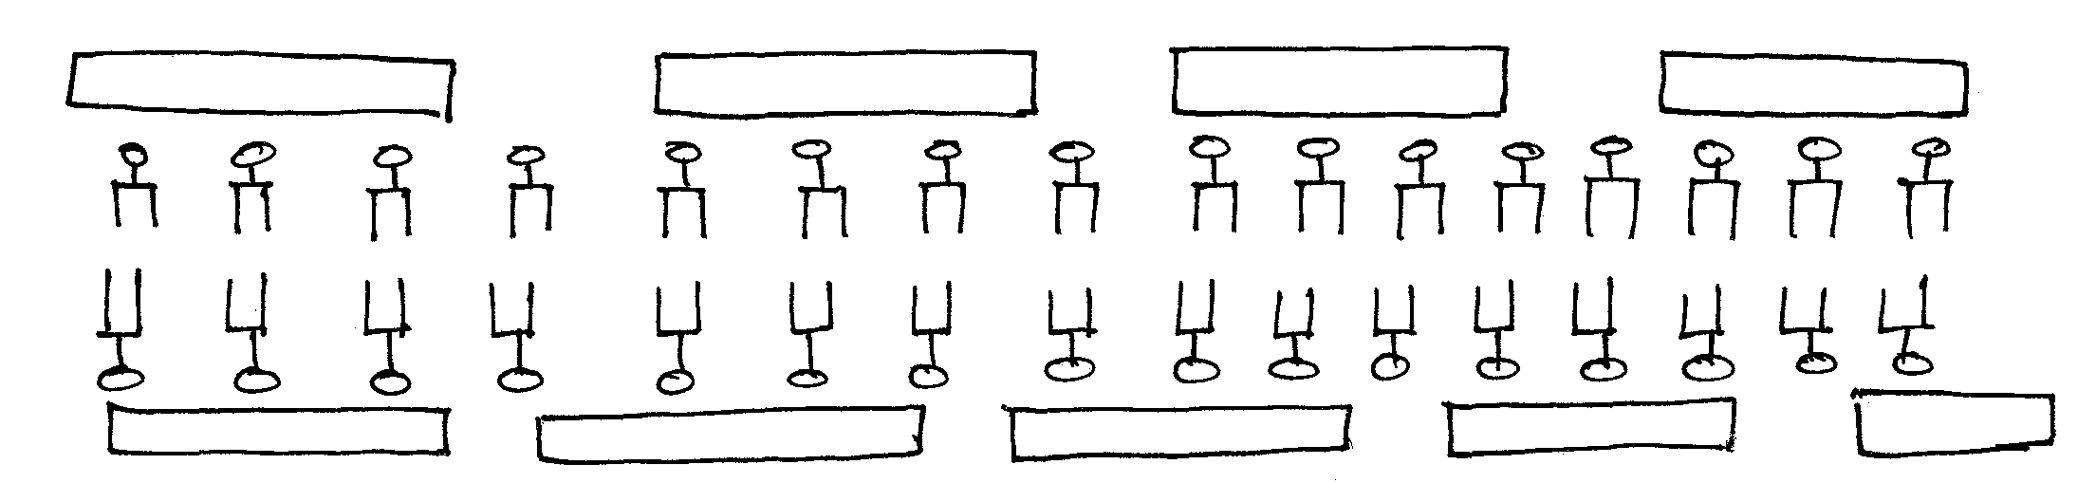
- Identify the structure. (1mk)
______________________________________________________________________________
- State two functions of the structure. (2mks)
__________________________________________________________________________________________________________________________________________________________________________________________________________________________________________
c.i) Name one organelle found in animal cells but absent in plant cell. (1mk)
______________________________________________________________________________
ii) State one function of the organelle you have named in c(i) above. (1mk)
____________________________________________________________________________________________________________________________________________________________
d) State 3 properties of structure you have identified in (a) above. (3mks)
____________________________________________________________________________________________________________________________________________________________________________________________________________________________________________________________________________________________________________________________________________________________________________________________________________________________________________________________________________________

5. The diagrams below represents a set up to investigate the conditions necessary for seed germination.
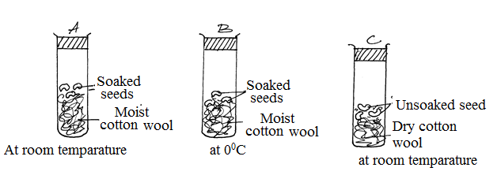

The set up was left for 7 days.
- What conditions were being investigated in the experiment? (2mks)
__________________________________________________________________________________________________________________________________________________________________________________________________________________________________________
- State three reasons for soaking seeds in set up A and B. (3mks)
______________________________________________________________________________________________________________________________________________________________________________________________________________________________________________________________________________________________________________________________________________________________________________________________________
- What were the expected results after seven days. (3mks)
- Set up A____________________________________________________________________
- Set up B ___________________________________________________________________
- Set up C ___________________________________________________________________
SECTION B – 40 MARKS
Answer question 6 compulsory and either question 7 or 8 in the spaces provided after question 8.

6. The table below shows how quantities of sweat and urine vary with external temperatures.

External Temperature ºC | Urine (cm³/hr) | Sweat cm³/hr
0 | 100 | 5
5 | 90 | 6
10 | 80 | 10
15 | 70 | 20
20 | 60 | 30
25 | 50 | 60
30 | 40 | 120
35 | 30 | 200
- Using the same axis, draw a graph of quantity of urine and sweat against the external temperature. (7mks)
- (i) State the quantity of urine and sweat produced when external temperature was 12.5ºC. (2mks)
__________________________________________________________________________________________________________________________________________________________________________________________________________________________________________
ii) State the physical process through which the body was cooled by sweating as temperature was rising. (1mk)
____________________________________________________________________________________________________________________________________________________________
iii) Account for the quantity of urine produced as the temperature increased. (4mks)

__________________________________________________________________________________________________________________________________________________________________________________________________________________________________________________________________________________________________________________________________________________________________________________________________________________________________________________________________________________________________________________________________________________________________
- State the nitrogenous waste that could be eliminated in urine or sweat in human beings. (3mks)
__________________________________________________________________________________________________________________________________________________________________________________________________________________________________________________________________________________________________________________________________________________________________________________________________________________________________________________________________________________________________________________________________________________________________
- State three behavioural mechanism that poikilotherms use to regulate their body temperature under hot conditions. (3mks)
______________________________________________________________________________________________________________________________________________________________________________________________________________________________________________________________________________________________________________________________________________________________________________________________________

7.a) Describe the process of double fertilization in flowering plants. (14mks)
b) State the changes that occur in a flower after fertilization. (6mks)
8.a) State the importance of locomotion in animals. (4mks)
b) Describe the adaptations of the finned fish to locomotion. (16mks)
____________________________________________________________________________________________________________________________________________________________________________________________________________________________________________________________________________________________________________________________________________________________________________________________________________________________________________________________________________________________________________________________________________________________________________________________________________________________________________________________________________________________________________________________________________________________________________________________________________________________________________________________________________________________________________________________________________________________________________________________________________________________________________________________________________________________________________________________________________________________________________________________________________________________________________________________________________________________________________________________________________________________________________________________________________________________________________________________________________________________________________________________________________________________________________________________________________________________________________________________________________________________________________________________________________________________________________________________________________________________________________________________________________________________________________________________________________________________________________________________________________________________________________________________________________________________________________________________________________________________________________________________________________________________________________________________________________________________________________________________________________________________________________________________________________________________________________________________________________________________________________________________________________________________________________________________________________________________________________________________________________________________________________________________________________________________________________________________________________________________________________________________________________________________________________________________________________________________________________________________________________________________________________________________________________________________________________________________________________________________________________________________________________________________________________________________________________________________________________________________________________________________________________________________________________________________________________________________________________________________________________________________________________________________________________________________________________________________________________________________________________________________________________________________________________________________________________________________________________________________________________________________________________________________________________________________________________________________________________________________________________________________________________________________________________________________________________________________________________________________________________________________________________________________________________________________________________________________________________________________________________________________________________________________________________________________________________________________________________________________________________________________________________________________________________________________________________________________________________________________________________________________________________________________________________________________________________________________________________________________________________________________________________________________________________________________________________________________________________________________________________________________________________________________________________________________________________________________________________________________________________________________________________________________________________________________________________________________________________________________________________________________________________________________________________________________________________________________________________________________________________
THIS IS THE LAST PRINTED PAGE!

