NAME……………………………………………………….…… INDEX NO.:………………………...
STREAM: .…..…………………………………………………… ADM NO: …………………………
DATE: …………………….………

231/1
BIOLOGY
(THEORY)
PAPER 1
AUGUST-2022
TIME : 2½ HOURS

MINCKS GROUP OF SCHOOLS
Kenya Certificate of Secondary Education. (K.C.S.E)
FORM FOUR

231/1
BIOLOGY
(THEORY)
PAPER 1
AUGUST-2022
TIME : 2½ HOURS

INSTRUCTIONS TO CANDIDATES
- Write your name, class and adm. No. in the spaces provided above.
- This paper consists of 27 questions. Attempt all questions in the spaces provided.

FOR EXAMINER’S USE ONLY

QUESTION | CANDIDATE’S SCORE
1 – 27

TOTAL

Answer all questions on the spaces provided.

- Suggest a biological tool that is most suitable for collecting each of the following organisms. (3mks)
- Scorpions
___________________________________________________________________________
- Safari ants on a tree
___________________________________________________________________________

- Butterfly in a coffee farm
___________________________________________________________________________
- State two structural differences between arteries and veins. (2mks)
____________________________________________________________________________________________________________________________________________________________________________________________________________________________________________________________________________________________________________
- The diagram below shows plant cells.
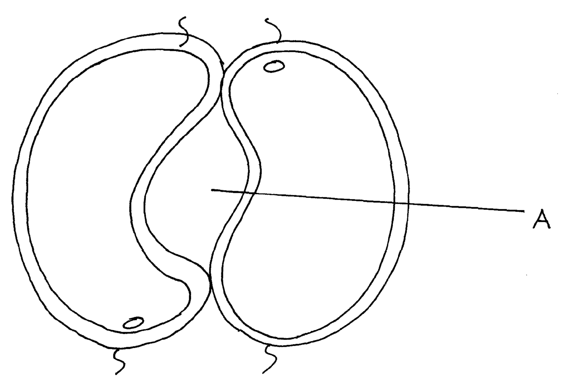

- Identify the cells shown above. (1mk)
______________________________________________________________________________________________________________________________________________________
- Explain how the cells are adapted to their function. (2mks)
____________________________________________________________________________________________________________________________________________________________________________________________________________________________________________________________________________________________________________

4.a) Name a growth hormone that had inhibitory effects in plant growth. (1mk)
______________________________________________________________________________________________________________________________________________________

b) State two characteristics of a meristematic cells. (2mks)
____________________________________________________________________________________________________________________________________________________________________________________________________________________________________________________________________________________________________________

5. The diagram below represents a nerve cell.
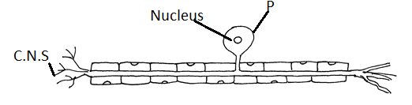
- Identify the type of nerve cell. (1mk)
______________________________________________________________________________________________________________________________________________________
- Give a reason for your answer in a above. (1mk)
______________________________________________________________________________________________________________________________________________________

- Using an arrow on the diagram. Indicate the direction of impulse movement. (1mk)

6. A student observed a raw of 16 epidermal cells in a microscopic field that was 8mm in diameter. Calculate the average length of each cell in micrometers. (2mks)

____________________________________________________________________________________________________________________________________________________________________________________________________________________________________________________________________________________________________________
7. State the causative agent of:- (2mks)
i) Malaria
______________________________________________________________________________________________________________________________________________________
ii) Candidiasis
______________________________________________________________________________________________________________________________________________________
8. Study the diagram below showing longitudinal section of a kidney.
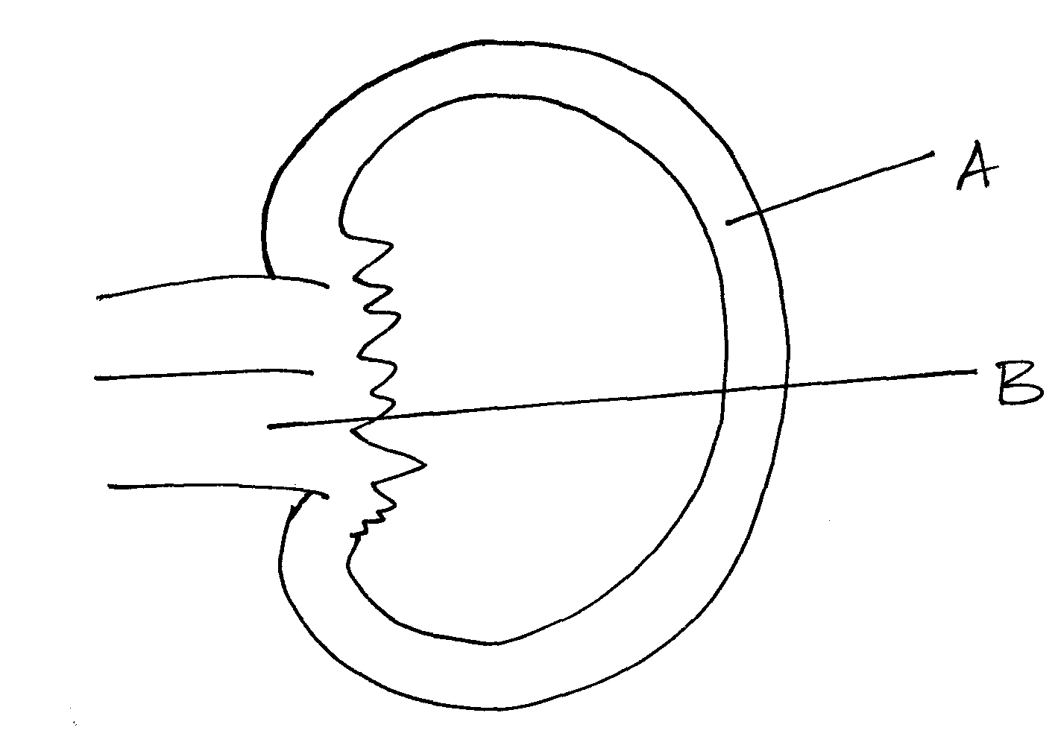
- Name the parts labeled A and B. (2mks)
A ______________________________________
B ______________________________________

- Which portions of the human nephron are only found in the part labeled A. (2mks)
________________________________________________________________________________________________________________________________________________________________________________________________________________________
9. Suggest three ways of reducing global warming. (3mks)
____________________________________________________________________________________________________________________________________________________________________________________________________________________________________________________________________________________________________________

10.a) Name the enzyme that completes fat digestion in human. (1mk)

___________________________________________________________________________

b) State two adaptations of herbivores which enable them to digest cellulose. (2mks)
______________________________________________________________________________________________________________________________________________________

11. The chemical equation below represents a reaction that occurs in cells.
2C₅₇ H₉₈O₆ + 145O₂ 102CO₂ + 98H₂O + Energy

- Calculate the R.Q. (2mks)
____________________________________________________________________________________________________________________________________________________________________________________________________________________________________________________________________________________________________________

- Identify the food substrate used in respiration. (1mk)
___________________________________________________________________________

- Name the compound that stores energy released during oxidation of glucose. (1mk)
______________________________________________________________________________________________________________________________________________________
12. The diagram below shows a set up used to investigate a certain response in ants.
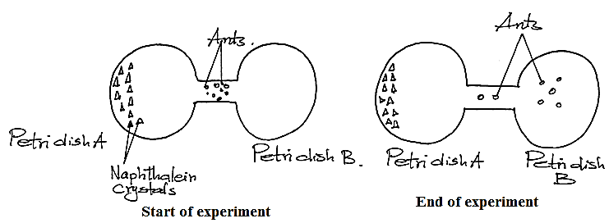
- Name the response exhibited by the ants. (1mk)

___________________________________________________________________________

- State the survival value of the response named in (a) above. (1mk)

______________________________________________________________________________________________________________________________________________________
13.a) Name the valves that close and the valves that open during ventricular systole. (2mks)
Open __________________________________________
Close __________________________________________
b) Name the part of the heart that acts as the pace maker. (1mk)

______________________________________________________________________________________________________________________________________________________

14. Explain why fossil records as evidence of organic evolution are usually incomplete.(2mks)
______________________________________________________________________________________________________________________________________________________

15. Explain why pteridophytes are considered more advanced than Bryophytes. (3mks)
____________________________________________________________________________________________________________________________________________________________________________________________________________________________________________________________________________________________________________

16. Study the diagram below representing parts of a mammalian skeleton.

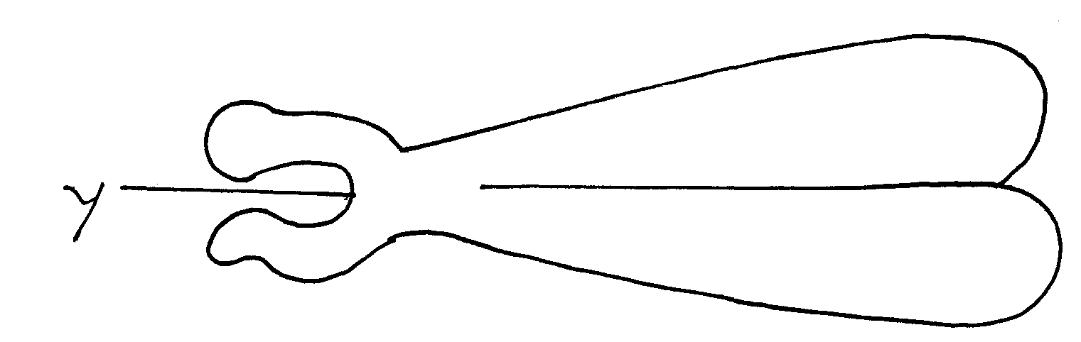
- Name the bone. (1mk)

______________________________________________________________________________________________________________________________________________________

- Which bone articulates with the above bone at point Y. (1mk)

______________________________________________________________________________________________________________________________________________________

- Name the type of joint formed with bone at point Y. (1mk)

___________________________________________________________________________

17. Explain why an individual with blood group O can donate blood to all other blood groups.
(2mks)
____________________________________________________________________________________________________________________________________________________________________________________________________________________________________________________________________________________________________________
18. The diagram below represents a stage during cell division.
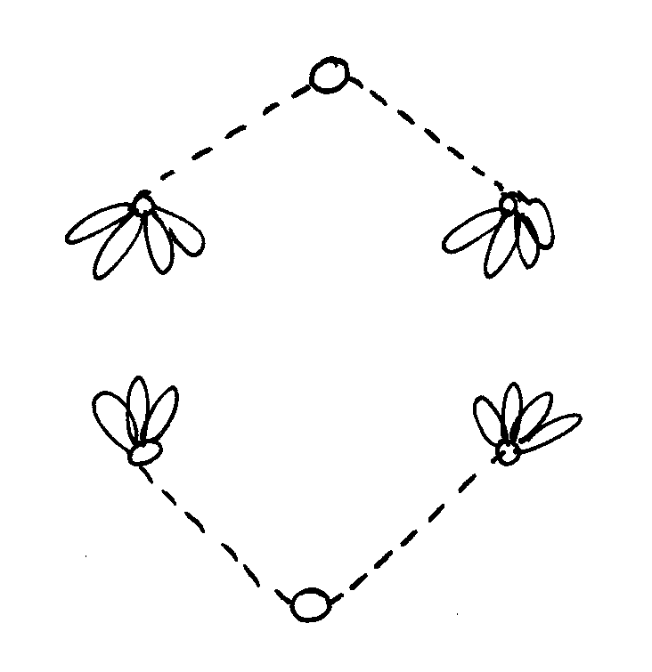
- Identify the stage of cell division. (1mk)
______________________________________________________________________________________________________________________________________________________

- Give two reasons for your answer in (a) above. (2mks)

______________________________________________________________________________________________________________________________________________________
19.a) What is an allele? (1mk)

______________________________________________________________________________________________________________________________________________________

b) State two causes of variations. (2mks)

____________________________________________________________________________________________________________________________________________________________________________________________________________________________________________________________________________________________________________
20. A group of students set up an experiment as shown below. The experimental set up were left for 20 minutes.

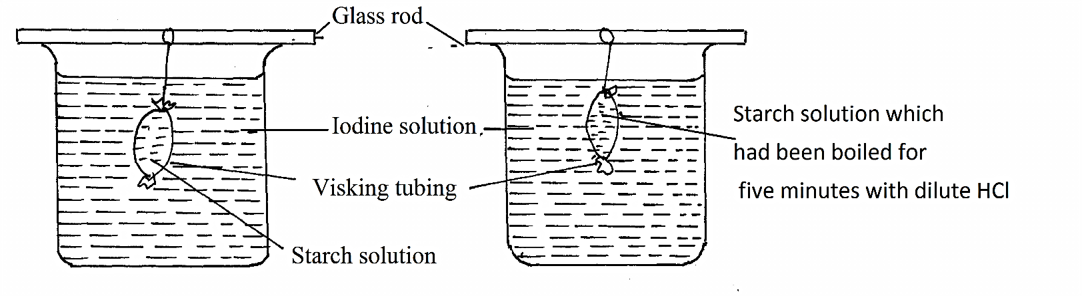
The observation after 20 minutes were as shown in the table.

Set up | Observation
 | Inside tubing | Outside tubing
A | Blue black colour | Colour of iodine
B | Colour of Iodine | Colour of iodine

- State the process being demonstrated in this experiment. (1mk)

______________________________________________________________________________________________________________________________________________________
- Explain the results in set up (A) above. (3mks)

____________________________________________________________________________________________________________________________________________________________________________________________________________________________________________________________________________________________________________

21. State three adaptations of respiratory surface in a bony fish. (3mks)
____________________________________________________________________________________________________________________________________________________________________________________________________________________________________________________________________________________________________________

22. The diagram below represent a cell organelle.
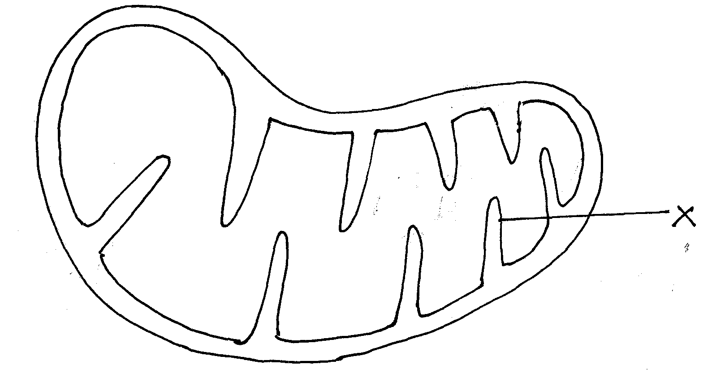

- Identify the organelle. (1mk)

______________________________________________________________________________________________________________________________________________________

- State the name of X. (1mk)

___________________________________________________________________________

- State the function of X. (1mk)

______________________________________________________________________________________________________________________________________________________
- Give an example of animal cell where the organ occurs in abundance. (1mk)

______________________________________________________________________________________________________________________________________________________
23. The equation below shows a process that occurs in plants.
2H₂O 4H⁺ + O₂
- Identify the process above. (1mk)
______________________________________________________________________________________________________________________________________________________

- Name the organelle in which the process above occurs. (1mk)

______________________________________________________________________________________________________________________________________________________

- Give two conditions necessary for the above process to occur. (2mks)

_________________________________________________________________________________________________________________________________________________________________________________________________________________________________
24.i) Distinguish between convergent and divergent evolution. (2mks)

____________________________________________________________________________________________________________________________________________________________________________________________________________________________________________________________________________________________________________
ii) Give one method by which age of fossils can be determined. (1mk)

___________________________________________________________________________
25. The graph below shows the effects of substrate concentration on the rate of enzyme reactions

B C

Rate of reaction

A Substrate concentration
- Account for the shape of the graph between:-
- A and B (2mks)

______________________________________________________________________________________________________________________________________________________
- B and C. (2mks)

____________________________________________________________________________________________________________________________________________________________________________________________________________________________________________________________________________________________________________
26. The diagram below illustrates the structure of a bread mould.

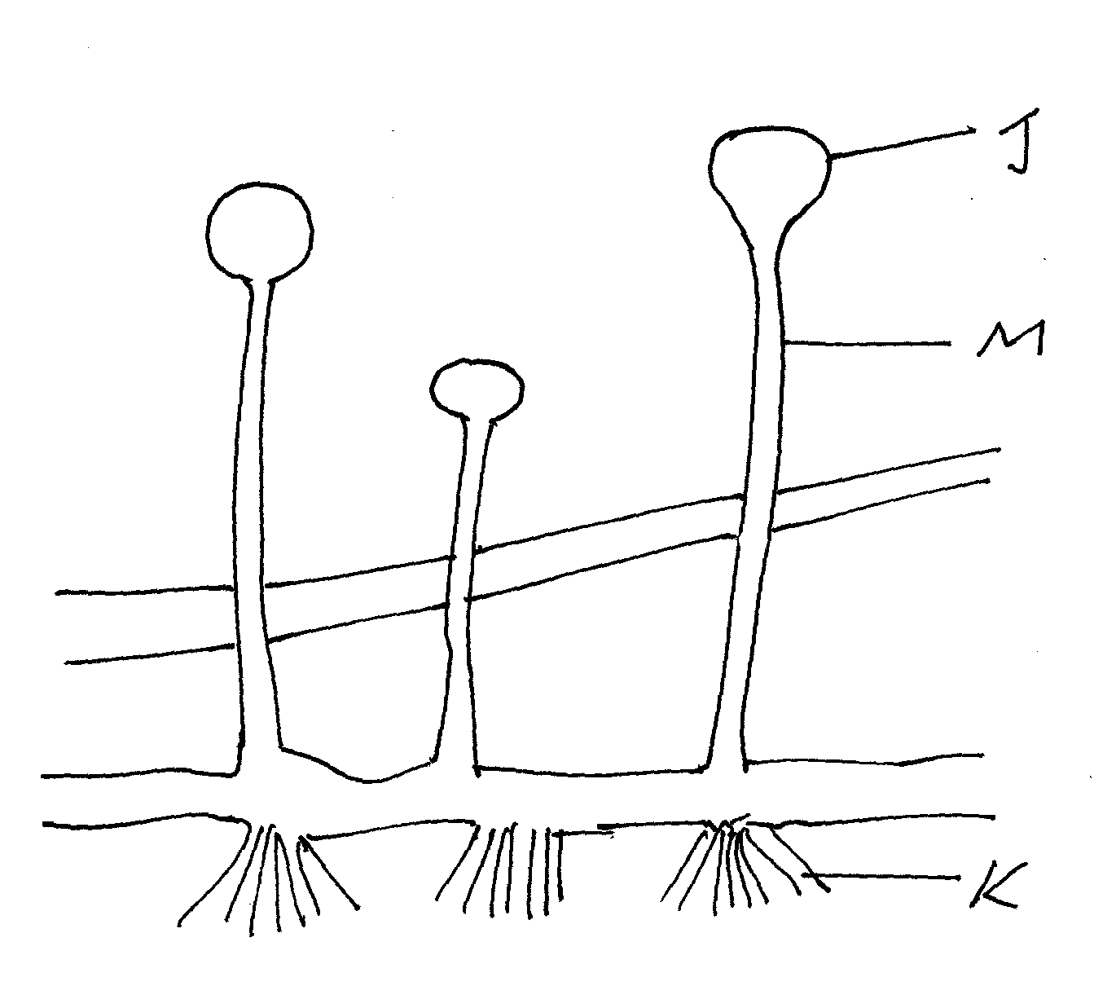

- Name the part labeled J & M. (2mks)
J _______________________________________________________________________
M_________________________________________________________________________
- State the functions of structure labeled K. (2mks)

___________________________________________________________________________ ___________________________________________________________________________ ___________________________________________________________________________
27. Name the part of human brain that controls the following functions. (2mks)
a) Controls peristalsis
______________________________________________________________________________________________________________________________________________________
b) Controls intelligence
______________________________________________________________________________________________________________________________________________________

THIS IS THE LAST PRINTED PAGE!

