FORM 4 PAPER 2 MARKING SCHEME
Section A
- The photograph below shows red blood cells that have been put in different solutions. Examine them and answer the questions that follow.
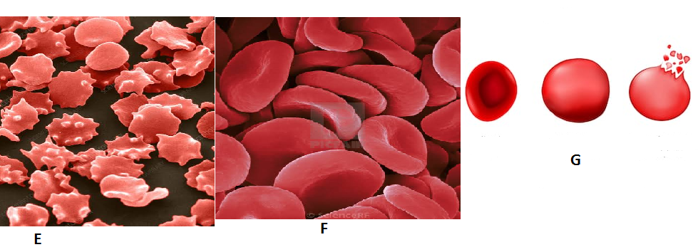
- i)Identify the type of solution in which F was placed. (1mk)
F – isotonic to cytoplasm of the cells;
ii) State the process which the red blood cells underwent in illustration G. (1mk)
G – Haemolysis;
- Account for the appearance the red blood cells underwent in illustration E. (3mks)
E – The cells were placed in a hypertonic solution to their cytoplasm; they therefore lost water by osmosis; shrunk and became crenated;
- Explain what would happen if plant cells are placed in the solution in which the cells in G were immersed. (3mks)
G – The cells would gain water; by osmosis; swell and become turgid;
- Study illustration below.
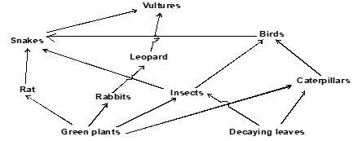

a. Identify the ecosystem. (1 mark)
Terrestrial ecosystem

b. i. Which organism have the least biomass in the food web? (1 mark)
Vultures
ii. Explain your answer in b (i) above. (1 mark)
- At each of the lower trophic level,
- some energy is lost as heat, during excretion , sweating.
- Some of the food is used during respiration to produce energy.
- Some of the parts of the organisms are not eaten.
- Some energy is lost as undigested or indigested food materials.
Ane one correct

c. Name the trophic level occupied by the following organisms.
i. Insects (1 mark)

Primary consumer.
ii. Leopards. (1 mark)

Secondary consumer
d. Construct a food chain in which the vulture is a quaternary consumer. (1 mark)
Green plants caterpillars Birds Snakes Vultures 1 mark
Green plants insects Birds Snakes Vultures 1 mark
Decaying leaves Caterpillars Birds Snakes Vultures 1 mark (any correct

e. i. Name one group of organisms not shown in the food web but play an important role in the ecosystem. (1 mark)
Saprophytic bacteria
Saprophytic fungi

ii. What is the role of the organisms you named in d (i) above? (1 mark)

Decomposition - Decomposers act upon the remains of plants and animals causing decay hence release inorganic materials (nutrients) which are later re - used by producers to form new organic compounds.

- An experiment was set up as show below.
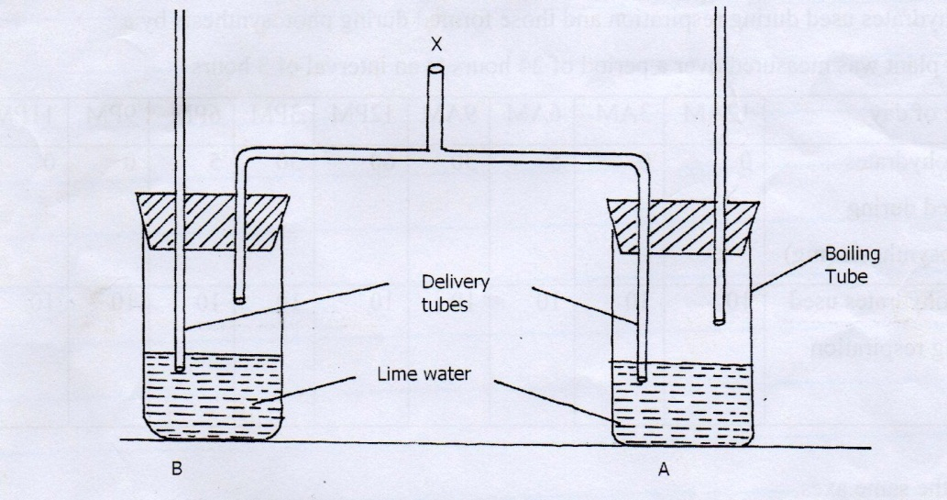

- A student blew air in and out through point X. Using arrows indicate how air gets in and out of the set up [2mks]
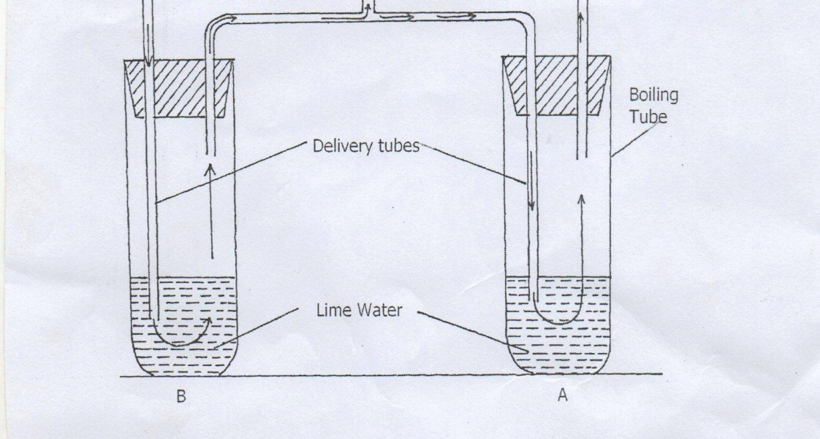

(b) [i] In which of the tube would lime water form white precipitate first. [1mk]
A
ii] Give a reason. [1mk]
Exhaled air has more carbon (IV) dioxide; than inhaled air
(c) What is the effect of lactic acid in the thigh muscle of an athlete after a short fast race? [2mks]
Poisonous if it accumulates; causes muscle cramps/fatigue;
(d) Identify the type of muscle in human being where the formation and effect of lactic acid is not felt [1mk]
Cardiac muscle;
(e) What is the biological significance of boiling milk. [1mk]
-Kill microorganisms (lactobacillus) bacteria ;
–High temperature denatures bacteria enzymes /stops anaerobic respiration;
- Study the diagram of a seed below and then answer the questions that follow.
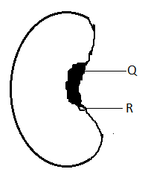
- (i) Name the scar labeled Q. (1mk)

Hilum;

(ii) State the functions of a microscopic pore labelled R during germination (3mks)
Allow entry of oxygen gas;
Allow exit of carbon (IV) Oxide
Allow entry of water

b)(i) Define the term Germination (1mk)

Process by which the seed develops into a seedling;

(ii) Under what conditions does the above process in (b) (i) occur? (3mks)

- Suitable temperature;
- Availability of water,
- Presence of oxygen;
- Presence of suitable hormones
- (gibberellins. Cytokinins) and enzymes.

- (a) A pig is an omnivore with all the four types of teeth. State two differences between a canine and a molar tooth. (2mks)

canine | Molar
Pointed tip | Broad with cusps;
One root | 2 or 3 roots;

- Distinguish between autotrophism and Heterotrophism mode of nutrition. (2mks)

Autotrophism is a mode of nutrition in which a living organism manufacture its own food, while Heterotrophism is a mode of nutrition whereby an organism feeds on different ready made food;

- How is lamina of a banana leaf adapted to is function. (4mks)

Its broad ; to increase surface area; to trap more light energy; and diffusion of gases;
Its thin; to provide a short distance for diffusion of C0₂ and 0₂;

SECTION B
Answer question 6 and either question 7 or 8 in the spaces provided

6.An experiment was carried out to investigate the effect of temperature on the rate of reaction catalyzed by an enzyme. The results are shown in the table below.
Temperature ⁰c | Rate of reaction in mg of product per unit time
5 | 0.2
10 | 0.5
15 | 0.8
20 | 1.1
25 | 1.5
30 | 2.1
35 | 3.0
40 | 3.7
45 | 3.4
50 | 2.8
55 | 2.1
60 | 1.1

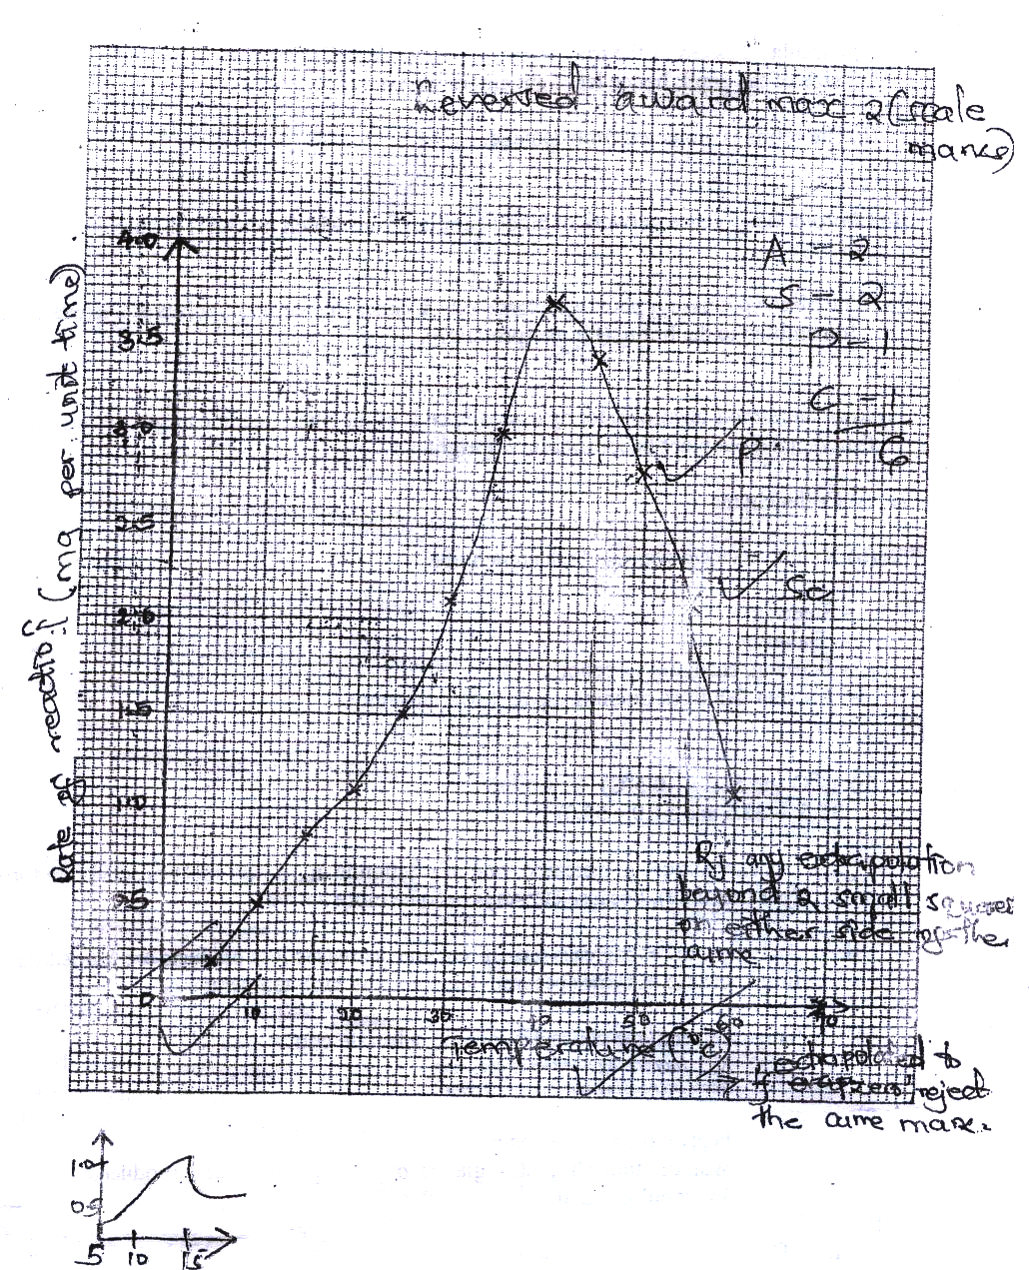(a) On the grid provided draw a graph of rate of reaction against temperature. ( 6 mks)

(b) When was the rate of reaction 2.6 mg of product per unit time? ( 2 mks)
33⁰C and 51.5 ( ± 0.5⁰C)
(32.5 - 33.5 and 51.0 – 52.0)
(c) Account for the shape of the graph between
(i) 5⁰ C and 40⁰ C ( 2 mks)
As temperature is increased rate of reaction is increased/ more products are formed (per unit time)
;because enzymes become more active;
(ii) 45⁰ C and 60⁰C ( 3 mks)
As temperatures increases rate of reaction decreases less products are formed (unit per time) ; because enzymes become denatured by high temperatures;
(d) Other than temperature name two ways in which the rate of reaction between 5⁰C and 40⁰C could be increased ( 2 mks)
Increase in enzyme concentration and substance concentration
Rj. Increasing number of enzymes
(e) (i) Name one digestive enzymes in the human body which works best in acidic condition ( 1 mk Pepsin, remain/ chymosin
(ii) How is the acidic condition for the enzyme named in (e) (i) above attained? ( 2 mks)
Wall of stomach/ gastric gland/ oxyntic/ parietal/ cell produce Hydrochloric
(f) The acidic conditions in (e) (ii) above is later neutralized
(i) Where does the neutralization take place? ( 1 mk)
Duodenum;
(ii) Name the substance responsible for neutralization ( 1 mk)
Bile juice/ acc any correct salt e.g. NaHCO₃
Acc: Bile

7. Describe the role of the following hormones in the menstrual cycle
a) Follicle Stimulating Hormone (FSH); Produced by the anterior lobe of the pituitary gland; it stimulates the development of the Graafian follicle in the ovaries; stimulates the ovarian tissue/wall; to secrete oestrogen;
b) Oestrogen; Brings about/stimulates the healing and repair of the uterine wall; after menstruation; stimulates the pituitary gland to secrete luteinising hormone;
c) Luteinising Hormone (LH) Produced by the pituitary gland; cause the bursting of the Graafian follicle; to release a mature egg/ovum/causes ovulation; stimulates the reorganisation/conversion of the Graafian follicle to form corpus luteum; stimulates the corpus luteum; to secrete progesterone hormone;
d) Progesterone Secreted by the corpus luteum; it stimulates the thickening of the endometrium/uterine wall; in preparation for implantation; inhibits secretion of the Follicle Stimulating Hormone; therefore preventing further development of the Graafian follicle; Max. 20 mks

- a)After a meal of carbohydrate, the glucose level in the blood rose to 150mg/ cm³ .Explain the role of the liver in bringing the sugar level down back to normal. (8mks)

The pancreas detects; and is stimulated to secrete insulin hormone; which is released into the blood and is transported to the liver; where it stimulates the liver to;
- convert excess glucose to glycogen for storage;
- inhibit conversion of glycogen into glucose;
- increase oxidation of glucose to release energy;
- convert excess glucose into fat;

b)Explain six importance’s of plants excretory products. (12mks)
Tannins; - treatment of leather;
- decoration of pots;
Caffeine – mild stimulant/increases mental activity and reduces fatigue;
Quinine – treatment of malaria;
Cannabis – manufacture of narcotic drugs;/insecticides;/ cigarettes;
Rubber; - make shoes;/ chewing gum;
Colchicine; - breeding research and in cancer therapy;
Gum Arabica; - in food processing industries and printing industries;
Papain – meat tenderizer;
Khat; - mild stimulant; (any 6)

