Term 1 – 2023 OPENER EXAM
BIOLOGY (231/3)
FORM FOUR (4)
Time: $1\frac{3}{4} Hours$

MARKING SCHEME

FOR EXAMINER’S USE ONLY:
Question | Maximum  Score | Candidate’s  Score
1 | 14
2 | 14
3 | 12
Total Score | 40

1. You are provided with specimen T.
a) Cut a 1 cm slice from the specimen and remove its peel. Place the soft inner part into a boiling tube labelled A.

Cut another 1 cm slice from the specimen and remove its peel. Using a pestle mash the soft inner part into a paste. Place the paste into a boiling tube labelled B.

Add 4 cm³ of dilute hydrogen peroxide solution into each of the boiling tubes A and B.

i) Record your observations (2mks)
A- less/ few bubbles/ slow effervescence/ fizzing/ froth;
B- Rapid bubbling/ effervescence/ fizzing/ froth/ foam/ more bubbles;
ii) Account for the results in 1. a) i) above (2mks)
Large surface area in B; than in A for enzymatic activity in boiling tube B;
iii) Write an equation for the breakdown of hydrogen peroxide (1mk)
2H₂O₂ 2H₂O + O₂
Accpt word equation
b) Cut a 2 cm slice from specimen T and remove its peel. Place the soft inner part in a mortar, and using a pestle mash it into a fine paste. Add a little of distilled water and stir the mixture. Pour the mixture into a beaker and allow it to stand for 2 minutes. Using the reagents provided, test for the food substances in the mixture. Record procedure, observation and conclusion in the table below (9mks)
Food substance being tested | Procedure | Observation | Conclusion
Starch | Add drops of Iodine solution; | Blue black; | Starch present;
Vitamin C | Add mixture to DCPIP ; | DCPIP decolourised; | Vitamin C present;
Reducing Sugar | Add Benedict’s solution to equal amount of banana paste, heat to boil; | Green ,yellow.,orange; | Reducing sugar present;

2. The following photomicrographs K and L illustrate cross sections of an organ as found in different plants. Use the photomicrographs to answer the questions below.

K L
phloem
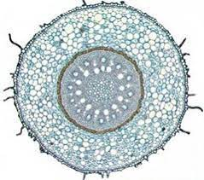
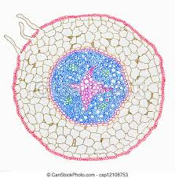
xylem
Endodermis

- Name the organ from which the above cross- sections have been obtained giving a reason for your answer. (2mks)

Organ Root

Reason Star shaped xylem/ phloem on the arms of xylem/

- Label the following parts on the photomicrograph K; (3mks)
Xylem
Phloem
Endodermis
- State the differences between cross section K and cross section L. (2mks)

cross section K | cross section L
Arrangement: xylem and phloem alternate | Xylem central and phloem on its arms
Transport water and dissolved mineral salts  Shape; Phloem and xylem rounded  Cell wall thickened with lignin  Do not have companion cells | Transport organic food  Xylem starshaped  Cell wall made up of cellulose only  Associated with companion cells in Angiosperms

- Identify any two differences between xylem and phloem. (2mks)

Xylem are dead tissues phloem are living tissues

- State two adaptations of xylem to their function. (2mks)

Have narrow lumen to increase on capillarity;
Have hollow lumen to allow passage of water;
Their cell walls are filled with lignin to strengthened the wall so that they do not collapse;
Continuos from roots to leaves to ensure that water reaches the leaves for photosynthesis
Have pits to allow lateral movement of water so that neighboring cells get water supply

- Name a tissue present in photomicrograph K that is absent in photomicrograph L. (1mk)

Pith;

- Give the function of each of the following tissues; (2mks)

Cortex - Storage tissue for food and water;

Endodermis – Controls the amount of water and dissolved mineral entering to the xylem in the root;

3. Below are photographs labelled L₁, L_{2,} L_{3,} L₄ and L₅ of twigs obtained from plants. Examine them.
L₁ L₂

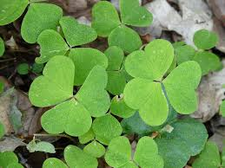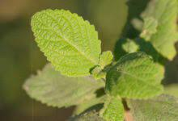
L₃ L₄
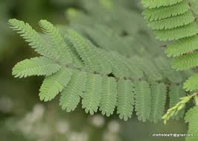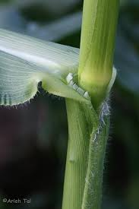

L₅

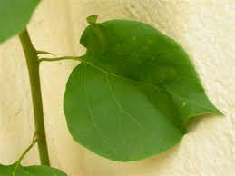

a) Using observable features in the photographs, complete the dichotomous key given below (2mks)
i. a) Leaves compound ………………………………………………… go to 2
b) Leaves simple …………………………………………………. go to 3

ii. a) Leaf bipinnate …………………………………………………… Mimosaceae
b) Leaf trifoliate .…………………………………………………… Oxalidaceae

iii. a) Leaf with network venation ………………………………………………… go to 4
b) Leaves with parallel venation …………………………………………….. go to 5

iv. a) Leaf with entire margin …………………………………………………..Nyctaginaceae
b) Leaf with serrated margin .…………………………………………………Verbenaceae

v. a) Leaf with solid petiole ………………………………………………… Agavaceae
b) Leaf with sheath like petiole ………………………………………………Graminae

b) Use the completed dichotomous key to identify the family to which each plant belongs. In each case show the steps you followed to arrive at the identity (10mks)

Specimen | Steps | Identity
L1 | Oxalidaceae | 1a, 2b
L2 | Verbenaceae | 1b, 3a, 4b Note; Tied to 1(a) part 1 (b)
L3 | Mimosaceae | 1a, 2a
L4 | Graminae | 1b, 3b, 5a Note: Tied to 1(a) part 1(b) and 3(b)
L5 | Nyctaginaceae | 1b,3a, 4a  Note: Tied to 1a part 1(b)

