SEPT/OCT 2022

231/3
BIOLOGY
PRACTICAL
PAPER 3
SEPT/OCT 2022
TIME 1 ¾ HOURS

BONDO SUB COUNTY JOINT EVALUATION

Kenya Certificate of Secondary Education 2022

231/3
BIOLOGY
PRACTICAL
PAPER 3
SEPT/OCT 2022

CONFIDENTIAL

MARKING SCHEME

- a) i)A seed; (1 mark)
ii) has one scar; (1 mark)
b) Any first three(3 marks)
- Dissolves the hydrolysed food substances;
- Transports soluble food substances to the embryo/growing regions/ plumule and radical;
- Softens the testa to allow emergence of the radical;
- Hydrolyses the stored food substances;
- Activates the enzymes;(which begin the breakdown of the stored food substances;
- Acts as a medium for enzyme action;

c)

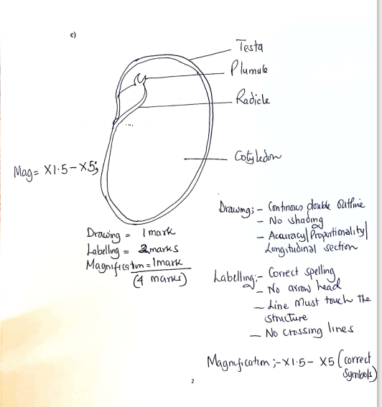

d) i)Spermatophyta;

ii) Ovule; accept ovules
2. a) (12 marks)

FOOD SUBSTANCE | PROCEDURE | OBSERVATION | CONCLUSION
Starch; | To 2cm³the food sample in the test tube  Add 3 drops of iodine solution and shake ; | Blue black colour; | Starch present;
Proteins; | To 2cm³ of the food sample in the test tube  Add 2cm³ of 10% Sodium Hydroxide and shake  Add 1% Copper(II) sulphate drop wise and shake; | Purple colour colour ; | Proteins present ;
Reducing sugar; | To 2cm³the food sample in the test tube  Add 2cm³ of Benedict’s solution and heat to boil; | Blue colour of Benedict’s solution persists; | Reducing sugars absent;

b i) Salivary Amylase/Ptyalin; (1 mark)
ii) Pepsin; (1 mark)

3.
(a) . (12marks)
Specimen | Type of fruit | Reason | Mode of dispersal | Adaptation to dispersal
X | Cypsela; | Persistent calyx; | Animal; | Presence of hooks for attachment to fur/clothing;
Y | Cypsela ; | Pappus of hairs; | Wind; | Hair like projections /pappus of hairs to increase surface area to be carried by air ;
Z | Legume/Pod; | Fruit wall not differentiated/presence of lines of weakness/sutures; | Self explosive mechanism; | presence of lines of weakness/sutures which splits open/dehisces;

b)

(i) (1 mark)
Axile/central; (1 mark)
(ii)
X is indehiscent while Z is dehiscent/X does not split open while Z splits open; (1 mark)

