BIOLOGY
PAPER 3
MARKING SCHEME

- a) i) Fruits (1mark)
ii) Has two scars (1mark)

b)i)
K1 | K2
Has green epicarp | Yellow/yellow green epicarp
Is hard to feel | Soft to feel
Produces sap-from epicarp | Has no sap on epicarp
No smell | Has an aromatic smell
(2marks)
ii)Ethylene/ethene(1mk)

c)Food test
Food substances | Procedure | Observation | Conclusion
Starch | To the food substance add three drops of iodine solution and shake | Colour turns blue black | Starch present
Reducing sugar | To the food substance add equal amount of Benedict’s solution and heat to boil | Colour of Benedict’s solution remain | Reducing sugars absent
(8MKS)
d) Drawing (3mks)
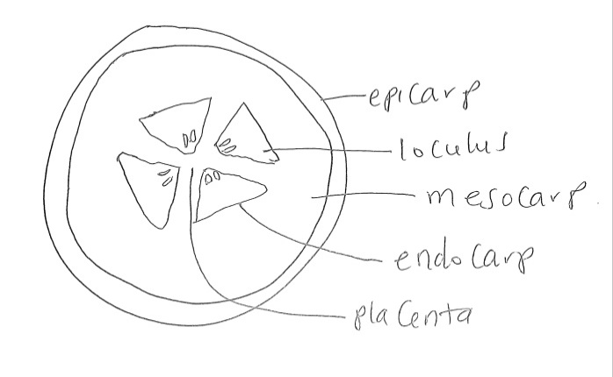

2) (a) X - Radius
-widens/broadens towards the ends.
Y - Ulna;
- Has olecranon process, presence of sigmoid notch;
Z - Humerus;-Has a smooth rounded head/has greater and lesser tuberosities/ has bicipital groove/ has trochlear/ has olecranon fossa;
(b) 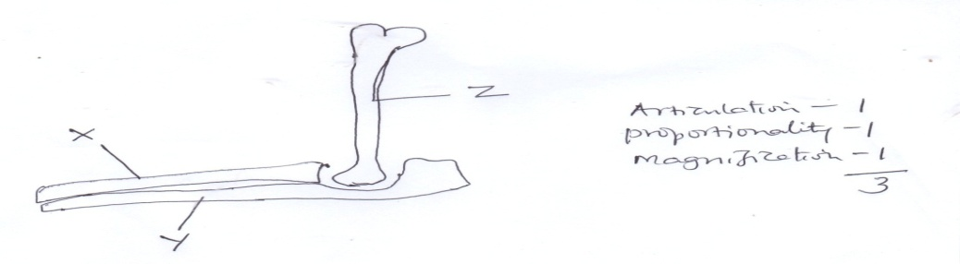
(c) – Has a smooth rounded head to articulate with glenoid cavity of scapula (to form a ball and socket joint);
- Has bicipital groove along which the tendon of biceps muscle passes.
- Has trochlear and condyles for articulating with sigmoid notch of ulna, (forming a hinge joint);
- Has (greater and lesser) tuberosities for muscle attachment;
- Has a long thick shaft to bear the weight of (anterior part) the body;
- It has olecranon fossa into which olecranon process fits when the limb is straightened.
3. a) On the photograph (3mks)
b) (i) on the photograph (3mks)
(ii) Tendons : (1mk)
- prevent atrioventricularvalvesfrom overstretching
- preventatrioventricular valves from turning inside out.
Septum (1mk)
- seperates oxygenated blood and deoxygenated blood hence preventing them from mixing
Thick muscle on the left ventricle (1mk)
- Generate pressure to pumb blood overvalong distance to other parts of the bod.
c) varicose vein (2mks)
Arteriosclerscis
Coronary thrombosis
Hypertension

