**NAME: ……………………………………… INDEXNUMBER: …………..**

**SCHOOL: …………………………………………….. DATE: ………..... SIGN:…….**

**231/2**

**BIOLOGY**

**PAPER 2 (THEORY)**

**SEPTEMBER 2022**

**TIME: 2 HOURS**

**KENYA CERTIFICATE OF SECONDARY EXAMINATIONS (K.C.S.E)**

**INSTRUCTIONS TO CANDIDATES**

* Write your **name** and **index number** in the spaces provided above
* Sign and write the date of examination in the spaces provided
* Answer all questions in section A
* In section **B** answer **question 6 (compulsory)** and either question 7 or 8
* Answers to all questions must be written in this booklet.

**FOR EXAMINERS USE ONLY**

|  |  |  |
| --- | --- | --- |
| **QUESTION** | **MAXIMUM SCORE** | **CANDIDATE’S SCORE** |
| **SECTION A** | **8**  **8**  **8**  **8**  **8** |  |
| **SECTION B** | **20**  **20**  **20** |  |
| **TOTAL** | **80** |  |

1. The diagram below shows three different types of neurons along a reflex arc.

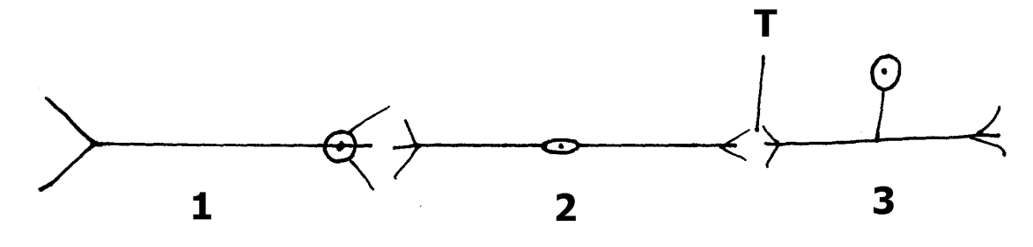

a) Identify the Neuron labelled 1,2 and 3. (3mks)

………………………………………………………………………………………………………………………………………………………………………………………………………………………………………………………………………………………………………………………

b) Using arrows show the direction of impulse transmission on the diagram. (1mk)

c) Name the part where the cell body of neurons 1 and 2 are located. (2mks)

……………………………………………………………………………………………………………………………………………………………………………………………………………...

d)Describe the transmission of impulses across the part labelled T. (2mks)

………………………………………………………………………………………………………………………………………………………………………………………………………………………………………………………………………………………………………………………………………………………………………………………………………………………………

2.The flow chart below shows blood transfusion pathway

A

O AB

B

1. What five conclusions can you draw from the flow chart? (5 mks)

…………………………………………………………………………………………………………………………………………………………………………………………………………………………………………………………………………………….………………………………...……………………………………………………………………………………………………………………………………………………………………………………………………................

1. Why is the knowledge of blood groups necessary before blood transfusion? (1 mk)

………………………………………………………………………………………………………………………………………………………………………………

1. Apart from knowledge of blood groups state two precautions that must beobserved during blood transfusion. (2 mks)

……………………………………………………………………………………………………………………………………………………………………………………………………………………………………………………………………….

3. The diagram shown below is a section through the mammalian nephron.

**S**

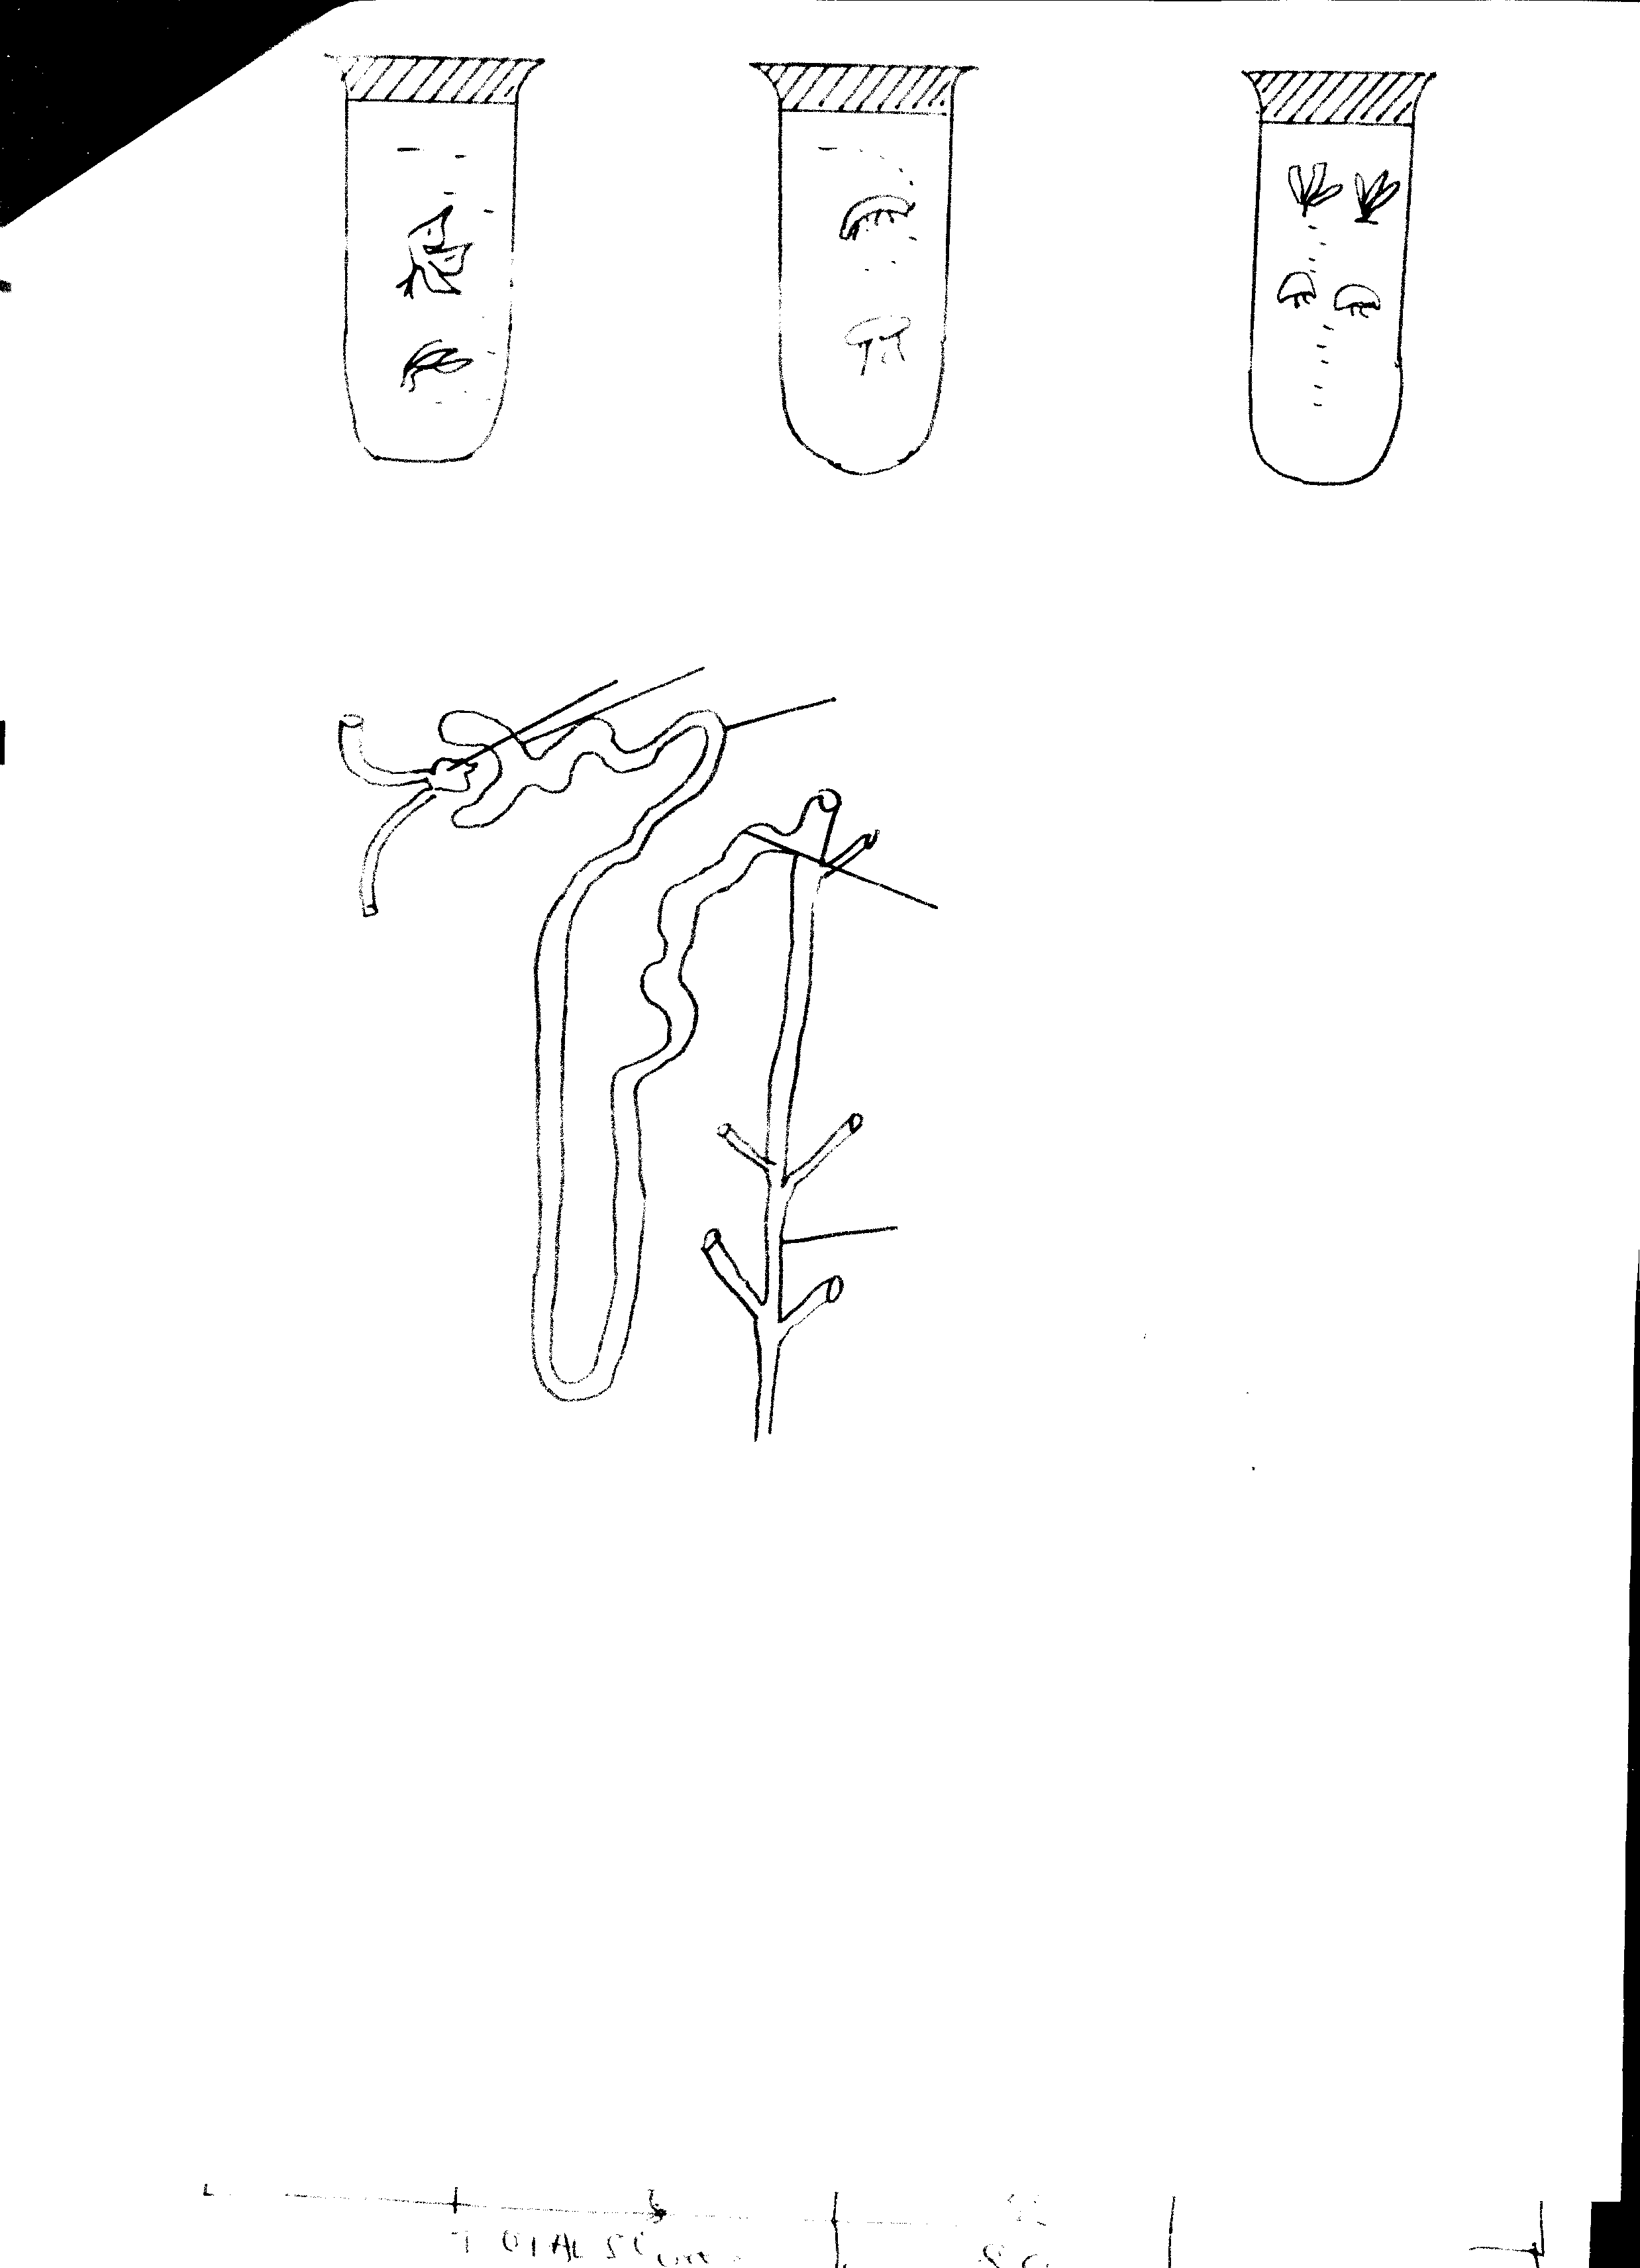

**X**

**U**

**N**

**T**

(i)Name parts :- (2mks)

**T**…………………………………………………………………………………

**U**…………………………………………………………………………………

ii) a) Name one hormone that has an effect on part labelled X and where is it produced (2mks)

………………………………………………………………………………………………………………………………………………………………………………………………………………

b)How will the concentration of urine be affected at region U in the absence of hormone referred to in (ii) (a) above. (1mk)

……………………………………………………………………………………………………...

c)Name the fluid formed in part labelled T. (1mk)

………………………………………………………………………………………………………………………………………………………………………………………………………………

d)Which conditions are responsible for formation of fluid at part labelled T. (2mks)

………………………………………………………………………………………………………………………………………………………………………………………………………………………………………………………………………………………………………………………………………………………………………………………………………………………………………………………………………………………………………………………………………

4 The genetic disorder haemophilia is due to a recessive sex linked gene. A man who is haemophilia married a woman who is a carrier for the condition.

a) Using the letter (H) to represent the normal condition and (h) for the haemophiliac condition.

(i) What is the genotype of the man and woman? (1 mk) Man…………………………………………………………………………………………

Woman……………………………………………………………………………………

(ii) Work out a cross between the man and woman. (4 mks)

………………………………………………………………………………………………………………………………………………………………………………………………………………………………………………………………………………………………………………………………………………………………………………………………………………………………………………………………………………………………………………………………………………………………………………………………………………………………………………………………………………………………………………………………………………………………………………………………………………………………………………………………………………………………………………………………………………………………………………………………………………………………………………………………………………………………

b)What is the chance that both the first and second sons will be haemophiliac? (2 mks)

………………………………………………………………………………………………………………………………………………………………………………………………………………………………………………………………………………………………………………………………………………………………………………………………

1. Haemophilia is more common in males than in female humans. Explain. (1 mk)

………………………………………………………………………………………………………………………………………………………………………………………………………………………………………………………………………...

5. A freshly obtained Tradescantia stem measuring 5 cm long was split lengthwise to obtain two similar-pieces. The pieces were placed in solutions of different concentrations in Petri dishes for 20 minutes.

The appearance after 20 minutes is as shown

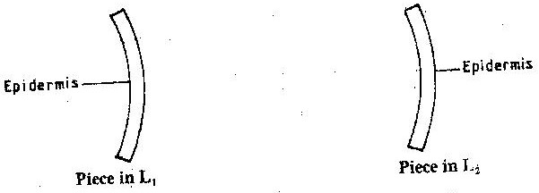

1. Account for the appearance of the pieces in solutions L1 and L2( 6 mks)

………………………………………………………………………………………………………………………………………………………………………………………………………………………………………………………………………...………………………………………………………………………………………………………………………………………………………………………………………………………………………………………………………………………...………………………………………………………………………………………………………………………………………………………………………………………………………………………………………………………………………............................................................................................................................

1. State the significance of the biological process involved in the experiment ( 2 mks)

………………………………………………………………………………………………

………………………………………………………………………………………………

………………………………………………………………………………………………

**SECTION B(40 MKS**)

**Answer question 6 (Compulsory) and either question 7 or 8 in spaces provided.**

1. An experiment was carried out to investigate transpiration and absorption of water in sunflower plants in their natural environment with adequate supply of water. The amount of water was determined in two hour intervals. The results are shown in the table below.

|  |  |  |
| --- | --- | --- |
| Time of day | Amount of water in grammes | |
| Transpiration | Absorption |
| 11.00 – 13.00 | 33 | 20 |
| 13.00 – 15.00 | 45 | 30 |
| 15.00 – 17.00 | 52 | 42 |
| 17.00 – 19.00 | 46 | 46 |
| 19.00 – 21.00 | 25 | 32 |
| 21.00 – 23.00 | 16 | 20 |
| 23.00 – 01.00 | 08 | 15 |
| 01.00 – 03.00 | 04 | 11 |

1. Using the same axes, plot graphs to show transpiration and absorption of water in grammes against time of day. (7mks)
2. At what time of day was the amount of water the same for transpiration and absorption? (1 mark)

…………………………………………………………………………………………………………

1. Account for the shape of graphs of:
2. Transpiration (3marks)

………………………………………………………………………………………………………………………………………………………………………………………………………………………………………………………………………………………………………………………………

1. Absorption (3 marks)

………………………………………………………………………………………………………………………………………………………………………………………………………………………………………………………………………………………………………………………………

1. What would happen to transpiration and absorption of water if the experiment was continued untill 05.00 hours? (2 marks)

……………………………………………………………………………………………………………………………………………………………………………………………………………………

1. Name **two** factors that may affect transpiration and absorption at any given time. (2 marks)

……………………………………………………………………………………………………………………………………………………………………………………………………………………

1. Explain how the factors you have named in (e) above affect transpiration. (2 marks)

………………………………………………………………………………………………………………………………………………………………………………………………………………………………………………………………………………………………………………………………

1. (a) Explain how the gills of fish are adapted to the process of gaseous exchange.(5 marks)

(b) Describe how gaseous exchange occurs in leaves of a terrestrial plant. (15 marks)

1. How is the mammalian eye adapted to its functions?(20marks)

………………………………………………………………………………………………………

………………………………………………………………………………………………………………………………………………………………………………………………………………………………………………………………………………………………………………………………………………………………………………………………………………………………………………………………………………………………………………………………………………………………………………………………………………………………………………………………………………………………………………………………………………………………………………………………………………………………………………………………………………………………………………………………………………………………………………………………………………………………………………………………………………………………………………………………………………………………………………………………………………………………………………………………………………………………………………………………………………………………………………………………………………………………………………………………………………………………………………………………………………………………………………………………………………………………………………………………………………………………………………………………………………………………………………………………………………………………………………………………………………………………………………………………………………………………………………………………………………………………………………………………………………………………………………………………………………………………………………………………………………………………………………………………………………………………………………………………………………………………………………………………………………………………………………………………………………………………………………………………………………………………………………………………………………………………………………………………………………………………………………………………………………………………………………………………………………………………………………………………………………………………………………………………………………………………………………………………………………………………………………………………………………………………………………………………………………………………………………………………………………………………………………………………………………………………………………………………………………………………………………………………………………………………………………………………………………………………………………………………………………………………………………………………………………………………………………………………………………………………………………………………………………………………………………………………………………………………………………………………………………………………………………………………………………………………………………………………………………………………………………………………………………………………………………………………………………………………………………………………………………………………………………………………………………………………………………………………………………………………………………………………………………………………………………………………………………………………………………………………………………………………………………………………………………………………………………………………………………………………………………………………………………………………………………………………………………………………………………………………………………………………………………………………………………………………………………………………………………………………………………………………………………………………………………………………………………………………………………………………………………………………………………………………………………………………………………………………………………………………………………………………………………………………………………………………………………………………………………………………………………………………………………………………………………………………………………………………………………………………………………………………………………………………………………………………………………………………………………………………………………………………………………………………………………………………………………………………………………………………………………………………………………………………………………………………………………………………………………………………………………………………………………………………………………………………………………………………………………………………………………………………………………………………………………………………………………………………………………………………………………………………………………………………………………………………………………………………………………………………………………………………………………………………………………………………………………………………………………………………………………………………………………………………………………………………………………………………………………………………………………………………………………………………………………………………………………………………………………………………………………………………………………………………………………………………………………………………………………………………………………………………………………………………………………………………………………………………………………………………………………………………………………………………………………………………………………………………………………………………………………………………………………………………………………………………………………………………………………………………………………………………………………………………………………………………………………………………………………………………………………………………………………………………………………………………………………………………………………………………………………………………………………………………………………………………………………………………………………………………………………………………………………………………………………………………………………………………………………………………………………………………………………………………………………………………………………………………………………………………………………………………………………………………………………………………………………………………………………………………………………………………………………………………………………………………………………………………………………………………………………………………………………………………………………………………………………………………………………………………………………………………………………………………………………………………………………………………………………………………………………………………………………………………………………………………………………………………………………………………………………………………………………………………………………………………………………………………………………………………………………………………………………………………………………………………………………………………………………………………………………………………………………………………………………………………………………………………………………………………………………………………………………………………………………………………………………………………………………………………………………………………………………………………………………………………………………………………………………………………………………………………………………………………………………………………………………………………………………………………………………………………………………………………………………………………………………………………………………………………………………………………………………………………………………………………………………………………………………………………………………………………………………………………………………………………………………………………………………………………………………………………………………………………………………………………………………………………………………………………………………………………………………………………………………………………………………………………………………………………………………………………………………………………………………………………………………………………………………………………………………………………………………………………………………………………………………………………………………………………………………………………………………………………………………………………………………………………………………………………………………………………………………………………………………………………………………………………………………………………………………………………………………………………………………………………………………………………………………………………………………………………………………………………………………………………………………………………………………………………………………………………………………………………………………………………………………………………………………………………………………………………………………………………………………………………………………………………………………………………………………………………………………………………………………………………………………………………………………………………………………………………………………………………………………………………………………………………………………………………………………………………………………………………………………………………………………………………………………………………………………………………………………………………………………………………………………………………………………………………………………………………………………………………………………………………………………………………………………………………………………………………………………………………………………………………………………………………………………………………………………………………………………………………………………………………………………………………………………………………………………………………………………………………………………………………………………………………………………………………………………………………………………………………………………………………………………………………………………………………………………………………………………………………………………………………………………………………………………………………………………………………………………………………………………………………………………………………………………………………………………………………………………………………………………………………………………………………………………………………………………………………………………………………………………………………………………………………………………………………………………………………………………………………………………………………………………………………………………………………………………………………………………………………………………………………………………………………………………………………………………………………………………………………………………………………………………………………………………………………………………………………………………………………………………………………………………………………………………………………………………………………………………………………………………………………………………………………………………………………………………………………………………………………………………………………………………………………………………………………………………………………………………………………………………………………………………………………………………………………………………………………………………………………………………………………………………………………………………………………………………………………………………………………………………………………………………………………………………………………………………………………………………………………………………………………………………………………………………………………………………………………………………………………………………………………………………………………………………………………………………………………………………………………………………………………………………………………………………………………………………………………………………………………………………………………………………………………………………………………………………………………………………………………………………………………………………………………………………………………………………………………………………………………………………………………………………………………………………………………………………………………………………………………………………………………………………………………………………………………………………………………………………………………………………………………………………………………………………………………………………………………………………………………………………………………………………………………………………………………………………………………………………………………………………………………………………………………………………………………………………………………………………………………………………………………………………………………………………………………………………………………………………………………………………………………………………………………………………………………………………………………………………………………………………………………………………………………………………………………………………………………………………………………………………………………………………………………………………………………………………………………………………………………………………………………………………………………………………………………………………………………………………………………………………………………………………………………………………………………………………………………………………………………………………………………………………………………………………………………………………………………………………………………………………………………………………………………………………………………………………………………………………………………………………………………………………………………………………………………………………………………………………………………………………………………………………………………………………………………………………………………………………………………………………………………………………………………………………………………………………………………………………………………………………………………………………………………………………………………………………………………………………………………………………………………………………………………………………………………………………………………………………………………………………………………………………………………………………………………………………………………………………………………………………………………………………………………………………………………………………………………………………………………………………………………………………………………………………………………………………………………………………………………………………………………………………………………………………………………………………………………………………………………………………………………………………………………………………………………………………………………………………………………………………………………………………………………………………………………………………………………………………………………………………………………………………………………………………………………………………………………………………………………………………………………………………………………………………………………………………………………………………………………………………………………………………………………………………………………………………………………………………………………………………………………………………………………………………………………………………………………………………………………………………………………………………………………………………………………………………………………………………………………………………………………………………………………………………………………………………………………………………………………………………………………………………………………………………………………………………………………………………………………………………………………………………………………………………………………………………………………………………………………………………………………………………………………………………………………………………………………………………………………………………………………………………………………………………………………………………………………………………………………………………………………………………………………………………………………………………………………………………………………………………………………………………………………………………………………………………………………………………………………………………………………………………………………………………………………………………………………………………………………………………………………………………………………………………………………………………………………………………………………………………………………………………………………………………………………………………………………………………………………………………………………………………………………………………………………………………………………………………………………………………………………………………………………………………………………………………………………………………………………………………………………………………………………………………………………………………………………………………………………………………………………………………………………………………………………………………………………………………………………………………………………………………………………………………………………………………………………………………………………………………………………………………………………………………………………………………………………………………………………………………………………………………………………………………………………………………………………………………………………………………………………………………………………………………………………………………………………………………………………………………………………………………………………………………………………………………………………………………………………………………………………………………………………………………………………………………………………………………………………………………………………………………………………………………………………………………………………………………………………………………………………………………………………………………………………………………………………………………………………………………………………………………………………………………………………………………………………………………………………………………………………………………………………………………………………………………………………………………………………………………………………………………………………………………………………………………………………………………………………………………………………………………………………………………………………………………………………………………………………………………………………………………………………………………………………………………………………………………………………………………………………………………………………………………………………………………………………………………………………………………………………………………………………………………………………………………………………………………………………………………………………………………………………………………………………………………………………………………………………………………………………………………………………………………………………………………………………………………………………………………………………………………………………………………………………………………………………………………………………………………………………………………………………………………………………………………………………………………………………………………………………………………………………………………………………………………………………………………………………………………………………………………………………………………………………………………………………………………………………………………………………………………………………………………………………………………………………………………………………………………………………………………………………………………………………………………………………………………………………………………………………………………………………………………………………………………………………………………………………………………………………………………………………………………………………………………………………………………………………………………………………………………………………………………………………………………………………………………………………………………………………………………………………………………………………………………………………………………………………………………………………………………………………………………………………………………………………………………………………………………………………………………………………………………………………………………………………………………………………………………………………………………………………………………………………………………………………………………………………………………………………………………………………………………………………………………………………………………………………………………………………………………………………………………………………………………………………………………………………………………………………………………………………………………………………………………………………………………………………………………………………………………………………………………………………………………………………………………………………………………………………………………………………………………………………………………………………………………………………………………………………………………………………………………………………………………………………………………………………………………………………………………………………………………………………………………………………………………………………………………………………………………………………………………………………………………………………………………………………………………………………………………………………………………………………………………………………………………………………………………………………………………………………………………………………………………………………………………………………………………………………………………………………………………………………