Term 1 – 2023 OPENER EXAM
BIOLOGY (231/2)
FORM FOUR (4)
Time: $2 Hours$

Name: …………………………………………………………. Adm No: ……………….
School: ……………………………………………………….. Class: …………………..
Signature: …………………………………………………….. Date: …………………...
INSTRUCTIONS
- This paper has TWO sections: A and B
- All Questions in Section A are Compulsory
- Question 6 is Compulsory
- Choose Either Question 7 or 8
- Write your Answers in the Spaces Provided
- Wrong Spelling of Technical Terms shall be Penalized
Section | Question | Max Score | Student’s Score
A | 1 | 8
 | 2 | 8
 | 3 | 8
 | 4 | 8
 | 5 | 8
B | 6 | 20
 | 7 or 8 | 20
TOTAL SCORE |  | 80

SECTION A (40 MARKS)
- The diagram shown below is an illustration of enzyme-substrate interaction
Substrate
MM
N
Enzyme
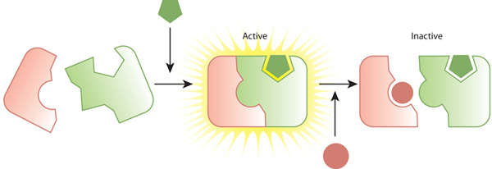
- Identify the following in the reaction above (2mks
i) M ……………………………………………………………………………………..
ii) N ……………………………………………………………………………………..
- What is the effect of removal of element N in the reaction above? (1mk
.....…………………………………………………………………………………………...
- i) Why are enzymes denatured by high temperatures? (1mk
.....…………………………………………………………………………………………... .....…………………………………………………………………………………………...
ii) Provide TWO properties of enzymes (2mks
.....…………………………………………………………………………………………... .....…………………………………………………………………………………………...
- If the reaction shown above is blood clotting process and the substrate is prothrombin. Give the correct identity of the following: (2mks
i) Enzyme…..…………………………………………………………………………..
ii) M …………………………………………………………………………………….

- The following diagram shows a set up before and the results after the experiment.
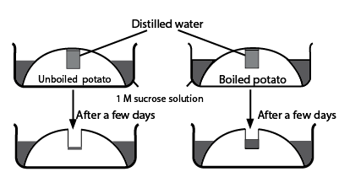
- What was the aim of the experiment? (1mk
.....…………………………………………………………………………………………... .....…………………………………………………………………………………………...
- Account for the observation made in the unboiled potato (2mks
.....…………………………………………………………………………………………... .....…………………………………………………………………………………………...
- State TWO importance of the physiological process investigated to a human cell (2mks
.....…………………………………………………………………………………………... .....…………………………………………………………………………………………...
- Which property of the cell membrane of cells is revealed by the results shown by:
i) Boiled potato (1mk
.....…………………………………………………………………………………………...
ii) Unboiled potato (1mk
.....…………………………………………………………………………………………...
- How is active transport different from the physiological process investigated above?
..................................................................................................................................…(1mk
- The following is an illustration of germination process of a seed
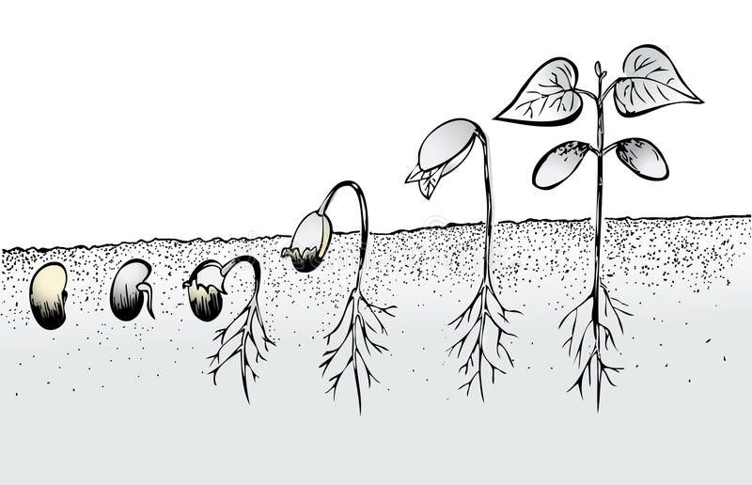
R
S
B
A
C
- Identify the type of germination represented above (1mk
.....…………………………………………………………………………………………...
- Give TWO reasons for your answer in a) above (2mks
.....…………………………………………………………………………………………... .....…………………………………………………………………………………………...
- Account for the expected change in dry weight of the cotyledon at stages A and B
.....…………………………………………………………………………………………........…………………………………………………………………………………… (2mks
- Explain the significance of part R being curved (1mk
.....…………………………………………………………………………………………... .....…………………………………………………………………………………………...
- Explain why stage C has the highest dry weight compared to the other stages (2mks
.....…………………………………………………………………………………………... .....…………………………………………………………………………………………...

- The following is an illustration of various stages of cell division in a cell
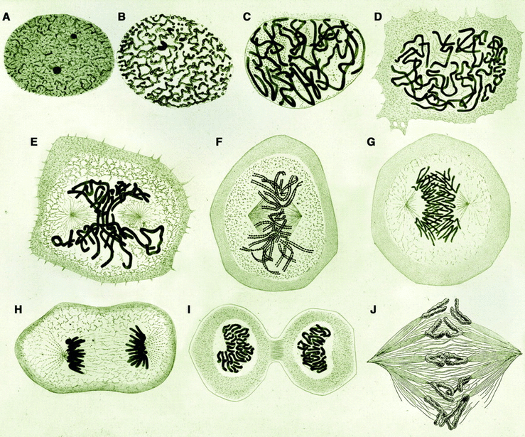
- Give a reason to show that the process illustrated above is:
i) Mitosis (1mk
.....…………………………………………………………………………………………...
i) Taking place in an animal. (1mk
.....…………………………………………………………………………………………...

b) With a reason identify the stage labelled F: (2mks
Stage…………………………………………………………………………………….
Reason ………………………………………………………………………………….
- What is the significance of the stage labelled H in cell division process (1mk
.....…………………………………………………………………………………………...
- State the differences between meiosis and mitosis in terms of the following (3mks
Feature | Meiosis | Mitosis
Number of Daughter Cells
Crossing over
Nucleus of Daughter cells
- The following diagram shows onion cells as observed in a field of view of a light microscope
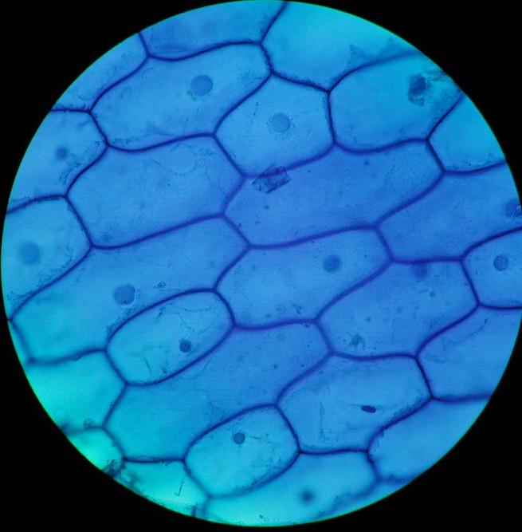
- Determine the following along the white line that run across the field of view: (2mks
i) Number of cells …………………………………………………………..
ii) Diameter of field of view ………………………………………………..mm
- i) From the information generated in a) above determine the diameter of one cell in micrometers (3mks
.....…………………………………………………………………………………………........…………………………………………………………………………………………........…………………………………………………………………………………………...
ii) If the field of view has a total magnification of X1500. Determine the actual diameter of one cell (2mks
.....…………………………………………………………………………………………........…………………………………………………………………………………………........…………………………………………………………………………………………...
iii) Give ONE weakness of this method of calculating size of a cell (1mk
.....…………………………………………………………………………………………........…………………………………………………………………………………………...
SECTION B (40 MARKS)
Question 6 is Compulsory. Choose to do either Question. 7 or Qn. 8
- The table shown below is the result of an experiment on the effect of temperature on the rate of photosynthesis of different batches of plants of same species by measuring the volume of Oxygen gas released at different temperatures
Batch | Temperature (⁰C) | Volume of Oxygen (cm³)
1 | 10 | 18
2 | 15 | 21
3 | 20 | 25
4 | 25 | 35
5 | 30 | 48
6 | 35 | 48
7 | 40 | 38
8 | 45 | 20
9 | 50 | 5
10 | 55 | 0

- On the graph provided, draw a graph of volume of Oxygen produced against temperature (6mks
- Account for the shape of the graph at temperature of:
i) 10-20ºC (3mks
.....…………………………………………………………………………………………........…………………………………………………………………………………………........…………………………………………………………………………………………...
ii) 40-50 ºC (3mks
.....…………………………………………………………………………………………........…………………………………………………………………………………………........…………………………………………………………………………………………...

- i) Determine the following from the graph
i) Optimum temperature for the process of photosynthesis in the plant studied (1mk
.....…………………………………………………………………………………………........…………………………………………………………………………………………...
ii) Volume of Oxygen produced at 23 ºC (1mk
.....…………………………………………………………………………………………........…………………………………………………………………………………………...
- Write a word equation to represent photosynthesis process (1mk
.....…………………………………………………………………………………………........…………………………………………………………………………………………...
- Apart from temperature, give THREE factors that increase rate of photosynthesis
.....…………………………………………………………………………………………........…………………………………………………………………………………………........…………………………………………………………………………………… (3mks
- Explain how optimum temperature during photosynthesis increases biodiversity in an ecosystem (2mks
.....…………………………………………………………………………………………........…………………………………………………………………………………………... .....…………………………………………………………………………………………........…………………………………………………………………………………………...
- a) Outline various ways of controlling air pollution (4mks
b) Describe adaptations of the mammalian heart to its functions (16mks
- a) Explain the effect of increased physical body activity on the following organs: (13mrks
i) Heart
ii) Kidneys
b) Outline structural differences that exist between members of Class Dicotyledonae and Class Monocotyledonae (7mks
.....……………………………………………………………………………………….....……..………………………………………………………………………………….....…………………..……………………………………………………………………........……………………………………………………………………………………….....………………………………………..……………………………………………….....…………………………………………………..……………………………………........……………………………………………………………………………………….....………………………………………………………………………..……………….....………………………………………………………………………………….. .....……………………………………………………………………………………….....……..………………………………………………………………………………….....…………………..……………………………………………………………………........……………………………………………………………………………………….....………………………………………..……………………………………………….....…………………………………………………..……………………………………........……………………………………………………………………………………….....………………………………………………………………………..……………….....………………………………………………………………………………….. .....……………………………………………………………………………………….....……..………………………………………………………………………………….....…………………..……………………………………………………………………........……………………………………………………………………………………….....………………………………………..……………………………………………….....…………………………………………………..……………………………………........……………………………………………………………………………………….....………………………………………………………………………..……………….....………………………………………………………………………………….. .....……………………………………………………………………………………….....……..………………………………………………………………………………….....…………………..……………………………………………………………………........……………………………………………………………………………………….....………………………………………..……………………………………………….....…………………………………………………..……………………………………........……………………………………………………………………………………….....………………………………………………………………………..……………….....………………………………………………………………………………….. .....……………………………………………………………………………………….....……..………………………………………………………………………………….....…………………..……………………………………………………………………........……………………………………………………………………………………….....………………………………………..……………………………………………….....…………………………………………………..……………………………………........……………………………………………………………………………………….....………………………………………………………………………..……………….....………………………………………………………………………………….. .....……………………………………………………………………………………….....……..………………………………………………………………………………….....…………………..……………………………………………………………………........……………………………………………………………………………………….....………………………………………..……………………………………………….....…………………………………………………..……………………………………........……………………………………………………………………………………….....………………………………………………………………………..……………….....………………………………………………………………………………….. .....……………………………………………………………………………………….....……..………………………………………………………………………………….....…………………..……………………………………………………………………........……………………………………………………………………………………….....………………………………………..……………………………………………….....…………………………………………………..……………………………………........……………………………………………………………………………………….....………………………………………………………………………..……………….....………………………………………………………………………………….. .....……………………………………………………………………………………….....……..………………………………………………………………………………….....…………………..……………………………………………………………………........……………………………………………………………………………………….....………………………………………..……………………………………………….....…………………………………………………..……………………………………........……………………………………………………………………………………….....………………………………………………………………………..……………….....…………………………………………………………………………………..

