MARKING SCHEME
MOMALICHE JOINT EVALUATION EXAM
Kenya Certificate of Secondary Education (KCSE)

INSTRUCTIONS TO CANDIDATES
- Write your name and index number in the spaces provided above
- Sign and write the date of examination in the spaces provided above
- This paper consists of TWO sections A and B.
- Answer ALL questions in section A in the spaces provided
- In section B answer question 6(compulsory) and either question 7 or 8in the spaces provided after question 8
- This paper consists of 8 printed pages
- Candidates should check the question paper to ascertain that all the pages are printed and that no questions are missing

FOR EXAMINERS USE ONLY
Section | Question | Maximum score | Candidate score
A | 1  2  3  4  5 | 8  8  8  8  8
B | 6  7  8 | 20  20  20
 | TOTAL | 80

SECTION A
- The following is an illustration of a certain process that occurs in mammals

+ Juice X process P

A fat molecule

(a) Name process P Emulsification ; (1mark)

(b) Name the juice involved in the process P Bile juice; (1 mark)
(c) List two Salts found in the juice name in (b) above that aids in process P (2 marks)
(i) sodium taurocholate ;
(ii) sodium glycocholate ;
(d) Give a reason why liver damage leads to impaired digestion of fats (1 mark)
Bile is produced in the liver ;
(e) What would be the likely effect on digestion if the small intestine of a human is reduced in an operation? (2 marks)
Surface area of digestion would be reduced hence the rate of digestion ;
- Absorption process would be reduced ; (2 x 1) (f) State the fate of excess glucose in the human body. (1 mark)
Stored in the body as fats or stored as glycogen in the liver and muscles
- The diagrams below shows samples of blood obtained from two different persons A and B. 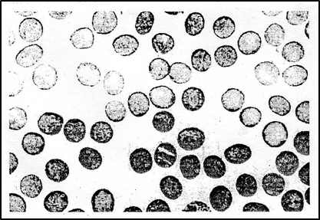 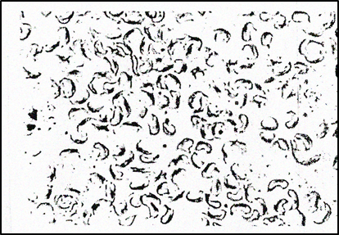
Blood sample from person A Blood sample from person B

a) What genetic disorder is person B suffering from? (1 mark)
Sickle cell anaemia
(b) State one advantage and one disadvantage of the disorder in (a) above when its in heterozygous state. (2 marks)
(i) Advantage – individual having this condition rarely suffer from malaria
(ii) disadvantage – suffocation due to insufficient supply of oxygen to the (respiring) body tissues ;
(c) Work out the genotypes and phenotypes of the resulting offsprings of marriage between person A and person B (5 marks)

♂ ♀
Parental phenotypes Person A Person B
Parental Genotype HbA HbA X HbS HbS (1 mk)
HbA

HbA
HbS
HbS
Gametes
fusion
(1mk)
(1mk)

F 1 Generation HbAHbS HbAHbS HbAHbS HbAHbS (1 mk)
Phenotypes; All have sickle cell traits, ♂ (1 mk)
Genotypes; All are HbAHbS;

The diagram below shows three different types of neurons along a reflex arc

(a) What is a reflex arc? (1mark)
Pathway followed by a nerve impulse that gives rise to a reflex action
(b) Identify the neurons labeled 1 and 2 (2 marks)
1- motor neurone
2 – relay neurone/intermediate neurone
(c) Using arrows show, the direction of impulse transmission on the diagram. (1 mark)
The arrows point towards neurone 1 from 2 and 3
(d) Name the part of the spinal cord where the cell bodies of neurone 1 and 2 are located
Grey matter (1 mark)
(e) Describe the transmission of impulse across the part labeled P (3 marks)
Impulse reaching the dendrite end of relay neurone causes the synaptic vesicles to release a acetylcholine/transmitter substance; into the synaptic cleft, the acetylcholine/transmitter chemical diffuses across the synaptic cleft; and causes the depolarization of the motor neurone/post synaptic membrane. Sodium ions from the cleft then flow through the post synaptic membrane causing an action potential which is transmitted as a nerve impulse along the motor neurone
4. During an ecological study of a grassland ecosystem, a group of students recorded the following observations.
- Grasshoppers feed on grass
- Guinea fowls feed on grasshoppers, termites
- Vultures feed on guinea fowls and leopards
- Leopards feed on gazelles
- Termites feed on grass
- Gazelles feed on grass
(a) From this record of observations construct a food web. (4 marks)
Guinea fowls
: Award a mark for every trophic level

Leopard
Vultures
Gazelles
Grass
Termites
Grasshoppers

(b) Write down, the food chains in which the guinea fowls are secondary consumers. (2 marks)
Grass Grasshoppers Guinea fowls;
Grass Termites Guineas Fowls;
(c) Name the organisms through which energy from the sun enters the food web. Grass
d) Name the organism that has the least biomass in the food web. (1mark)
Vultures
4.Below is a chemical equation, study it and answer the questions that follow:-
A
Carbon(IV) oxide + water Oxygen + glucose
B
(a) Name process A and B (2 Marks)

5.(a) A- Photosynthesis ;
B – Respiration

(b) What is the biological significance of process A (1 mark)
Provision of food to plants organisms when convert light energy into chemical energy to make their own food which is later consumed by animals ;
(c) In which organelle does process A and B take place? (2 marks)
A – chloroplast ;
B – Mitochondrion ;

(d) Name two stages of process B (2 marks)
Glycolysis ; Kreb’scycle
(e) Define compensation point ( 1mark)
This is the point when the rate of photosynthesis is equal to the rate respiration / All the carbon dioxide released in respiration is used up by photosynthesis.
SECTION B (40 MARKS)
Answer Question 6 (Compulsory) And Either Question 7 Or 8 In The Spaces Provided After Question 8

6.The graph below shows changes in pH and oxygen saturation in river water over a 24 hour period
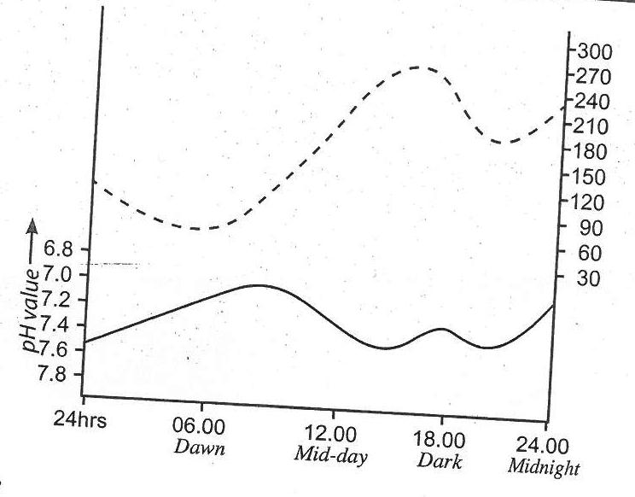
% Oxygen saturation
Key
_______ pH value
…………. % saturation of oxygen dissolved

a) when is the pH value and dissolved oxygen saturated % highest? (2 marks)
(i)pH -3.00 p.m or 1500
(ii) dissolved oxygen -3.00 p.m of 1500 –
(b) Account for the pH value recorded
(i) Between 06.00 and 9.00 a.m (2 marks)
pH increased between 06.00 to 09.00; because of increased rate of photosynthesis ; in aquatic plants, which consumed more carbon(IV) oxide gas dissolved in water;
(ii) Between 2100 and 2400 midnight (2 marks)
pH decreased between 2100 to 2400; of carbon (IV) oxide which was being produced; by the respiring; water plants, but was not being used for photosynthesis;
(c) Explain the influence of light intensity on % saturation of oxygen dissolved in this study (4 marks)
Increasing light intensity increases the rate of photolysis/photosynthesis hence increased production of oxygen gas while decreasing light intensity decreases the rate of photolysis; hence reduce production of oxygen gas;
Acc. Photosynthesis instead of photolysis
(d) State two structural adaptations that the submerged plants in this river have, which enable them to carry out photosynthesis (2 marks)
Have dissected/branched leaves which provide a large surface area of light absorption and gaseous exchange;
Leaves have chlorophyll which is very sensitive to light;
(e) Explain the variations that will be recorded if a similar study was carried out in a river near a nitrate fertilizer industry. (4 marks)
Some nitrate fertilizer would get into the river water; thus causing rapid growth of many water plants;
Many water plants, photosynthesize food under high light intensity using a lot of carbon (IV) oxide gas thus raising pH value; and produce a lot of Oxygen, increasing the concentration of oxygen;
The very many water plants also respire rapidly under low light intensity thus producing large volume of carbon (IV) oxide gas which greatly lowers the pH of water ;
- Explain the various ways in which a typical cell is adapted to its functions (20 marks)
Has a cell membrane; with pores; that regulates substances entering and leaving the cell; cytoplasm; contain sugars and salts; for maintaining its osmotic pressure; also has a liquid medium; for all biochemical reactions; nucleus; contain chromosomes having hereditary material; and controls all the activities of the cell; ribosomes; are sites for protein synthesis; golgi bodies/apparatus; for secretion of hormones and enzymes; formation of lysosomes; lysosomes; contain lytic enzymes for breaking down worn-out organelles; secretory vesicles; formed from golgi apparatus for secreting substances; smooth endoplasmic reticulum; synthesizes and transports lipids; rough endoplasmic reticulum; transport proteins; nucleolus; controls the activities of the nucleus; produces ribosomes; mitochondria; form sites for energy production; centrioles; formation of cilia and flagella; forms spindle fibres used in cell division; plant sap vacuoles; store salts and other dissolved substances; controls osmotic pressure and turgidity of cells; food vacuoles involved in digestion of engulfed food; chloroplasts; form sites for photosynthesis in plant cells; Max. 20 mks
- Discuss the causes, effects and control measures for water pollution (20 marks)
Causes of water pollution are varied: industrial effluents; have heavy metals that poison aquatic organisms; untreated organic matter has phosphates/sulphates/nitrates/salts; that cause eutrophication; causing algal bloom that deprives the water of nutrients; when the algae die, they lead to an increase in putrefying bacteria whose decomposition activities lead to the release of awful smells/odours; oil effluents clog respiratory surfaces of aquatic organisms/death due to suffocation; domestic effluents/sewage; form a habitat of pathogens that spread water borne diseases; decomposing sewage promotes eutrophication leading to algal bloom; death promotes/attracts saprophytic bacteria that use up oxygen in water; causing suffocation/death to aquatic organisms; agrochemicals/fertilizers; phosphates/nitrates; cause eutrophication; heavy metals in agrochemicals (herbicides/pesticides); affect respiratory surfaces/cause breathing problems; Hot water; raise temperature of water; killing organisms; dissolves less oxygen; reducing its content in water; Oil spillage; in oceans from tanks/refineries; soak feathers of marine birds preventing flight; clogs respiratory surfaces leading to death; coats photosynthetic phytoplanktons; reduces light penetration hampering photosynthesis; Sediments; from soil erosion makes water dirty; making it unfit for consumption; clogs respiratory surfaces hindering gaseous exchange; reduces light penetration hindering photosynthesis; Control methods: Enforcement of environmental laws; Use of unleaded fuel/petroleum products; Proper treatment and disposal of sewage wastes; Treatment of industrial effluents before release; Public education on correct use of inorganic fertilizers and agrochemicals; and use of alternatives such as biological control of weeds/pests/organic manure; Use of undersea pipelines instead of tankers to transport oil products; Cooling hot water before release to water bodies; Max. 20 mks

