Term 1 – 2023-OPENER EXAM
BIOLOGY (231/2)
FORM FOUR (4)
Time: $2 Hours$

MARKING SCHEME

SECTION A
- a)i) M – Co-factor/Co-enzyme;
ii) N – Inhibitor;
b) Enzyme-Substrate complex will be activated/Reaction will proceed/Substrate binds to enzyme’s active site/Substrate will be broken down to products; OWTTE
c)i) Since they are protein in nature;
ii) Reactions are reversible; They are Substrate-specific; Protein in nature/Denatured by temperature beyond optimum/extreme pH; Mark 1st 2
d)i) Enzyme-Thrombokinase/Thromboplastin;
ii) M – Vitamin-K; Calcium Ions;
- a) Investigate the effect of temperature/boiling on osmosis;
b) The sucrose solution is hypertonic/more concentrated than the cell sap of potato cells (and the Distilled water in the depression); a concentration gradient is formed and water molecules move from the distilled water into the potato cells by osmosis; (leading to now water in the depression in the potato)
c) Maintains osmotic pressure of the cells/osmoregulation; Facilitate entry and exit of water into/out of the cell cytoplasm;
d)i) Semi-permeability;
ii) Sensitive to changes in temperature/denatured (destroyed) by high temperature beyond optimum;
e) Active transport requires energy; requires carrier molecules; Occurs against concentration gradient; Mark 1st one

- a) Epigeal
b) Cotyledon are carried above the ground; Elongated hypocotyl;
c) Dry weight reduces; stored food are hydrolysed to supply energy for cell division/germination/growth/development/formation of new tissues;
d) To push through the soil so as to prevent damage to delicate bud by soil particles as it emerges above the ground;
e) Photosynthesis occurs; thus food is stored/formation of new tissues/growth due to high rate of cell division;
- a)i) Two daughter cells are formed at stage J;
ii) Constriction along the equator to form two daughter cells at stage J;
b) Stage: metaphase;
Reason: Chromosomes are aligned along the equator of the cell;
c) Separation of the daughter chromatids;
d)
Feature | Meiosis | Mitosis
Number of Daughter Cells | 4 | 2;
Crossing over | Occurs | Does not occur;
Nucleus of Daughter cells | Haploid | Diploid:

- a)i) Number of cells: 7 cells;
ii) Diameter: 65millimeters;
bi) Diameter of one cell = (65mm ÷ 7 cells)/1cell;
= 9.29mm;
= 9.29 x 1000micrometers
= 9290micrometers;
ii) Actual diameter = Image length ÷ Magnification
= 9290 micrometers ÷ x1500;
= 6.1933micrometers;

SECTION B

- a)
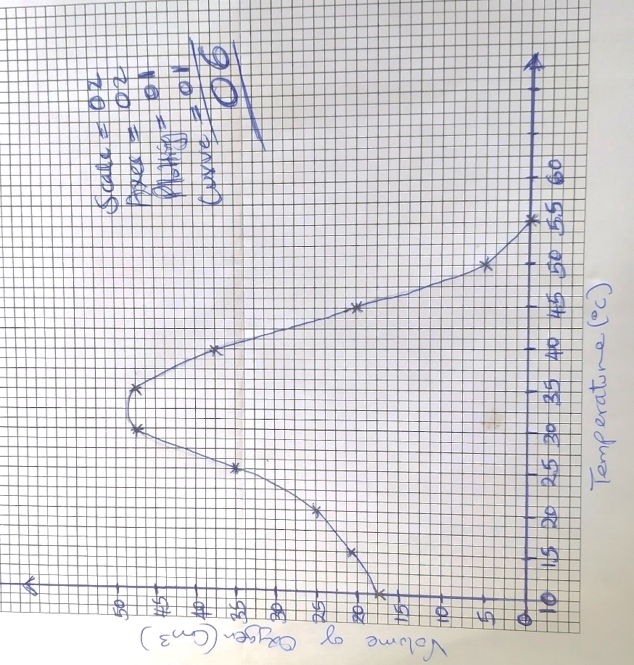
b) i) Low Oxygen production; Since low temperatures inactivated the photosynthetic enzymes; causing low rate of photosynthesis;
ii) Declining Oxygen production; Since temperature beyond optimum denature/destroy enzymes; causing low rate of photosynthesis;
c) i) 32.5 ± 0.5 ºC;
ii) 30cm³;
d) Water + Carbon (IV) Oxide Glucose + Oxygen;
e) Optimum light intensity; Rainfall/More water; Optimum Carbon (IV) Oxide concentration; Mark 1st 3
f) Increase primary productivity/Growth rate thus more food/plant material; more herbivores migrate to the ecosystem that attract more carnivores; which reproduce (leading to high diversity);

- a)
- Fit vehicles with catalytic converters in their exhaust pipes to reduce emission of polluting gases
- Use lead free fuels in motor vehicles
- Develop and use renewable energy sources such as solar and wind energy
- Use of biological methods to control pests, diseases and weeds
- Ban smoking in public
- Use CFC free aerosols

b)
- It has valves which prevent the back flow of blood.
- Cuspid valves have tendons that prevent the valves from turning inside out during systole/when ventricles contract.
- The ventricles have thicker walls to generate high pressure to pump blood.
- The wall of left ventricle thicker than the right ventricle to pump blood over longer distance;
- It has cardiac muscles which contract and relax continuously without fatigue;
- The cardiac muscles are myogenic i.e. contract and relax without nervous stimulation;
- Cardiac muscles are interconnected to form a network of fibres to rapidly and uniformly spread the waves of contractions throughout the heart wall;
- The cardiac muscles have numerous mitochondria to generate energy for efficient muscular contraction;
- It has sino atrial node (SAN) that acts as pace maker/Generates waves of contraction;
- It has atrioventricular node (AVN) which relay contraction waves from sino atrial node (SAN) to the purkine tissue;
- Has purkine tissue to relay waves from the atrioventricular node (AVN) to the ventricular myocardium/All parts of the heart;
- It has coronary artery that supply heart tissue with blood in order to nourish the heart/ supply nutrients and oxygen to the heart muscles.
- It has coronary vein to remove Carbon (IV) oxide and metabolic wastes from heart tissues;
- It is divided into 4 chambers for the atria to receive blood and the ventricles to pump blood out of the blood;
- It has a septum to prevent the mixing of low Oxygen/High Carbon (IV) Oxide concentration and that of high Oxygen/Low Carbon (IV) Oxide concentration for efficient Oxygen supply to tissues;
- It is enclosed by pericardium to prevent over dilation/ overstretching of the heart/keep the heart in position.
- The pericardium secretes pericardial fluid to reduce friction /lubricate the heart;
- Heart is covered with thick adipose/fat tissue to absorb shock;
- Has vena cava and pulmonary vein to supply blood to the heart;
- Has aorta and pulmonary artery to transport blood away from the heart;
- Has Pericardium that prevents over-dilation of the heart during diastole;

- a) i) Heart: Heartbeat/rate/frequency increases; this increases blood pressure; and more blood is pumped to the muscles; at a faster rate; supplying more Oxygen; and nutrients; for continued Oxidation of food/respiration; to give more energy to sustain (vigorous) contraction and relaxation of muscles (during physical activity); the high pressure also ensure faster transport of Metabolic/Nitrogenous wastes/Lactic acid/Carbon (IV) Oxide to excretory organs for their elimination; such wastes if allowed to accumulate, intoxicate/poison cells;
ii) Kidney: Kidney help maintain blood plasma pH; and Osmotic pressure (of body fluids); by eliminating excess Hydrogen ions that accumulate due to production of lactic acid/Carbon (IV) Oxide during exercise; to maintain Osmotic pressure of blood; the kidneys conserve Sodium/Na⁺ ions; and reabsorb more water molecules; leading to reduction of volume of Urine produced; More Urea/Nitrogenous wastes are also filtered out by the kidney into the urine;

b)
Class Monocotyledonae | Class Dicotyledonae
One cotyledon | Two cotyledons;
Parallel venation in leaves | Net venation in leaves;
In most monocots, leaf petiole is modified to form a leaf sheath | Leaf petioles are not modified into sheath/Have leaf stalk;
Lack pith in stem | Have pith in the stem;
Most lack lateral meristems / vascular cambium hence no secondary/ lateral growth | lateral meristems/ vascular cambium common, resulting in secondary growth;
Flower parts in multiples of 3 | Flower parts in multiples of 4 or 5;
Fibrous root system | Tap root system;
In root, vascular bundles are arranged in a ring with phloem and xylem alternating | In the root, xylem is centrally placed and star-shaped, with phloem alternating with the arms of the xylem ;
Vascular bundles scattered in stem cortex | Vascular bundles arranged in a ring near the outer edge of the stem;

