SUKELLEMO JOINT PREMOCK
PAPER 1
231/1
TIME: 2HOURS
JOINT EXAMINATIONS
JUNE 2022.
NAME: ………………………………………………………….. CLASS: ………………….
SCHOOL: ……………………………………………………….
Instructions candidate.
- Answer all the questions in this paper in the spaces provided.
- This paper consists of 11 printed pages. Candidate should check the question paper to ensure that all pages are printed as indicated and that no question is missing.
- Candidate should answer the question in correct English.

For examiner use only.
1 | 2 | 3 | 4 | 5 | 6 | 7 | 8 | 9 | 10 | 11 | 12 | 13 | 14 | 15 | 16 | 17

18 | 19 | 20 | 21 | 22 | 23 | 24 | 25 | 26 | 27 | 28 | 29
Total  Score | Candidate’s  Score
80

- Identify the characteristics of living organisms shown by the following; (2marks)
- Bursting of the sporangium in Rhizopous.
………………………………………………………………………………………
- A cheetah chasing after a gazelle.
………………………………………………………………………………………..
- Define the following terms as used in biology;
- Entomology. (1mark)
…………………………………………………………………………………………………………………………………………………………………….
- Histology. (1mark)
…………………………………………………………………………………………………………………………………………………………………….
- State three significance of Osmosis to plant nutrition. (3marks)
……………………………………………………………………………………………………………………………………………………………………………………………………………………………………………………………………………………………………………………………………………………………………………………………………………………………………………………………………
- The diagram below represents amoeba. Study it and answer the questions that follow;

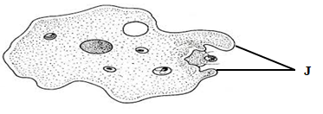
- Name the respiratory surface found in the above organism. (1mark)
……………………………………………………………………………………
- i. Identify the structures labeled J. (1mark)
…………………………………………………………………………………

- State two functions of the structure named in (b) (i) above. (2marks)
……………………………………………………………………………………………………………………………………………………………………………………………………………………………….
- Below is a diagram of a mammalian cell. Study it and answer the questions that follow.
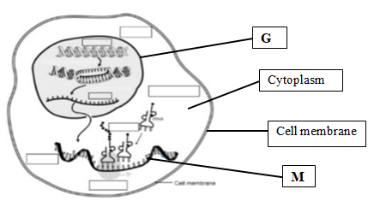
a) Identify the structures labeled; (2marks)
G. …………………………………………………..
M. …………………………………………………..
b) State the function of the structure labeled M. (1mark)
………………………………………………………………………………………………………………………………………………………………………………
- Give two roles of the colon in human digestive system. (2marks)
……………………………………………………………………………………………………………………………………………………………………………………
- Distinguish between dentition and dental formula. (2marks)
………………………………………………………………………………………………………………………………………………………………………………………………………………………………………………………………………………
………………………………………………………………………………………….
- Name a carbohydrate that is abundance in the following;
- Ripe fruits. (1mark)
……………………………………………………………………………………..
- Blood of vertebrates. (1mark)
………………………………………………………………………………………
- Apart from photosynthesis identify one other function of chloroplast in plants. (1mark)
……………………………………………………………………………………………………………………………………………………………………………………..
- Below is a transverse section of a root. Study the diagram and answer the question that follows.
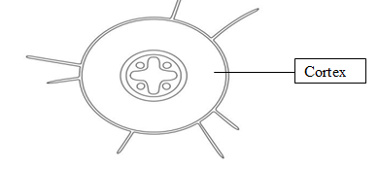
- Identify the class from which the section was obtained. (1mark)
………………………………………………………………………………………
- Give a reason for your answer in (a) above. (1mark)
………………………………………………………………………………………………………………………………………………………………………………………………………………………………………………………………………
- State one adaptation of endodermis to its function. (1mark)
………………………………………………………………………………………………………………………………………………………………………………
- Name two tissues found in the cortex. (2marks)
……………………………………………………………………………………..
……………………………………………………………………………………..

- Distinguish between Guttation and transpiration. (2marks)
…………………………………………………………………………………………………………………………………………………………………………………………………………………………………………………………………………………………………………………………………………………………………………
- During a field study, students from Kenya high school found a woody plant as illustrated below.
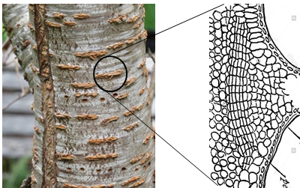
- Identify the above structure. (1mark)
……………………………………………………………………………………
- Give two adaptations of the structure named in (a) above. (2marks)
……………………………………………………………………………………………………………………………………………………………………………………………………………………………………………………………………………………………………………………………………………………………..
- Where is the above structure located in halophytes? (1mark)
……………………………………………………………………………………..
- State two structural differences between a cell wall and a cell membrane. (2marks)
…………………………………………………………………………………………………………………………………………………………………………………………………………………………………………………………………………………………………………………………………………………………………………

- a) Identify the cells that secrete the following along the alimentary canal.
- Hydrochloric acid. (1mark)
..........................................................................................................................................
- Rennin. (1mark)
………………………………………………………………………………………….
- State two significance of smooth muscles in the digestive system. (2marks)
……………………………………………………………………………………………………………………………………………………………………………………………………
- During an investigation of a certain metabolic reaction, students set up the apparatus as shown below.
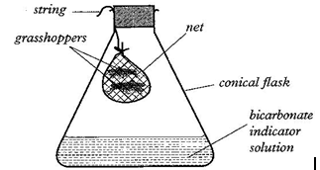
- Identify the physiological process being investigated. (1mark)
………………………………………………………………………………..
- Account for the observation made in the conical flask after 30 minutes.
(2marks)
……………………………………………………………………………………………………………………………………………………………………………………………………………………………………………………..
- a) State three ways in which human skin protects the body against bacterial infection.
(3marks)
………………………………………………………………………………………………………………………………………………………………………………………………………………………………………………………………………………………………………………………………………………………………………………………………
b, Name the protein found in the Malpighian layer of the skin and state its function.
Name. ……………………………………………………………………. (1mark)
Function. …………………………………………………………................... (1mark)
17. A student mixed a sample of urine from a person with Benedict’s solution and heated, the colour changed to orange.
a) What did the student conclude on the health status of the person? (1mark)
……………………………………………………………………………………………
b) Which organ in the person may not be functioning properly? (1mark)
……………………………………………………………………………………......
- An investigation was carried out on a mammalian kidney.
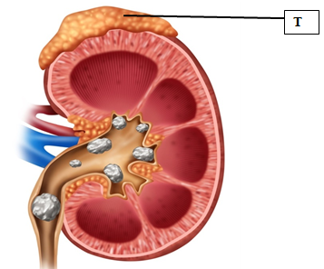
- Name the structure labeled T. (1mark)
………………………………………………………………………………………
- What is the function of the structure named in (i) above in the kidney. (1mark)
………………………………………………………………………………………………………………………………………………………………………………
- Identify the disease shown in the kidney above. (1mark)
……………………………………………………………………………………..
- State the importance of Saprophytic fungi in an ecosystem. (1mark)
…………………………………………………………………………………………………………………………………………………………………………………….
- List two assumptions made when using Capture-recapture as a method of estimating population. (2marks)
………………………………………………………………………………………………………………………………………………………………………………………………………………………………………………………………………………………………………………………………………………………………………..
- Give two reasons why Pteridophytes are considered more advanced than Bryophytes.
(2marks)
…………………………………………………………………………………………………………………………………………………………………………………………………………………………………………………………………………………......................................................................................................................................
- Study the diagram below and answer the following questions.
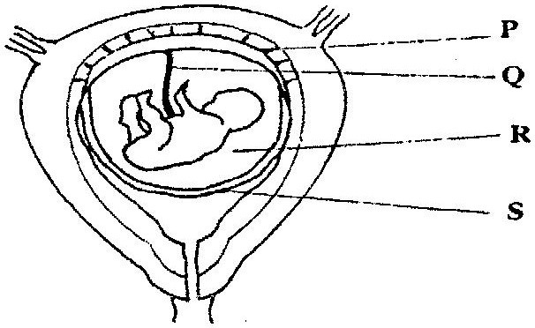
- State the function of the part labeled Q. (2marks)
………………………………………………………………………………………………………………………………………………………………………………………………………………………………………………………………………………………………………………………………………………………………

- State the role of the part labeled R. (1mark)
……………………………………………………………………………………………………………………………………………………………………………..
- Identify a hormone produced by part labeled P. (1mark)
…………………………………………………………………………………….
- Give the function of Prolactin in female reproductive cycle. (1mark)
……………………………………………………………………………………………………………………………………………………………………………………
- Below is a photograph illustrating a germinating seedling.
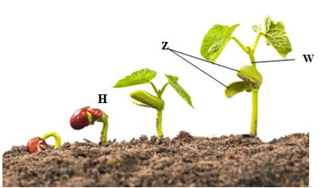
- Identify the type of germination. (1mark)
………………………………………………………………………………………
- Give two functions of the structure labeled Z? (2marks)
………………………………………………………………………………………………………………………………………………………………………………………………………………………………………………………………………………………………………………………………………………………………
- What the name given to the part labeled W? (1mark)
………………………………………………………………………………………
- Explain how seedling H responds to light causing it to straighten. (2marks)
………………………………………………………………………………………………………………………………………………………………………………………………………………………………………………………………………………………………………………………………………………………………
- a) Define vestigial structures? (1mark)
…………………………………………………………………………………………………………………………………………………………………………………………………………………………………………………………………………….
b) State two examples of vestigial structures in man. (2marks)
……………………………………………………………………………………………………………………………………………………………………………………
- The figure below shows some cells from parts of mammalian respiratory tract.
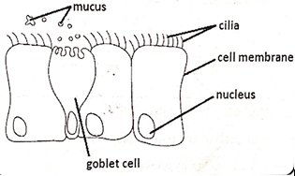
- Identify the part of the respiratory tract where the cells were obtained from. (1mark)
…………………………………………………………………………………………..
- Explain the role of: (2marks)
- The mucus
……………………………………………………………………………………………………………………………………………………………………
- The cilia.
…………………………………………………………………………………………………………………………………………………………………..
- Mycorrhiza is a symbiotic association between two organisms. Name the two organisms that make this association. (2marks)
……………………………………………………………………………………………………………………………………………………………………………………

- State the significance of diffusion in the following;
  - Pollination. (1mark)
……………………………………………………………………………………………………………………………………………………………………
  - Skeletal muscle cell. (1mark)
……………………………………………………………………………………………………………………………………………………………………
…………………………………………………………………………………
- Explain the significance of the following;
- The cardiac muscle is myogenic. (1mark)
……………………………………………………………………………………………………………………………………………………………………………………………………………………………………………………………………………………………..
- The left ventricle of a mammalian heart is more muscular than right ventricle.
(1mark)
……………………………………………………………………………………………………………………………………………………………………………………………………………………………………………………………………………..
- Most of carbon (IV) oxide is not dissolved in the blood plasma. (1mark)
…………………………………………………………………………………………………………………………………………………………………………………….

THIS IS THE LAST PRINTED PAGE.

