Term 1 – 2023 OPENER EXAM
BIOLOGY(231/1)
FORM FOUR (4)
Time: $2 Hours$

Name: …………………………………………………………. Adm No: ……………….
School: ……………………………………………………….. Class: …………………..
Signature: …………………………………………………….. Date: …………………...

INSTRUCTIONS
- All Questions are Compulsory
- Write your Answers in the Spaces Provided
- Wrong Spelling of Technical Terms shall be Penalized

Max  Score | Student’s Score
80

- Define the term guttation (1mk
………………………………………………………………………………………………………………………………………………………………………………………………

- a) Name the muscle that regulates entry of food bolus into the stomach (1mk
………………………………………………………………………………………………………………………………………………………………………………………………
- How is parotid gland important in starch digestion? (2mks
………………………………………………………………………………………………………………………………………………………………………………………………

- a) Why are proteins said to be amphoteric? (1mk
………………………………………………………………………………………………………………………………………………………………………………………………b) Under which condition does the body resort to using protein as a respiratory substrate?
…………………………………………………………………………………………………………………………………………………………………………………...……(1mk

- Use the diagram shown below to answer the question that follows
R
- Name the organelle shown above (1mk
…………………………………………………………………………………………
- Name structure R and give its importance to the functioning of the organelle shown?
Name………………………………………………………………………….… (1mk Importance……………………………………………………………………………..………………………………………………………………………………...… (1mk
- The illustration shown below is a graph of enzymatic reaction
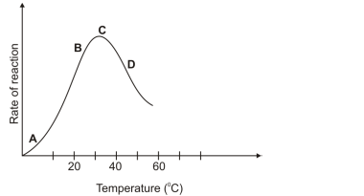
- Account for the rate of reaction shown at D (2mks
……………………………………………………………………………………………………………………………………………………………………………………
- Why is the rate of reaction maximum at C? (1mk
……………………………………………………………………………………………………………………………………………………………………………………

- a) Name an enzyme and co-enzyme important in blood clotting (2mks
i) Enzyme ………………………………………………………………………………
ii) Co-enzyme …………………………………………………………………………..
b) How is blood clotting important in defense of the body? (1mk
…………………………………………………………………………………………...………………………………………………………………………………………….

- a) Why are members of Kingdom Monera referred to as Prokaryotes? (1mk
…………………………………………………………………………………………..
b) Distinguish Class Insecta and Arachnida in terms of the following features (3mks
Feature | Insecta | Arachnida
Antennae
Number of legs
Cephalothorax
- Form 3 students in Garisa High school used the set up below to investigate a physiological process
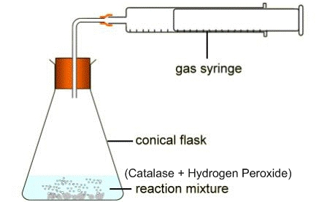
Plunger
- Account for the observation made on movement of the plunger after 5 minutes (2mks
…………………………………………………………………………………………..…………………………………………………………………………………………...………………………………………………………………………………………….
- State the importance of the physiological process investigated to human body? (1mk
…………………………………………………………………………………………..

- State the importance of the absence of the following organelles in the erythrocytes
i) Nucleus (1mk
…………………………………………………………………………………………...….………………………………………………………………………………………………
ii) Mitochondria (1mk
…………………………………………………………………………………………...….………………………………………………………………………………………………

- Even after Susan had placed a few living fish, crabs and some worms in an aquarium filled with water, his teacher of Biology told him that the aquarium did not qualify to be referred as an ecosystem. Give TWO reasons why the teacher made that observation. (2mks
…………………………………………………………………………………………...………………………………………………………………………………………….…….……………………………………………………………………………………...………
- The following are common worms encountered by learners in their ecology lesson. Construct a 2-step dichotomus key using the following features (4mks
- Body Segmentation
- Suckers
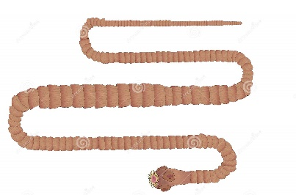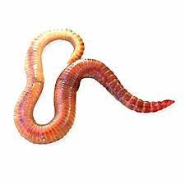
Tapeworm Roundworm Earthworm
…………………………………………………………………………………………..…………………………………………………………………………………………...………………………………………………………………………………………….……..………………………………………………………………………………………………..

- Describe double fertilization in flowering plants (4mks
…………………………………………………………………………………………...….…………………………………………………………………………………………………………………………………………………………………………………...….………………………………………………………………………………………………………

- Use the diagram shown below to answer questions that follow
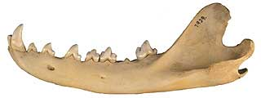
- Give TWO reasons why the jaw shown above is of a carnivorous animal (2mks
…………………………………………………………………………………………...….…………………………………………………………………………………………………………………………………………………………………………………..
- Use X to label the tooth used in seizing prey on the diagram above (1mk
- A photograph of a common animal is shown below
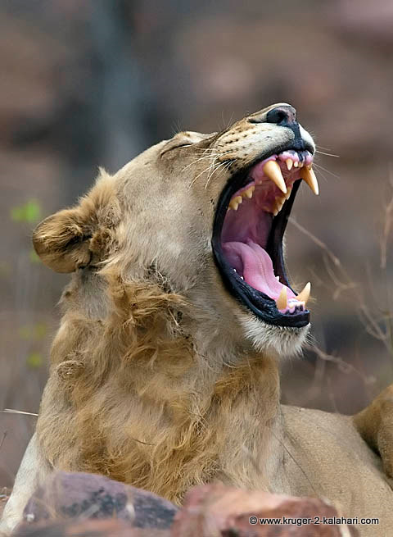
- Give the name of the Class to which the animal shown above belongs (1mk
…………………………………………………………………………………………...….………………………………………………………………………………………
- Give TWO reasons for your answer in a) above (2mks
…………………………………………………………………………………………...….………………………………………………………………………………………

- The diagram shows the position of the pin after an experiment
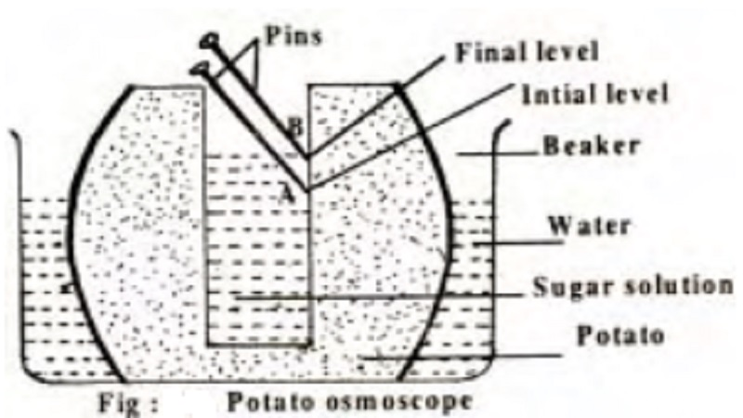
- Which physiological process was being investigated (1mk
…………………………………………………………………………………………..
- Account for the observation made in the experimental set up above (3mks
…………………………………………………………………………………………..…………………………………………………………………………………………..…………………………………………………………………………………………..
- The table below shows the nitrogenous wastes released by various animals
Animal | Nitrogenous Waste
Human Beings | Urea
Desert Rat | Uric acid
Freshwater Fish | Ammonia

- What is the advantage of a desert rat excreting its nitrogenous waste as uric acid?
…………………………………………………………………………………………..…………………………………………………………………………………….(1mk
- Explain why freshwater fish excretes its nitrogenous waste as Ammonia (2mks
…………………………………………………………………………………………..…………………………………………………………………………………………..…………………………………………………………………………………………..

- a) Name the tissue in the pancreas that forms insulin (1mk
………………………………………………………………………………………………
b) Describe how glucagon hormone helps regulate blood sugar (2mks
…………………………………………………………………………………………..…………………………………………………………………………………………..…………………………………………………………………………………………………..

- a) Samson observed 9 cells along the diameter of field view of microscope that had a radius of 1.5mm. Determine the diameter of one cell in micrometers (3mks
…………………………………………………………………………………………..…………………………………………………………………………………………..…………………………………………………………………………………………..…………………………………………………………………………………………..……………………………………………………………………………………………………….
b) Why is fine adjustment knob used when the high power objective lens is in position?
…………………………………………………………………………………………..…………………………………………………………………………………………..(1mk
- The diagram shown below shows a leaf that was used to study photosynthesis. After the experiment, drops of Iodine solution were placed on the processed leaf
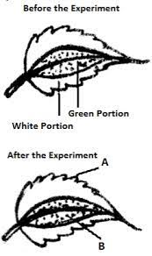
- Which food substance was being tested for? (1mk
…………………………………………………………………………………………..
- Fill in the table below to show the colours observed in the following regions (2mks
Region | Colour
A
B

- Account for observation made on part of the leaf labelled A (2mks
…………………………………………………………………………………………..…………………………………………………………………………………………..…………………………………………………………………………………………..

- State the economic importance of the following metabolic wastes from plants (3mks
i) Papain ……………………………………………………………………………………
ii) Colchicine ………………………………………………………………………………
iii) Tannin ………………………………………………………………………………….

- The experiment set up shown below was used to investigate a physiological process
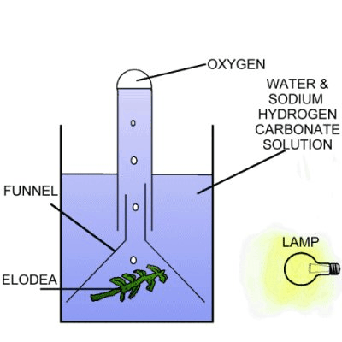
- What was the aim of the experiment? (1mk
…………………………………………………………………………………………..
- Why was Sodium Hydrogen Carbonate added in the water (2mks
…………………………………………………………………………………………..…………………………………………………………………………………………..
- How can one confirm that the gas released in the experiment is Oxygen (1mk
…………………………………………………………………………………………..…………………………………………………………………………………………..

- Give TWO advantages of using glucose as a respiratory substrate (2mks
………………………………………………………………………………………………………………………………………………………………………………………..…..…………………………………………………………………………………………………

- Account for the following observations about human reproductive system (2mks
- The male releases millions of spermatozoa in one ejaculation during copulation
…………………………………………………………………………………………..…………………………………………………………………………………………..
- The semen is alkaline
…………………………………………………………………………………………..…………………………………………………………………………………………..

- a) Why is blood group AB said to be a universal recipient? (2mks
………………………………………………………………………………………………………………………………………………………………………………………..…..…
b) State TWO precautions observed before blood transfusion (2mks
………………………………………………………………………………………………………………………………………………………………………………………………………………………………………………………………………………………..…..…

- State the role of the following during seed germination
- Water (1mk
………………………………………………………………………………………………………………………………………………………………………………………………
- Oxygen (2mks
………………………………………………………………………………………………………………………………………………………………………………………………

- Give the differences between insect-pollinated and wind-pollinated flowers in terms of the following features (3mks
Feature | Insect pollinated | Wind-pollinated
Size of pollen grain
Length of Filament
Size of petals

END

