SUKELLEMO JOINT EXAMINATIONS
PAPER 1 231/1
MARKING SCHEME
- Identify the characteristics of living organisms shown by the following; (2marks)
- Bursting of the sporangium in Rhizopous.
Reproduction
- A cheetah chasing after a gazelle.
Movement and Locomotion
Rej;Nutrition
- Define the following terms as used in biology;
- Entomology. (1mark)
Study of insects
- Histology. (1mark)
Study of tissues
- State three significance of Osmosis to plant nutrition. (3marks)
-Absorption of water from the soil, water used for photosynthesis;
-When the guard cell gain water by osmosis, becomes turgid ,stomata open and carbon (IV) oxide diffuse into the leaf to carryout photosynthesis
-Cells of herbaceous plant gain water become turgid obtaining mechanical support and are able to grow upright to receive maximum sunlight for photosynthesis.
- Change in turgor pressure in insectivorous plant enables these plants to trap insect and obtain nutrients through nastic response.

- The diagram below represents amoeba. Study it and answer the questions that follow;

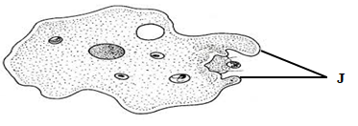
- Name the respiratory surface found in the above organism. (1mark)
Cell membrane.
- i. Identify the structures labeled J. (1mark)
Pseudopodia. Rej; Pseudopodium.
- State two functions of the structure named in (b) (i) above. (2marks)
Used for feeding by engulfing.
Used for locomotion.
- Below is a diagram of a mammalian cell. Study it and answer the questions that follow.
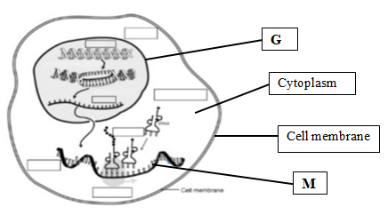
- Identify the structures labeled; (2marks)
G. Nucleus.
M. messenger Ribonucleic acid.

b) State the function of the structure labeled M. (1mark)
It carries genetic information from DNA to the site of protein synthesis in the cytoplasm.
- Give two roles of the colon in human digestive system. (2marks)
Have bacteria that synthesis vitamin K;
Absorption of water;
- Distinguish between dentition and dental formula. (2marks)
Dentition is description of the type, arrangement and specialization of the teeth while dental formula is the description of the number, type and position of the teeth in the jaws of the animal.
- Name a carbohydrate that is abundance in the following;
- Ripe fruits. (1mark)
Fructose
- Blood of vertebrates. (1mark)
Glucose
- Apart from photosynthesis identify one other function of chloroplast in plants. (1mark)
Storage of starch.
Storage of chlorophyll pigment
- Below is a transverse section of a root. Study the diagram and answer the question that follow;
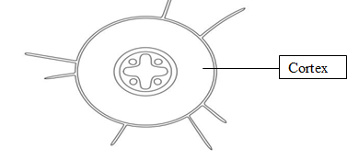
- Identify the class from which the section was obtained. (1mark)
Dicotyledonae.
Rej. dicotyledonae/dicot/Dicotyledonous

- Give a reason for your answer in (a) above. (1marks)
A star shaped xylem
- State one adaptation of endodermis to its function. (1mark)
Have starch grains that are broken down to produce energy for active pumping of water across the endodermis into the xylem tissue.
- Name two tissues found in the cortex. (2marks)
Collenchyma;
Sclerenchyma;
Parenchyma;
Any two
- Distinguish between Guttation and transpiration. (2marks)
Guttation is the loss of water inform of water droplets through hydathodes while transpiration is the loss of water inform of water vapour through the stomata, lenticel or cuticle.
- During a field study, students from Kenya high school found a woody plant as illustrated below.
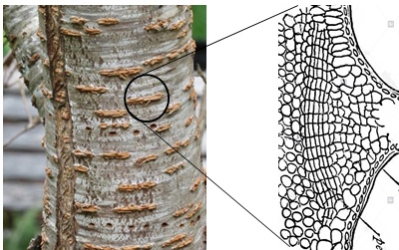
- Identify the above structure. (1mark)
Lenticel;
- Give two adaptations of the structure named in (a) above. (2marks)
Loosely packed cork cells for proper circulation of respiratory gases;
Moist surface to dissolve respiratory gases;

- Where is the above structure located in halophytes? (1mark)
Pneumatophores;
- State two structural differences between a cell wall and a cell membrane. (2marks)
Cell wall | Cell membrane
Made up of cellulose | Made up of protein and phospholipid;
Fully permeable | Semi-permeable/selectively permeable;

- a) Identify the cells that secrete the following along the alimentary canal.
- Hydrochloric acid. (1mark)
Parietal cell/ oxyntic cell;
- Rennin. (1mark)
Chief cells;
- State two significance of smooth muscles in the digestive system. (2marks)
Bring about Peristalsis;
Contraction of the muscles in the stomach brings up Churning;
- During an investigation of a certain metabolic reaction, students set up the apparatus as shown below.
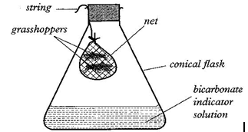
- Identify the process being investigated. ( 1mark)
Respiration;
- Account for the observation made in the conical flask after 30 minutes.
(2marks)
The grasshopper respire producing carbon IV oxide; which reacts with bicarbonate indicator solution making it turn from red yellow
- a) State three ways in which human skin protects the body against bacterial infection. (3marks)
Sebaceous gland secretes sebum that is antiseptic preventing infection;
Cornified layer has keratin that protects entry of bacteria;
The sweat on skin surface creates acidic pH preventing bacterial infection;
b, Name the protein found in the Malpighian layer of the skin and state its function.
Name. Melanin; (1mark)
Function. Absorb the harmful ultra violet rays; (1mark)
17. A student mixed a sample of urine from a person with Benedict’s solution and heated, the colour changed to orange.
a) What did the student conclude on the health status of the person? (1mark)
Person was suffering from diabetes mellitus;
b) Which organ in the person may not be functioning properly? (1mark)
Pancreas;
Rej; pancrease

- An investigation was carried out on a mammalian kidney.
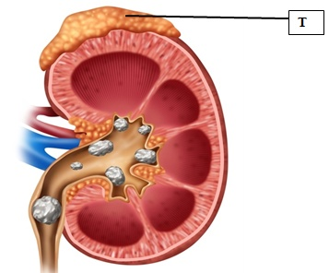
- Name the structure labeled T. (1mark)
Adrenal gland;
- What is the function of the structure named in (i) above in the kidney. (1mark)
Produce aldosterone hormone for reabsorption of sodium ion in the kidney tubules;
- Identify the disease shown in the kidney above. (1mark)
Kidney stones;
- State the importance of Saprophytic fungi in an ecosystem. (1mark)
Cause decomposition of organic matter hence release of nutrients back to the ecosystem;
- List two assumptions made when of using Capture-recapture as a method of estimating population. (2marks)
No immigration or emigration of the organism from the area of study;
Organisms mix freely both the marked and unmarked;
No death of organism during the period of study
- Give two reasons why Pteridophytes are considered more advanced than Bryophytes.
(2marks)
Have well developed vascular bundles for transport;
Have a differentiated body unlike the bryophyte with a thallus body;
Have root system, adventitious root for absorption;

- Study the diagram below and answer the following questions.
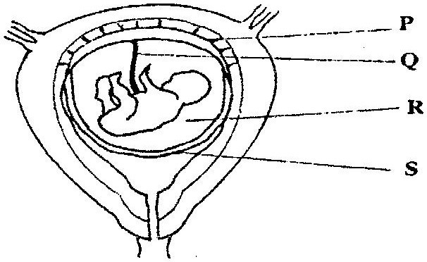
- State the function of the part labeled Q. (2marks)
Umbilical vein carries oxygenated blood rich in in nutrients from the placenta to the fetal circulation;
Umbilical artey carry deoxygenated blood together with metabolic waste from the fetal circulation to the placenta;
- State the role of the part labeled R. (1mark)
Absorb shock protecting the foetus;
- Identify a hormone produced by part labeled P. (1mark)
Progesterone;
- Give the function of Prolactin in female reproductive cycle. (1mark)
Stimulates production of breast milk;

- Below is a photograph illustrating a germinating seedling.
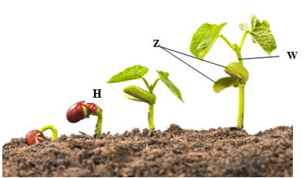
- Identify the type of germination. (1mark)
Epigeal germination;
- Give two functions of the structure labeled Z? (2marks)
Store food for growth;
Protects plumule during germination;
For photosynthesis before formation of first foliage leaves;
- What the name given to the part labeled W? (1mark)
Epicotyl;
- Explain how seedling H responds to light causing it to straighten. (2marks)
Light makes auxins to diffuse to the dark side; causing the dark side to have rapid cell elongation than the lit side hence the shoot straightens;
- a) Define Vestigial structures? (1mark)
Are structures that ceased to be functional and over time have reduced in size;
- State two examples of vestigial structures in man. (2marks)
Appendix;
Coccyx;

- The figure below shows some cells from parts of mammalian respiratory tract.
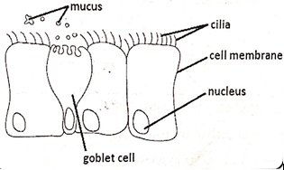
- Identify the part of the respiratory tract where the cells were obtained from. (1mark)
Trachea.
- Explain the role of: (2marks)
- The mucus
Trap solid particles and microorganisms preventing them from getting to the lungs;
- The cilia.
Waft the trapped particles and microorganisms removing them from the trachea;
- Mycorrhiza is a symbiotic association between two organisms. Name the two organisms that make this association. (2marks)
Fungi;
Roots of trees/plant;
- State the significance of diffusion in the following;
  - Pollination. (1mark)
Scents from the flowers diffuse in the air attracting insect pollinators;
  - Skeletal muscle cell. (1mark)
Oxygen from the alveoli diffuses from the blood plasma into the skeletal muscle cells where it used for respiration;
Carbon (IV) oxide from the muscle cells diffuse into the blood and taken to the lungs;

- Explain the significance of the following;
- The cardiac muscle is myogenic. (1mark)
Contraction and relaxation does not depend on nervous stimulation;
- The left ventricle of a mammalian heart is more muscular than right ventricle.
(1mark)
Pump blood at higher pressure to all part of the body;
- Most of carbon (IV) oxide is not dissolved in the blood plasma. (1mark)
To avoid altering the blood pH;

THIS IS THE LAST PRINTED PAGE.

