NAME………………………………………………………. INDEX NO…………………/…………
ADMISSION NUMBER……………………. CLASS………………………
CANDIDATES SIGNATURE………………

231/3
BIOLOGY
(PRACTICAL)
Paper 3
SEPT 2021
1³/₄ Hours
EAGLE EXAM - 2021
Kenya Certificate of Secondary Education (K.C.S.E)

INSTRUCTIONS TO CANDIDATES

- Write your name and Index Number in the spaces provided above.
- Sign and write date of examination in the spaces provided above.
- Answer ALL questions in the spaces provided in the question paper.
- You are not allowed to start working with the apparatus for the first 15 minutes of the 1³/₄ Hours allowed for this paper. This time is to enable you to read the question paper and make sure you have all the chemicals and apparatus that you may need.
- All workings must be clearly shown where necessary.
- Mathematical tables and silent electronic calculators may be used.

For Examiners use only.
Section | Question | Maximum Score | Candidates Score
 | 1 | 14
 | 2 | 12
 | 3 | 14
 | Total score | 40

This paper consists of 6 Printed pages.
Candidates should check the question paper to ensure that all the
Papers are printed as indicated and no questions are missing

- You are provided with liquids L₁, L₂, L₃, L₄
- (i) Put 3 drops of L₂ on a white tile.
Add one drop of iodine solution.
Observation …………………………………………………………………….. [1mk]
Conclusion ……………………………………………………………………… [1mk]
(ii) Put 2cm³ of L₂ into the test tube and add equal volume of Benedict’s solution and heat.
Observation …………………………………………………………………… [1mk]
Conclusion …………………………………………………………………… [1mk]
- Label two test tubes A and B. Into each of the test tubes put 2cm³ of the remaining L₂ liquid.
To test tube A, add 10 drops of liquid L₁ and 10 drops of liquid L₃.
To test tube B, add 10 drops of liquid L₁ and 4 drops of liquid L₄
Put the two test tubes, A and B in a waterbath maintained at between 38-39ºC for 30 minutes.
Repeat iodine and Benedict’s tests in each of the test tubes and record your results in the table below. [4mks]

Test tube | Observations
 | Iodine test | Benedict’s test
A
B

- Account for the results in:
- Test tube A
Iodine test …………………………………………………………………………………………………………………………………………………………….. [1mk]
Benedict’s test …………………………………………………………………………………
………………………………………………………………………… [1mk]
- Test tube B
Iodine test …………………………………………………………………
…………………………………………………………………………… [1mk]
Benedict’s test ……………………………………………………………….
………………………………………………………………………… [1mk]

- Suggest the identity of liquid L1 [1mk]

………………………………………………………………………………………………

- Why was the water bath maintained at 38ºC [1mk]

……………………………………………………………………………………………………………………………………………………………………………………………………

- You are provided with specimens labelled A, B, C and D.
- Precisely, classify the specimens [2mks]

B ______________________________
D ______________________________

- (i) Cut specimen A longitudinally and make a well labelled diagram. [4mks]

(ii) Calculate magnification of the drawing in b (i) above. Show your working [2mks]
…………................................................................................................................................................................................................................................................................................................................................................................................................................................................................................................................................................................................................
- (i) Name the agent of dispersal of the cut specimen [1mk]
…………………………………………………………………………………………………
(ii) Give two reasons for your answer [2mks]

………………………………………………………………………………………………………………………………………………………………………………………………………………………………………………………………………………………………………

- (i) Open specimen C longitudinally, observe and name the type of placentation shown. [1mk]
……………………………………………………………………………………………………………………………………………………………………………………………………

(ii) With reason, identify the agent of dispersal and give a reason for your answer. [2mks]
………………………………………………………………………………………………………………………………………………………………………………………………………………………………………………………………………………………………………

- Study the photographs below and answer the questions that follow.
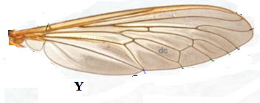
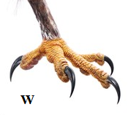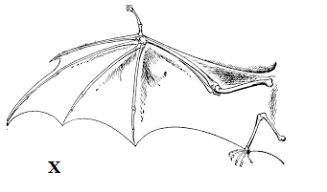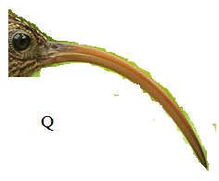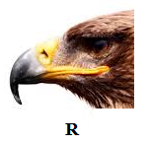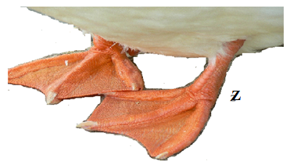

- Name the type of structures shown by: [2mks]

- X & Y ……………………………………………………..
- W & Z ……………………………………………………..
- State the structural difference between structures X and Y [1mk]

…………………………………………………………………………………………………………………………………………………………………………………………………………
- Name the type of evolution shown by structures Q and R [1mk]
…………………………………………………………………………………………………………………………………………………………………………………………………………..
- State the adaptations of structures W and Z
W …………………………………………………..
Z ……………………………………………………

- Name the types of skeletons shown by structures X and Y [2mks]
X ……………………………………………………
Y ……………………………………………………
- By comparing structures Q and R, predict the type of food being fed on by the animals and give a reason in each case. [4mks]
Q ………………………………………………………………………………………………………………………………………………………………………………………………………….
R ………………………………………………………………………………………………………………………………………………………………………………………………………..

- A part from structures X and Y, name two other examples of similar structures in animals. [2mks]
……………………………………………………………………………………………………………………………………………………………………………………………………………………………………………………………………………………………………………….

