TERM 2-2022
BIOLOGY (QUESTION PAPER)
FORM FOUR
TIME: 1 ³/4 HOURS
PAPER 3

Name………………………………………………………………… Adm No………………………………..
School…………………………………………………………………. Class…………………………………….
Signature……………………………………………………………….. Date………………………………………

INSTRUCTIONS TO CANDIDATES:
- .Write your name, index number, admission number, school and stream in the spaces provided above.
- Sign and write the date of examination in the spaces provided above.
- You are required to spend the first 15 minutes of the 1³/4 hours allowed for this paper reading the whole paper carefully before commencing your work.
- Answer ALL the questions in this paper in the spaces provided.
- Candidates should answer the questions in English.
FOR EXAMINER’S USE ONLY
Question | Maximum score | Candidate’s score
1 | 16
2 | 12
3 | 12
Total | 40
This paper consists of 8 printed pages.
Candidates should check the question paper to ascertain that all the pages are printed as indicated and no questions are missing

1. You are provided with Specimen A, Solution X and Solution Y.
(a) Cut out a cylindrical portion of the petiole from Specimen A measuring 5cm long (reserve the leaves for part b of the question). Make a longitudinal section through the petiole so as to divide it into two identical straight halves as shown below;
Petiole
Scalpel
Place one straight half of the petiole into the boiling tube containing solution X, and label the tube as Set up I. Place the other straight half of the petiole into the boiling tube containing solution Y, and label the tube as Set up II. Leave the two set ups to stand for 30 minutes.
Remove the two halves of the petiole from the solutions and examine them.
(i) Account for the curvature of half of the petiole in set up I. (5marks)
...................................................................................................................................................................................................................................................................................................................................................................................................................................................................................................................................................................................................................................................................................................................................................................................................................................................................................................................................................................
(ii) Based on your observation of the curvature of half of the petiole in set up II, state the nature of solution Y in relation to plant cells. (1mark)
.....................................................................................................................................

(b) Cut the leaves of specimen A into small pieces and place them into a mortar. Add 10ml of distilled water, then grind them using a pestle so as to obtain an extract called solution R. Using the reagents provided, carry out various tests using the procedures in the table below to determine the food substances in the solution R. In each case, state the observation and conclusion made. (6 marks)
Food substance | Procedure | Observation | Conclusion
Proteins | -Place 2ml of solution R into a test tube.  - Add equal amount of NaOH solution.  -Add CuSO₄ solution dropwise and shake
Reducing sugars | -Place 2ml of solution R into a test tube.  -Add equal amount of Benedict’s solution.  -Boil the mixture.
Vitamin C | -Place 2ml of DCPIP into a test tube.  -Add solution R dropwise as you shake.

(c) The photograph I below shows the internal structure of Specimen A. Study it carefully and answer the questions that follow.
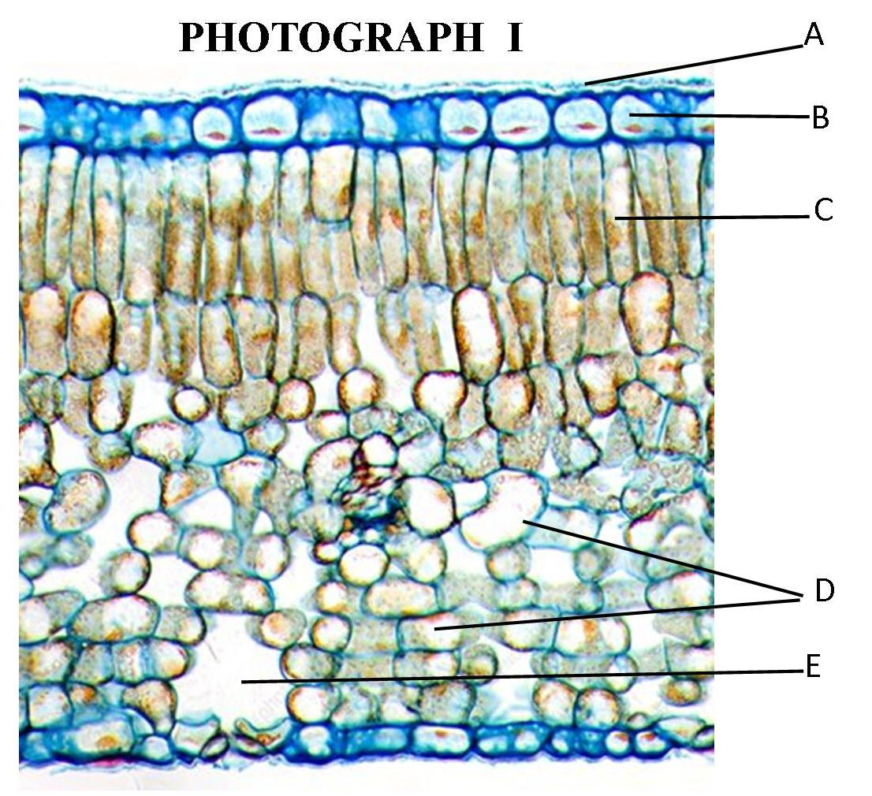

(i) Identify the structures labelled A and B. (2marks)
A..................................................................................................................................
B...................................................................................................................................
(ii) State one structural difference between cells C and D. (1mark)
..........................................................................................................................................................................................................................................................................
(iii) What is the function of the part labelled E ? (1mark)
.....................................................................................................................................

2. You are provided with Specimens X, Y and Z.
(a) State the type of dry, indehiscent fruit represented by specimen X. (1mark)
.....................................................................................................................................

(b) With a reason, state the method of dispersal of specimen Y. (2marks)
(i) Method of dispersal.............................................................................................
(ii) Reason.................................................................................................................
(c) Cut specimen Z transversely so as to obtain two identical halves. Draw and label the cut surface of one half. (3marks)

(d) Below is a photograph of the internal longitudinal section of Specimen X.

(i) Name the parts labelled P and S. (2marks)
P...................................................................................................................................
S...................................................................................................................................
(ii) State the function of the part labelled T. (1mark)
.....................................................................................................................................
(iii) Identify the region that would stain blue black with iodine solution. (1mark)
.....................................................................................................................................
(e) The magnification of the internal longitudinal section in the above photomicrograph was X30,000. Measure the distance of the dark horizontal line between V and W in millimetres. Calculate the actual width of the section between V and W in micrometres. (2marks)
..............................................................................................................................................................................................................................................................................................................................................................................................................................................................................................................................................................................................................................................................................................................................................................................................................................
3. Below are photographs II and III of the mammalian kidney and skin respectively. 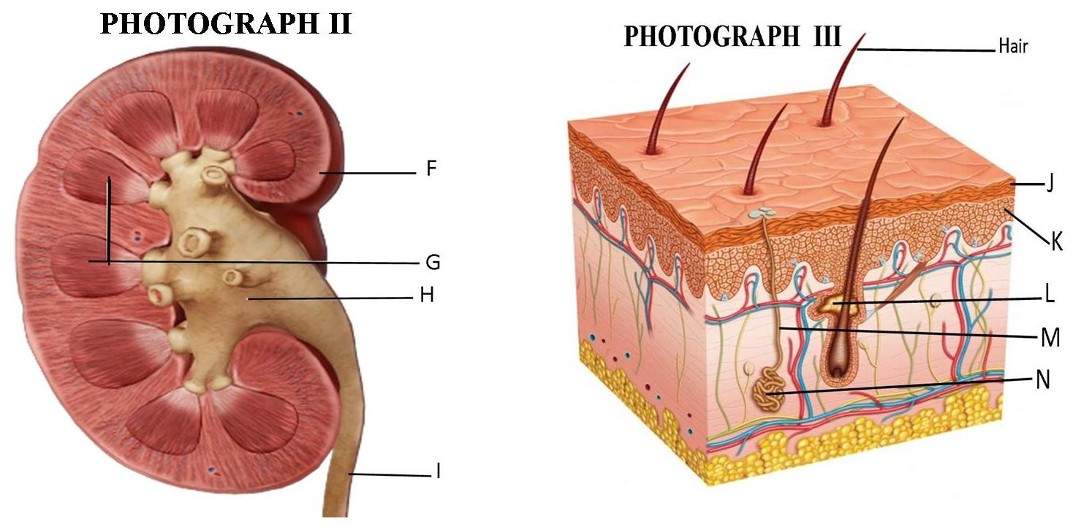 (a) Identify the layers labelled F, J and K. (3marks)
F...................................................................................................................................
J....................................................................................................................................
K..................................................................................................................................
(b) State the function of each of the parts labelled L and M. (2marks)
L .................................................................................................................................
M................................................................................................................................

(c) Explain how the structure labelled N is adapted to its function. (1mark)
...............................................................................................................................................................................................................................................................................................................................................................................................................
(d) Identify part in photograph II that contains glomeruli. (1mark)
.....................................................................................................................................
(e) The cells in the layer labelled J can be examined using the light microscope shown below.
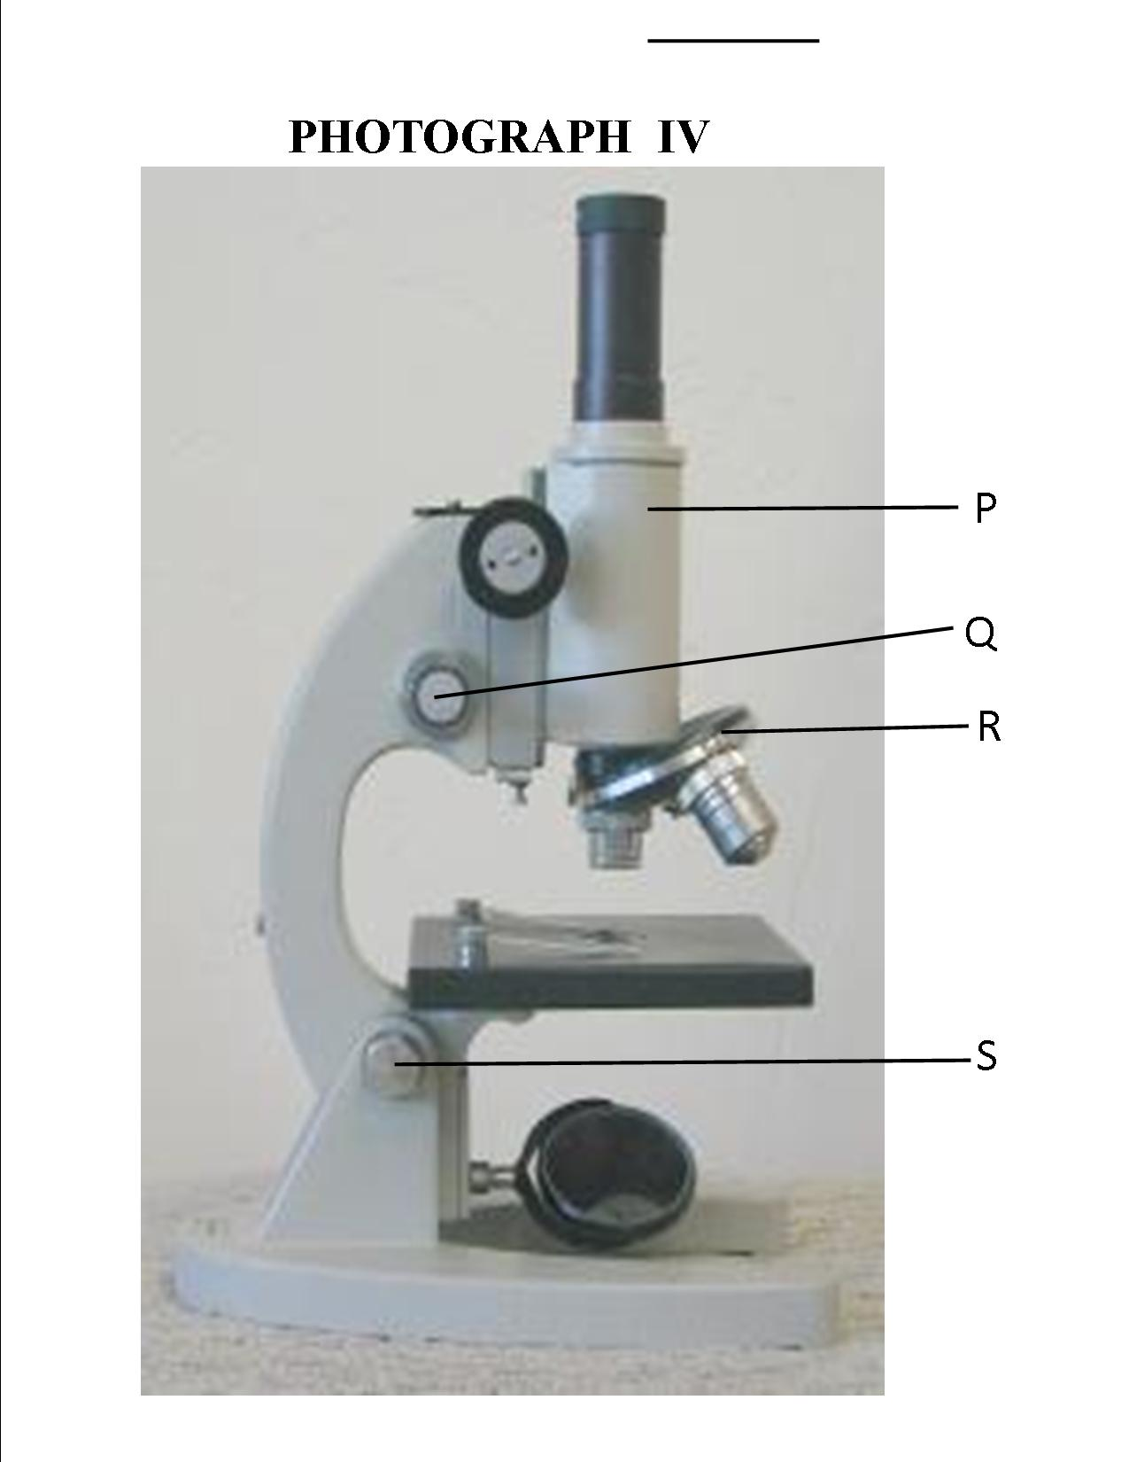

(i) Identify on the above photograph the structure that would be adjusted to improve on the clarity of blurred images of the cells in layer J. (1mark)
.....................................................................................................................................
(ii) State the significance of using a sharp razor or scalpel to cut through layer J to obtain the cells for examination in the above microscope. (1mark)
.....................................................................................................................................
(iii) Name the part labelled S in the above microscope. (1mark)
.....................................................................................................................................
(iv) State two functions of the light microscope during examination of the cells in layer J. (2marks)
...............................................................................................................................................................................................................................................................................................................................................................................................................

