TERM 2-2022
BIOLOGY (MARKING SCHEME)
FORM FOUR
TIME: 1 ³/4 HOURS
PAPER 3

Name………………………………………………………………… Adm No………………………………..
School…………………………………………………………………. Class…………………………………….
Signature……………………………………………………………….. Date………………………………………

1 (i) Solution X is hypotonic to/ less concentrated than cells/ cell sap of specimen A/ Petiole; hence water molecules move from solution X to the (cells of) petiole by osmosis; leading to increase in size of the cells/ petiole; The inner cortical cells lack cuticle; hence absorb more water/ absorb water faster than the outer epidermal cells; that are covered by cuticle ; The cortical tissue expands/ increases in size more than the epidermal tissue; leading to curvature of the petiole outwards;

(ii) Hypertonic/ More conc. / Has more solute molecules/ Has less water molecules;

(b)
Observation Conclusion
Proteins No colour change/ (Green) colour Proteins absent;
Of solution R persists;

Reducing sugars 1. Colour changes to green/ Green 1. Traces/ little
Colour of solution R persists; reducing sugar
2. Acc. No colour change present;
2. Reducing sugar
Absent

Note: rj No change alone
Response 1. are matched
Response 2. are matched

Vitamin C DCPIP solution is decolourised/ Vitamin C
Present;
Becomes colourless;

(c) (i)
A Cuticle;
B Upper epidermis/ Upper epidermal cell/ layer;

(ii)
C D
Cylindrical/ regular Irregular
Closely packed Loosely packed
Contain chloroplast Contain fewer chloroplast
Note: Mark first one only

(iii) Allows for free diffusion/ circulation of respiratory gases/ water vapour;

- (a) Caryopsis;
(b) (i) Self dispersal/ Explosive mechanism;
(ii) Presence of lines of weakness/ sutures; Rj weak lines
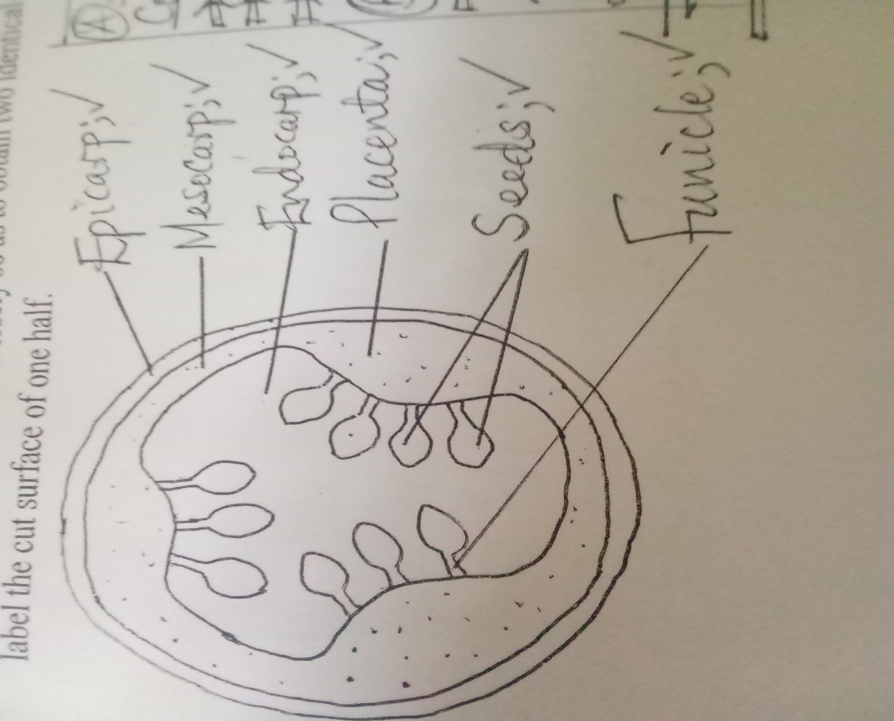

(d) (i)

P Coleorhiza;
S Plumule;

(ii) Protects S/ plumule from damage by soil particles;

(iii) Q/ Endosperm;

(e) Distance between V and W = 3.5 – 13.7mm

Actual width = 13.5 x 1000 ; OR Actual width = 13.7 x1000
X30,000 X30,000
= 0.45micrometers; = 0.46micrometers

OR Actual width = 13.6 x 1000 ;
X30,000
= 0.45micrometers;

- (a)

F Cortex;

J Cornified layer;

K Granular layer;

(b)
L Secrete sebum which keeps hair and epidermis supple/ waterproof/ contain antiseptic substances/ kill micro-organisms;

M Conduct sweat to the skin surface;

(c)
Coiled to increase surface area for absorption of excess water/ mineral salts/ urea/ lactic acid/ sweat from the surrounding blood vessels/ tissues;

Made up of numerous secretory cells that absorb excess water / mineral salts/ urea/ lactic acid/ sweat;

(d)
F/ Cortex;

(e) (i)
Q/ Fine adjustment knob;

(ii)
To avoid destruction/ distortion/ of the cells/ tissues/ layer;
To obtain thin sections;
Note: Any one

(iii)
Hinge/ Hinge screw;

(iv)
Magnifies the cell;
Increases the resolution/ resolving power of the eye;

