NAME……………………………………ADM………………..STREAM…
231/2
BIOLOGY PAPER 2
SEPTEMBER 2021
TIME: 2 HOURS

FORM FOUREAGLE JOINT EXAMINATION
KENYA CERTIFICATE OF SECONDARY EDUCATION (KCSE)
INSTRUCTIONS TO CANDIDATES
- Write your name and index number in the spaces provided above.
- Sign and write the date of examination in the spaces provided.
- Question six is compulsory.
- Choose either question 7 or 8
FOR EXAMINERS USE ONLY
QUESTION | MAXIMUM SCORE | CANDIDATE SCORE
1 | 8
2 | 8
3 | 8
4 | 8
5 | 8
6 | 20
7 | 20
8 | 20
TOTAL | 80

- Study the flow chart below of a process that takes place in both plants and animals.
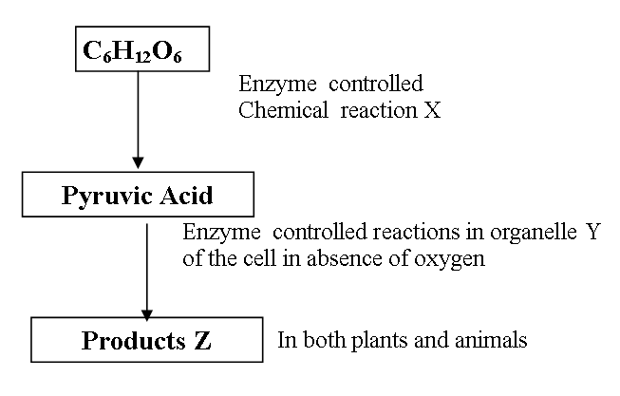
a) Name the above process. (1mk)
………………………………………………………………………………………………………………………………………………………………………………………………………………
b) i) In the above process name the chemical reaction represented by X. (1mark)
……………………………………………………………………………………………………………………………………………………………………………………………………………
ii) Name the part of the cell where the enzyme controlled reactions in b(i) above takes place. (1mark)
c) Name the products Z in
i) Plants…………………………………………. (1mark)

ii) Animals…………………………………………………………. (1mark)

d)What would be the fate of pyruvic acid if oxygen supply is availed in the mitochondria of an animal cell (2marks) ………………………………………………………………………………………………………………………………………………………………………………………………………………………………………………………………………………………………………………………………………………………………………………………………………………………………………………………………
(e) Define the term oxygen debt (1mark)
………………………………………………………………………………………………………………………………………………………………………………………………………………………………………………………………………………………………………………………………………………

2. .In a certain bird species red flight feathers is controlled by gene R while white flight feather is controlled by gene r. The heterozygous condition Rr results into pink flight feathers.
- Using a punnet square, find the genotype of a cross between pink flight feathered bird and white flight feathered bird. (4 marks)
………………………………………………………………………………………………………………………………………………………………………………………………………………………………………………………………………………………………………………………………………………………………………………………………………………………………………………………………………………………………………………………………………………………………………………………………………………………………………………………………………………………………………………………………………………………………………………………………………………………………..
- Which type of dominance is illustrated here? (1 mark)
…………………………………………………………………………………………………………………………………………………………………………………………………………………………………..
- i) Identify the nuclei acid whose base sequence is shown below. (1 mark)
…………………………………………………………………………………………………………………………………………………………………………………………………………………………………..
G - A - C - U - A - G - C - G - U
(ii) Give a reason for your answer in (i) above (1 mark)
……………………………………………………………………………………………………………………………………………………………………………………………………………………………………
(iii) If this nucleic acid was involved in protein synthesis, how many amino acid would be present in the protein synthesized. (1 mark)
………………………………………………………………………………………………………………………………………………………………………………………………………………………………………………………………………………………………………………………………………………………
- .The diagram below represents a longitudinal section through the ileum wall.
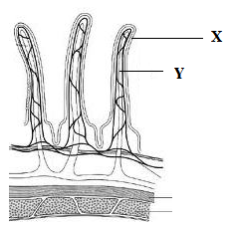

- Identify the structures labeled X and Y (2 marks)
X………………………………………………………….
Y…………………………………………………..........
- State one function of X and Y (2 marks)
X……………………………………………………………………………………………………………..
……………………………………………………………………………………………………………….
Y………………………………………………………………………………………………………………
………………………………………………………………………………………………………………..
- State two functions of the ileum (2 marks)
……………………………………………………………………………………………………………………………………………………………………………………………………………………………………………………………………………………………………………………………………………………….
- Explain the role of the liver in digestion (1 mark)
…………………………………………………………………………………………………………………..
- State the endocrine (hormonal) role of pancreas in a mammal (1 mark)
………………………………………………………………………………………………………………………………………………………………………………………………………………………………………………………………………………………………………………………………………………………………………
4. The diagram below represents the female reproductive system.
B
A
C
D

(a) Name the structures labeled A and C (2 marks) A .................................................................................................................
C ……………………………………………………………………………………………………………
(b) State the conditions that results if implantation occurs at point labeled D. (1 marks) ………………………………………………………………………………………………………………
(c) Name the hormone secreted by the part labeled A and for each give one function (4 marks) ............................................................................................................................................................................................................................................................................................................................................................................................................................................................................................................................................................................................................................................................................................................................................
(d) What role does part labeled B play during pregnancy? (1 mark)
.....................................................................................................................................................................................................................................................................................................................................................................
5. The diagram below shows some components of a light microscope.
- Name the parts labeled (2 marks)
K ………………………………………………………………………………………………
M ………………………………………………………………………………………………
- State the functions of (2 marks)
P ………………………………………………………………………………………………
Q ………………………………………………………………………………………………
- A student was viewing a prepared slide of a plant cell under high power microscope. The features of the cell were blurred. Which one of the labeled parts of the microscope would the student use to obtain:-
- A sharper outline of the features. (1 mark)
………………………………………………………………………………………………
- Give the formula used to calculate magnification in a light microscope. (1 mark)
…………………………………………………………………………………………
- A student was preparing a section of a plant cell to be viewed on a light microscope. Give a reason for each of the following steps:-
(i)Cutting a very thin section………………………………………………………………………………………………...... (1 mark)
(ii)Staining the section……………………………………………………………....................... (1 mark)
(iii)Putting the section in water…………………………………………………………………. (1 mark)
Answer question 6 (compulsory) and either question 7 or 8 in the spaces provided after question
6 During germination and growth of a cereal, the dry weight of the endosperm, the embryo and total dry weight were determined at two day intervals. The results are shown in the table below.
Time after planting (Days) | Dry weight of endosperm (mg) | Dry weight of embryo (mg) | Total dry weight (mg)
0 | 43 | 2 | 45
2 | 40 | 2 | 42
4 | 33 | 7 | 40
6 | 20 | 17 | 37
8 | 10 | 25 | 35
10 | 6 | 33 | 39
a) On the same axes, draw graphs of dry weight of endosperm, embryo and the total dry weight against time. (7marks) b) What was the total dry weight on day 5? …………………………………………………………… (1mark)
c) Account for: i) Decrease in dry weight of endosperm from day 0 to day 10. (2marks) ……………………………………………………………………………………………………………………………………………………………………………………………………………………………………………………………………………………………………………………………………………………….
ii) Increase in dry weight of embryo from day 0 to day 10. (2marks)
………………………………………………………………………………………………………………………………………………………………………………………………………………………………………………………………………………………………………………………………………………………….. iii) Decrease in total dry weight from day 0 to day 8. (1mark)
………………………………………………………………………………………………………………………………………………………………………………………………………………………………………………………………………………………………………………………………………………………… iv) Increase in dry weight after day 8. (1mark)
……………………………………………………………………………………………………………………………………………………………………………. d) State two factors within the seed and two outside the seed that cause dormancy.
i) Factors within the seed…………………………………………………………….. (2marks)
……………………………………………………………………….
ii) Factors outside the seed. …………………………........................................ (2marks)
………………………………………………………………….. e) Give two characteristics of meristematic cells……………………………………………… (2marks)
……………………………………………………………………………………………………………………………………………………………………………..

7. Describe how the mammalian skin is adapted to its functions (20 mrks)
8. a) Describe how xerophytes are adapted to living in their habitat. (10 mks)
b) Explain how an upright position is maintained in herbaceous plants. (10 mks)
……………………………………………………………………………………………………………………………………………………………………………………………………………………………………………………………………………………………………………………………………………………………………………………………………………………………………………………………………………………………………………………………………………………………………………………………………………………………………………………………………………………………………………………………………………………………………………………………………………………………………………………………………………………………………………………………………………………………………………………………………………………………………………………………………………………………………………………………………………………………………………………………………………………………………………….……………………………………………………………………………………………………………………….……………………………………………………………………………………………………………………….……………………………………………………..………………………………………………………………...……………………………………………………………………………………………………………………….……………………………………………………………………………………………………………………….……………………………………………………………………………………………………………………….……………………………………………………………………………………………………………………….……………………………………………………………………………………………………………………….……………………………………………………………………………………………………………………….……………………………………………………………………………………………………………………….……………………………………………………………………………………………………………………….…………………………………………………………………………………………………………………………………………………………………………………………………………………………………………………………………………………………………………………………………………………………………………………………………………………………………………………………………………………………………………………………………………………………………………………………………………………………………………………………………………………………………………………………………………………………………………………………………………………………………………………………………………………………………………………………………………………………………………………………………………………………………………………………………………………………………………………………………………………………………………………………………………………………………………………………………………………………………………………………………………………………………………………………………………………………………………………………………………………………………………………………………………………………………………………………………………........................................................................................................................................................................................................................................................................................................................................................................................................................................................................................................................................................................................................................................................................................................................................................................

