EAGLE MARKING SCHEME BIOLOGY PP2
1 (a)anaerobic;
(b) (i) Glycolysis;
(ii) Cytoplasm;
(c) (i) Alcohol/ ethanol, carbon IV oxide and energy;
(Rej.. if only one product is given) + Energy
(ii) Lactic acid, energy
(d) Pyruvic acid will be further oxidized by oxygen (in a series of enzymatic reactions/ Krebs cycle) into carbon IV oxide, water and energy;
(reject if all products are not mentioned)
(e) The amount of oxygen required to get rid of the lactic acid that accumulates in the body tissues when supply of oxygen is less than demand;
2(a) phenotype pink white
Genotype Rr X rr ;
♀ ♂ | R  ; | r
r | Rr | rr
r | Rr | rr
Gametes

Offspring
b) Incomplete;
(c) (i) Ribonucleic acid; Rej. RNA
(ii) Has uracil base
(iii) Three (3);
Reason – Has three codons.
3(a) X – Villas
Y – Lacteal
(b) X – Increase surface area for absorption;
Y – Absorption of fatty acids and glycerol;
(c) Digestion;
Absorption of end products of digestion;
(d) – Produce bile juice which contain bile salts for emulsification of fat/bile salts provide
Alkaline medium suitable for enzymes present in pancreatic juice;
(e) Produce hormones insulin and glycogen;
Rej. if one hormone is mentioned
4. (a) A - ovary; C - uterine wall;
(b) Ectopic pregnancy;
(c) Oestrogen -Repair and healing of endometrium, stimulate pituitary to secrete LH.
Progesterone -Proliferation/thickening of endometrium.
- together with oestrogen inhibits production of FSH.
-inhibits production LH
(d) Secrete a thick plug of mucus which prevent entry of air and micro organisms;
5a) K- eye piece; M-coarse adjustment knob;
b) P-concentrate the light/focuses the light;
Q- magnification of the image; Rej object/specimen for image
c) i) – N ; rej. named part
ii) – Eyepiece magnification X objective lens magnification ; Rej. Length of the drawing
length of the actual
d) i) to allow light to pass through ;
ii) To make the features more clear and distinct; Rej. Without distinct
iii) For cells to remain turgid/ prevent dehydration;
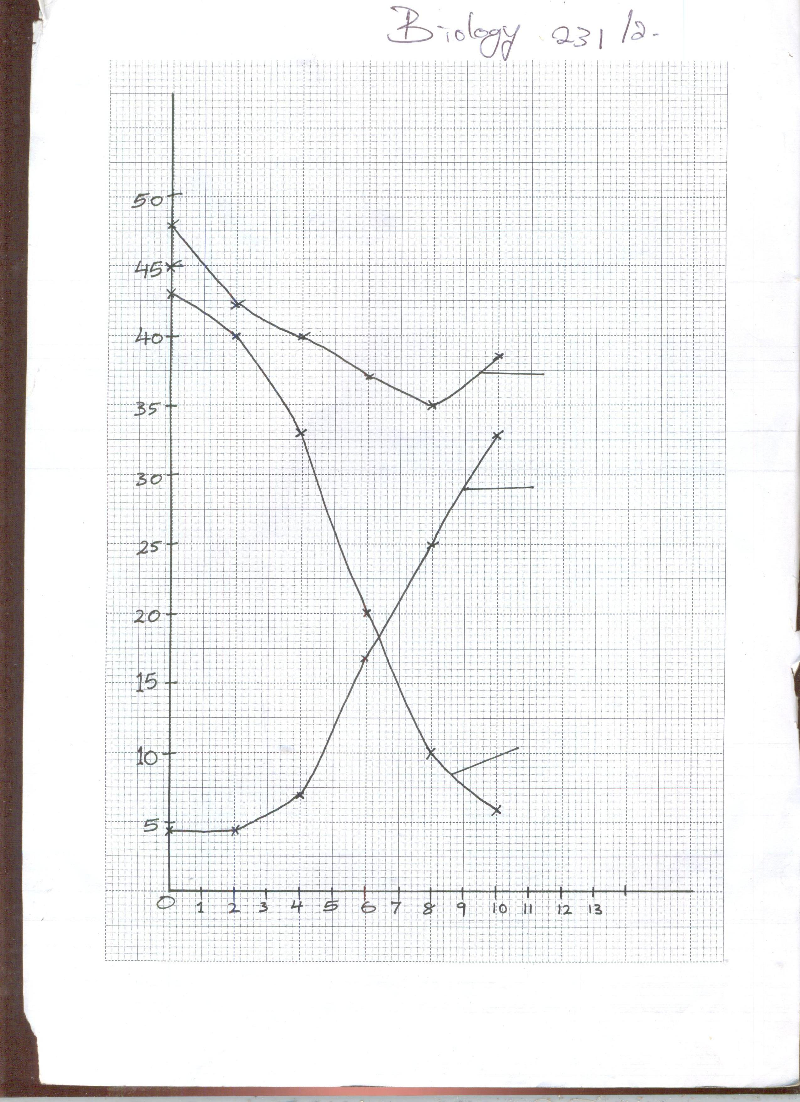
Time (Days)
Total weight of endosperm
Dry weight of embryo
Dry weight of embryo
Dry weight of endosperm
Dry weight (mg)

SECTION B

6 b) 38.5mg; ± 0.5 Rej wrong units , Acc without units
c) i) Hydrolysis of starch into simple sugar/glucose; which is translocated to the embryo; oxidation (of simple sugars) respiration to carbon (iv) oxide/energy/Heat
ii) New cells materials/tissue are synthesized (from proteins); bringing about growth of embryo;
iii) First leaf carried out photosynthesis (Leading to growth)
d) i) presence of absiscic acid; Acc presence of germination inhibitors.
Embryo not fully developed;
Absence of hormones/enzymes that stimulate germination; impermeable seed coat; (Any two)
ii) Unsuitable temperature/lack of suitable temp/ unfavourable temperature;
lack of water;
Absence of light;
Lack of Oxygen; any 2
e) Dense cytoplasm;
- Thin cell wall
-Absence of vacuoles

7. Describe the structure and function of the mammalian skin (20marks)
It has a cornified layer made up of dead cells and is tough and impermeable to water; to protect
the skin against mechanical damage; bacterial infections and water loss; granular layer; whose
cells divide to form the cornified layer; malpighian layer; which is made up of diving cells that
give rise to a new granular layer; contains melanin; to protect skin against ultra-violet
rays/radiations; Sebaceous glands; which secrete sebum; to make the skin supple/soft and
waterproof; sebum is also antiseptic; Blood vessels; dilate during hot weather; increasing blood
flow near the skin surface; heat loss is enhanced; constrict; in cold weather; less blood flow;
minimize heat loss; Sensory nerve endings and receptors; enable detection of external
environmental changes; Highly coiled sweat glands; secrete sweat; to control body
temperature; when hot sweat evaporates cooling the body; sweat contains excretory products;
subcutaneous fat/adipose tissue in dermis; for insulation; hair; to regulate body temperature; in
cold weather erector pili muscles contract; hair is raised, air trapped to insulate the body; in hot
weather, erector pili muscles relax; hair lies flat reducing insulation; dense network of blood
capillaries; supply nutrients/oxygen to skin tissues; as well as carrying away wastes and carbon
(IV) oxide away from the skin tissues; adipose tissue/sub-cutaneous layer; serves as an
insulator; helping in temperature control; helps in manufacture of vitamin D; Max. 20 mks

8.a) - Have thick, fleshy (succulent) and green stems; that are modified for water storage and photosynthesis; stomata are reduced in number/located in cavities on the epidermis(sunken stomata) / located mainly on lower part of leaf surface/Exhibit reversed stomata rhythm to minimize transpiration;
- Some are deep rooted; to enable them reach deep water table; others have superficial roots; to absorb surface water after a short shower; In some leaves are permanently folded; to prevent direct exposure of stomata to environmental conditions thus minimizing transpiration; Others shed off their leaves at the onset of dry season to minimize transpiration; in some leaves are small in size/reduced in size to scale-like structures to minimize transpiration; (12 max 10)

b) -Plant cells have a cellulose cell wall; which is rigid; plants absorb water through osmosis and cells become turgid; which makes the tissues firm and erect; Collenchyma cells have thickened cell walls; to give strength; Xylem vessels have thick and lignified walls; that strengthen plants. Tracheids and fibres; in mature plants have dead thick lignified cells; for strength and support. Parenchyma cells are round and tightly packed together; which maintains shape and firmness; of the plants. (11 max 10)

