OPENER EXAM
TERM 1 - 2023
BIOLOGY FORM 4
50 MARKS.
TIME 1 ½ HOURS
NAME………………………………………………………ADM NO…………….CLASS…..

- Name the organelles that perform each of the following functions: 2 MRKS
- Digestion and destruction of worn out organelles.

- Osmoregulation

- a) In which kingdom do bacteria belong? 1MRK

- Give any two benefits of bacteria to man 2MRKS

- Study the dental formula given below:
I 0; C 0 ; PM 3; M 2
4 0 3 3
(a) Identify with reasons the mode of feeding of the animals whose dental formula is
given above 3MRKS

(b) Calculate the total number of teeth in the mouth of the above animal. 1MRKS

- Explain why small mammals such as moles feed more frequently than larger ones such
as elephants 1MRKS

- The flow diagram below represents blood clotting process
Prothrombum
Vitamin K
Platelets
Z
X
Ca²⁺
Y
Fibrinogen

a) Name the proteins represented by the letters; V, Y, Z 3MRKS

b) State the importance of blood clotting 1MRK

c) Why doesn’t the physiological process above occur in undamaged blood
vessels 1MRK

- State two major structural differences between fruit and a seed 2MRKS

- The eggs of birds are relatively much larger than those of mammals. Explain. 2MRKS

- Differentiate between continuous and discontinuous variations 2MRKS

- Members of the same species of organism tend to differ due to variation. State three causes of variation in organisms. 3MRKS

- Wekesa and Wanjiku who are siblings are both normal as their parents but have a hemophilic brother. Give the Genotype of their parents. 2MRKS

- There are at least 205 known sex – linked recessive disorder
- Name any two of them. 2MRKS

- State a reason why sex – linked recessive traits tend to effect the male child. 1MRK

- State why if a mother has the trait all her sons will have it. 2MRKS

- State the meaning of the following terms giving an example in each case: 2MRKS
- Sex-linked genes

- Multiple alleles

- Give an example of a sex-linked trait in human on: 2MRKS
Y – Chromosome

- X – Chromosome

- Study the genetic chart below showing the inheritance of the gene responsible for haemophilia in a family.
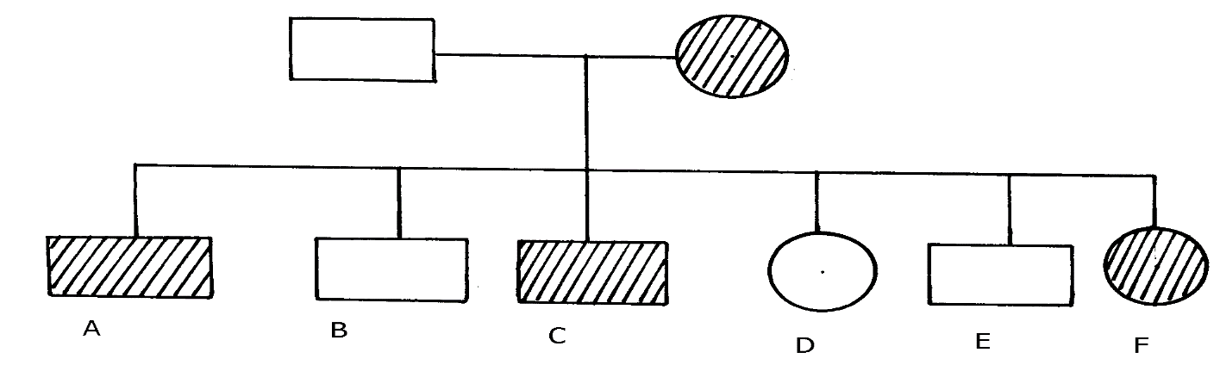

a) Write the genotype of individuals A, B, F 3MRKS

b) A member of this family labelled F marries a haemophiliac male. What will be the
phenotypic ratio of the offspring? Show your workings using a genetic cross.

- Other than the condition stated above, state any other two common genetic disorders
that result from gene mutation. 2MRKS

- In man blood group inheritance is controlled by multiple alleles in which allele A is co dominant to allele B. a woman heterozygous for blood group A married a man heterozygous for blood group B
a) State the genotype of both parents 2MRKS

b) Using a punnet square, show the genotypes of F₁ generation. 4MRKS

c) State one application of knowledge of blood group inheritance in man 1MRK

