Term 2 - 2022
BIOLOGY
(QUESTION PAPER III)
PRACTICAL
FORM FOUR
TIME: 1 ¾ HOURS
Name: …………………………………………………………. Adm No: ……………….
School: ……………………………………………………….. Class: …………………..
Signature: …………………………………………………….. Date……………………..

INSTRUCTIONS TO CANDIDATES:
- Write your name, index number and school in the spaces provided above.
- Sign and write the date of examination in the spaces provided above.
- Answer all the questions in the spaces provided.
- You are required to spend the first 15 minutes of the 1¾ hours allowed for
- this paper reading the whole paper carefully before commencing your work.
- This paper has three questions.
- Students should check the question paper to ascertain that all the papers are printed as indicated and that no questions are missing.
- Candidates should answer the questions in English.
FOR EXAMINER’S USE ONLY:
Question | Maximum  Score | Candidate’s  Score
1 | 14
2 | 12
3 | 14
Total Score | 40

1. You are provided with visking tubing labeled J, a piece of thread and a solution labeled K.

Dip the visking tubing in distilled water to moisten it, open it, and then tie one end tightly with the thread provided.
Half-fill the visking tubing with solution K then tie the open end of the tubing tightly. Ensure solution K does not spill out of the tubing.
Immerse the visking tubing into distilled water in a beaker. Ensure that the visking tubing is completely immersed in the distilled water.
Leave the set-up for 20 minutes. Record your observations after 20 minutes.

(a) (i) Observations (1mk)

……………………………………………………………………………………………………...

(ii) Explain you observations in a (i) above. (2mks)

……………………………………………………………………………………………………...

……………………………………………………………………………………………………...

(b) Remove the visking tubing carefully. Ensure the contents of the visking tubing do not mix with that of the beaker.Using the reagents provided, test for the food substance present in the visking tubing and the beaker.
I. Visking tubing (4mks)
FOOD TEST | PROCEDURE | OBSERVATIONS | CONCLUTION
Starch

Reducing sugars

II. Beaker (4mks)
FOOD TEST | PROCEDURE | OBSERVATIONS | CONCLUTION
Starch

Reducing sugars

(c) Explain observations in the visking tubing and Beaker in 1(b) above. (3mks)
2. The photographs I and II below illustrate parts of mammalian systems. Study them and answer the questions that follow.
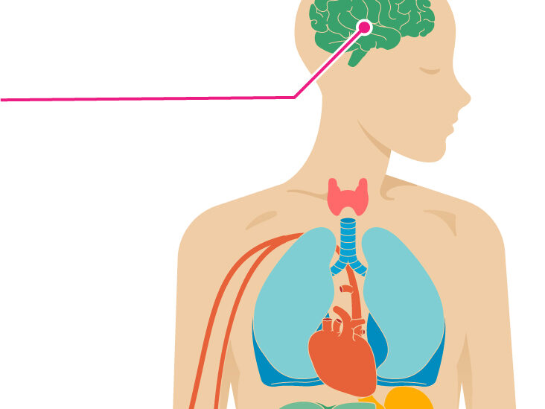
PHOTOGRAPH I
M
L
Z
Y
X
N
PHOTOGRAPH II
P

(a) Identify the two mammalian systems shown above. (2mks)
……………………………………………………………………………………………………………………………………
……………………………………………………………………………………………………………………………………
(b) Name the membrane that covers part marked P and Z. (2mks)
P…………………………………………………………………………………………………………………………………
Z…………………………………………………………………………………………………………………………………
(c) Describe two ways by which organ P and Z are protected. (2mks)
……………………………………………………………………………………………………………………………………
……………………………………………………………………………………………………………………………………
(d) How is the part labelled Y adapted to perform its function. (2mks)
……………………………………………………………………………………………………………………………………
……………………………………………………………………………………………………………………………………
(e) Identify the part labelled N. (1mk)
…………………………………………………………………………………………………………………………………..
(f) State the difference in the content of blood in L and M. (1mk)

L | M

(g) State the role of the inner part of X in ensuring a healthy system. (2mks)
……………………………………………………………………………………………………………………………………….
……………………………………………………………………………………………………….................................
3. You are provided with specimens labeled S_{1 ,} S₂ and S₃
- Using a scalpel blade split S₁ longitudinally and draw a well labeled diagram to show the internal structures. (4mks)

- With a reason, state the class of the plant from which specimen S₁ was obtained.
- Class (1mk)
……………………………………………………………………………………………………………………..
Reason (1mk)
…………………………………………………………………………………………………………………….

- Specimen S₂ is a germinated seedling of S₁.
In the table below, name three structures of S₁ and identify the structures they developed into in specimen S₂ (3mks)

Structure in S₁ | Structure developed into, in S₂
1_____________________  2_____________________  3_____________________ | _______________________________  _______________________________________  ___________________________________
- i) Using specimens S₂ and S₃ ,name the type of germination. (2mks)
S₂ ……………………………………………………………………………………………………………………….
S₃ ……………………………………………………………………………………………………………………….
ii) Give a reason for your answer in S₃ above. (2mks)
………………………………………………………………………………………………………………………
……………………………………………………………………………………………………………………….
iii) Account for the type of germination in S₂ (2mks)
…………………………………………………………………………………………………………………..,..
……………………………………………………………………………………………………………………..

