Term 2 - 2022
BIOLOGY
(MARKING SCHEME PAPER II)
FORM FOUR
TIME:2 HOURS
Name: …………………………………………………………. Adm No: ……………….
School: ……………………………………………………….. Class: …………………..
Signature: …………………………………………………….. Date: ……………………

1 a) 1. (a) Leaf compound ……………………………… go to 2;
(b) Leaf simple ……………………………… COTTON WOOD;

2. (a) Leaf pinnate …………………………………..go to 3;
(b) Leaf bipinnate …………………………………HONEY LOCUST;

3. (a) Leaf margin serrated…………………………...WHITE CLOVER;
(b) Leaf margin smooth……………………………BLACK WALNUT;

b) Put similar organisms together and separate different;
Put organisms in correct group for future reference;
Arrange information about organisms in an orderly manner to avoid confusion
Establish evolutionary relationship between different organisms

2. (a) (i) Villi; rej. Villus

(ii) Increase surface area for absorption of digested food;
(b) A- Epithelium;
B- Lacteal;
C – Blood capillaries;
(c) B- responsible for absorption of fats; rej. Fatty acids and glycerol
C- Important for transporting digested food;
(d) Secrete mucus to lubricate food; Form a protective layer for the gut wall to prevent it from being digested;

3. a) Man/ ♂ ♀/ Woman
Parental phenotypes Bald man Wife

Parental genotypes XY^{B} x XX ;
Gametes
X Y^{B} X X

F1 generation XX XX XY^{B} XY^{B}

Correct gametes; f1 generation; fusion lines;
(b) i) 0; acc. Zero/ none
ii) The gene for baldness is located on the Y chromosome which the girls lack;

(c) Blood group;
(d) Sickle cell anaemia;

4. a) i) Open circulatory system.
ii)Transporting fluid/ blood flows into the general body cavity/ coelom;
b) X -Aorta ;
Y- Ostia ;
z- Dorsal diaphragm ;
c) Blood flows under low pressure; therefore nutrients are supplied to the tissues/ waste products are removed from the tissues at a lower rate;
d) It has a large surface area to volume ratio, materials can diffuse into and out of the body fast;

5. (a) (i) Active transport;
(ii) Reabsorption of glucose/ salts in kidney tubules; Absorption of digested food from the alimentary canal into the blood stream; Excretion of waste materials from cell of the body; Accumulation of substances in the body to counter osmotic imbalance in saline Environment; STRICTLY IN MAMAMALS
(b) Cell membrane/Plasma membrane;
(c) Increasing supply of oxygen/ oxygen concentration;
Increasing supply of glucose/ glucose concentration;

6.

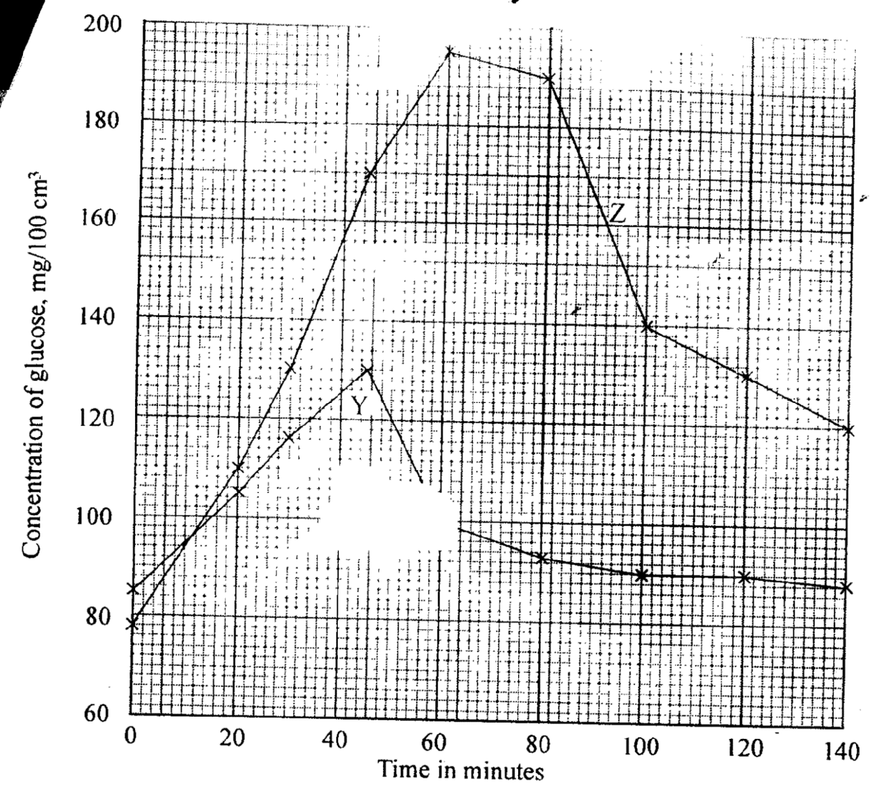

b) Y – 120mg / 100cm³ ± 1;
Z – 178mg / 100cm³ ± 1;
c) i) Blood sugar level increased to 130 mg / 100cm³; glucose is being absorbed from the intestines;
- Some of it by – passes the liner without entering the cells thus raising blood glucose level;
ii) Glucose concentration declined to normal 90mg / 100cm³ high blood glucose stimulates the pancreas to produce insulin ; which stimulates the liver cells to take up glucose ; and consists it to glycogen; (4mks)
d) Some of the glucose is used in respiration to generate energy; some is lost in urine; (2mks)
7.(a) (i) Food web; Food chain; Pyramid of biomass; Pyramid of numbers;
(ii) A lot of food; causes population increase; leading to high rate of reproduction; and immigration;
Little food ; leads to stiff competition (for food) ; leading to low rate of reproduction; high rates of deaths; and emigration; thus reducing the population.
(b) Leaves are modified to spines/ thorns; to reduce surface area over which transpiration can occur; Shed their leaves during the dry season; to reduce the surface area exposed to transpiration; Leaves have thick , waxy cuticles; to minimize rate of cuticular transpiration. Leaves for some plants can roll or fold; to reduce rate of transpiration by not exposing stomata to environmental factors. Have sunken stomata; which accumulates moisture in sub-stomatal air spaces hence low diffusion gradient thus reducing transpiration rate. Reduced number of stomata; hence low rate of transpiration. Some plants have reversed stomatal rhythm; to prevent excessive water loss by transpiration. Possession of very deep roots; to absorb water from deep in the soil surface; Possession of parenchyma cells in swollen stems and leaves; for storage of water; Many leaves are sclerophylous/ possess resin coatings; to increase reflection of solar radiation ; hence lower transpiration rate.
NB Award transpiration once

8). Mitochondria;
Has a double membrane surrounding it and inner membrane folded to form cristae which increases the surface area for attachment of respiratory golgi body/apparatus, are stack of membrane bound like sac/is a system of membranes sacs/hollow spaces; that transports glycoproteins/carbohydrates and proteins; They package glycoproteins; secrete mucus/enzymes/synthesized proteins.
Lysosomes
Are spherical in shape and enclosed by a single membrane; contain hydrolytic enzyme which destroy worn out organelles, micro-organism/ingest food/breakdown large molecules.
Endoplasmic reticulum
Are membrane bound cavities in cytoplasm; smooth endoplasmic reticulum site for lipid/sterot transport. Rough endoplasmic reticulum ahs ribosome on its surface; and transport proteins.
Centrioles
Rod shaped; located outside the nuclear membrane, for formation of fibs and cilia
Cytoplasm;
It’s a fluid medium; where chemical reaction occurs, contains organelles and inclusions (e.g. glycogen granules, fat droplets and dissolved substances).
Cell membrane
Encloses all cell organelles; has phospholipid layer between two protein layers/it’s a lipoprotein layer has pores that selectively allows substances to pass in and out of the cell/its semipermeable.
Nucleus
Has a double membrane/nuclear membrane around it, which has pores to allow substances in and out of the nucleus; Has nucleoplasm, which contain nucleolus/chromatin, nucleus controls all cell activities, Nucleolus manufactures ribosomes and centrioles.
Ribosomes
Are spherical in shape and suspended in cytoplasm and attached on endoplasmic reticulum; synthesis proteins.

